Upper YDL – Yate May – 2026

On a scorching day, where any breeze would have been greatly appreciated our team of nine greens achieved 14 PB’s between them. The highlight was a stunning win in the 400m for Liam Shekyls. The men just missed out on the Under 20’s 4 x100m record.
A huge thanks to Mariann Wood for pulling the squad together. They scored 246 points, just one point ahead of a composite South Wales team. This shows the importance of every athlete and every point. We also scored maximum points for supplying officials, with newly qualified Tom Straker joining Phil Wells, Magda Michniok, Paul Mabberley & Colin Wood in officiating.
Having placed 8th in the first match, we improved to 7th. We look forward to the final match of the season on Sunday 12th July at Gloucester. This is an opportunity for ALL our U18 and U20 athletes to turn out and show how strong athletics is in Herefordshire.

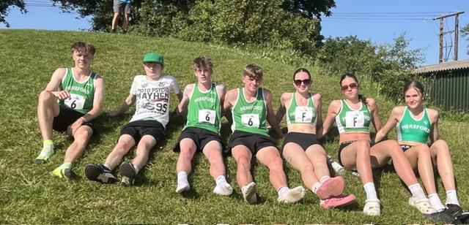

Men U20

Harry Vaughan 100m 12.41 -0.2w (5A)

Will Andrews 100m 12.78s -0.3w PB (5B)

4 x100m 46.18s 3rd (Liam, Harry, Fred, Ruben)

Men U18

Liam Shekyls. 100m 11.42 +0.6w PB (6A), 200m 23.11s -0.5w (2A), 400m 51.17s (1A) PB

Fred Tyler 400m 53.91s PB (2B), 800m 2m14.83s (6A), Discus 24m PB (6A)

Ruben Mabberley. 400m 53.12s PB (U20 3A) 110mH 16.43s -0.6w PB (4A), Javelin 36.73m PB (3A)

Women U18

Victoria Rossiter. 100m 13.50s +0.6w PB (7A), Triple Jump 10.12m 0w (2A)

Zofia Michniok 100m Hurdles 17.81s -0.3w PB (3A), Long Jump 4.23m -0.3w (5A), Triple Jump 9.91 0w (1B)

Maisie Wood High Jump 1.45m (2A), Triple Jump 9.58m 0w (U20 4A), Shot 9.45m PB (5A)

Erin Straker High Jump 1.45m =PB (2B), Shot 7.56m PB (4B), Javelin 22.75m (5A)

4 x 100m 55.69s 4th (Maisie, Erin, Zofia, Victoria)

