ADDENDUM #1
RFP Title: ETCOG Air Quality Technical Services 2026 RFP
RFP No#: EDAQCTS26R
Issued by: East Texas Council of Governments
Original RFP Issue Date: February 5, 2026
Addendum Issue Date: February 25, 2026

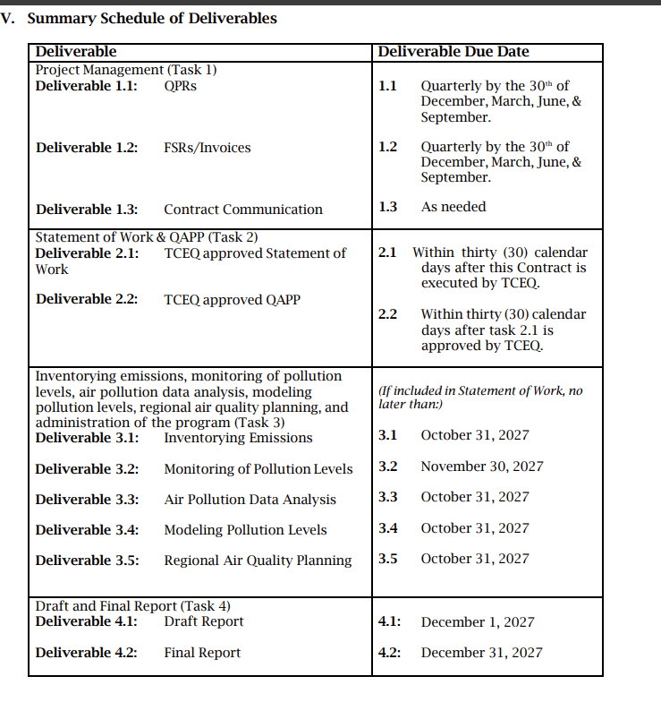

All proposers must acknowledge receipt of this Addendum #1 in their bid proposal submission. Failure to acknowledge receipt of this Addendum may result in disqualification.

Authorized By:
Name:__________________________________________
Title:____________________________________________
Signature:_______________________________________
Date:___________________________________________

