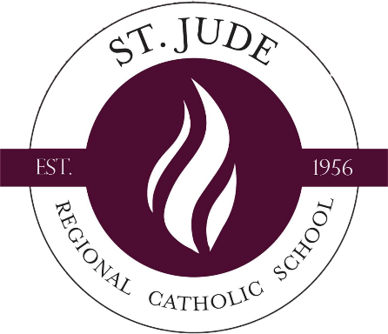

Pastor’s Verification Form 2026-2027

Deadline: March 2, 2026
$1,000-Roman Catholic

Forms will not be accepted after this date.
Name of Child(ren) and Grade(s) entering: _______________________________________________________________
__________________________________________________________________________________________________

Address: __________________________________________________________________________________________
This is to certify according to parish records and/or my personal knowledge.

Name of Parents/Guardians: _________________________________________________________________
Phone number: _____________________________
Parish of registration: ________________________________________________
Parish Envelope number: ___________

PARISH OFFICE USE ONLY
(Check only those items which apply to this family.)
Registered____________ Practicing____________ Contributing______________
Pastor’s Signature: _________________________________________________________
Date: _________________________
Additional Comments if Desired: ______________________________________________
________________________________________________________________________
Parish Seal

