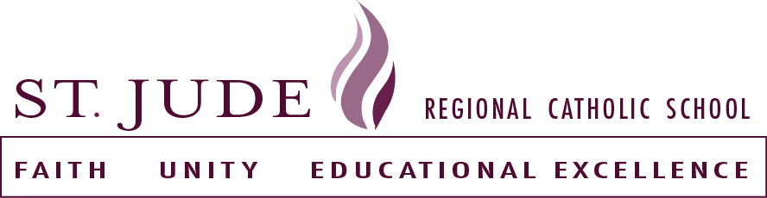

Parent/Student
Handbook Agreement Form
Due no later than August 29, 2025
Each student must bring in a handbook agreement and give to homeroom teacher

I/We have read the St. Jude Regional Catholic School Parent/student handbook. I/We have reviewed it with my/our child/children.

Parent signature/print name____________________________________
Parent signature/print name ___________________________________

Student signature and grade __________________________________________

Student signature and grade ___________________________________________

Student signature and grade ____________________________________________

Student signature and grade ____________________________________________

