Dear Patients and Families,

Our clinic has unfortunately experienced unexpected water damage. As a result, our main facility is currently closed until further notice while we complete the necessary repairs to ensure a safe and healthy environment for everyone.

Adult Therapy Services: Temporary Location
We are committed to continuity of care and have secured a temporary space to continue serving our adult therapy patients. Beginning Monday June 8th, adult therapy appointments will take place at:
- The ARC of Indian River County, 1375 16th Ave, Vero Beach, FL 32960
- Click here for Google Maps directions

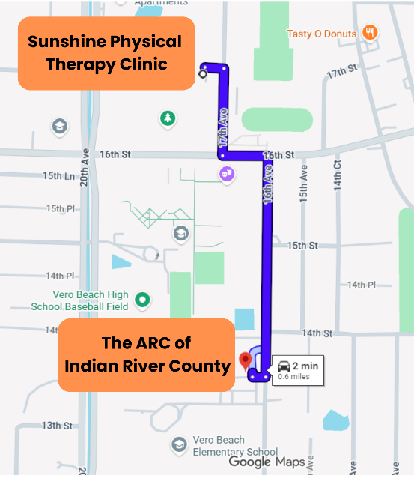

Finding Us at The ARC of Indian River County
When you arrive, look for the "Welcome to Sunshine Physical Therapy" signs featuring our logo to guide you directly to the correct entrance. Parking is available onsite.

For Our Pediatric Families
We know how crucial consistent therapy is for our youngest patients. Please note that our pediatric department is currently closed along with the rest of the main clinic. However, we are actively working on a plan to safely reopen the pediatric space so services can resume at our clinic as soon as possible. We expect to have more definitive details next week and will notify families immediately with an update.

Next Steps & Appointments
Our team is currently working hard to manage this transition.
- If you have an upcoming appointment, a member of our staff will reach out to you shortly to discuss next steps, relocation, or rescheduling.
- If you have immediate questions, you can still reach us at 772-562-6877.
- Stay tuned to our website, www.sunshineptc.org and social media pages for progress updates.

Thank you so much for your patience, understanding, and flexibility as we navigate this unexpected hurdle.

Warm regards,
Sunshine Physical Therapy Team

