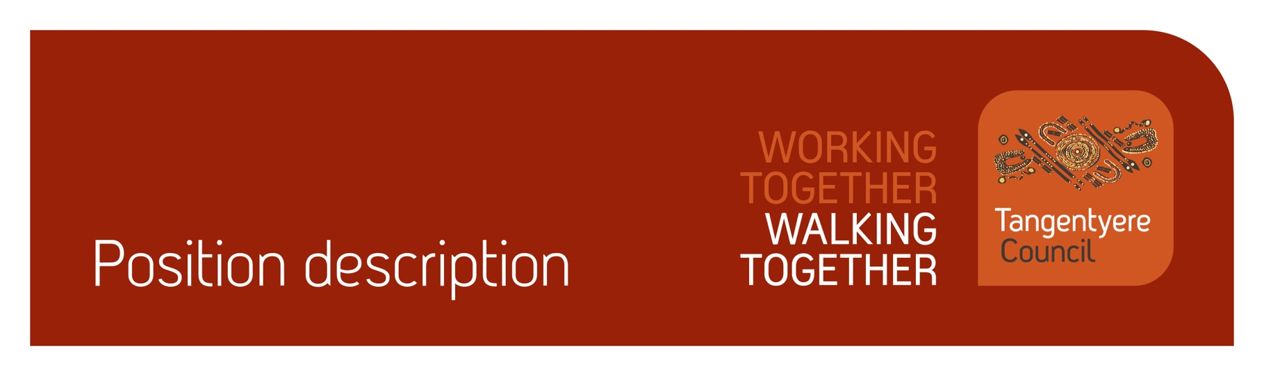

Position title | Youth Employment Pathways (YEP) Intern
Division | Youth, Family and Community Safety
Classification | 1.1
Prepared by | Brooke Turnbull
Date | 06/03/2026
Staff reporting to position | 0

Position Summary
Tangentyere Council Aboriginal Corporation (TCAC) is a community-controlled Public Benevolent Institution delivering human services and social enterprise activities for the benefit of Aboriginal people from the Alice Springs Town Camps, urban Alice Springs, and Central Australia.
The Tangentyere Council Youth, Family & Community Safety (YFCS) Division delivers a range of services across Town Camps and Alice Springs, supporting children, young people, families, and communities through daytime and after-hours services focused on recreation, diversion, out of home care, community safety, and family support programs.
The Youth Employment Pathways (YEP) program is for young people aged 15–25 living in Alice Springs Town Camps. The program supports young people entering paid casual work by providing on-the-job training and mentoring to develop core workplace skills and by offering opportunities to gain relevant training, hands on experience and qualifications in the community and youth services. The program recognises the importance of culture, community, and family, and supports young people in building workplace skills while remaining connected to their community.
The YEP Intern will work within Tangentyere’s Youth and Community Safety at programs such as the 3 Brown Street Youth Service, the Child & Youth Outreach Service, and Night & Youth Patrols. The YEP intern requires no prior work experience and will be provided intensive coaching and mentoring to develop workplace skills. The role will support the delivery of the services and participate in a wide range of training & development opportunities.
As part of your role, you will be working with children, people with disabilities, and vulnerable individuals. It is your obligation to always ensure their safety and report any concerns in line with our duty of care obligations. We have zero tolerance when it comes to abuse of any kind and will take disciplinary action, including up to termination of employment, should we determine that abuse has taken place or there has been a failure to report any suspected or alleged abuse.

Responsibilities
- Participate in training, mentoring and development opportunities.
- Work as part of a team and develop positive work habits.
- Assist the team to deliver program activities.
- Workplace compliance, quality & safeguarding.
- Assist with achieving quality management objectives across the organisation.
- Assist with achieving safeguarding objectives across the organisation.
- Assist with achieving compliance objectives across the organisation.
- Other duties as required.

Major Accountabilities
Accountabilities | Performance Indicators
- Participate in training, mentoring and development.  - Actively contributes to the development and achievement of individual goals. | - Participates in compulsory training, including Therapeutic Crisis Intervention, first aid, mandatory reporting and other relevant training  - Attends and actively engages in training sessions and learning opportunities.  - Shows willingness to learn and asks questions.  - Observe and learn how staff engage safely and respectfully with children and young people.  - Demonstrates improvement in communication, teamwork, and other workplace skills.  - Reflects on feedback and applies it.  - Engages with mentors and supervisors to attend shifts and create Support and Development Plans to build confidence and capability in the workplace.
- Work as part of a team and develop positive work habits. | - Communicates in a timely way when unable to attend scheduled shifts.  - Reliable and consistent attendance at work.  - Seeks guidance when unsure.  - Contributes to team discussions where appropriate.  - Compliance with the Tangentyere Council policies and procedures.  - Follow directions and guidance from supervisors and mentors.  - Contribute ideas and take part in making programs and processes better.
- Assist the team in delivering program activities.  - Ensure the safety of children is prioritised through all aspects of the work  - The voice of children, families and the community is reflected in the work. | - Activities are set up and packed down safely.  - Follows instructions from mentors or other YFCS staff.  - Young people feel welcome, safe, and encouraged to join in the youth programs.  - Operates as a good role model for young people accessing YFCS services.  - Young people understand what activities are happening and how they can join in.  - Any issues or incidents affecting youth program or young people are reported immediately to the shift lead.  - Ensure the safety of children, families, and vulnerable people, reporting any concerns to leadership as required.  - Listen to and include the voices of children, families, and clients in your work and help them provide feedback.
- Assist with achieving quality management objectives across the organisation.  - Commitment to the Tangentyere Council Quality Management Objectives. | - All work-related actions and behaviours are aligned with the organisations mission and values.  - Actively participate in and promote a continuous improvement culture across the organisation.  - Understand and comply with organisation policies and procedures.  - Maintain organisation and client records in accordance with legislative and organisational policy requirements.  - Ensure all decisions made in the course of your duties are transparent and align with organisational policy and procedures.  - Assist clients to provide feedback when required.  - Contribute to QMS area audits as required in a timely manner.  - Contribute to implementing change when identified through the QMS as required.  - Provide feedback on the QMS as required.
- Assist with achieving safeguarding objectives across the organisation. | - Report any concerns or suspicions of abuse of children, people with a disability or vulnerable peoples in line with duty of care and mandatory reporting obligations.
- Assist with achieving compliance objectives across the organisation. | - Maintain own records and manage Employment Hero compliance for staff, where applicable.  - Maintain current certifications (Driver’s Licence, Working with Children (Ochre Card), Police Check, and where relevant, RN Registration, White Card and First Aid Certificate etc.) and upload evidence in Employment Hero.  - Complete probation reviews (6, 12 and 22 weeks) within the approved timeframe.  - Read and acknowledge all relevant policies in Employment Hero.
- Other duties as required. | - Additional tasks that may arise from time to time are completed within the required timeframe and to a suitable standard.  - Work as a team member to provide a safe and collaborative environment.  - Assist YFCS management to create new programs for youth engagement.
Ways of Working
The Youth, Families & Community Safety (YFCS) Division operates from a trauma-informed, strengths-based framework that empowers children, young people, families, and communities to achieve outcomes of their choosing. This approach is grounded in respect for Aboriginal cultures and human rights, and is guided by ethical practice, critical thinking, collaboration, and integrated service delivery.

Competencies
Tangentyere core competencies
- Commitment
- Teamwork
- Communication
- WHS
- Cultural Awareness

Relationships
Internal

- Youth, Family & Community Safety Division
- Community Centre Division
- Social Services Division
- Tangentyere Employment Services
- Family Violence Prevention Division
- Human Resources & Work Health & Safety
- IT
- Central Australia Youth Like Up Service (CAYLUS)
- Finance

External
- Youth Services
- Education Institutions & Registered Training Organisations
- Other key stakeholders

Qualifications and Selection Criteria
Required
- Identify as Aboriginal and/or Torres Strait Islander and live in an Alice Springs Town Camp
- Be 15 – 25 years old
- Willingness to participate and engage in training, mentoring and development plans
- Willingness to operate as a role model for young people accessing Tangentyere services
- Holds a valid Ochre Card and a Current Satisfactory Police Check.

Desired
- A First Aid Certificate, training will be provided as needed.
- Current NT Driver's License (P-Plates accepted) and own transport.
- A knowledge of effective ways to engage young people, the impact of trauma and strengths-based practice and/or willingness to train in these areas. Transferable life experiences are also valued.
- Basic computer skills, training will be provided.

Verification
This section verifies that the position holder and the manager have read the attached position description and are satisfied that it accurately describes the position.
Position holder
Name
Date effective
Signature
Manager
Name
Date effective
Signature

