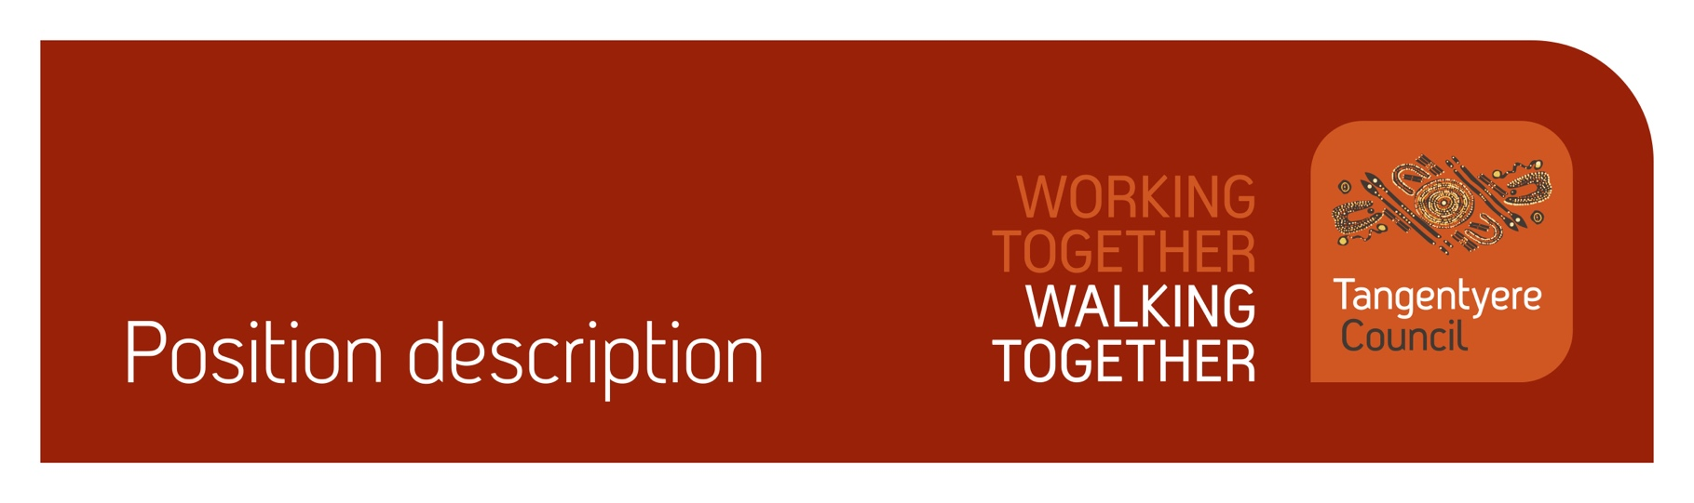

|  |  |
| --- | --- |
| Position title | Youth Trainee |
| Division | Youth and Community Safety |
| Classification | 1.1 |
| Prepared by | Sabin Bohara |
| Date | 24/03/2025 |
| Staff reporting to position | 0 |

# Position summary

Tangentyere Council Aboriginal Corporation (TCAC) is a community controlled    
Public Benevolent Institution delivering human services and social enterprise activities for    
the benefit of Aboriginal people from the Alice Springs Town Camps, Urban Alice Springs    
and Central Australia.

Youth and Community Safety (YCS) Division brings together a range of programs that target Aboriginal children, youth and community to provide supports and services that support improved health, educational and wellbeing outcomes. The Division includes the youth services based in Alice Springs and surrounding town camps, Night and Youth Patrol, Child and Youth Outreach and Brown Street Youth Service. The youth services aim to provide planned and intention activities and supports for young people which aim to build their social and emotional skills, support their development, provide referral to other services, and strengthen engagement by young people with training, education and employment.

The Youth Trainee is an entry level position identified for Aboriginal young people, aged 16 – 25 years. The position’s purpose is to reduce barriers to young people’s access to employment. The role will be providing ad hoc casual employment that will enable a young person to undertake paid employment within a supervised and supportive environment. The intention is to support young people develop their work ready skills, foster a sense of personal leadership and create opportunities for young people to contribute to Tangentyere Council.

Youth Trainees will be engaged on a casual basis to undertake various activities and roles. This may include running discrete youth activities such as facilitating discussion groups and gathering formal consultation information; leading youth activities such as sports or artistic endeavours; contributing to organisational planning and program development. Youth Trainees may be responsible for running a broad variety of youth activities, under supervision, and may be involved in planning and creating new activities for young people.

Where appropriate, Youth Trainees may be required to participate in team meetings and youth governance meetings sharing their thoughts and experiences of youth issues and activities with the broad youth services team.

Youth Trainees may be expected to work unsupervised for short periods of time, running an activity or discrete space within a broader youth program, but they will not be left at a site alone and will not be the responsible nominated person for an activity. Where a Youth Trainee is employed as part of a youth activity, they will not form part of required staff: child ratios.

As part of your role, you will be working with children, people with a disability and people who are vulnerable. It is your obligation to always ensure their safety and report any concerns in line with our duty of care obligations. We have zero tolerance when it comes to abuse of any kind and will take disciplinary action, including and up to termination of employment, should we determine that abuse has taken place or there has been a failure to report any suspected or alleged abuse.

# Responsibilities

* Working with young people in a safe and respectful manner.
* Role modelling respectful, fair, and trustworthy behaviours in their work.
* Running discrete youth activities with young people, under supervision.
* Supporting youth workers to navigate community, family and cultural issues affecting young people.
* Using relationships and communication with young people to make sure all equipment is looked after properly and returned to the program after use.
* Advocating for young people’s rights and participation in the community.
* Notifying Youth Workers if issues arise in the delivery of activities

# Major Accountabilities

|  |  |
| --- | --- |
| Accountabilities | Performance indicators |
| * Leading activities at youth programs. | * Young people feel welcome, safe, and encouraged to join in at the youth programs. * Young people understand what activities are happening and how they can join in. * Young people are aware of upcoming events and opportunities provided through the youth programs. * Young people's feedback about activities and programs are collected and passed onto Youth Workers * Any issues or incidents affecting youth program or young people are reported immediately to the Youth Workers * Young people are supported through challenging behaviour and issues at youth program. |
| * Ensure all equipment and infrastructure is respected and looked after by young people. | * Young people are told the expectation and need for proper care for of equipment and resources. * Young people are immediately supported when they are upset or overly excited. * Waste of resources is minimised. * Equipment and resources are collected and returned upon completion of the activity. * Any issue with equipment or infrastructure is reported immediately to the youth workers. |
| * Preparation for Youth Programs | * Cleaning and tidying of youth spaces. * Organising youth equipment. * Food preparation and cooking. |
| * Act professionally and work as part of a team | * Comply with all Tangentyere policies and procedures. * Comply with legislative obligations and reporting requirements. * Work cooperatively and collaboratively as part of the Youth Services team. * Completed Therapeutic Crisis intervention training within a year of Appointment * Undergo relevant training as necessary. |
| * Other duties as required. | * Take reasonable direction and demonstrate flexibility as required to deliver a quality, responsive service. * Cleaning work sites as appropriate, including kitchens, bathrooms, and staff and client spaces. |

# Relationships

**Internal**

|  |  |  |  |
| --- | --- | --- | --- |
| Youth & Community Safety Manager | | Social Services Division | |
| Community Centre Coordinators | | CAYLUS | |
| Tangentyere Youth Services staff  CDP participants  Patrol services | | Other Tangentyere staff, as required | |
|  | |  | |

External

|  |
| --- |
| * Youth Centres (e.g. Alice Springs Youth Centre, Gap Community Centre) |
| * Other non-government organisations * YORETS and other Territory Family staff * NT Police * Other key stakeholders |

# Competencies

Tangentyere core competencies

* Commitment
* Teamwork
* Communication
* WHS
* Cultural Awareness

# Qualifications and Selection Criteria

Required

* An ability to work a minimum of 3 hours per shift.
* Good communication skills and an ability to develop rapport and support with young people, and family members.
* Current NT Driver’s Licence, Ochre Card, Triple dose Covid-19 Vaccination and Current Satisfactory Police Check.

**Preferred**

* A First Aid Certificate, but training will be provided as needed.
* A knowledge of effective ways to engage young people, the impact of trauma and strengths-based practice and/or willingness to train in these areas. Transferable life experiences is also valued.

# Verification

This section verifies that the position holder and the manager have read the attached position description and are satisfied that it accurately describes the position.

Position holder

|  |  |
| --- | --- |
| Name |  |
| Date effective |  |
| Signature |  |

Manager

|  |  |
| --- | --- |
| Name |  |
| Date effective |  |
| Signature |  |