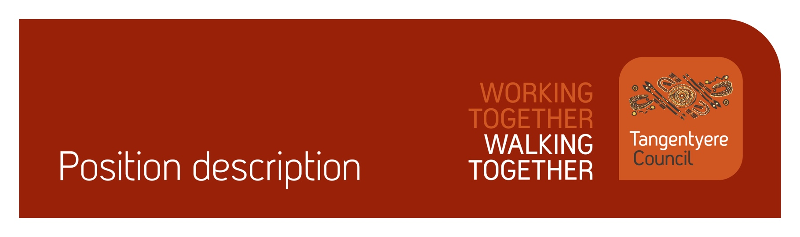

|  |  |
| --- | --- |
| Position title | Safe House Carer |
| Division | Youth Families & Community Safety (YFCS) |
| Classification | 1.1 – 3.1 |
| Prepared by | Maree Corbo and Ben Poona |
| Date | 17/10/22 |
| Staff reporting to position | 0 |

# Position Summary

Tangentyere Council Aboriginal Corporation (TCAC) is a community controlled Public Benevolent Institution delivering human services and social enterprise activities for the benefit of Aboriginal people from the Alice Springs Town Camps, urban Alice Springs, and Central Australia.

The Tangentyere Safe House (Ndarndarinjika Safe Houses) provides short term crisis accommodation for Aboriginal children between the ages of 0-12 years old, including respite care. Working from a child centred approach the aim of the program is to ensure that young people are supported therapeutically through the safe provision of a physically, emotionally, and culturally appropriate family environment. The program recognises continued connection to family and culture as integral to a child’s identity and has cultural safety as a fundamental principle of its service provision.

This position is responsible for the day-to-day support for Aboriginal children in our care, the primary focus of this role is to ensure the children are supported through a physically, emotionally, and culturally safe family environment. Safe House Carers work on a roster system within a home care setting and are required to attend to all aspects of the house whilst on duty with a primary focus on the care and supervision of all children residing in our houses.

As part of your role, you will be working with children, people with a disability and people who are vulnerable. It is your obligation to always ensure their safety and report any concerns in line with our duty of care obligations. We have zero tolerance when it comes to abuse of any kind and will take disciplinary action, including and up to termination of employment, should we determine that abuse has taken place or there has been a failure to report any suspected or alleged abuse.

# Responsibilities

* Maintain high standards of care, supervision, and protection to young people by providing a safe and consistent living environment in the Safe House.
* Identify and attend to the physical, emotional, and cultural needs of young people living in the Safe House.
* Maintain program documentation and client confidentiality in accordance with Tangentyere Council’s policy and procedures.
* Maintain high standards of practice and accountability for actions and decisions in accordance with the Safe House reporting any breaches of Policy and Procedures to the Team Leader/Coordinator.
* Assist with achieving quality management objectives across the organisation.
* Assist with achieving safeguarding objectives across the organisation.
* Assist with achieving compliance objectives across the organisation.
* Other reasonable duties as required.

# Major Accountabilities

|  |  |
| --- | --- |
| Accountabilities | Performance indicators |
| * Maintain high standards of care, supervision, and protection to young people by providing a safe and consistent living environment in the Safe House. * Respond to the emotional, physical, and cultural needs of the children in the House. * Assist to establish a homelike, caring, and nurturing environment to help children feel a sense of safety, stability, security, and trust. * Treat children with kindness at all times. | * Provide developmentally appropriate support and activities for children in our care. * Respond to the needs of children in the house. * Work in a safe manner and ensure safety of children and staff in the house. * Participate in daily household duties during the shift to ensure a clean and happy environment is maintained. * Nutritious meals are prepared. * Contribute and participate in various cultural, education, living, social and recreational skills as developed in the plans for children to meet their induvial needs. * Children feel safe, secure, and cared for at all times. |
| * Identify and attend to the physical, emotional, and cultural needs of young people living in the Safe House. * Children’s safety and wellbeing is prioritised throughout all aspects of the program. * Be aware of children’s needs while in the House – emotionally, physically, developmentally, and spiritually, and act appropriately to support them. | * Information is fed back to other staff, team leader/coordinator or Practice Lead regarding a child’s needs as required. * Feedback information to staff, Team Leader and/ Coordinator or the Practice Lead if a child’s needs require following up. * Shift notes are written after each shift. |
| * Maintain program documentation and client confidentiality in accordance with Tangentyere Council’s policy and procedures. * Confidentiality and privacy for children and their families is maintained at all times. | * Shift reports are completed. * Job responsibility check lists are completed. * Shift reports, job responsibility check lists are completed. * All other documentation requirements completed as needed. |
| * Maintain high standards of practice and accountability for actions and decisions in accordance with the Safe House reporting any breaches of Policy and Procedures to the Team Leader/Coordinator. * Ensure an awareness of the Safe House Policies and Procedures. * Behave honestly, ethically, and safely in all actions whilst on shift. * Attend team meetings and training as directed. | * Team leader/Coordinator are informed of any incidents, concerns, or issues. * Paperwork is completed as required. * An awareness of the Safe House Policies and Procedures. * Work within the Safe House framework and attend to all individual shift responsibilities. * Team meetings are attended. * Training completed as required. |
| * Assist with achieving quality management objectives across the organisation. * Commitment to the Tangentyere Council Quality Management Objectives. | * All work-related actions and behaviours are aligned with the organisations mission and values. * Actively participate in and promote a continuous improvement culture across the organisation. * Understand and comply with organisation policies and procedures. * Maintain organisation and client records in accordance with legislative and organisational policy requirements. * Ensure all decisions made in the course of your duties are transparent and align with organisational policy and procedures. * Assist clients to provide feedback when required. * Contribute to QMS area audits as required in a timely manner. * Contribute to implementing change when identified through the QMS as required. * Provide feedback on the QMS as required. |
| * Assist with achieving safeguarding objectives across the organisation. | * Report any concerns or suspicions of abuse of children, people with a disability or vulnerable peoples in line with duty of care and mandatory reporting obligations. |
| * Assist with achieving compliance objectives across the organisation. | * Maintain own records and manage Employment Hero compliance for staff, where applicable. * Maintain current certifications (Driver’s Licence, Working with Children (Ochre Card), Police Check, and where relevant, RN Registration, White Card and First Aid Certificate etc.) and upload evidence in Employment Hero. * Complete probation reviews (6, 12 and 22 weeks) within the approved timeframe. * Read and acknowledge all relevant policies in Employment Hero. |
| * Other reasonable duties as required. | * Additional tasks that may arise from time to time are completed within the required timeframe and to a suitable standard. * Work as a team to provide a safe and collaborative environment. |

# Relationships

Internal

|  |  |
| --- | --- |
| * All staff within the Safe House | * Safe House Coordinator |
| * Youth, Families & Community Safety (YFCS) Dvision | * Youth Services |

External

|  |  |
| --- | --- |
| * Department of Children and Families | * Gap Youth Centre |
| * Youth Hub | * CREATE foundation |

# Competencies

**Tangentyere core competencies**

* Commitment
* Teamwork
* Communication
* WHS
* Cultural Awareness

# Qualifications and Selection Criteria

Required

* Experience working with Aboriginal people including children.
* Good communication skills – both written and oral.
* Capacity to work outside normal business hours and willingness to work over night shifts and/or weekends, attend meetings and relevant training.
* Current NT Drivers Licence, NT Working with Children (Ochre) Card, satisfactory Police Check, and proof of full (3) vaccination against COVID-19.

Desired

* Ability and willingness to attain a first aid certificate.
* Working knowledge of Aboriginal Language/s.
* An understanding of the social justice issues facing Aboriginal People and the role of the Tangentyere Council programs in addressing these issues.

# Verification

This section verifies that the position holder and the manager have read the attached position description and are satisfied that it accurately describes the position.

Position holder

|  |  |
| --- | --- |
| Name: | Tayah Coulthard-Todd |
| Date effective: | 20-08-2025 |
| Signature: |  |

Manager

|  |  |
| --- | --- |
| Name: |  |
| Date effective: |  |
| Signature: |  |