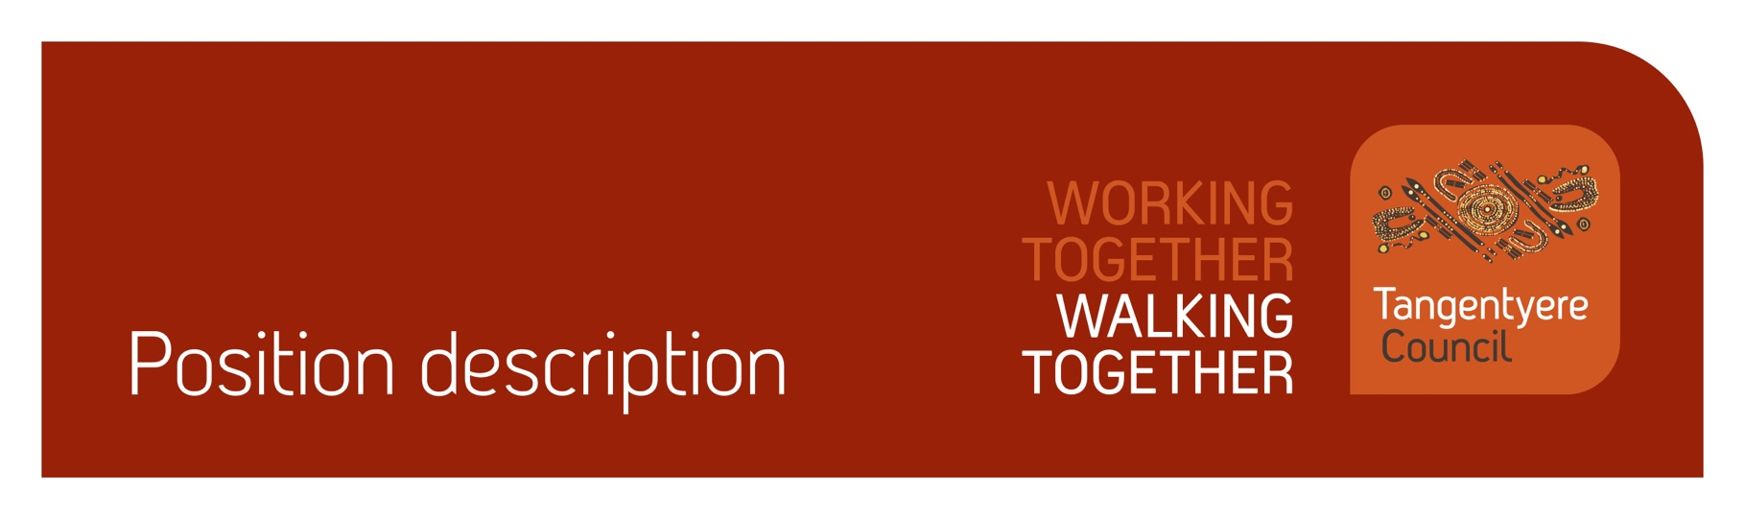

Position title | Town Camp Governance and Safety Project Officer
Division | Office of the Chief Executive
Classification | Level 7
Prepared by
Date | 20/11/2025
Staff reporting to position | 0 (may be subject to change)

Position Summary
Tangentyere Council Aboriginal Corporation (TCAC) is an Aboriginal Community Controlled Organisation (ACCO) delivering human services and social enterprise activities for the benefit of Aboriginal people from the Alice Springs Town Camps, urban Alice Springs, and Central Australia.
Led by our Board of Directors, the Office of the Chief Executive (OCE) is working closely with Town Campers to ensure all aspects of Housing Management across all Town Camps transitions back to TCAC in a manner which upholds principles of self-determination and supports strong governance within Housing Associations/Committees utilising the local – decision making framework.
The Town Camp Governance and Safety Project Officer is a full-time position working within the OCE team to ensure new and existing governance and organisational policies and programs address local priorities and needs to achieve meaningful and lasting outcomes.
The Town Camp Governance and Safety Coordinator leads internal coordination and response to issues on Town Camps, facilitates leadership and governance meetings using the Town Camp Wellness Framework, and supports the development of a Town Camp Authority Group. The role works closely with the Tangentyere Board, Town Camp Association members and a range of stakeholders to manage incidents, drive follow-up actions, and strengthen community-led decision making.
Town Campers and other Aboriginal and Torres Strait Islander people are preferred candidates for this position and are strongly encouraged to apply.
As part of your role, you will be working with children, people with a disability and people who are vulnerable. It is your obligation to always ensure their safety and report any concerns in line with our duty of care obligations. We have zero tolerance when it comes to abuse of any kind and will take disciplinary action, including and up to termination of employment, should we determine that abuse has taken place or there has been a failure to report any suspected or alleged abuse.

Responsibilities
- Coordinates the development and ongoing of the Town Camp peacemaking projects and the Town Camp Authority Group.
- Supports the facilitation of Town Camp meetings relating to peacemaking, mediation and governance.
- Drives an effective internal response to issues and incidents emerging on Town Camps, including supporting Tangentyere departments to access external service providers as needed.
- Ensures that all documentation is completed to a high quality and information sharing occurs in an effective and professional manner.
- Manage the end-to-end submissions process, including data collection, documentation preparation, submission, and follow-up reporting.
- Provide reports to internal stakeholders including the board and Executive.
- Assist with achieving quality management objectives across the organisation.
- Assist with achieving safeguarding objectives across the organisation.
- Assist with achieving compliance objectives across the organisation.
- Other reasonable duties as required.

Major Accountabilities
Accountabilities | Performance indicators
- Support and promote the development of the Town Camp peace making and mediation projects These projects are Board led initiatives which ensures Town Camp leadership is involved in developing and actioning approaches to respond to and support conflict resolution across Town Camps. | - Support the coordination of workshops to develop model and framework, driven by TCAG and senior Town Campers and TCAC Board.  - Support coordination of governance related workshops for this group and Town Camp association members  - Coordinate the development of the Town Camp Authority Group (TCAG).  - Support the development of a Peace Making and Mediation service for Town Campers.
- Supports the facilitation of Town Camp Meetings. | - Coordinates and supports the response to Town Camp meetings, including general and safety meetings.
- Drives an effective response to issues and incidents emerging on Town Camps, including facilitating service navigation and referrals, in collaboration with internal and external service providers. | - Supports the development of effective responses to incidents on Town Camp, including coordination of appropriate internal and external stakeholders.  - Advocates for responses and actions are culturally safe and relevant to the Town Camp context.  - Ensures that progress updates to Town Campers occurs in a timely, professional, and respectful manner.  - Record of Town Camps serviced maintained.  - Issues and Actions Register maintained.  - Develop and work within an approved risk assessment and mitigation framework.
- Ensures that all documentation is completed to a high quality and information sharing occurs in an effective and professional manner. | - Maintain effective documentation through issues and actions registers, meeting attendance lists, workshop participation lists and other data collection as directed by senior OCE staff.
- Manage the end-to-end submissions process, including data collection, documentation preparation, submission, and follow-up reporting | - Coordinate and administer funding submissions relating to governance and conflict management.  - Maintain accurate records of grant and submission activities  - Identify and monitor grant opportunities across various sectors, such as government, corporate, and private foundations.
- Assist with achieving quality management objectives across the organisation.  - Commitment to the Tangentyere Council Quality Management Objectives. | - All work-related actions and behaviours are aligned with the organisations mission and values.  - Actively participate in and promote a continuous improvement culture across the organisation.  - Understand and comply with organisation policies and procedures.  - Maintain organisation and client records in accordance with legislative and organisational policy requirements.  - Ensure all decisions made in the course of your duties are transparent and align with organisational policy and procedures.  - Assist clients to provide feedback when required.  - Contribute to QMS area audits as required in a timely manner.  - Contribute to implementing change when identified through the QMS as required.  - Provide feedback on the QMS as required.
- Assist with achieving safeguarding objectives across the organisation | - Report any concerns or suspicions of abuse of children, people with a disability or vulnerable peoples in line with duty of care and mandatory reporting obligations.
- Assist with achieving compliance objectives across the organisation | - Maintain own records and manage Employment Hero compliance for staff, where applicable.  - Maintain current certifications (Driver’s Licence, Working with Children (Ochre Card), Police Check, and where relevant, RN Registration, White Card, and First Aid Certificate etc.) and upload evidence in Employment Hero.  - Complete probation reviews (6, 12 and 22 weeks) within the approved timeframe.  - Read and acknowledge all relevant policies in Employment Hero.
- Other reasonable duties as required. | - Additional tasks that may arise from time to time are completed within the required timeframe and to a suitable standard.

Relationships
Internal
- Office of the Chief Executive | - Youth, Families & Community Safety
- Community Centre Division  - Employment services including municipal services | - Family Safety and Social Services Division  - Tangentyere Constructions
External
- Department of Logistics and Infrastructure  - Department of Children and Families  - Community Housing Central Australia  - Department of Chief Minister and Cabinet | - Department of Housing  - NT Police, Fire and Emergency Services  - Alice Springs Town Council

Competencies
Tangentyere core competencies
- Commitment
- Teamwork
- Communication
- WHS
- Cultural Awareness

Qualifications and Selection Criteria
Required
- Demonstrated ability to analyse complex issues, develop strategies, monitor performance, and evaluate outcomes.
- Sound oral, written communication and computer application skills including the ability to develop high quality documents and research tools.
- Good organisational skills including the ability to plan and prioritise tasks and the ability to exercise initiative and work effectively with minimal supervision.
- Demonstrated ability to undertake consultation processes and to facilitate meetings.
- High level interpersonal and communication skills, particularly in an inter-cultural environment, including the ability to produce concise and accurate reports, briefings, and submissions.
- Demonstrated commitment to community led practice, human rights, and self-determination.
- Experience in social research and/or an understanding of issues related to ethical research methodologies.
- Relevant tertiary level academic or research qualifications.
- Current NT Drivers Licence, NT Working with Children (Ochre) Card, satisfactory Police Check, and proof of full (3) vaccination against COVID-19.
- High-level administrative and organizational skills, including time management and the ability to prioritize multiple tasks
Desired
- Current First Aid Certificate, or ability and willingness to attain.
- An understanding of Aboriginal culture as well as a broad range of contemporary issues affecting Central Australian Aboriginal people.
Verification
This section verifies that the position holder and the manager have read the attached position description and are satisfied that it accurately describes the position.
Position holder
Name
Date effective
Signature
Manager
Name
Date effective
Signature

