This Equipment Rental Agreement (“Agreement”) is entered into by and between:

Renter Name (“Renter”): ______________________________________________________________

Shipping Street Address:______________________________________________________________
(the address where we will send you the Hand Cradle)

Shipping City, State and ZIP:_____________________________________________________

AND:

Owner Names (“Owner”): iNeedPeace.com / NutritionalScan.com / Reframing Perceptions LLC or Amy Tavares or
Melanie Kahleh or Cindy Garcia

Shipping Address (the address you will send the Hand Cradle back to):

iNeedPeace.com NutritionalScan.com, 2245 Texas Drive, Suite 300, Sugar Land, TX 77479

- Equipment to be Rented (“Equipment”):
Manufacturer | Item | Item Number | Description
ZYTO Corp | Hand Cradle  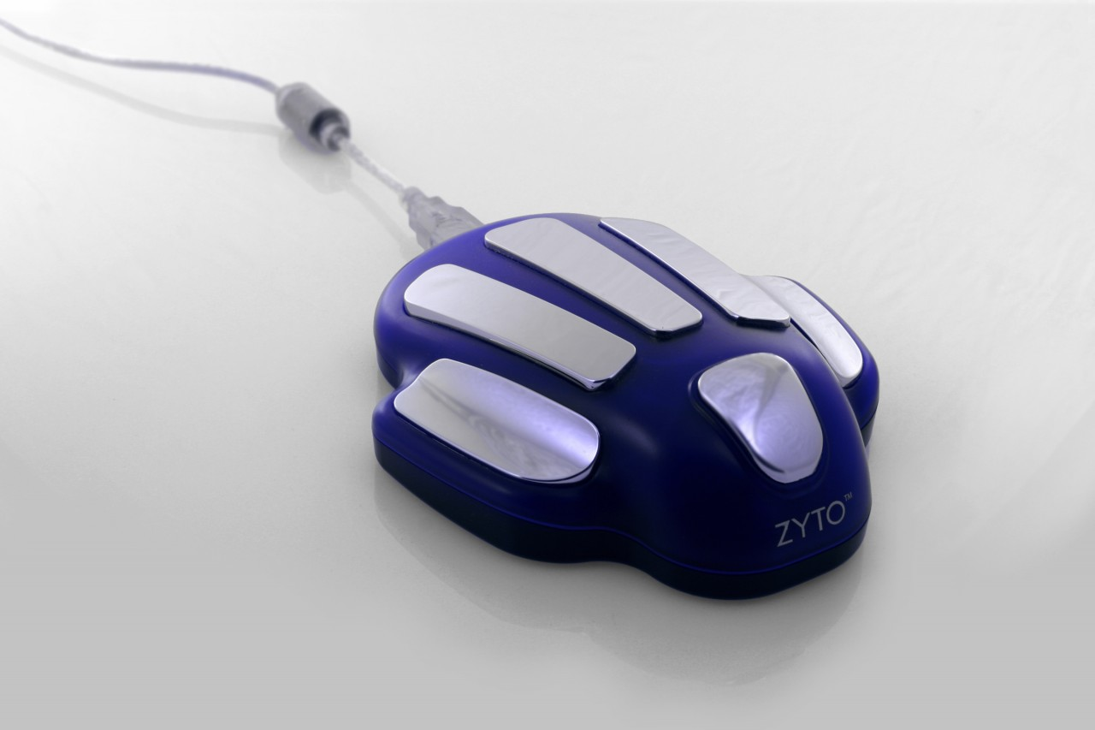 | Varies depending on the unit shipped | The Hand Cradle is registered with the United States Food and Drug Administration (FDA) as a Class 2 medical Galvanic Skin Response (GSR) measurement device. It consists of electrical circuit boards encased in a plastic/metal case and is considered non-invasive by the FDA.

- Rental Rate
Item | Rental Price | Sales Price
ZYTO Corp  Hand Cradle | No rental agreement charge. However, Renter pays shipping to send item back to Owner’s address at agreed upon time frame (below). | $295

- Rental Period and Payment:
This rental period will start on (date rented Equipment is shipped) ________________________

and last for a period of (usually about 1 or 2 weeks) _______________________________.

- The Renter shall keep and maintain the rented Equipment during the terms of the rental at his/her own cost and expense. The Renter shall keep the Equipment in a good state of repair, normal wear and tear excepted.
- The Renter shall pay the Owner full compensation of $295 for replacement and/or repair of any Equipment which is not returned because it is lost or stolen or any Equipment which is damaged and in need of repair to put it into the same condition it was in at the time of rental; normal wear and tear excepted. The Owner’s invoice for replacement or repair is conclusive as to the amount Renter shall pay under this paragraph for repair or replacement.
____________ (Renter’s initials here)
- The Renter shall not remove the Equipment from the address of the Renter or the location shown herein as the place of use for the Equipment without prior written approval of the Owner. The Renter shall inform the Owner upon demand of the exact location of the Equipment while it is in the Renter’s possession.
- The Equipment shall be delivered to Renter and returned to Owner at the expense of the Renter. Ship the Equipment back to Owner’s shipping address: Owner Names (“Owner”):
iNeedPeace.com NutritionalScan.com, 2245 Texas Drive, Suite 300, Sugar Land, TX 77479

____________ (Renter’s initials here)
- No allowance will be made for any rented Equipment or portion thereof which is claimed not to have been used. Acceptance of returned Equipment by Owner does not constitute a waiver of any of the rights Owner has under the rental Agreement.
- The Owner may terminate this Agreement immediately upon the failure of Renter to make rental payment when due, or upon Renter’s filling for protection from creditors in any court of competent jurisdiction.
- The Owner makes no warranty of any kind regarding the rented Equipment, except that Owner shall replace the Equipment with identical or similar Equipment if the Equipment fails to operate in accordance with the manufacturer’s specifications and operation instructions. Such replacement shall be made as soon as practicable after Owner returns the Equipment.
- Renter indemnifies and holds Owner not liable for all injuries or damage of any kind while operating any Equipment rented thereof.
- The Renter shall pay all reasonable attorney and other fees, the expenses and costs incurred by Owner in protection of Owner’s rights under this rental Agreement and for any action taken by Owner to collect any amounts due the Owner under this rental Agreement.
- These terms are accepted by the Renter upon delivery of the terms to the Renter or the agent or any other representative of Renter.

Renter Signature:_________________________________________________________________

Date signed:_____________________

Printed Name:____________________________________

Owners Signatures:_________________________________________________________________

Date signed:_____________________

Printed Name:___Amy Tavares, Melanie Kahleh, Cindy Garcia_____

