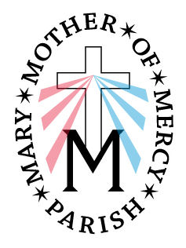

Mary, Mother of Mercy Parish
Our Lady of Lourdes Church
Extraordinary Minister of Holy Communion
Guidelines

- Please remember to go into the sacristy and sign in the book. The only time you do not have to sign is when you are replacing a minister at the last minute.
- All ministers (Eucharistic and Lector) line up in back of church before Mass for the procession.
- As you process towards the altar, step to either side in front of the first pew. When the priest bows at the altar, bow with him and then go to your pew.
- All Ministers sit towards the front of the church (within the first 4 pews).
- Proceed to the altar as soon as the congregation finishes the short prayer “Lord, I am not worthy that you should enter under my roof, but only say the word and my soul shall be healed.” Simply go to the bottom steps of the Sanctuary, bow, and then proceed up to the Altar.
- Once in the Sanctuary, you need to line up on the right side of the Altar, CLOSE TO THE ALTAR, IN LINE WITH THE EDGE OF THE ALTAR NOT by the lectern. Be Not Afraid to go close! (see drawing below). Aside from making it easier for the priest to hand you the vessels, it’s a great symbol of gathering at the Altar as you begin your special ministry of service to the rest of the Assembly.
EM
EM
EM
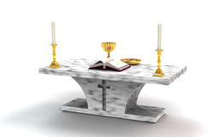

- If a choir is present, one minister should go to them immediately. They will be standing in their area, ready to receive, so that they may begin the music for that part of the Mass. The Priest or Deacon will direct you.
- Go to the far side aisles for distribution. If there is no Deacon, one minister will go in the middle next to the Priest.
- When you finish distributing Communion, look to see if there is any other long line that you could assist. After distributing the Holy Eucharist, if an altar server is with you, take the paten from the altar server and carry it to the altar.
- Go to back of altar and either give the ciborium to the Priest/Deacon or place the ciborium on the altar. You do not have to wait for someone to take it.
- You can use the water jar to purify your fingers either by the tabernacle or the credence table (where the altar servers stand). If the Priest/Deacon is returning the vessels to the tabernacle, wait, bow with the Priest/Deacon and once the doors are closed, return to your seat.
- NOTE: IF a host is accidently dropped, you pick it up and you consume it at once and then continue to distribute Communion. If it dropped from someone’s mouth, just pick it up and hold it while you continue to distribute Communion. When you return to the altar, give it to the Priest or Deacon. He will then dissolve it and put it in the sacraium (a special sink in the sacristy which empties directly in the ground, not the sewer system).

Thank you for your service to our parish and our people.

