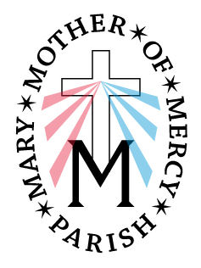
Mary, Mother of Mercy Parish
Minister of the Word Guidelines

IMPORTANT: ALWAYS PREPARE BOTH READINGS IN CASE THE OTHER READER IS NOT AT MASS

- All ministers must go to the sacristy prior to Mass to sign in.
- A few minutes before the hour of the Mass (5, 8, 10, 12), the first lector is to go to the ambo (lectern) and welcome the congregation, read the announcements and the intention for the Mass. This is found in the folder under the ambo.
- Return to the back of church for the procession. As you process towards the altar, step to either side in front of the first pew. When the priest bows at the altar, bow with him and then go to your pew. Lectors should sit on the right side of the church at Our Lady of Lourdes Church and on the left side at Our Lady Queen of Peace.
- After the opening prayer when the priest, deacon and congregation sits, the 1st reader goes to the middle of the aisle, bows from the waist, and proceeds to the ambo for the reading. After the reading, TURN THE PAGE TO THE SECOND READING and then go back to the center aisle, bow, and return to your seat. (NOTE: If there is no 2nd reader, then sit on the chair by the ambo while the responsorial psalm is sung. At the end, stand and read the 2nd reading. Also, if there are no cantors, then the 1st reader says the responsorial psalm.)
- After the Responsorial Psalm is sung, the 2nd reader proceeds to the altar following the same process. If there is a Deacon at Our Lady of Lourdes Church and you see the gold/silver Lectionary on the altar, remove the red lectionary from the ambo and place underneath because the Deacon will read from the silver/gold covered lectionary book placed on the altar. If no book is on the altar, leave the lectionary as is.
- If there is no Deacon, it is the responsibility of the 2nd reader to read the petitions (found in the binder under the lectern). Approach the altar AT THE END of the Nicene Creed, after the Amen – you do not need to go to the center, approach altar on the right, bow, and go to lectern. When the priest is finished the opening prayer for petitions, you then can read them. DO NOT LEAVE THE ALTAR UNTIL THE PRIEST FINISHES THE PRAYER AND PEOPLE START TO SIT DOWN.

Thank you for your service to our parish and our people.

