St. Joan of Arc Parish School
120 Nashotah Road
Nashotah, WI 53058
262-646-5861

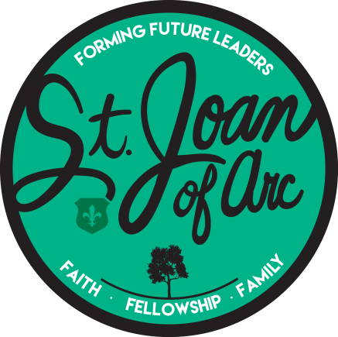

Student-Athlete Handbook

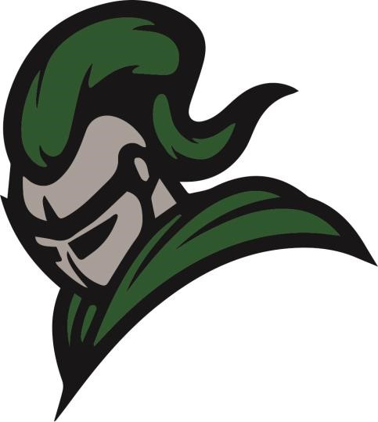

St. Joan of Arc Parish School Athletics

Mission Statement

The mission of St. Joan of Arc Athletics is to:

- Minister to youth and families
- Build teams as Christian communities
- Development character
- Grow spiritually
- Intrinsically motivate
- Promote teamwork and the enjoyment of sports and physical fitness

Philosophy

As a Catholic school, St. Joan of Arc upholds Christian values and principles. We recognize that the value of athletics is realized only when it fosters the development of the human person, both in spirit and in body, by cultivating Christian character, strengthening personal integrity, and promoting the pursuit of excellence in all endeavors.

Participation on a team is a privilege. With this privilege come responsibilities in preparation, attitude, sportsmanship, and academics. These responsibilities apply both in and out of school, in athletic and non-athletic settings. We recognize the need for God’s support and guidance in meeting these responsibilities.

League Affiliation

St Joan of Arc participates in the Parkview Parochial League (PPL). The league comprises area Catholic schools administered by the Archdiocese of Milwaukee. St Joan of Arc competes athletically under the rules and regulations set forth by these two organizations.

Fees and Equipment

St Joan of Arc does not require an athletic fee for parish school and Christian formation students participating in volleyball, cross country, basketball, and track in grades 4th–8th. Fundraising and volunteer assistance ensure all program operating expenses are covered. In certain instances, a minimal fee may be required to purchase a uniform that the student will be able to keep.

Athletic Teams

St Joan of Arc offers the following sports for students in grades 4th-8th. Volleyball and basketball teams compete in the PPL.

Season | Girls | Boys
Fall | Volleyball  Cross Country | Volleyball  Cross Country
Winter | Basketball | Basketball
Spring | Track & Field | Track & Field

Archdiocese of Milwaukee

The Athletic Association adopts the Archdiocese Rules and the By-laws of the Parkview Parochial League (PPL).

Coaching Expectations and Requirements

Coaches are first and foremost educators and must work in coordination with parents, who are the primary educators of children. At all times, coaches must be examples of Christ and serve as role models for student-athletes to emulate. They must be messengers of the school mission and ensure that athletic programs embody the Catholic characteristics prevalent at St. Joan of Arc.

All coaches must comply with all PPL policies and regulations and the St. Joan of Arc Family Handbook.

Parent Meeting

Prior to the start of each sport’s season, the coach of each team will hold a mandatory meeting for all student-athletes and their parents. During this meeting, they will introduce themselves and share their expectations for the season.

Coaches shall hand out the PPL rules and regulations and reiterate the mission of athletics at St. Joan of Arc.

The Coach’s Code

The Coach’s Code is as follows:
- Foster team loyalty through encouragement and constructive criticism.
- Carefully explain and demonstrate fundamentals at a level easily understood by the players.
- Consider individual differences in both the ability to learn and the ability to perform.
- A positive coach is a Double-Goal Coach. Winning is important, but teaching life lessons is even more important.
- Reward effort, not just good outcomes. Look to recognize players for unsuccessful effort.
- Emphasize that all players are representatives of the school, and thus their performance directly reflects on the success of this athletic program.
- Demand courtesy and respect for each other, opponents, and adults in competitions.
- Refrain from and always prohibit profanity.
- Emphasize that respect for coaches, officials, and opposing teams must be maintained, and that any deviation from this requirement will not be tolerated.
- Encourage the players to maintain their academic performance.
- Recognize that they are agents of the Athletic Board and are subject to its rules and guidelines.

Student-Athlete Expectations and Requirements

Student Expectations and Requirements

Students and parents should recognize that participation in the athletic program is a privilege for all students who possess the ability, attitude, disposition, cooperative spirit, and the desire to represent the St. Joan of Arc community in a favorable light. By joining the school’s athletic program, a student becomes a representative of their team and of St. Joan of Arc School.

Eligibility and Probation

For student-athlete eligibility
- Please see Extracurricular Activities in the Family Handbook.

For student-athlete probation and disciplinary actions
- Please see probation in the Family Handbook

All student-athletes must recognize the time commitment required of a team. One is expected to attend all practices and games. If one cannot attend a practice or game, please make sure the coach and/or athletic director has been notified in advance. Consequences for a missed practice or game will be determined by the team rules as outlined by the coach/team at the beginning of the season, in addition to the natural consequences that result from missing practice instruction or game experience.

Procedure for Registration

A student can become a full, participating member of a St. Joan of Arc athletic team once the following documents are reviewed, signed, and submitted to the school:

- Form 6145.2 (a) Medical Information & Emergency Consent
- Form 6145.2 (b) Risk Acknowledgment & Consent to Participate
- Form 6145.2 (c) Physical Examination
- Form 6145.2 (l) Parent and Athlete Concussion Acknowledgment
- Sportsmanship Pledge – Student Athlete
- Sportsmanship Pledge – Parent / Guardian

In the interest of the student-athlete’s safety and in accordance with PPL rules, they will not be allowed to participate in practices or games until these criteria are met.

Dress Code/Uniforms

Student-athletes are highly visible representatives of the school and, as such, are responsible for using good judgment in their overall appearance. All teams, regardless of level, are responsible for ensuring that their game attire reflects their class and excellence. All game shirts must be tucked in. No player should modify their uniform. Student-athletes must wear a school-issued uniform and treat it with respect. Uniforms must be returned to the athletic director within seven (7) days of the last game. Progress reports and/or report cards may be withheld until the uniform is returned. If a uniform is not returned, parents are responsible for the cost of replacing it.

Sportsmanship

All student-athletes are expected to represent St. Joan of Arc School in an exemplary manner, both on and off the court or field. Student-athletes are expected to display the best of Christian courtesy and manners toward all officials, coaches, opposing coaches, players, and spectators. At all times, good sportsmanship is the rule, not the exception. The penalty for unsportsmanlike behavior during a practice or game will be at the coaches' discretion for each sport, with input from the athletic director. Penalties may range from sitting out practice to a one-game suspension. In extreme cases, such as an athlete being ejected from a game, multi-game suspensions and dismissal from the team may be appropriate. The athletic director and principal will make the final decision after a meeting with the student-athlete, coach, and parent.

Parent Expectations and Requirements

The Role of the Parent

Parent/Guardians Expectations

The role of the parent is as follows:
- Parents are their children’s primary role models.
- Parents are responsible for maintaining good communication with the teachers of the student-athlete to ensure that academic and behavioral standards are met.
- Parents must actively participate in the work of running the athletic program, and all time spent will be included in the Volunteer Program as described in the Family Handbook.
- Each parent must remember that they are a representative of the local school. Their conduct at games and/or sporting events must reflect the principles of Christian behavior by respecting officials, coaches, athletes, and other parents or spectators.
- Parents will not use profanity at games or sporting events.
- Parents are responsible for getting their student-athlete to and from practices (barring illness) on time.
- Parents are responsible for notifying the appropriate member of the school’s Athletic Board if their child has been prevented from playing in a game.

The Parent’s Code

The Parent’s Code is as follows:
- Parents are required to attend the Parent-Athlete meeting for each sport.
- Parents are encouraged to attend all games.
- Parents are required to help at home games, including admissions, kitchen, cleanup, etc.
- Parents will participate in all fundraisers sponsored by the Athletic Board.

Playing Time

Basketball Playing Time

4th-6th student-athletes will receive equal playing time in all league games, as close as substitution timing allows. For tournament games, equal playing time is not guaranteed. Each student-athlete shall play the equivalent of one quarter in each of their tournament games.

7th grade student-athletes will be guaranteed one quarter (6 minutes) of playing time per game for the year. This playing time is accumulated over the entire season, not necessarily in each game. However, each student-athlete shall be guaranteed the opportunity to play in each game, with no specified time allotted. Each student-athlete shall participate in each tournament game, with no specified time allotted.

8th grade student-athletes are guaranteed to play in each game, with no specified time allotted. Each student-athlete shall participate in each tournament game, with no specified time allotted.

Volleyball Playing Time

4th-6th student-athletes will have equal playing time in all league matches, as close as substitution rules defined by the PPL will allow. For tournament matches, there is no guarantee of equal playing time. However, each student-athlete shall play the equivalent of one game during tournament matches.

7th grade student-athletes will be guaranteed one game of playing time per match, for the year. This playing time is accumulated over an entire season, not necessarily during each match. However, each student-athlete shall be guaranteed that they will play in each match with no specified time allotted. Each student-athlete shall participate in each tournament match with no specified time allotted.

8th-grade student-athletes are guaranteed to play in each match, with no specified time allotted. Each student-athlete shall participate in each tournament match with no specified time allotted.

All sports

The above playing time requirements can be adjusted by the coach, the principal, or the pastor for any of the following reasons: attitude, missing practices, not listening to the coach, etc. Or they may be limited in accordance with the Family Handbook.

