EVERYTHING IS AWESOME
From: The Lego Movie

Everything is awesome
Everything is cool when you're part of a team,
Everything is awesome
When you're living out a dream

Everything is better when we stick together,
Side by side, you and I are gonna win forever,
Let's party forever

We're the same, I'm like you,
you're like me,
We are working in harmony

Everything is awesome
Everything is cool when you're part of a team
Everything is awesome When you're living out a dream

Woo! Three, two, one, go!

Everything is better when we stick together.
Side by side, you and I are gonna win forever
Let's party forever
We're the same,
I'm like you, you're like me
We are working in harmony

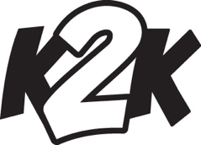
Everything is awesome
Everything is cool when you're part of a team,
Everything is awesome
When you're living out a dream
Blue skies, bouncy springs
We just named two awesome things A Nobel Prize, a piece of string
You know what's awesome? Everything!

Dogs with fleas, allergies
A book of Greek antiquities
Brand new pants, a very old vest Awesome items are the best

STAFF: Trees, frogs, clogs,
CAMPERS: they're awesome
STAFF: Rocks, clocks, and socks, CAMPERS: they're awesome
STAFF: Figs, and jigs, and twigs, CAMPERS: that's awesome
Everything you see or think or say is awesome

