THE GERMAN SOCIETY’S

2025 - 2026 FRIDAY FILM FEST SCHEDULE
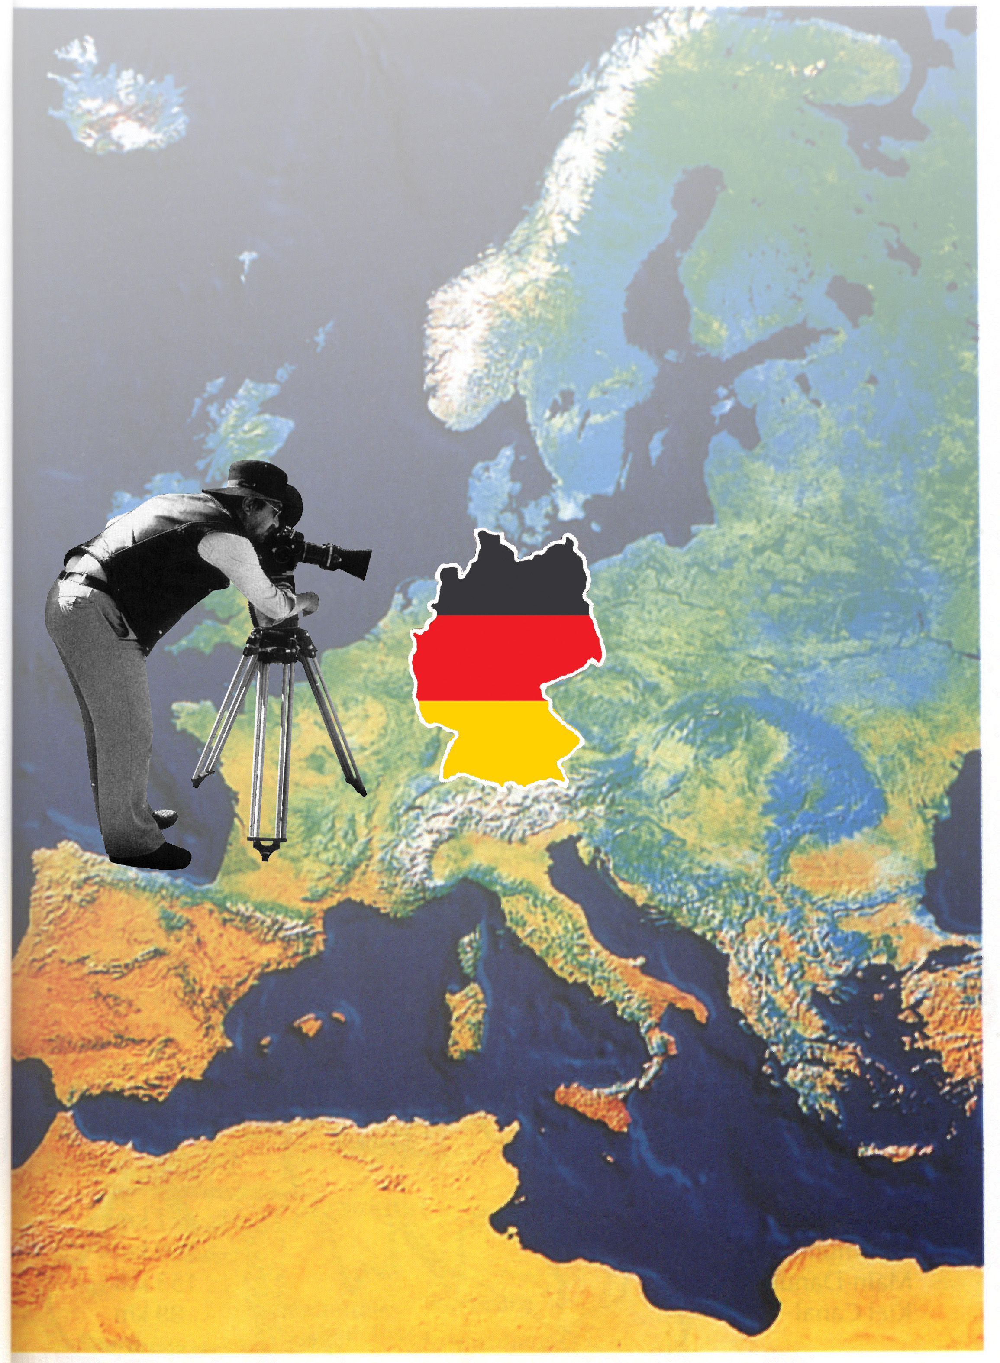

“Man muß die Welt sehen können und zu ihr hingehen.”
Döblin Berlin Alexanderplatz

October 10 September 5 (2024) English/German with English Subtitles
This movie is about the 1972 Munich Olympic hostage taking of Israeli athletes and the failed rescue by the German police seen through the live covergae of the ABC sports crew.
November 21 500 Jahre Bauernkrieg (1525) German with English Subtitles
1. Thomas Müntzer und der Krieg der Bauern. Docudrama / ZDF (2010)
2. Bauernkriegspanorama Bad Frankenhausen. Monumentalbild von Werner Tübke. (German)

January 16 Riefenstahl (2024) German with German Subtitles
This documentary explores Leni Riefenstahl’s artistic achievements, her complex connections to the Nazi regime and her life and work after the war.

February 20 Munich. The Edge of War. (2021) English/German with English Subtitles
Based on the 2017 best seller “Munich” by Robert Harris, this spy thriller takes place around the 1938 Munich Conference and the appeasement of Hitler by Chamberlain in the Sudeten-crisis

March 20 Zwei zu Eins (2024) German with German Subtitles
This comedy is based on real events shortly after the introduction of the West- German Mark in East-Germany on July 1, 1990. Zwei zu eins refers to the exchange rate in the currency union.

April 17 Die Kaiserin (2022/2024) German with English Subtitles n R
This TV series is a historical drama based on the life of Empress Elisabeth of Austria. We selected episode 6 of season 1 that aired in 2022. Season 2 became available on Netflix in 2024.
May 15 Eine Million Minuten (2024) German with English Subtitles
This is the true story of a family in which the father gets inspired by the dreams of his daughter and embarks on a trip of a life time with his family.
-------------------------------------------------------------------------------------------------------------------------------------
6:30 PM • Donations $15, $12 for GSP members • Film, Food & Discussion
The German Society of PA • 611 Spring Garden St. • Philadelphia • 215-627-2332
It's 1989 in

