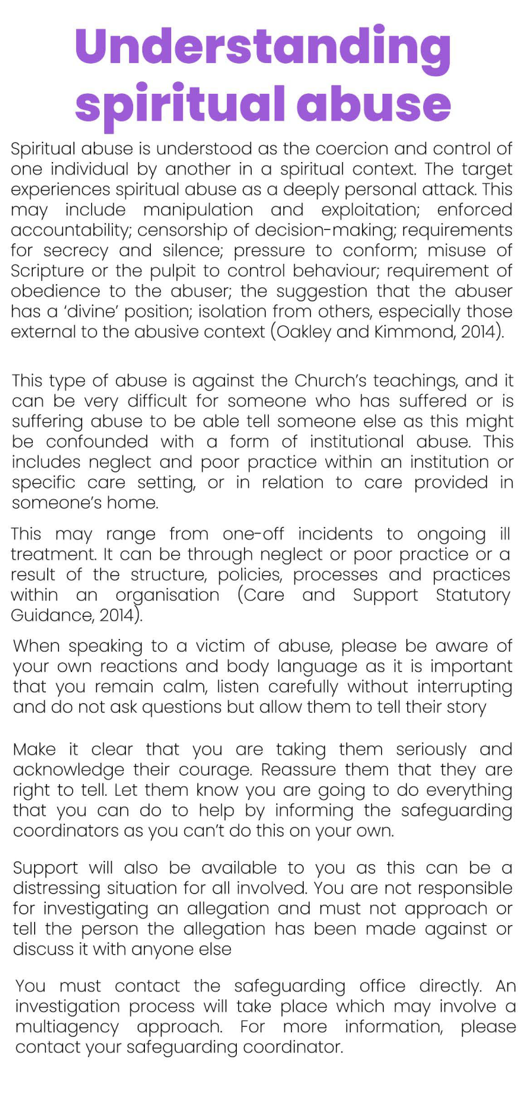
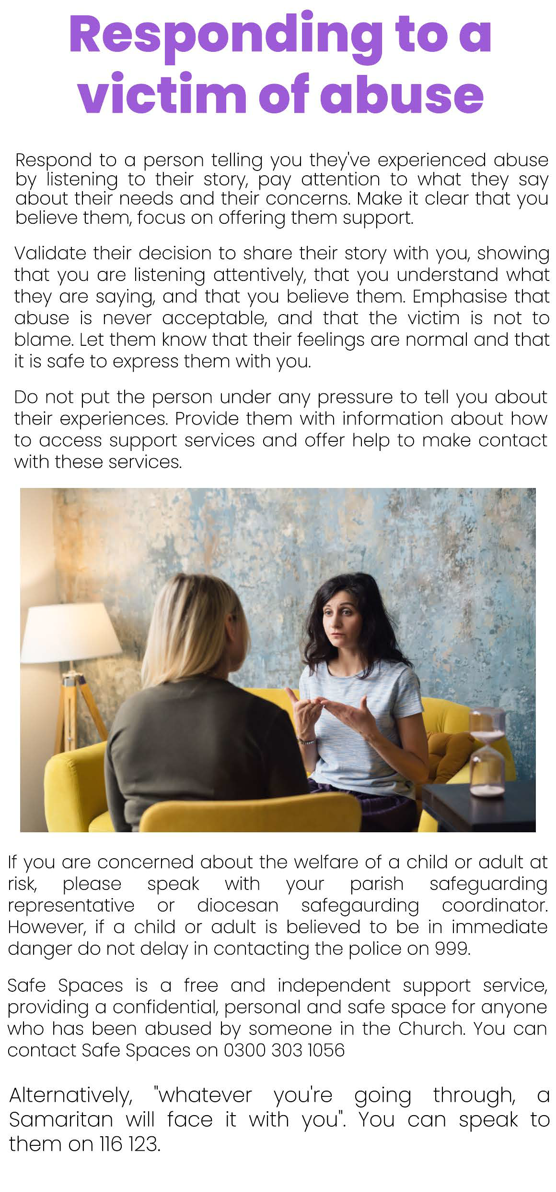
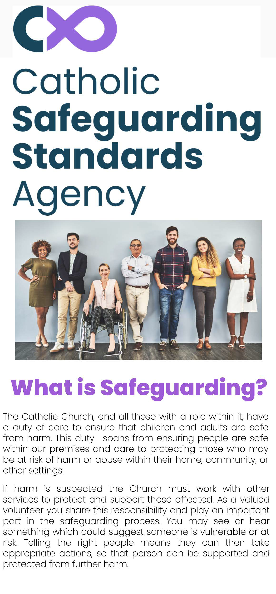
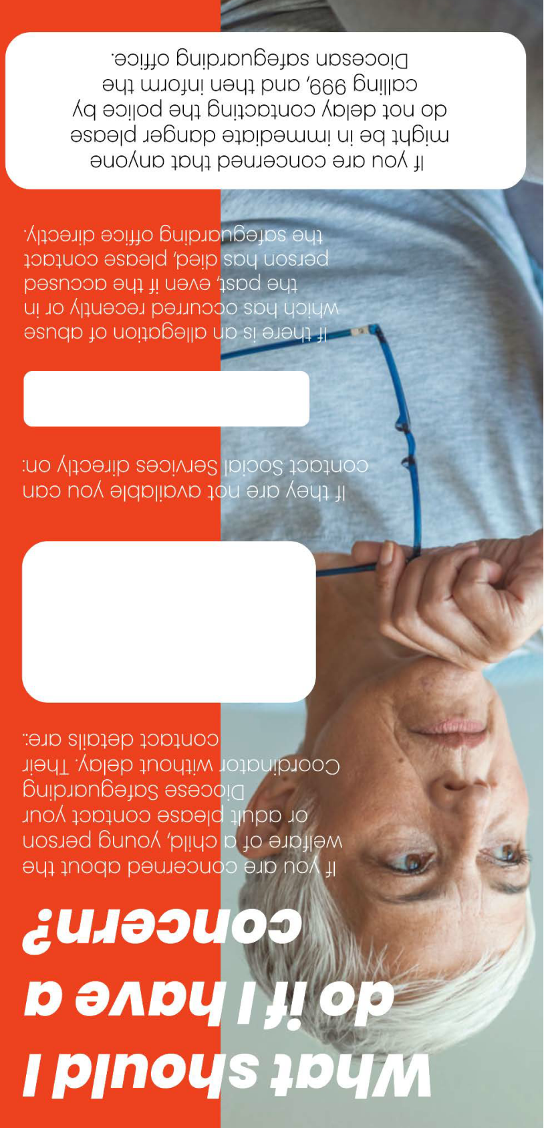
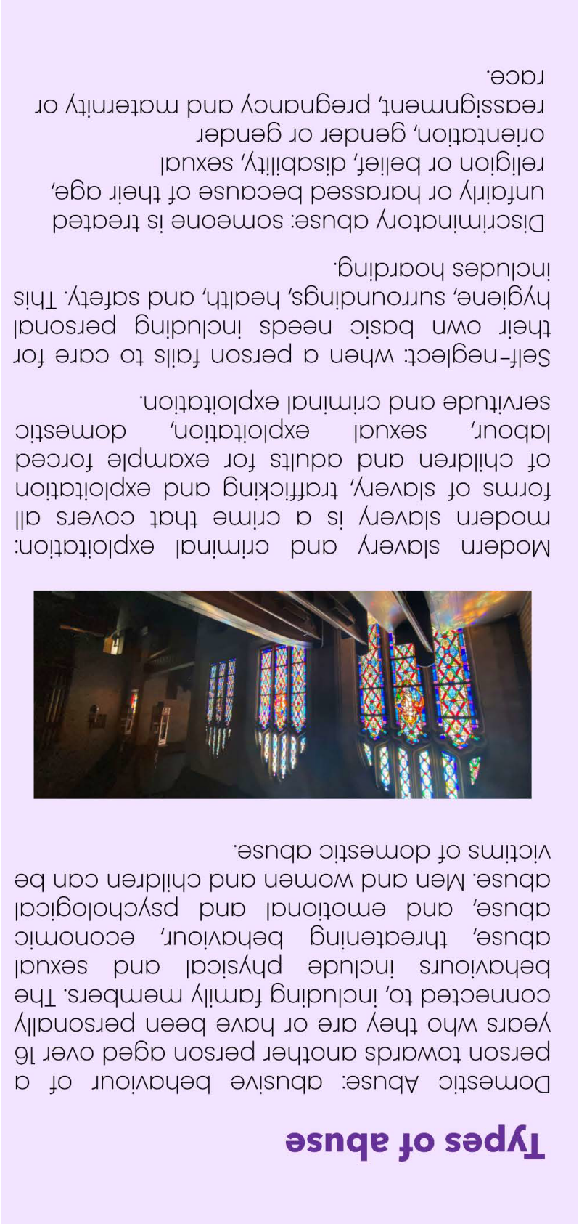
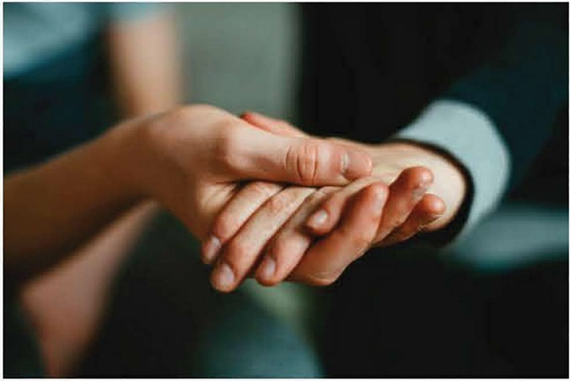

What kinds of abuse or
harm are there?
There are several types of harm or abuse.
Unfortunately, some adults and children may
be suffering more than one. Types of abuse
include:
Physical abuse: hurting an adult or child
physically by using force or violence for example
hitting, shaking, burning, poisoning.
Sexual abuse, including sexual exploitation:
forcing, encouraging, or misleading an adult or
child into sexual activity whether, or not, they
understand what is happening. This can
include grooming, physical contact or
exposure to sexual material in person or on­
line.
Neglect and omissions of care: failing_ to m:et
an adult or child's basic needs including
physical, emotional, safety, educational and
medical needs.
Emotional or psychological abuse: persistently
making an adult or child feel worthl��s �nd
unloved. This can include deliberately ndlcul1ng,
frightening, isolating or bullying them but can
also be a result of seeing or hearing others
being illtreated.
Financial and material abuse: can include theft,
fraud, scamming, pressure and intimidation
regarding wills, property or inheritanc: and
misuse or stealing of property or possessions.

