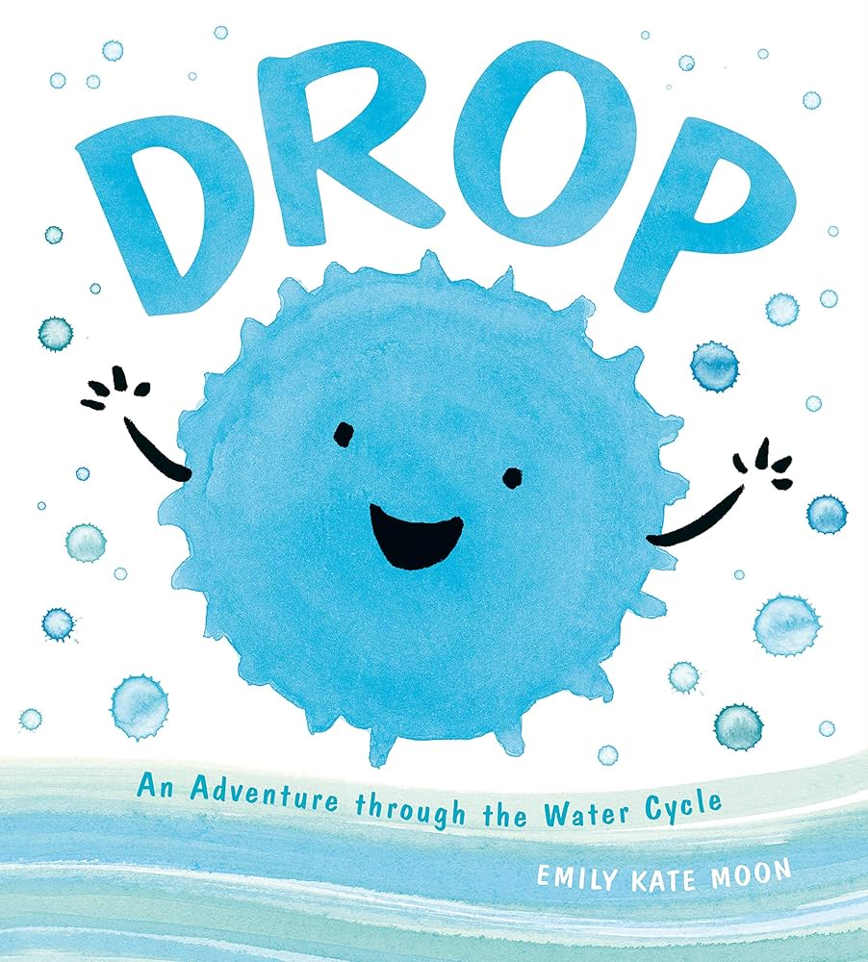
Drop: An Adventure through the Water Cycle
By Emily Kate Moon

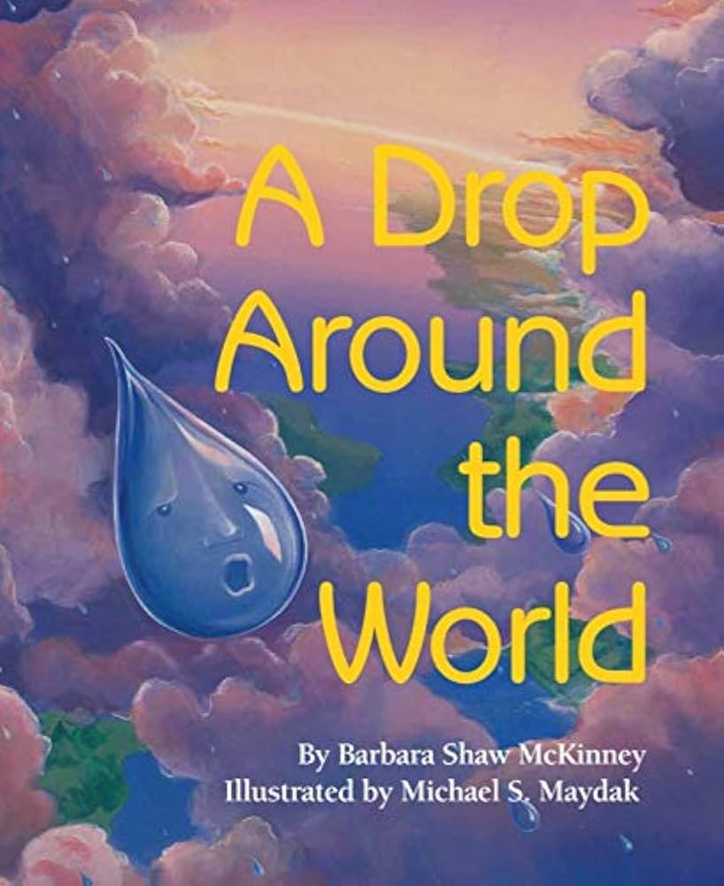
A Drop Around the World
By Barbara Shaw McKinney, Illustrated by Michael S. Maydak

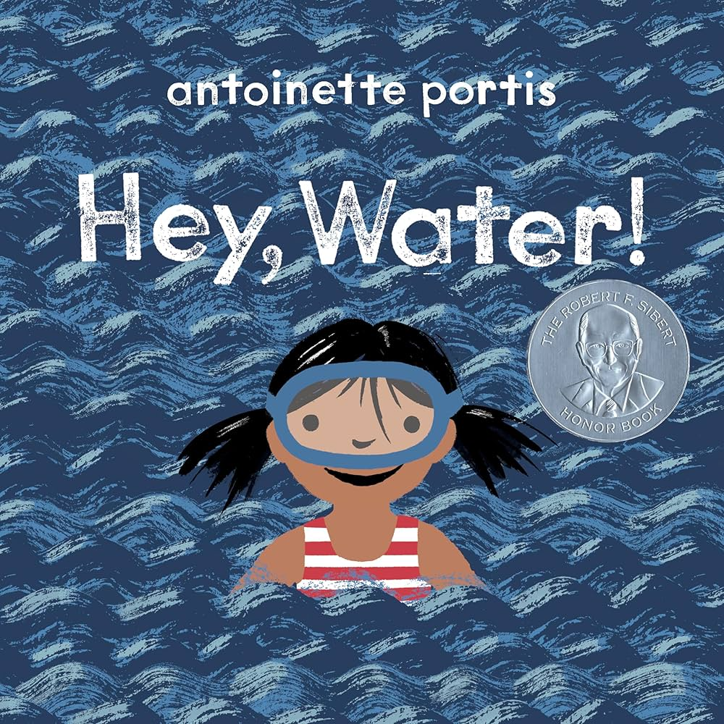
Hey, Water!
By Antoinette Portis

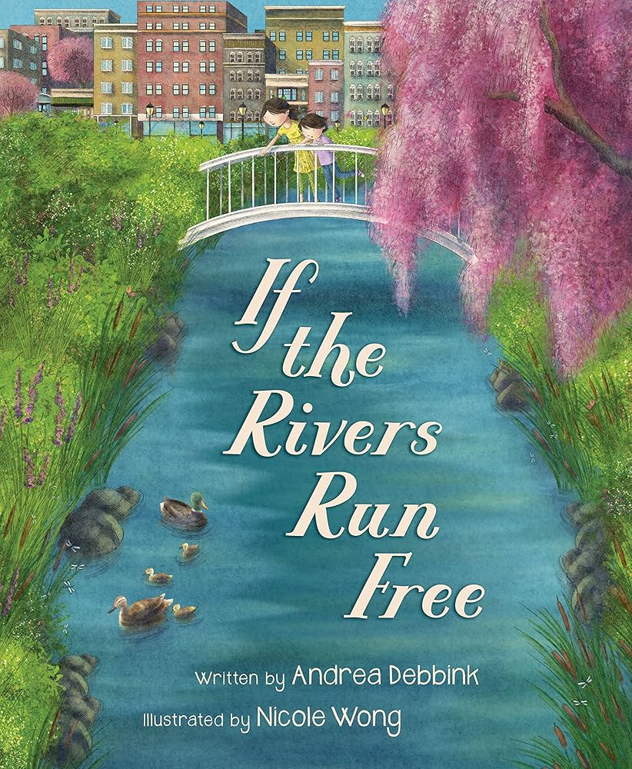
If the Rivers Run Free
By Andrea Debunk, Illustrated by Nicole Wong

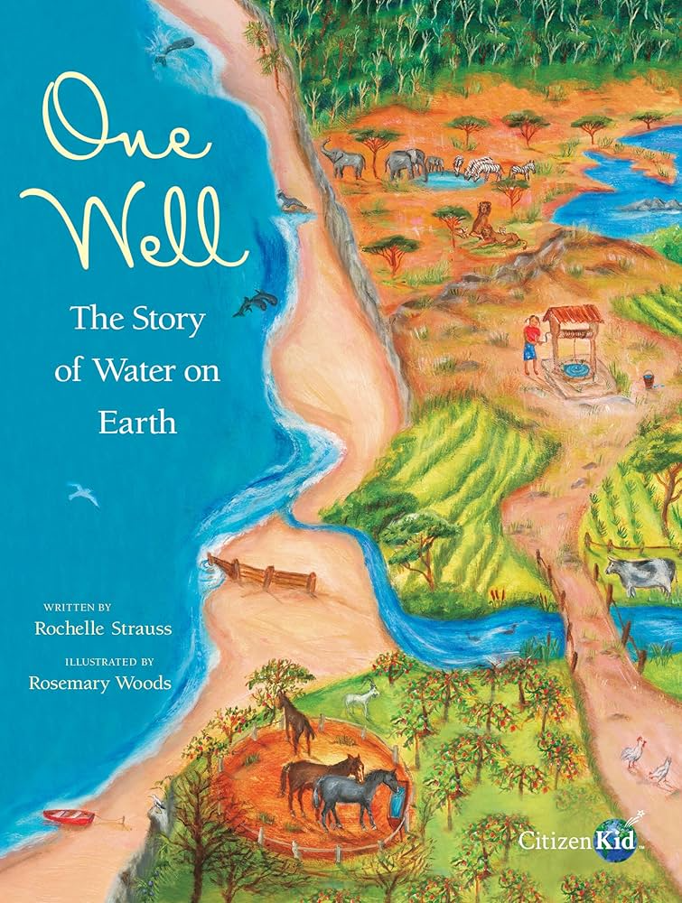
One Well: The Story of Water on Earth
By Rochelle Strauss, Illustrated by Rosemary Woods
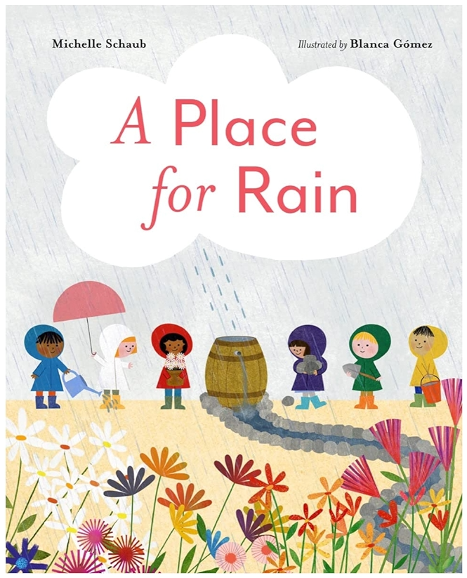
A Place for Rain
By Michelle Schaub, Illustrated by Blanca Gómez

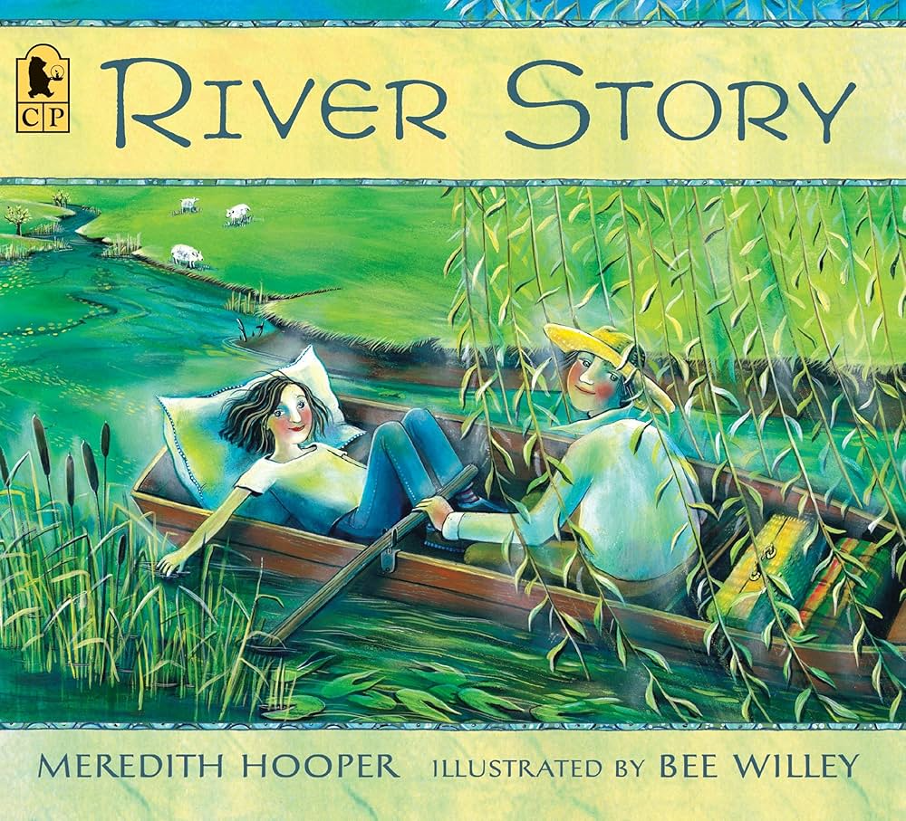
River Story
By Meredith Hooper, Illustrated by Bee Willey

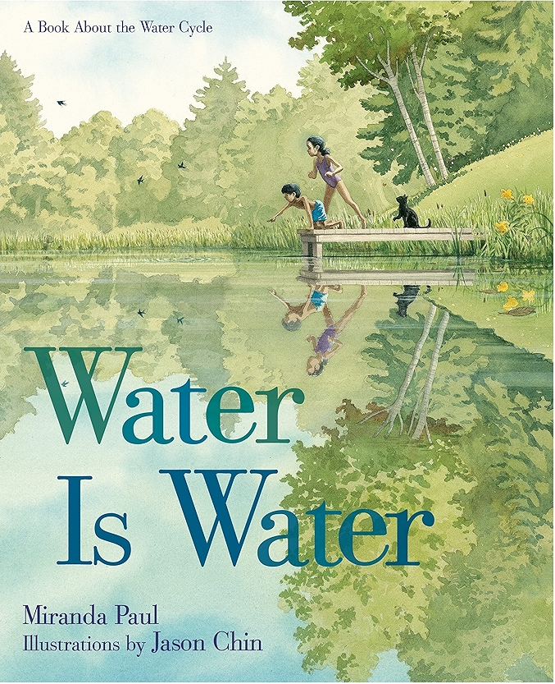
Water Is Water
By Miranda Paul, Illustrated by Jason Chin

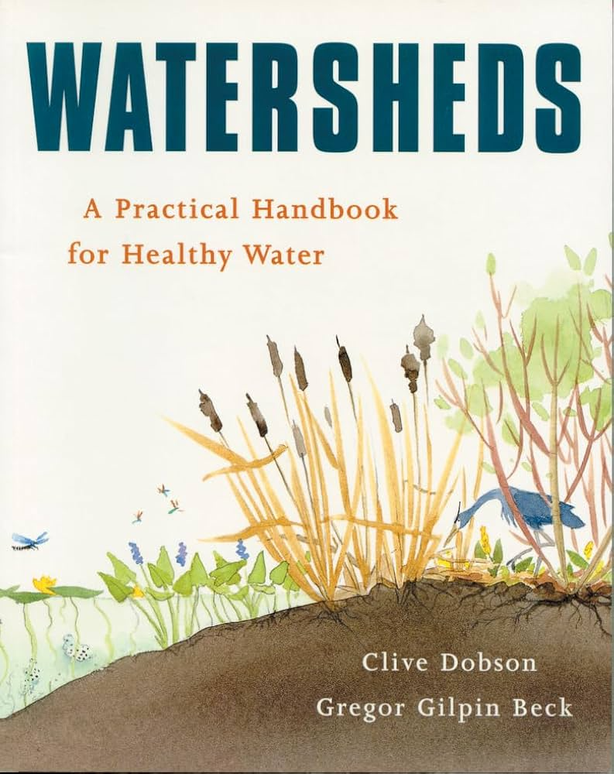
Watersheds: A Practical Handbook for Healthy Water
By Gregor Gilpin Beck, Illustrations by Clive Dobson

