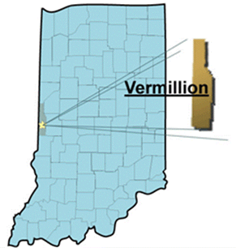

1. Sediment Transported to Surface Water
2. Sheet and/or Rill Erosion
3. Plant Pest Pressure
4. Plant Structure and Composition
5. Organic Matter Depletion
6. Compaction
7. Inadequate Livestock Water Quantity, Quality and/or Distribution
8. Emissions of Greenhouse Gasses
9. Ephemeral Gully Erosion
10. Terrestrial Habitat for Wildlife/Invertebrates

*Based on USDA-NRCS resource list descriptions*

Other concerns mentioned:

*Other Erosion*

*Ponding/Flooding*

*Inadequate livestock water quantity, quality, or distribution*

*Nutrients transported to groundwater supply*

**Top 10**

**Resource Concerns**

**2024 Local Led Meeting**