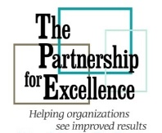
The Partnership for Excellence
829 Bethel Road, #212
Columbus, OH 43214
www.thepartnershipforexcellence.org

2026 Quest for Success - Call for Presentations
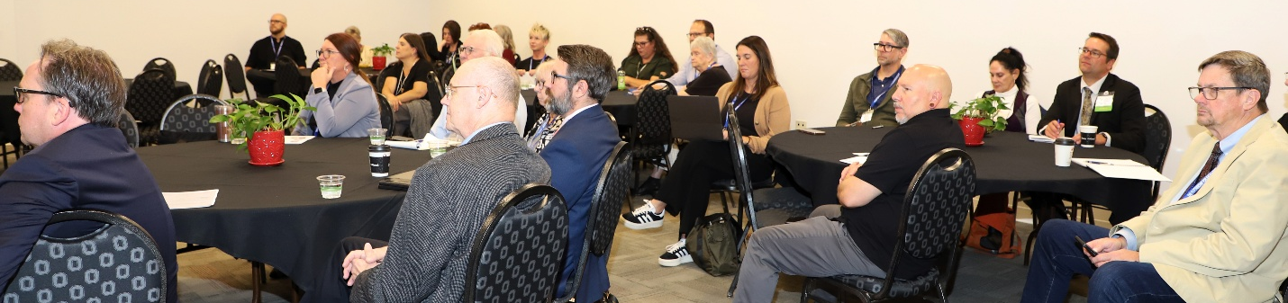
The Partnership for Excellence – 2026 Quest for Success Conference
September 15, 2026, Quest Conference Center, Westerville, Ohio
Celebrating 28 Years of Performance Excellence!

The Partnership for Excellence is seeking qualified speakers to present at our 2026 Quest for Success Conference on September 15, 2026. The conference theme is Reset. Recharge. Rise.

Individuals volunteering to speak at the 2026 Quest for Success Conference will submit the following completed Request for Proposal (RFP) for consideration.

Proposals to be submitted to TPE no later than April 15, 2026.
What elements of the theme will your presentation address?
Check all applicable: Reset ___ Recharge ___ Rise ___

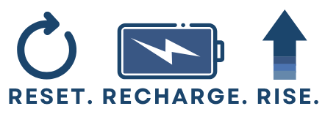

Speakers are responsible for their own travel expenses. Sessions on the day of presentation are complimentary. Fees apply to other conference activities. When registration opens in June, all speakers must register for the conference at Quest for Success Conference | The Partnership for Excellence

Questions regarding this RFP can be directed to Margot Hoffman, President & CEO at 614-425-7157.

INSTRUCTIONS FOR COMPLETING THE RFP:
1. Complete the Administrative Section of the RFP (see next page)
2. Submission to include:
- Photo(s) and short bio(s) of presenter(s)
- Presentation title and summary of proposed presentation (one paragraph)
4. Send the completed RFP (Administrative Section and Submission) to margot.hoffman@partnershipohio.org by April 15, 2026.

REQUEST FOR PROPOSAL - ADMINISTRATIVE SECTION

Contact information

Lead Presenter:

Name __________________________________________________________________

Title ______________________________ Organization __________________________

Address_________________________________________________________________

City ____________________________State_______ Zip Code____________________

Phone Number _____________________ E-Mail Address ________________________

Co-Presenter: (if applicable)

Name __________________________________________________________________

Title ______________________________ Organization __________________________

Address_________________________________________________________________

City ____________________________State_______ Zip Code____________________

Phone Number _____________________ E-Mail Address ________________________

Consent to release material information and likeness:

If selected to speak at the 2026 TPE Quest for Success conference, I authorize The Partnership for Excellence to use information provided here and materials submitted in conjunction with this RFP to promote the 2026 conference (check below if you agree to this statement):

_______ Agreed to by Presenter _______ Agreed to by Co-Presenter(s) if applicable

Would you be interested in leading a future TPE webinar? _______ Yes _______ No

Signed ______________________________________________ Date ___________________

