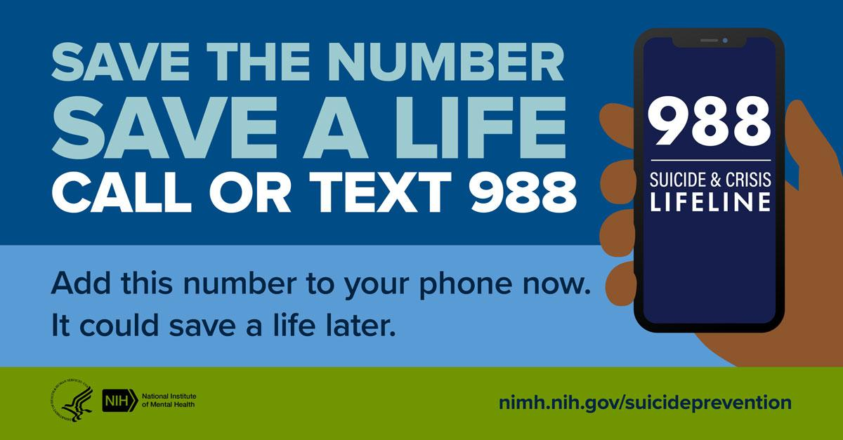

Save the number, save a life. Add the 988 Suicide & Crisis Lifeline (988) to your phone now—it could save a life later. Trained crisis counselors are available to talk 24/7/365. Visit https://go.nih.gov/hoMF6tt for more info.

