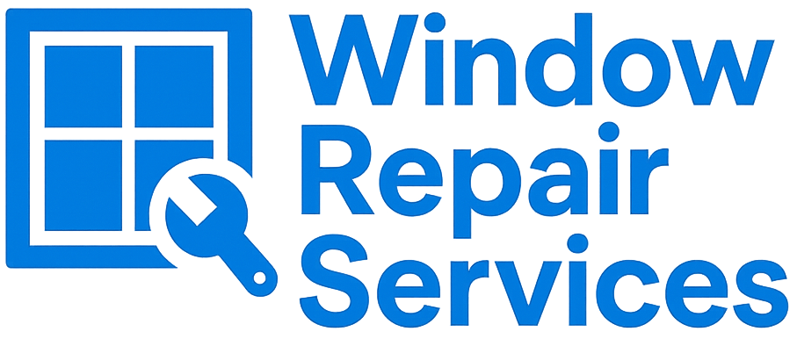

Window Repair Services – 6 Month Window and Door Adjustment Guarantee
At Window Repair Services, we take care to ensure every adjustment is completed precisely for smooth window operation and a proper seal. All adjustment work carried out by us is covered by a 6-month guarantee against faults related to our workmanship.

✅ What’s Covered
- Adjustments to windows or doors performed by Window Repair Services to improve alignment, closing, or sealing.
- Faults directly caused by workmanship issues within 6 months of the service date.
- Minor re-adjustments required due to natural settling of parts fitted or adjusted by Window Repair Services.
- Labour and any minor parts supplied as part of the original adjustment service.

❌ What’s Not Covered
- General wear and tear from normal operation or age of components.
- Issues caused by building movement, frame distortion, or structural changes.
- Further deterioration of parts that were adjusted but not replaced (e.g., worn hinges, handles, or mechanisms).
- Misuse, accidental damage, or neglect following the adjustment.
- Tampering, further adjustments, or repairs completed by anyone other than Window Repair Services.
- Environmental factors such as temperature changes, weathering, or seasonal expansion and contraction.

🕓 Guarantee Terms
- The 6-month period begins on the date of the completed adjustment.
- The guarantee applies to the original property and customer only; it is non-transferable.
- Any warranty claim must be supported by proof of service or invoice.
- Any work carried out under this guarantee does not restart or extend the original 6-month period.
- This guarantee does not affect your statutory rights.

📞 Contact Us
If you experience a problem covered under this guarantee, please contact us:
Window Repair Services
📍 3rd Floor, 86-90, Paul Street, London, England, United Kingdom, EC2A 4NE
📞 (+44) 1285 700 949
📧 mail@WindowRepair.Services
🌐 www.WindowRepair.Services

