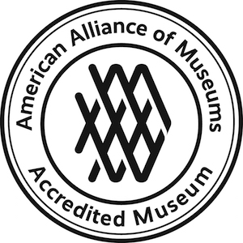
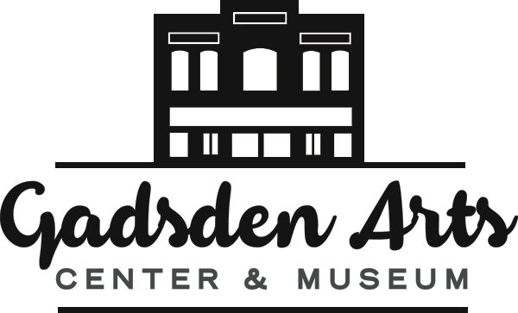
Gadsden Arts Center & Museum
13 North Madison, Quincy, FL 32351
(850) 875-4866, Fax: (850) 627-8606
www.gadsdenarts.org
ashley.williams@gadsdenarts.org
EXHIBITION PROPOSALS

The Gadsden Arts Center & Museum curates exhibitions in 4 galleries and 1 multiuse space that rotate periodically throughout the year. On the first floor, the Sara May Love Gallery has 150 linear feet dedicated to featuring work by nationally recognized artists with an established style, cohesive body of work, and strong record of exhibitions and/or collections from around the country or abroad. Additionally, the museum curates exhibitions of art historical significance from private collections and museums for the Sara May Love Gallery. Also on the first floor, the Zoe Golloway Gallery is an intimate gallery with 47 linear feet dedicated to artwork by nationally and regionally recognized artists.

On the second floor, the Munroe Family Community Gallery is a spacious 60 linear feet committed to exhibiting the work of regional artists in our community. Also on the second floor is the Bates Permanent Collection Gallery showcasing work from the Gadsden Arts Center & Museum Permanent Collection, and the Bates Community Room, a multiuse space exhibiting artwork from members of the Gadsden Arts Artists Guild.

All galleries are equipped with environmental controls, LED lighting, and HD security cameras. The Gadsden Arts Center & Museum has approximately 25 pedestals of and a secure wall display case available for 3-dimensional works of art.

All artists or groups wishing to exhibit at the Gadsden Arts Center & Museum must submit the attached Exhibition Proposal Form including at least 15-20 quality images as examples of the work to be included in an exhibition, a biographical sketch, and a resume including a list of past exhibitions, awards, and collections. Artists are encouraged to submit a new body of work (exception: retrospectives). Proposals may be submitted at any time either by mail, email, or in person, but ALL parts of the proposal must be included. Emailed proposals are preferred.

The Curator and Executive Director screen all applications on a rolling basis and proposals deemed appropriate for the Sara May Love Gallery are then reviewed by the Gadsden Arts Exhibition Committee four times a year. Exhibitions in all galleries are scheduled 24-36 months in advance. The Committee reviews proposals quarterly, and all Exhibition Committee selection decisions are final.

The Exhibition Committee will not accept applications from artists who have had a solo exhibition at the Gadsden Arts Center & Museum within 5 years, unless it is a new body of work. For all major exhibitions (group exhibitions and Art in Gadsden excluded), artists agree to not have a large/solo exhibition of the same work anywhere in the Big Bend region within 3 years preceding their exhibition at Gadsden Arts. Depending upon the gallery, exhibitions are open 8-14 weeks.

Marketing and educational materials for the first-floor galleries are produced by Gadsden Arts and include: a 5x7 invitational postcard sent to Gadsden Arts membership, press releases sent to over 100 media outlets, and Artist Talks online or at the museum. Please note, Gadsden Arts Center & Museum does not handle art sales through the exhibition galleries; prospective buyers will be referred to the artist.

Please note, no shipping, transportation, housing, materials allowance, or honorariums are provided to the artist/ender unless otherwise specified on the exhibition acceptance letter. Exhibiting artists are responsible for shipping/delivery and pick up of artwork or must arrange for, and cover, shipping costs.

EXHIBITION PROPOSAL FORM, pg 1

Name:
Organization (if applicable):
Mailing address:
City, State, Zip:
Phone: Email:
Website:
Are you a member of Gadsden Arts? Yes No
Have you exhibited at the Gadsden Arts Center & Museum before? Yes No
If Yes, when?
Please describe the work/proposal to be considered (please note: the committee prefers to review a cohesive body of work from each artist’s application):

Submit between 15-20 images for consideration and please provide image information on the following page (or email to ashley.williams@gadsdenarts.org). You may also send a website link, but you must send images with the information Please include an artist statement or resume relevant to the exhibition. Call Ashley Williams at (850) 627-5021 if you have any questions.

Date submitted:

The Gadsden Arts Center & Museum Exhibition Committee reviews work four times each year. Please do not contact Gadsden Arts Center & Museum staff to inquire about the status of your submission. You will be notified when a decision is made.

EXHIBITION PROPOSAL FORM, pg 2
Complete the following information for the images provided. Send at least 10-20 images per proposal.

# | Title | Medium | Dimensions in inches (w x h x d) | Year created | Insurance/  market value
1 |  |  |  |  | $
2 |  |  |  |  | $
3 |  |  |  |  | $
4 |  |  |  |  | $
5 |  |  |  |  | $
6 |  |  |  |  | $
7 |  |  |  |  | $
8 |  |  |  |  | $
9 |  |  |  |  | $
10 |  |  |  |  | $
11 |  |  |  |  | $
12 |  |  |  |  | $
13 |  |  |  |  | $
14 |  |  |  |  | $
15 |  |  |  |  | $
16 |  |  |  |  | $
17 |  |  |  |  | $
18 |  |  |  |  | $
19 |  |  |  |  | $
20 |  |  |  |  | $
21 |  |  |  |  | $
22 |  |  |  |  | $
23 |  |  |  |  | $
24 |  |  |  |  | $
25 |  |  |  |  | $
26 |  |  |  |  | $
27 |  |  |  |  | $
28 |  |  |  |  | $
29 |  |  |  |  | $
30 |  |  |  |  | $
31 |  |  |  |  | $
32 |  |  |  |  | $
33 |  |  |  |  | $
34 |  |  |  |  | $
35 |  |  |  |  | $
36 |  |  |  |  | $
37 |  |  |  |  | $
38 |  |  |  |  | $
39 |  |  |  |  | $
40 |  |  |  |  | $

