Curriculum Vitae

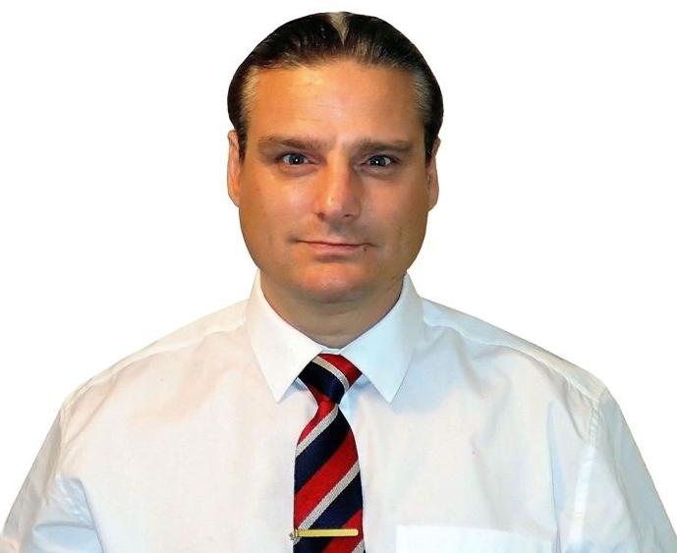

077 6181 7614 (UK +44)
Telephone
Chris Brennan
B.Sc (Hons) M.Sc M.A. Pg.Dip
Name

COVID status
4th vaccination 22/12/2022
Address

53 Symonds Avenue
Upper Haugh
Rotherham
South Yorkshire
S62 7LW, ENGLAND
British (English)

Nationality

Website
www.chrisbrennan.uk

Marital Status
E-Mail

Single (No children)
christopherbrennan@hotmail.com
Referee

Mr Colin Clayton
Department of Computing
Rotherham College
Eastwood Lane
Rotherham
ENGLAND
E-Mail: colinclayton@rotherhamcollege.org

Professor David Kent (Ph.D)
Woosong University
Woosong Language Institute
196-5 Jayang Dong
Daejeon
SOUTH KOREA
E-Mail: dbkent@wsu.ac.kr

Experience


School Teacher (Supply)
Masterclass Education Barnsley, ENGLAND. January 2022 - March 2023

- Assignments included working as a Network Engineer at St Wilfrid’s school and IT teacher at Woodfields and Brinsworth Academy in Yorkshire

College Teacher
Jiangsu Educational Services for International Exchange Nanjing, CHINA. November 2019 – March 2020 (COVID outbreak)

- Teaching English and IT to students who were to study in the USA / Australia / UK. College dissolved due to COVID-19 outbreak

College Teacher
Rotherham College of Arts and Technology (RCAT) Rotherham, England. January 2018 – October 2019

- Teaching IT to BTEC students (Contract position)

University Teacher
Woosong University Daejeon, SOUTH KOREA. August 2016 – December 2017

- Teaching English at Woosong University / Solbridge Business School (18 hours/week)

University Teacher
Catholic University of Daegu Daegu, SOUTH KOREA. March 2015 – August 2016

- Teaching English to various majors (14 hours/week). Student evaluation averages: 1st Semester: 87%, 2nd Semester: 85%, 3rd Semester: 82%

Technical College Teacher
National Industrial Training Institute (NITI) Ab Qiaq, SAUDI ARABIA. April 2014 – February 2015

- Teaching English to Saudi Aramco™ engineers using Q-Skills and Headway book series (Oxford University Press©). Student-to-Teacher ratio ≈ 20:1

University Teacher
King Saud University & The University of Dammam Riyadh & Dammam, SAUDI ARABIA. November 2011 – December 2013

- Teaching English (20 hours/week) at King Saud University and The University of Dammam, Dammam – 2 months. Student-to-Teacher ratio ≈ 20:1

University Teacher
Nanjing Xiaozhuang University & Part-time Posts Nanjing, CHINA. March 2007 – October 2011

- Teaching English (15 hours/week) at Nanjing Xiaozhuang University to various majors on 2 campuses. Student-to-Teacher ratio ≈ 30:1

University Teacher
Woosong University Daejeon, SOUTH KOREA. September 2006 – February 2007

- Teaching English at Woosong University and Solbridge International School (16 hours/week) to undergraduates, adults, and children

Systems Engineer
UPS Supply Chain Solutions Biel, SWITZERLAND. November 2005 – May 2006

- Supporting users of bespoke UPS™ and IBM™ partner applications. Fault isolation/resolution. On-call support (7am-10pm). Root cause analysis

University Teacher
The University of Science & Technology Beijing Beijing, CHINA. September 2004 – June 2005

- Teaching English to undergraduates. Student-to-Teacher ratio ≈ 15:1

Secondary School Teacher
Select Education Newcastle & Sheffield, ENGLAND. February 2003 – July 2004

- Taught IT and Science in secondary schools in Newcastle and Sunderland

Optical Network Engineer
Nortel Networks Amsterdam, THE NETHERLANDS. January 2000 – August 2002

- Telephone and on-site technical support of customers using Nortel™ SDH and PDH multiplexors. Reproducing customer issues in the laboratory





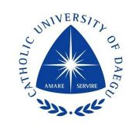



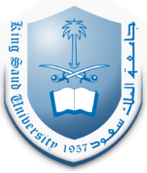





Academic & Professional

Master's Degree (M.A.)
M.A. TESOL & Multimedia Assisted Language Learning (Cumulative GPA=4.00)
Woosong University Daejeon, SOUTH KOREA. 2006-2010
Design and Development of Interactive Multimedia Instructional Programs course
Analysis and Evaluation of Multimedia-Oriented Systems course
ESL/EFL Curriculum and Materials Development course
Qualitative Research Design & Methods course
Media Technology in English Education course
Network Based Language Learning course
Theory and Pedagogy of CALL course

M.A. Thesis

Investigating the efficacy of a Multimedia-Based language learning tool for University students
Master's Degree (M.Sc)
M.Sc Computer-Based Information Systems
Sunderland University Sunderland, ENGLAND. 2003-2004
Information Systems Engineering examination
Network Systems Engineering examination
Information Systems Analysis examination
Application Development examination
Software Construction examination
Database Systems examination

M.Sc Thesis

Development of a Microsoft™ Access congestion charging database for Sunderland local government, England
Postgraduate Diploma (Pg.Dip)

Pg.Dip Interactive Computing System Design
Loughborough University (UK ranked 6th 2024) Loughborough, ENGLAND. 1996-1998
The Interactive Systems Design Process examination
Formal Foundations of System Design examination
Human-Computer Communication examination
Socio-Technical Systems Design examination
User Interface Technology examination
Supporting Technology examination
Honours Degree (B.Sc)
B.Sc (Honours) Information Technology & Human Factors
Loughborough University (U.K. ranked 6th 2024) Loughborough, ENGLAND. 1992-1995
Organisational issues in I.T. Development and Implementation examination
Intermediate Experimental Design and Analysis examination
Psychology of Human-Computer Interaction examination
Artificial Intelligence and Interface Design examination
Computing and Computer Applications examination
Analysis of Occupational Skills examination
Human Factors in Transport examination
Organisational Behaviour examination
I.T. and Communications examination
Advanced I.T. Systems examination

B.Sc Dissertation
Design, development, and evaluation of a speech controlled mobile telephone for vehicle drivers
TEFL Graduate Certificate
Certificate in Teaching English as a Foreign Language
120 Hour TEFL course. https://teflgraduate.com/certificate-verification. Cert no: TG1207480. ENGLAND. (2024)
Microsoft™ MCSE+I Certification

Microsoft™ Certified Systems Engineer + Internet (MCSE+I)

Implementing and Supporting Windows NT® Server 4.0 in the Enterprise examination

Internetworking with Microsoft™ TCP/IP on Microsoft™ Windows NT4.0 examination

Implementing and Supporting Windows NT® Workstation 4.0 examination

Implementing and Supporting Windows NT® Server 4.0 examination

Internet Information Server® examination

Networking Essentials examination
Cisco™ CCNA Certification

Cisco™ Certified Network Associate (CCNA)
Routing and Switching 2.0 examination. (Score: 92%)
CompTIA™ exam
CompTIA™ A+
220-1001 Core 1 (Score: 84%)
Travel – I have enjoyed 23 years of work and travel to 43 countries: China, USA, Costa Rica, Japan, The Philippines Vietnam, South Korea, Thailand, Cambodia, Laos, Indonesia (Bali and Lombok), India, Saudi Arabia, Russia, Italy, France The Netherlands, Luxemburg, Liechtenstein, Czech Republic, Switzerland, Germany, Belgium, Spain, Sweden, Norway Denmark, Finland, Austria, Poland, Romania, Greece, Turkey, Malta, Northern Ireland, Scotland, Wales, Taiwan, Kuwait Bahrain, Qatar, and The UAE, and 4 SARs: Monaco, Macau, Tibet, and Hong Kong

I also enjoy Electronics, Microcontrollers (RaspberryPi Pico), IoT / Remote Access. I design and assemble electronic circuits on perfboard with components such as 2N7000 and 2N2222 transistors, Opto-isolators, 74HCT244 Line Drivers, Relays LCD and IPS Displays, NeoPixels, IRLZ44N and IRLB3034 MOSFETs, TC4420 MOSFET Drivers, Sensor modules Schottky and TVS diodes, and use protocols: I2C, SPI, UART, PWM, TCP sockets, and program with MicroPython

111
18th Edition Wiring Regulations

Institution of Engineering and Technology (IET) Certified – Level 3
18th Edition Wiring Regulations (BS7671:2018 + A2:2022) course and examination (Score: 82%). ENGLAND. (2025)
BTEC OND Diploma (Electronics)
BTEC (OND) Electronic and Electrical Engineering – Level 3
Rotherham & Loughborough colleges. ENGLAND. (1997)
BTEC Level 3 Diploma (Telecoms)
BTEC Diploma in Professional Competence for IT and Telecoms Professionals – Level 3
Aim2Learn. Sheffield, ENGLAND. (2023)

Intellectual Property
Nortel Networks™

Electronic circuit and software invention for Nortel Networks™ for the seamless integration of the Nortel Meridian desk telephone with applications in Windows® (Technical report available on request). THE NETHERLANDS (2000)
Publications

Realising the benefits of Computer Assisted Language Learning (CALL)

Brennan, C. (2009). Interfaces Journal. Volume 3, Issue 1. Woosong University, Daejeon, SOUTH KOREA (2009)
Interests000000000000000000

Code Institute certificates: 5 Day Coding Challenge (HTML, CSS, JavaScript) and Introduction to Data Analytics (Python) 2x A-Levels - Biology (B), Computer Studies (C). 15x GCSEs - Psychology (A-Star), Business Studies (A), Law (A) Chemistry (A), Sociology (A), Accounting (B), CDT Technology (B), Biology (B), Computer Studies (C), English (C) Geography (C), Maths (C), Physics (C), General Studies (C), Religious Studies (C). RSA Word Processing Stage 1, 2, 3 and RSA Stage 2 Diploma in Text Processing. UK driver’s licence since 1990 (No points)
CSCS Card number 13627488. EUSR card number 588347 (Telecoms) - Energy & Utility Skills Register (EUSR)
Health & Safety - Health, Safety, and Environmental exam for Operatives (Score: 96%)

Miscellaneous qualifications

