GRADE 12
SUBJECT | CONTENT | TIME | MARKS
ENGLISH HOME LANGUAGE | Focus on Current Events – News – International and National Topics  Section A: Question One – Text A – Prose Comprehension (Current Events) and  Text B: Visual stimulus – Cartoon, Advertisement, Graphs, Posters (National and International topics) - 30 Marks.  Section B: Question 2 – Summary Writing – 10 Marks.  Section C: Language Structures and Conventions:  Question 3: Advertising – Current Advertisements – 10 Marks  Question 4: Cartoons – Zapiro/ South African cartoons/Madam and Eve/ Calvin and Hobbes/ Hagar the Horrible/ Dilbert/’ International cartoons – 10 Marks  Question 5: Textual Editing/ Language – 10 Marks  NOTE: Please revise with Past Papers and memorandums.  PAPER 2: LITERATURE  Section A: Poetry – 9 poems from Anthology. Plus, Unseen poem – 30 Marks  Section B: Drama: ‘The Crucible’ – Contextual Questions or Essay Question – 25 Marks  Section C: Novel – ‘The Portrait of Dorain Gray’ – Contextual Questions or Essay Question – 25 Marks  NOTE: Please revise with Past Papers and memos.  PAPER 3: CREATIVE AND TRANSACTIONAL WRITING  The theme of this paper is on Current Events – National and International News.  SECTION A: Essay – Genre: Discursive, Argumentative, Quote Essays and Visual Stimulus.  SECTION B: Transactional Writing: select 2 topics.  NOTE: Please revise with Past papers and memos. Current Event topics for both Sections. | 2 Hours  2 and half hours  3 Hours | 70  80  100
AFRIKAANS FAL | Paper 1 [80]  Q1 – Comprehension [30]  Q2 – Summary [10]  Q3 – Advertisement [10]  Q4 – Comic strip [10]  Q5 – General language structures[20]  Paper 2 [70]  Fiela se kind : Act 1 and 2 [35]  Poetry: [35]  - Ken jy die see…  - Sproeireën  - Haar uitvaart  - Die heks van Heksrivier  - Eksamenlokaal  - Dans van die reën  - Krisis  - Wetenskapmannetjies  Paper 3 [100]  Section A =Essay [50]  Section B =Long transactional text [30]  Section C=Short transactional text [20]
MATHEMATICS | Paper 1:  - Equations and Inequalities  - Number Patterns, Sequences and Series  - Functions, Inverse Functions and Logarithmic Functions  - Differential Calculus  Paper 2:  - Statistics  - Analytical Geometry  - Trigonometry  - 2D/3D Trigonometry  - Trigonometric Functions  - Euclidean Geometry | 3 hrs  3hrs | 150  150
MATHEMATICAL LITERACY | Paper 1:  Basic skills  Finance (all sub topics)  Taxation, VAT, tariffs,  income and expenses,  bank fees, simple and compound interest, hire purchase,  quotation, annuities, home loans, depreciation, inflation, exchange rates  Data Handling  Probability  Paper 2:  Basic skills  Finance  Maps & Plans  Measurements  Probability | 2hrs | 100
LIFE ORIENTATION | Chapter 1: Development of the self in society  Unit 1,2,3,4,5 pages 3 to 36  Chapter 3: Study skills  Unit 1,2,3 pages 62 to 73  Chapter 5: Career and Career Choices  Unit 1,2,3 pages 79 to 101  Chapter 7: Democracy and Human Rights  Unit 1,2,3, pages 115 to 139  Chapter 9: Social and environmental responsibility  Unit 1,2,3 pages 157 to 172  Chapter 2,4 and 6 is Physical Education. Summarise all the key words in the mentioned chapters.  Entrepreneurship booklet | 2 ½ Hrs | 100
PHYSICAL SCIENCE | PRACTICAL  - Acid Base Titration  Paper 1 – Physics  Newton I – III (Gr 11)  Newtons’ Gravitational law (Gr 11)  Vertical Projectile motion  Momentum & Impulse  Work, Energy & Power  Doppler Effect  Electrostatics (Gr 11)  Electricity (Ohms Law including internal resistance & electrical energy and power)  Paper 2 – Chemistry  Stoichiometric Calculations  Organic chemistry  Rates of reaction  Energy and Change (exothermic & endothermic reactions)  Chemical Equilibrium  Acids & Bases (gr 11) | 2 hrs  3hrs  3hrs | 60  150  150
LIFE SCIENCE | DNA, RNA and protein synthesis (19 marks)  Meiosis (15 marks)  Reproduction in vertebrates (5 marks)  Human reproduction (28 marks)  Genetics (33 marks)  Nervous system, eye and ear (38 marks)  Endocrine system - NO homeostasis (13 marks) | 2.5 hrs | 150
HISTORY | PAPER 1:  SOURCE BASED QUESTIONS  Question 1: The Cold War: The Extension of the Cold War  Question 2: Independent Africa case Study -Angola  Question 3: Civil Society Protest from the 1950’s to the 1970’s: Civil Rights Movement  ESSAY QUESTIONS  Question 4: Case study: Vietnam  Question 5: Independent Africa; Congo  Question 6: Black Power Movement  PAPER 2:  SOURCE BASED QUESTIONS  Question 1: The Crisis of Apartheid in the 1980s  Question 2: TRC  Question 3: The end of the Cold War and the new world order: the events of 1989; Globalisation  ESSAY QUESTIONS  Question 4: The challenge of Black Consciousness to the apartheid state  Question 5: Coming of the democracy to South Africa  Question 6: The end of the Cold War and the new world order: the events of 1989 | P1 – 3 HOURS  P2 – 3 HOURS | P1 – 150 MARKS  P2 – 150 MARKS
GEOGRAPHY | PAPER 1 ( 3 hours; 150)  Climate and Weather (pg 68-121)  QUESTION 1  60 marks  Short Questions (15)  3 sub-questions of 15 marks each on Climate and Weather  QUESTION 2  Geomorphology (pg122-169)  60 marks  Short Questions (15)  3 sub-questions of 15 marks each on Geomorphology  QUESTION 3:  Mapwork All work covered Gr 10 - 12  30 marks  Map Skills and calcuations (10 marks)  Map Interpretation (12 Marks)  GIS (8 marks)  PAPER 2 ( 3 hours; 150)  QUESTION 1  RURAL SETTLEMENT (PG170-197)  60 marks  Short Questions (15)  3 sub-questions of 15 marks each on Rural Settlement  QUESTION 2  Urban Settlement (pg 198-hg247)  60 marks  Short Questions (15)  3 sub-questions of 15 marks each on Urban Settlement  QUESTION 3:  Mapwork All work covered Gr 10 - 12  30 marks  Map Skills and calcuations (10 marks)  Map Interpretation (12 Marks)  GIS (8 marks)
ACCOUNTING | Paper 1:  - Concepts relating to companies, Concepts relating to GAAP  - Ledger accounts of companies; & interpretation thereof  - Accounting equation of companies,  - Adjustments & final accounts of companies; Trial balances  - Income Statement (Statement of Comprehensive Income),  - Balance Sheet (Statement of Financial Position) & Notes,  - Cash Flow Statement and notes,  - Analysis and interpretation of financial statements of companies,  - Audits, Shareholding, Professional bodies.  Paper 2:  - Bank Reconciliation & Internal controls,  - Debtors age analysis and Creditors Reconciliation and Internal controls,  - Fixed assets – calculations, fixed asset register, ledger accounts, fixed asset note, disposals, internal control.  - Cost accounting – manufacturing calculations and Production Cost Statement & notes.  - Inventory systems – FIFO, WAM and Specific identification method. | 2 hrs  2 hrs | 150 marks  150 marks
ECONOMICS | Protectionism (The entire chapter on protectionism and free trade) -NB!  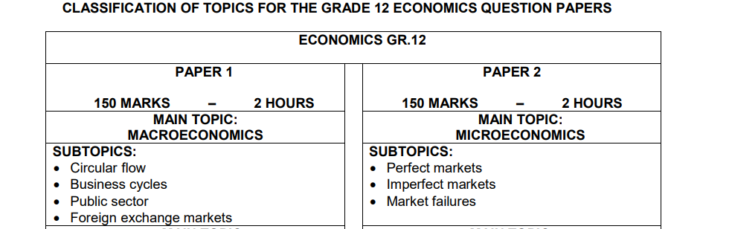
BUSINESS STUDIES | PAPER 1  Business Environments- Impact of legislation, Business Strategies and Business Sectors  Business Operations- Human Resources Function and Quality of performance  PAER 2  Business Ventures- Leadership and management, investment opportunities and Insurance  Business Roles- Ethics and professionalism, Creative thinking and problem solving and team performance | 2 hours  2 hours | 150 marks  150 marks
HOSPITALITY STUDIES | Cocktail functions Preparing venues and setting tables  Handling guests Preserved food  Desserts Gelatine  Costing Vegetarian  Pastry Choux pastry  Meat Food-borne diseases  Wine Non-alcoholic beverages
TOURISM | Section 1 – Global events  Section 2 – Unforeseen circumstances and Political Situations  Section 3, 4, 5 – Tour plan, route plan, Itinerary, Budget  Section 6 – Health and Safety  Section 7 – Travel Documents  Section 8, 9 – Time Zones  Section 10, 11 – World Icons, Factors, Characteristics  Section 12 – Foreign Exchange  Section 14 – Foreign Markets Share  Section 15 – Marketing  Section 16, 17 – Sustainable and Responsible Tourism  Section 18 – World Heritage Sites | 3hrs | 200
EGD | 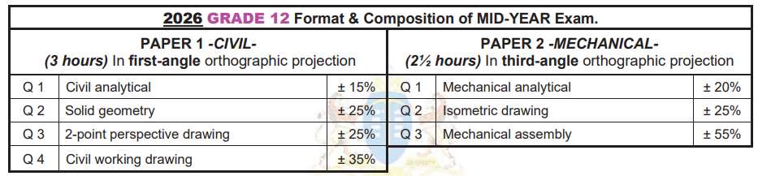 | Paper 1: 3 Hours  Paper 2: 2.5 Hours
CAT | Paper 1 Practical  Word: Section 3 & gr10 and 11 work (45 marks)  Excel: Section 4 & gr 10 and 11 work (functions and graphs) (40 marks)  Access: Section 5 & gr 11 work (tables, forms, queries and reports) (35 marks)  HTML: Section 6 & gr 10 & 11 work (whole HTML tag sheet) (15 marks)  General: All aspects incl mail merge, electronic forms etc (15 marks)  All these aspects covered in grade 10 & 11  Paper 2 Theory  System Technologies – ICT, Hardware and software: Section 1 (25 marks)  Network & Internet Technologies – Internet, cybercrimes & E-communication: Section 2 (20 marks)  Social Implications – Impact of ICT on global community (15 marks)  Solution Development – practical aspects tested theoretically (15 marks)  Scenario based (all aspects can be asked) (50 marks) | Paper 1 3hrs  Paper 2  3hrs | 150  150
IT | P1: Practical  Chapter 1,3,4,5 AND All Grade 10,11 work  P2: Theory  Modules 1.1, 2.1, 2.2,3.1, 4.1, 4.2,4.3,1.2,1.3,3.2  All theory from Gr10 –Gr11  Delphi Theory | 3 hrs  3 hrs | 150  150
VISUAL ARTS | Question 1: The voice of the emerging artist  - George Pemba  - Gerard Sekoto  Question 2: South African artists influenced by African and/or indigenous art forms  - Walter Battiss  - Alexis Preller  Question 3: Socio-political art – including Resistance Art of the ‘70s and ‘80s  - Jane Alexander  - Manfred Zylla  Question 4: Art, craft and spiritual works mainly from rural South Africa  - Jackson Hlungwani  - Noria Mabasa  Question 7: Gender issues: masculinity and femininity  - Penelope Siopis / Jane Alexander  - Mary Sibande | 3 hours | 100 marks

