GRADE 10
SUBJECT |  | CONTENT |  | TIME |  | MARKS
ENGLISH HOME LANGUAGE |  | Paper 1: Language  Comprehension (30)  Summary (10)  Advertisement (10)  Cartoon (10)  Language – Prose (10)  Paper 2: Literature  Seen Poetry (20)  On Aging  Foreign  A Young Man’s Thoughts Before June 16th  Caged Bird  Unseen Poem (Poetic Devices, Structure, Tone, Diction, Mood) (10)  Contextual Questions: Macbeth Acts 1-5 (25)  Essay Question: Macbeth (study literature essay structure, characters and themes) (25) |  | 2 hours  2½ hours |  | 70  80
AFRIKAANS FAL |  | Paper 1  Leesbegrip (30)  Opsomming (10)  Taal (40)  - Advertensie tegnieke  - Meervoude & verkleining  - Byvoeglike naamwoorde  - Voegwoorde  - Soorte sinne  - Sinonieme & Antonieme  - Direkte en Indirekte rede  - Ontkenning  - Lydende & bedrywende vorm  - Intensiewe vorme  - Lettergrepe  - Homonieme  - Trappe van Vergelyking  - Afkortings  - Infinitief  - Stam (Root of a word)  - Vraagsinne  - Een woord vir ‘n omskrywing  - Deelwoorde  - Voorsetsels  - Samestellings  - Tye (verledetyd, toekomendetyd, teenwoordigetyd)  - Woordorde(STOMPI)  Paper 2  Gedigte:  - Toemaar die donker man  - Kinders van die wind  - Nkosi Sikelel ‘i-Afrika  - Sara Baartman  Betower – Bedryf 1 – 4
MATHEMATICS |  | Paper 1  Chapter 1: Algebraic Expressions  Chapter 2: Equations and Inequalities  Chapter 3: Exponents  Chapter 5: Functions (straight line, parabola ONLY)  Paper 2  Chapter 8: Analytical Geometry  Chapter 6: Trigonometry  Chapter 9: Euclidean Geometry |  | 1.5 hrs  each |  | 75 marks each
MATHEMATICAL LITERACY |  | Paper 1  Chapter 1 and 2: Numbers, number formats and calculations with numbers  Chapter 3: Finance  Chapter 6: Data handling  Chapter 7: Probability  Paper 2  Chapter 4: Measurement  Chapter 5: Maps, plans and representations  Chapter 7: Probability  REMEMBER YOUR CALCULATOR!!! |  | 1 hour each |  | 50
LIFE ORIENTATION |  | All term 1 & term 2 slides on MS TEAMS  - Self-awareness and self-esteem pg 28.  - Power and power relations pg 16.  - Gender inequality pg 16.  - Career decision making pg 40.  - Discrimination and violation of human rights pg 62  - Study Skills pg 100  - Social and environmental responsibility pg 126 |  | 2 ½ hours |  | 100
PHYSICAL SCIENCE |  | PRACTICAL  - Electrical Circuits  ONE PAPER WILL BE WRITTEN WITH BOTH PHYSICS AND CHEMISTRY  Physics  - Transverse Waves.  - Longitudinal Waves.  - Sound.  - Electromagnetic Radiation.  - Electrostatics.  Chemistry  - Macroscopic Properties.  - States of Matter and Kinetic Molecular Theory.  - The Atom.  - The Periodic Table.  - Chemical Bonding. |  | 2 hours  2 hours |  | 70  100
LIFE SCIENCE | Scientific Method, Biosphere to Ecosystem (Biospheres, Biomes and Ecology), Biodiversity and classification, History of Life, Chemistry of Life and Cells.  Breakdown will be as follows:  Make use of all printed slides handed out during Term 1 and 2 as well as the Remote Learning Booklets for Term 1 and 2. |  | 2.5 h |  | 150
  TOPIC | WEIGHTINGS
  TOPIC | % |  | Marks
  Biosphere to ecosystems | 38 |  | 56
  Biodiversity & Classification | 12 |  | 19
  History of life on Earth | 19 |  | 28
  The chemistry of life | 19 |  | 28
  Cells: The basic unit of life | 12 |  | 19
  TOTAL | 100 |  | 150
HISTORY |  | Question 1:  Case Study – Political changes 1750 – 1820 – SOURCE  - The rise of Ndwandwe kingdom under Zwide (Zulu kingdom)  - In the east: break-up of the Ndwandwe kingdom and the rise of the Zulu state and its consolidation under Dingane and Legacy of Shaka  Question 2:  Case Study – Political changes 1820 – 1835 – ESSAY  - Rise of Ndebele kingdom under Mzilikazi  - Rise of Basotho kingdom under Moshoeshoe (1820 – 1835)  - The role of Boer, Kora and Grigua raiders (broad outline)  - Other states and paramountcy’s: Gaza, Swazi, Pedi, Mpondo (broad outline) |  | 2 HOURS |  | 100 MARKS
GEOGRAPHY |  | Term 1 Climatology (60 Marks)  Composition and structure of the atmosphere  Heating of the atmosphere  Moisture in the atmosphere  Types of precipitation  Reading and interpreting synoptic weather maps  Mapwork  Conventional signs and symbols  Navigating position using compass directions  Direction: True and magnetic bearing  Landforms and contours  Coordinates  Scale  Aerial photos  GIS  Term 2 Geomorphology (60 Marks)  Geomorphology: Classification of rocks  Plate tectonics  Folding and faulting  Earthquakes  Volcanoes  Mapwork  Contour lines: Identification of different landforms associated with types of rocks.  Landforms and contours  World map showing location plate and plate boundaries  Coordinates: minutes and seconds  World map showing the ring of fire and location of earthquakes and volcanoes  True bearing and magnetic bearing  Mapwork will count 30 Marks
ACCOUNTING |  | Concepts relating to sole traders  Concepts relating to GAAP  Bookkeeping: documents & journals of sole traders  Ledgers and trial balances of sole traders  Accounting equation of sole traders  Adjustments & final accounts of sole traders & trial balances  Salaries & wages - recording & interpretation  Ethical behaviour in financial environments  Preparation of debtors' & creditors' lists to agree to Control accounts  Application of internal control & audit processes |  | 2 hours |  | 200 marks
ECONOMICS |  | Paper 1: Macroeconomics  SUBTOPICS  • Basic concepts  • Basic economic problem  • Circular flow & Quantitative elements  • Business cycles  Paper 1: Microeconomics  SUBTOPICS  • Dynamics of markets  • Public sector intervention  • Production possibility curve |  | 2 hours each |  | 150 Marks each
BUSINESS STUDIES |  | PAPER 1  BUSINESS ENVIRONMENTS:  - Mico-environment  - Market environment  - Macro environment  - Interrelationship between the environments  - Business sectors  BUSINESS OPERATIONS:  - Business functions  - Concept of quality  PAPER 2  BUSINESS VENTURES:  - Forms of ownership  BUSINESS ROLES:  - Socio-economic issues  - Social responsibility |  | 1 ½ hours  1 ½ hours |  | 100 marks  100 marks
HOSPITALITY STUDIES |  | 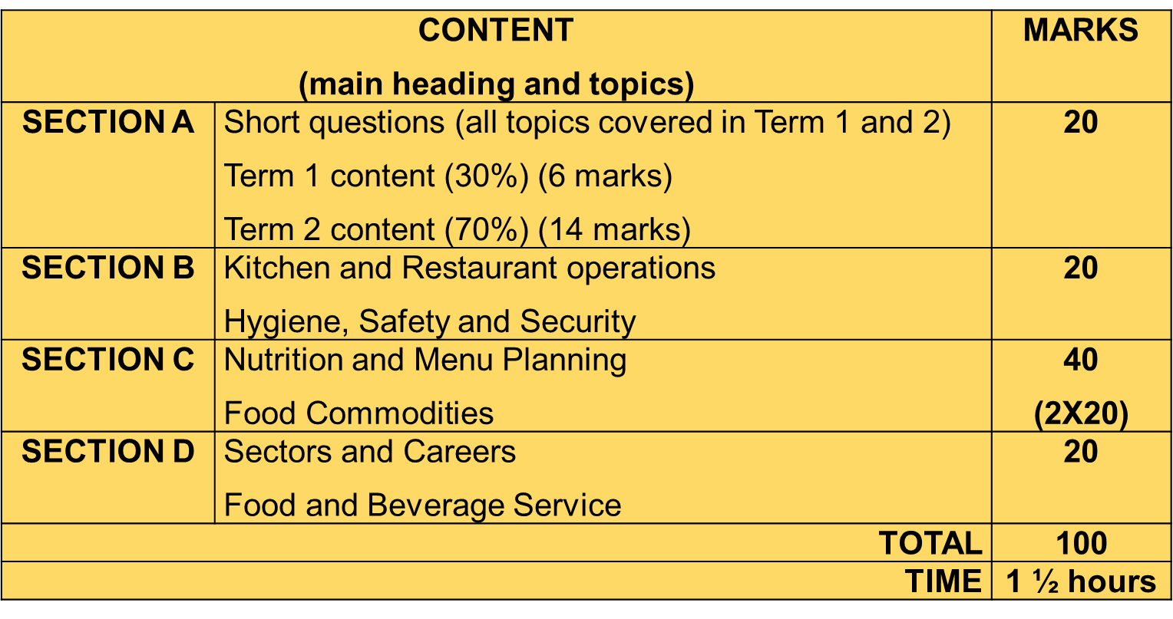  Term 1:  Sectors & careers  Food & Beverage establishments  Hygiene  Equipment  Mis-en-place  Recipes  Food pyramid  Cooking methods  Scones & muffins  Fruit  Term 2:  Pancakes & crumpets  Eggs  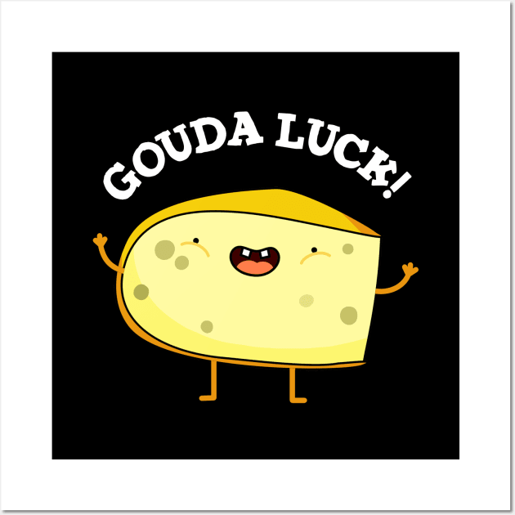  Cereals  Dairy products  Minced Meat  Pasta  Salads and salad dressing  *All terminology*  (All Term 1 & 2 work) |  | 1.5 hours |  | 100 marks
TOURISM |  | SECTION A: SHORT QUESTIONS  All content tested in Section B - D  SECTION TOTAL= [25]  SECTION B: mapwork and tour planning  Term 1 Week 11. Map terminology and map symbols  Term 2 Week 12 Different types of maps in a tourism context  Term 2 Week 13. Mapping South Africa  Term 2 Week 14. Working with a world map  Term 2 Week 15. Distance indicators and distance tables and travel time calculations  SECTION TOTAL= [20]  SECTION C: tourism sectors  Term 1 Week 2. Introduction to tourism  Term 1 Week 3. Types of tourists and tourist profiles  Term 1 Week 5. The different modes of transport  Term 1 Week 6. Different types of accommodation establishments AND  The South African grading system for accommodation establishments  Term 1 Week 7. Concepts and terminology used in accommodation establishments AND In-room technology  Term 1 Week 8. Food and beverage establishments  Term 1 Week 4. The attraction sector  Term 1 Week 9. The structure of the South African tourism industry: The Public sector  Term 1 Week 10. The structure of the South African tourism industry: The Private sector  SECTION TOTAL = [40]  SECTION D: domestic tourism  Term 2 Week 16. Technology used for payments in South Africa  Term 2 Week 17. Domestic tourism  Term 2 Week 18. Domestic Tourism Statistics  SECTION TOTAL = [15] |  | 1.5 Hours |  | 100 marks
EGD |  | Question 1: Free hand drawing  Question 2: Scale drawing  Question 3: Geometrical construction  Question 4: Isometric drawing  Question 5: Mechanical drawing  Study all general concepts and study your textbook |  | 3 hours
CAT |  | Paper 1 = Practical  Word Processing - Modules 3.1-3.5  Excel spreadsheets – Modules 4.1- 4.2  Use Study Guide and Practical activities for extra practise  Paper 2 = Theory  Modules – 1.1- 1.7 (System Technologies)  Modules- 2.1 (Network and Internet Technologies)  Module – 6.1 (Information Management)  Practical aspects tested theoretically  Information Management  - All notes and slide shows copied in class (Including PRACTICAL)  - Use Study Guide as additional study material.  - Check for additional resources on teams |  | 2hrs  2hrs |  | 100  100
IT |  | Paper 1 (Practical)  Delphi  Chapters 1,2,3  Chapter 4: Decisions (up to Radiogroups)  Paper 2 (Theory)  1.1 Algorithms – Flowcharts and Pseudo code  2.1 Basic concepts of computing Theory  2.2 Basic concepts of hardware Theory  2.3 Basic concepts of system software Theory  3.1 Networks  3.2 Electronic communication  4.1 Data as the computer sees it Theory  4.2 File management Theory  5.1 Social, ethical and legal issues surrounding ICTs Theory  5.2 Green, health and global e-communication issues - AND ALL DELPHI THEORY |  | 2 hrs  2 hrs |  | 100  100
VISUAL ARTS |  | Chapter 1: What is Visual art?  - Formal elements of art  - Composition and the elements of composition and design  - Media and techniques  - Printmaking  - Three-dimensional media – Sculpture  - Subject matter and themes  - Style  - Function, contextual influences and meaning / interpretation  Chapter 2: African Art  - Terminology  - Background  - Pre-historic art  - Rock art in South Africa  - African tribal art  Chapter 5: The Classical world  Greece  - Geometric period  - Archaic period  - Classical period  - Hellenistic period  Ancient Rome  - Roman art, sculpture and architecture |  | 2 hours |  | 100 marks

