Playing Field


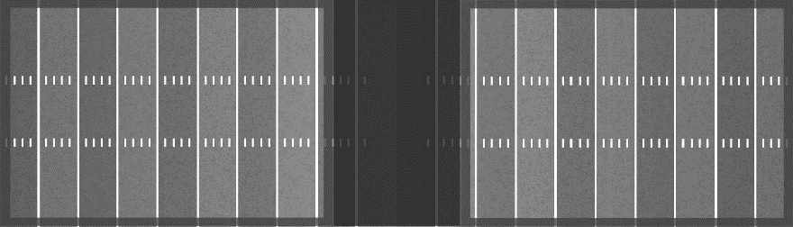
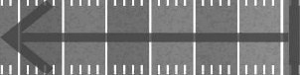
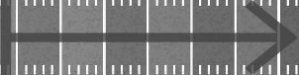

- The playing field is 40-by-35 1/3 yards, allowing for two fields to be created on a traditional 100-yard field at the same time.
- The sidelines extend between the inside of the numbers on a traditional football field and should be marked with cones every five yards. Use traditional pylons, if available, to mark the goal fine and the back line of the end zone.
  - Additional cones can be placed between the five-yard stripes and in line with the inside of the numbers to further outline the playing surface if desired.
  - We will be using orange sidelines and markings for Rookie Tackle
  - It is the coach’s responsibility to keep his team’s parents and fans off the traditional 100 yard field for safety reasons.
  - After each play, the ball is spotted in the middle of the field. Hash marks are not used.

- Player Safety Rules
- Players must wear a mouthpiece during all practices and games.
- Rubber Cleats are allowed, metal spikes are not permitted.
- Stiff arming of any kind is not allowed.
- A defensive player may not intentionally push a player running down the sidelines out of bounds unless the defensive player makes a play for the offensive players flags and the offensive player goes out of bounds. Pushing ball carriers in the back or up high will not be allowed.
- A player may not be tackled or intentionally knocked down while carrying the ball. The player’s flag must be pulled.
- Trash talking of any kind is not allowed.
- A violation of the rules above (C-F) will result in the following:
- First game offense- warning to player and 10 yd penalty to team
- Second game offense- Ejection of player from game and 10 yd penalty
- Third Season offense- Ejection from game, 10 yard penalty and suspension from next game.

II. General Game Rules
- The home team is responsible for supplying 2 adult non coaches to operate the chains. The visiting team is responsible for supplying 2 adult non coaches one for the down-marker and one for the scoreboard.
- A coin toss will determine who gets the ball first.
- Games will consist of 4 running quarters of 10 minutes each. Halftime will be 5 minutes. Each team will get a total of two one minute time outs per half. Unused time outs from the first half will not be carried into the second half. Officials can stop the clock at their discretion.
- Each team may have 2 coaches on the field during the game.
- The offensive team takes possession of the ball on its own 40-yard line at the start of the game.
- If the offensive team fails to gain a down on four plays possession of the ball changes and the opposing team starts its drive where the ball is dead unless the offensive team announces, prior to fourth down that they want to punt. If the offensive team declares a punt, the ball will be moved 25 yds up the field, but no farther than the opposing teams 25 yard line.
- There are no kick off punts.
- There are no fumbles, however interceptions will be allowed. The defensive team may advance an interception.
- Substitutions may be made on any dead ball.

- A play is ruled dead when:
- The ball carrier’s flag is pulled.
- The ball carrier’s flag falls out.
- The ball carrier steps out of bounds.
- The ball carrier’s knee touches the ground.
- The ball hits the ground (including a bobbled center/QB exchange)
- A touchdown or safety is scored; or
- The official determines there is a rules violation. This includes all flag violations as noted immediately below.

- The flags must be on each side with the Velcro on the belt facing out. The flags may not be wrapped. The belt must be tight so it doesn’t twist when the flags are grabbed. The end of the belt must be tucked in the players pants. Anything other than that is a flag violation.
III. Playing Time Rules
- Each team will have 7 players on the field.
- Each player must start on either offense or defense
- Each player should get an equal amount of playing time over the course of the season even though each player will not get equal playing time during each game.
- The designated “ball touching positions” are:
- Quarterback
- Fullback
- Running back
- Split end: and
- Tight end

These are designated as the “ball touching positions”. From the start of the year, you must rotate these 5 positions very half until every child on your team has had an opportunity to play a ball touching position for at least 3 full halves in the season. This should take 4 of 5 games. After each player has played 3 full halves of a game in one of the ball touching positions you are free to do whatever you wish for the reminder of the season within the following set of rules:

- No player can play a ball touching position for more than 2 quarters in any individual game

- It is the coaches’ responsibility to make sure that the lineup/player rotation plan is written out before each game. The lineup/player rotation sheet must be shared with the opposing team before each game. No complaints regarding playing time rules will be heard if the lineups are not exchanged prior to the game. You may use whatever form you prefer but the coach must be given a copy of it.
- Each player should get the chance once during the year to be quarterback for at least one set of downs and each kid should score once, whether it is a touchdown or an extra point.

IV. Offensive Rules

Each play must include three offensive linemen — a center and two guards, one on either side of the center. These players are ineligible for first touch as the receiver of a pass regardless of the numbers on their jerseys. Player rotations may result with traditional non-lineman numbers at these positions for the purpose of fundamental skill development.
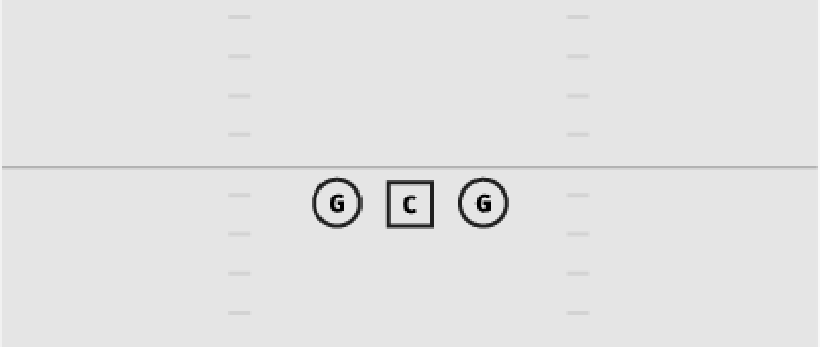

Guards and Center are required to play from a two-point stance. There are no three-point stances.
- The distance between a guard and center may not exceed three feet (1 yard) but may be closer.
- All 3 offensive linemen are ineligible for first touch on a pass, including a guard who is uncovered by an end.
- The quarterback-center exchange is started with the QB placing the ball on the centers back. There is no traditional snap and no shotgun.
- Quarterback sneaks are prohibited in all situations.
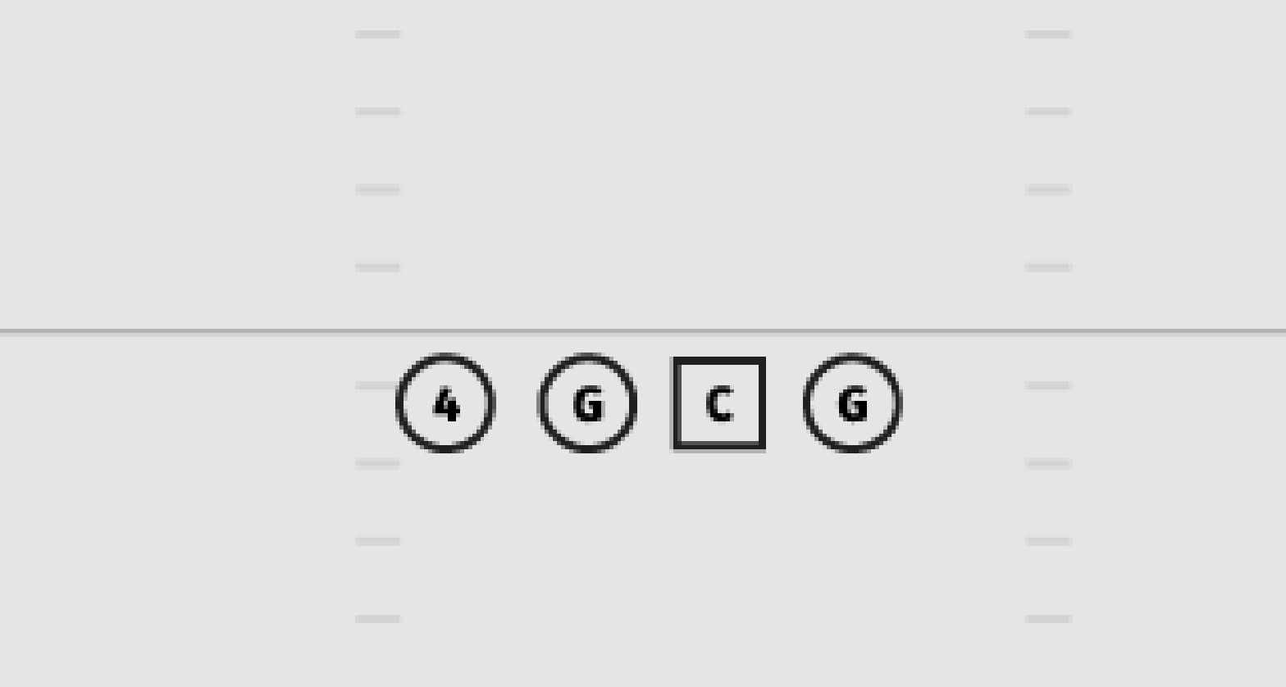
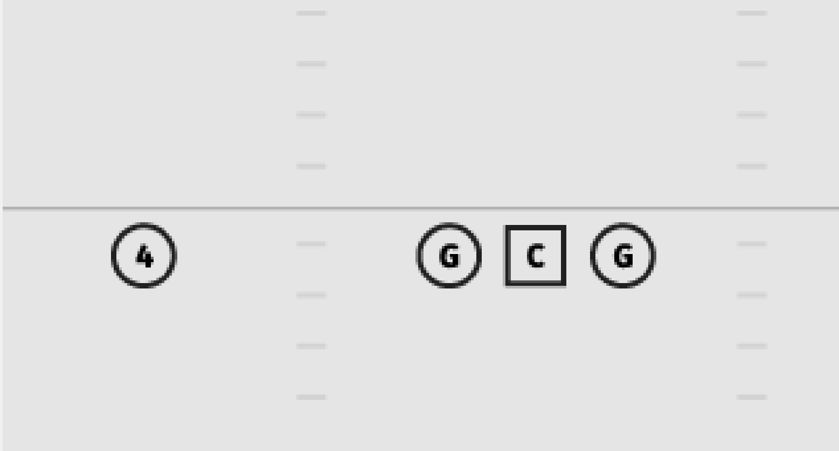
- The offense must have four players on the line of scrimmage. No more, no less. The fourth player can be d tight end or split end. See figures below.

or

- The four offensive players who are not playing guard or center may be deployed in positions at the coach’s discretion as long as one is on the line of scrimmage.

- The offensive team may run the ball up the middle. However, this cannot be done on consecutive plays. After a play in which the ball is run between the tackles, the next play must be designed to start outside. If the ball is run up the middle on consecutive plays the ball will be placed back to the original line of scrimmage and the offense will lose a down.
- The same player cannot run the ball on consecutive downs except for the quarterback on an obvious broken play situation. This also applies to touchdowns. The player who scores the touchdown cannot then attempt to score the extra point.
- Each time the ball is potted the offense will have 35 seconds to snap the ball. This will be enforced more strictly as the year progresses. (We want the kids to develop a sense for the rhythm of the game).
- Blocking shall be done from an upright position using open hands with the arms extended and both feet on the ground. Centers, guards, tight ends, split eds or any other offensive player at the line of scrimmage must first block the defensive player immediately in front of them. Body blocks, crack back blocks, and rolling blocks are not permitted.

V. Defensive Rules

- Defenses may only have two defensive linemen unless an offensive formation includes a tight end. In that case, a third defensive linemen may line up over the tight end.
- Defensive lineman must be in a two-point stance.
- Defense lineman over guards must be aligned head up.

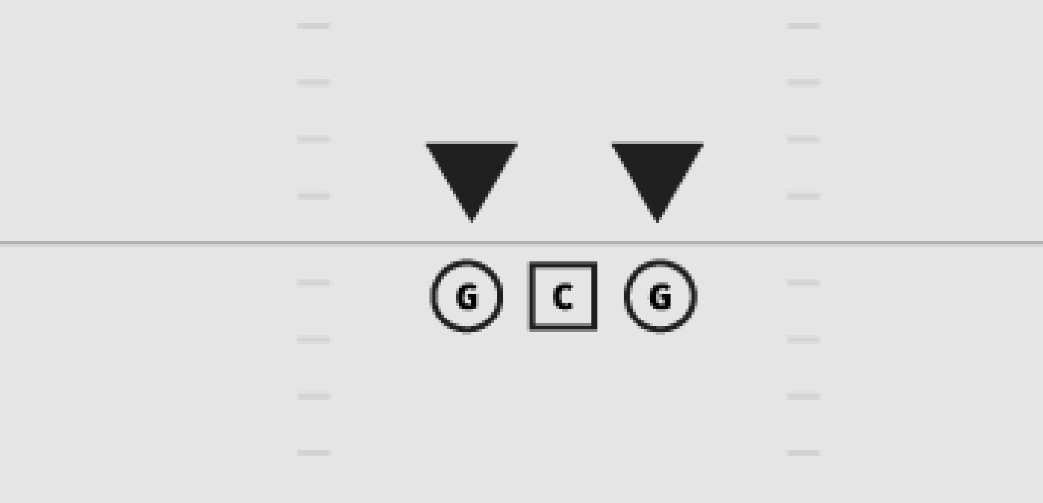

- The defense must have one player at least 10 yards from the ball.
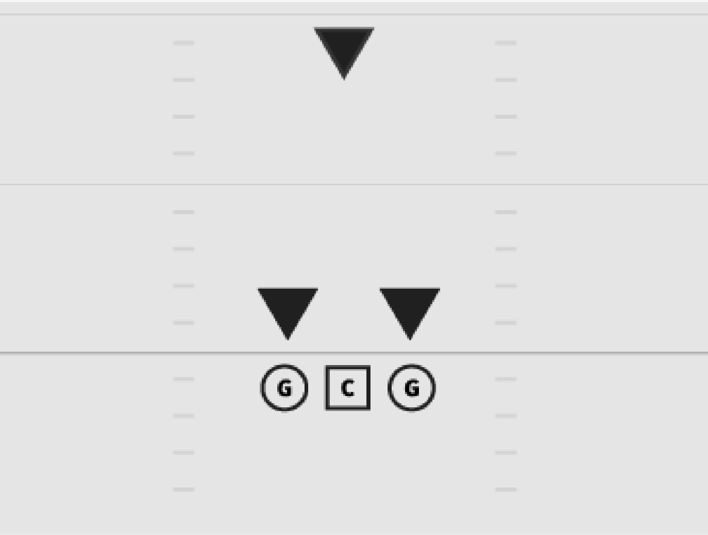

- The remaining four players can be deployed at the coach’s discretion but must be four yards off the line of scrimmage unless covering a tight end or split end on the line of scrimmage.
  - Example: If the offense aligns with its fourth line of scrimmage player as a tight end, then the defense may align a player directly over the tight end on the line of scrimmage to balance the running surface.
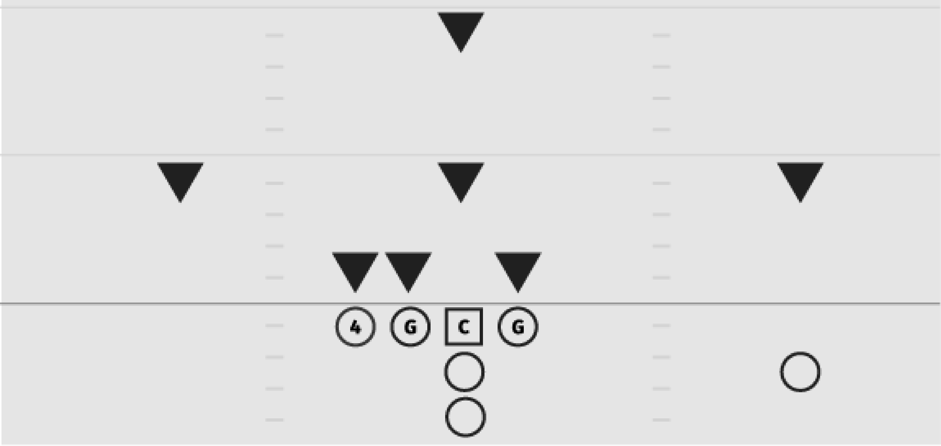

  - Defenses are not required to match the fourth player on the line of scrimmage but have the option to do so.
  - No blitzes are allowed. Players within the box at the snap can penetrate upon the snap. Linebackers, safeties and cornerbacks (both on the line and at depth) can flow to the ball naturally after a handoff is made, but predetermining penetration to a specific gap is illegal.

VI. Scoring Rules

A touchdown is worth 6 points. An extra point run in from the 2 ½ yd line is worth 1 point. An extra point run in from the 5 yd line is worth 2 points. A completed pass for an extra point is worth 3 points regardless of which yard line the play starts from.

