September
2026

Sunday | Monday | Tuesday | Wednesday | Thursday | Friday | Saturday
 | RETURN TO LEARN CAMPAIGN ALL SEPTEMBER LONG!  Donate today! | 1  Kona Ice @ 4pm | 2 | 3 | 4 | 5
6 | 7    CLUB  CLOSED | 8  Kona Ice @ 4pm | 9   | 10  Wings Etc. Give Back Night! Proceeds go back to the Valpo Club |   11 | 12
13 | 14  Monday Readers 4:00-5:00pm | 15  Kona Ice @ 4pm | 16 | 17 | 18  BINGO NIGHT  6:30pm-7:30pm  Register Today!  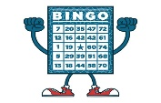  $3 per bingo card | 19  Take a Kid Fishing Day  FREE  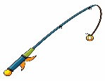  9am-1pm
20 | 21  Monday Readers 4:00-5:00pm | 22  Kona Ice @ 4pm | 23 | 24 | 25  Back To the School Year Party $5      6pm-8pm | 26
27 | 28  Monday Readers 4:00-5:00pm | 29  Kona Ice @ 4pm | 30

Reminders:
Silent Auction Baskets in the lobby! From September 8th-25th
All proceeds go to the Valpo Boys and Girls Club!
Kona Ice – September 1, 8, 15, 22, 29

Concessions – Monday through Friday at 4pm



