Planning the Mass of Christian Burial
at Good Shepherd Parish

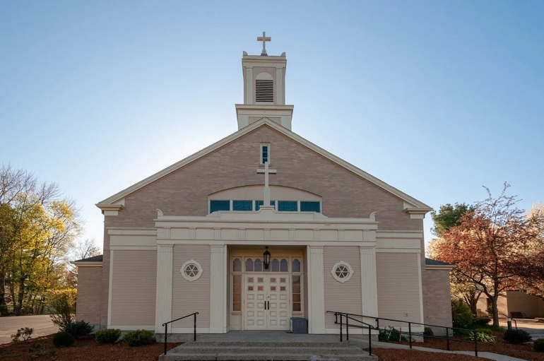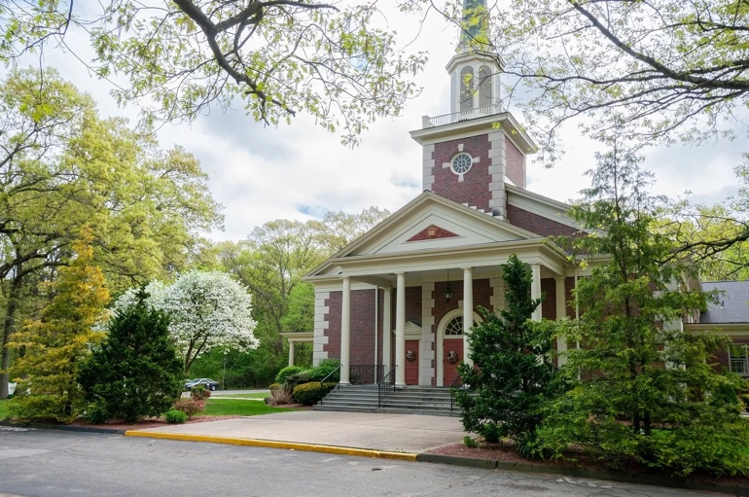

St. Zepherin Church & St. Ann Church

One Parish, Two Worship Sites

On behalf of the Good Shepherd Parish parishioners and staff, please accept our most sincere condolences on the loss of your loved-one. Although death saddens those who remain, as Christians we live in the hope of God’s merciful and redeeming love. The funeral Mass is an opportunity to gather as God’s People and pray the deceased loved-one into Heaven. Amidst your grief, we aspire to make the planning of this Mass as simple as possible. Please review the enclosed information carefully to guide you through planning the celebration. Please submit your selections no later than 48 hours prior to the Mass in order to ensure adequate preparation time for our staff.

Please complete the following information
and contact Fr. Ren immediately to schedule the funeral Mass.

(NB: If burial is taking place at St. Zepherin Cemetery, please complete and send this page to the Business Manager immediately so we can make the needed arrangements. Please contact the Business Manager for the most up-to-date burial rates.)

Name of Decedent __________________________________________

DOB _______________ DOD _______________ Age _______________

Address ______________________________________________________________________

Next of Kin_____________________ Relationship to the deceased ______________________

Phone _______________ Address ____________________________________________

Funeral Home___________________ Phone _______________ Fax _______________

Day/Time of Wake ____________________________________________________________

Date & Time of Funeral Mass ____________________________________________________

 St. Ann Church St. Zepherin Church Casket Urn

Pallbearers ___________________________________________________________________

One family member or friend is invited to offer some Words of Remembrance, not to exceed five minutes in length. __________________________________________________________

To complete the following information, please refer to the planning book Through Death to Life.

First Reading during most times of the year (pp. 26-30) ________________________________

First reading during the Easter season only (pp. 31-33) _________________________________
[March 28th – May 16th, 2027]

Name of person reading the First Reading __________________________________________

Responsorial Psalm (pp. 35-44) ___________________________________________________

Second Reading (pp. 45-55) ______________________________________________________

Name of person reading the Second Reading ________________________________________

General Intercessions (see below): A B

Options for the General Intercessions
Option A
- In baptism, N. received the light of Christ. Scatter the darkness now and lead [him/her] over the waters of death. Lord, in your mercy: Hear our prayer.
- Our [brother/sister] N. was nourished at the table of the Savior. Welcome [him/her] into the halls of the heavenly banquet. Lord, in your mercy: Hear our prayer.
- The family and friends of N. seek comfort and consolation. Heal their pain and dispel the darkness and doubt that come from grief. Lord, in your mercy: Hear our prayer.
- We are assembled here in faith and confidence to pray for our [brother/sister] N. Strengthen our hope so that we may live in the expectation of your Son’s coming. Lord, in your mercy: Hear our prayer.

Option B
- For N. who in baptism was given the pledge of eternal life, that [he/she] may now be admitted to the company of the saints. We pray to the Lord. Lord, hear our prayer.
- For our [brother/sister] who ate the body of Christ, the bread of life, that [he/she] may be raised up on the last day. We pray to the Lord. Lord, hear our prayer.
- For the family and friends of our [brother/sister] N., that they may be consoled in their grief by the Lord, who wept at the death of his friend Lazarus. We pray to the Lord. Lord, hear our prayer.
- For all of us assembled here to worship in faith, that we may be gathered together again in God’s kingdom. We pray to the Lord. Lord, hear our prayer.

For the death of a priest, deacon, other member of a religious order, or child, please contact the parish office for additional options for the general intercessions.

Name of person reading the General Intercessions ____________________________________

Names of those bringing forward the Gifts (up to 4 people)
_____________________________________________________________________

Below is a sample of music that may be sung during the Mass. This list is not meant to be comprehensive and is simply a limited selection of funeral-specific music.
Recordings of these songs are available on YouTube for your reference.
Any liturgically-appropriate music may be selected.
Please note: Secular or popular music is not appropriate for the purposes of the funeral Mass.

Song | Composer | Processional | Preparation | Communion | Recessional
Abide with Me | William Monk |  | X
Age to Age | Janet Vogt |  | X
All Is Well with My Soul | Philip Bliss |  | X
All Shall Be Well | Barbara Bridge |  | X
Amazing Grace | NEW BRITAIN | X | X |  | X
An Irish Blessing | Tom Kendzia |  |  |  | X
Ave Maria | Franz Schubert |  | X
Be Not Afraid | Bob Dufford | X | X |  | X
Be Still, My Soul | Jean Sibelius |  | X
Be Thou My Vision | SLANE | X | X |  | X
Behold the Lamb | Martin Willett |  |  | X
Center of My Life | Paul Inwood |  | X
Christ Be Beside Me | Laura Wasson |  | X
Christ Before Us | Janèt Whitaker |  | X
Christ, Be Our Light | Bernadette Farrell | X | X
City of God | Dan Schutte |  |  |  | X
Come to the Water | John Foley | X | X | X
Come, Follow Me | Gael Berberick |  | X
Eat This Bread | Jacques Berthier |  |  | X
Eye Has Not Seen | Marty Haugen |  | X
Fly Like a Bird | Ken Canedo |  |  |  | X
Gift of Finest Wheat | Robert Kreutz |  |  | X
Give Me Jesus | Spiritual |  | X
God of Mercy | Ricky Manalo |  | X
Haily Mary,  Gentle Woman | Carey Landry |  | X
Here at This Table | Janèt Whitaker |  |  | X
Here I Am, Lord | Dan Schutte | X
Holy Darkness | Dan Schutte |  | X
How Great Thou Art | Stuart Hine |  |  |  | X
I am the Bread of Life | Suzanne Toolan |  |  | X
I Have Loved You | Michael Joncas |  | X
I Heard the  Voice of Jesus | KINGSFOLD | X |  |  | X
I Know That  My Redeemer Lives | Scott Soper |  |  |  | X
I Received  the Living God | Anonymous |  |  | X
I, the Lord | Tom Kendzia |  | X
In Every Age | Janèt Whitaker |  | X
Song | Composer | Processional | Preparation | Communion | Recessional
In This Place | Trevor Thomson | X |  | X
Let There Be  Peace on Earth | Miller & Jackson |  |  |  | X
Like a Shepherd | Bob Dufford |  | X
Lord of All Hopefulness | SLANE | X |  |  | X
On Eagle’s Wings | Michael Joncas | X | X |  | X
Only This I Want | Dan Schutte |  | X
Panis Angelicus | César Franck |  |  | X
Parable | M.D. Ridge |  | X
Prayer of St. Francis | Sebastian Temple |  | X
Precious Lord,  Take My Hand | Thomas Dorsey |  |  |  | X
Say to the  Frightened Heart | Bob Hurd |  | X
Seek Ye First | Karen Lafferty |  | X
Shelter Me, O God | Bob Hurd |  | X
Shepherd of My Heart | Francis O’Brien |  | X
Softly and Tenderly, Jesus is Calling | Will Thompson |  |  |  | X
Stand by Me | Tom Kendzia |  | X
Taste and See | James Moore |  |  | X
The King of Love  My Shepherd Is | ST. COLUMBA |  | X
The Lord is My Hope | M.D. Ridge |  |  |  | X
These Alone  Are Enough | Dan Schutte |  | X
Unless a Grain of Wheat | Bernadette Farrell |  |  | X
We Walk by Faith | Marty Haugen |  | X
Where My Father Lives | M.D. Ridge |  | X
You Are Near | Dan Schutte | X | X

Processional Song ______________________________________________________________

Preparation Song ______________________________________________________________

Communion Song _____________________________________________________________

Recessional Song ______________________________________________________________

Please understand that music choices are not considered finalized until approved by the Director of Music Ministry.

Interment:
Burial Location ________________________________________________________________

If being buried at St. Zepherin Cemetery:
Section _____________ Lot # _____________ Cemetery arrival time _____________

Associated Fees

Remuneration for the Mass of Christian Burial at Good Shepherd Parish is $800.
This includes the cost of an accompanist and cantor, as well as a donation to the parish.

The parish hall is available following the Mass/burial if the family wishes to host a reception. The cost to rent the parish hall is $200 and includes the use of the space only. Family members are responsible for setup, decorations, refreshments, etc.

Please check here if you would like to rent the hall for your collation.

Please note that all fees are subject to change at any time.

Please make your check payable to GOOD SHEPHERD PARISH.

Staff Contact Information

For financial matters:
Liliana Lucas, Finance & Operations Manager – GSP-BusinessManager@goodshepherdwayland.org

For musical matters:
Bethany C. Ratcliff, Director of Music Ministry – MusicDirector@goodshepherdwayland.org

For matters regarding the celebration of the Mass:
Rev. Laurence “Ren” Tocci, Pastor – frren@goodshepherdwayland.org

For all other matters:
Vina Sousa, Administrative Assistant – vsousa@goodshepherdwayland.org

All staff members can be reached by phone at 508-650-3545.

