

**September 28th, 2024**

Union Congregational Church seeks to create a celebrating covenanting, affirming and justice seeking faith community that inspires people to unite and create a peaceful, loving world.

* We welcome LGBTQ+ people into the full life of the church, as an Open & Affirming Congregation.
* Listening devices are available at the rear of the Sanctuary, for enhanced audio accessibility during the service. Ushers can assist.
* For kids: The Pray-ground is in the Vestry (off the sanctuary). You’ll find a table with activity bags for children to use during the service. Kids are welcome at the table or with their parents in worship. All ages are welcome in Sunday School, but we ask a parent/guardian to accompany any children under 6.
* Stay connected: Missed a sermon or want to share it digitally? Listen to our Sunday sermons on our Podcast, CommUnion, at [www.ElkRiverUCC.org/watch](http://www.ElkRiverUCC.org/watch). You’ll also find our live stream if you can’t attend in person and an online bulletin to follow along. Hard copies of the sermon are available by the front door.

* Indicates to rise Bold text indicates to speak

**Order of Worship**

**Prelude:**

**Welcome –** Rev. Nora P. Elliott

May Peace be with you

**And also with you.**

**Gathering Prayer**

**God of abundance and justice, gather us in from our scattered places. Open our minds to know the ones at our gates, open our hearts to receive your word, and open our lives to be changed by your grace. Amen.**

**Offering Peace**

*Please greet each other with* **"May peace be with you."**

**\*Opening Hymn:** Come, We Who Love God's Name #379 NCH



**Call to Worship**

One: We come carrying the weight of the world; wealth, worry, privilege and pain.

**Many: God, help us to lay down what keeps us apart.**

One: The prophets cry out against the ease of the comfortable.

**Many: Christ calls us to see those whom the world ignores.**

One: Beloved, hear this good news: God’s mercy is wider than our fear, deeper

than our failures, and stronger than our divisions.

**Many: Thanks be to God; our discomfort is a sign of our communion with**

**You. Amen**

**Scripture**–

**Amos 6:1a, 4–7**

Woe to you who live in luxury in Zion, and to you, self-important people on the mountain of Samaria… Lying on ivory beds and reclining on their couches, they dine on lambs from the flock, and young calves from the stalls. They hum to the tune of the harp, and fancy themselves musicians like David. They drink straight from the bottle and anoint themselves with the finest oils. But they show no care for the ruin of Joseph! That is why they will be the first to be exiled—they will receive no more, at festive banquets!

**Luke 16:19–31**

“Once there was a rich person who dressed in all purple and linen and feasted splendidly every day. At the gate of this person’s estate lay a beggar named Lazarus who was covered with sores. Lazarus longed to eat the scraps that fell from the rich person’s table… One day poor Lazarus died and was carried by the angels to the arms of Sarah and Abraham. The rich person likewise died and was buried. In Hades, in torment, the rich person looked up and saw Sarah and Abraham in the distance, and Lazarus resting in their company. “Sarah and Abraham, ‘the rich person cried, ‘have pity on me! Send Lazarus to dip the tip of his finger in water and cool off my tongue, for I am tortured by these flames!’ But they said ‘My child, remember that you were well off in your lifetime, while Lazarus was in misery. Now Lazarus has found consolation here, and you have found torment.

But that’s not all. Between you and us there is a fixed chasm, so that those who might wish to come to you from here can’t do so, nor can anyone cross from your side to us.’ “The rich person said, ‘I beg you, then, to send Lazarus to my own house where I have five siblings. Let Lazarus be a warning to them, so that they may not end in this place of torment.’ But Sarah and Abraham replied, ‘They have Moses and the prophets. Let your siblings hear them.’ ‘Please, I beg you,’ the rich person said, if someone would only go to them from the dead, then they would repent.’ ‘If they don’t listen to Moses and the prophets,’ Sarah and Abraham replied, ‘they won’t be convinced even if someone should rise from the dead!’”

**Time with Children:** What can money buy?

**Sermon:** “Who is at our Gate?”

**Responsive hymn:** As a Fire is Meant for Burning

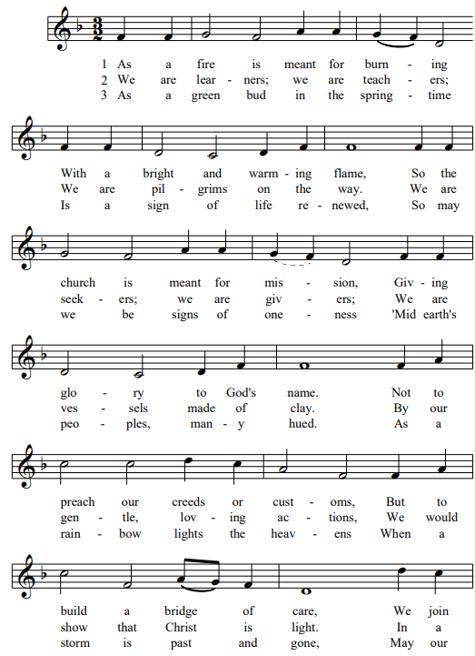



**Offertory:**

Scan QR code with smart phone camera to give electronically.

**Special Music:**

**\*Doxology** NCH #780 Praise God from Whom All Blessings Flow

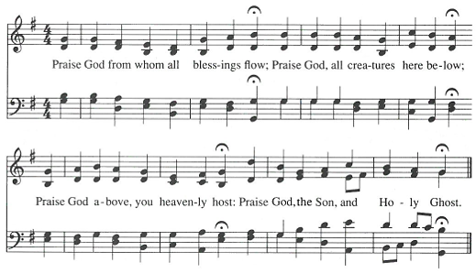

**Amen**

**\*Prayer of Dedication:**

**Generous God, you pour out blessing upon blessing, yet you also call us to share.**

**Take these gifts, given from grateful hearts, and use them to open gates, heal wounds, and build a community where all are fed, and all find welcome. Amen.**

**Community Prayers:**

Pastor Nora will offer a blessing for each prayer raised and then invite the congregation to pray together, **"Oh God, hear our prayer."**

**Prayer of Jesus –** Traditional Inclusive

**Our Loving God, who art in heaven, hallowed be thy name. Thy kin-dom come, thy will be done on earth as it is in heaven. Give us this day our daily bread, and forgive us our debts as we forgive our debtors. Save us from temptation, and deliver us from evil. For thine is the kin-dom, and the power, and the glory forever. Amen.**

**\*Closing Hymn:** Take my Life, God, Let It Be

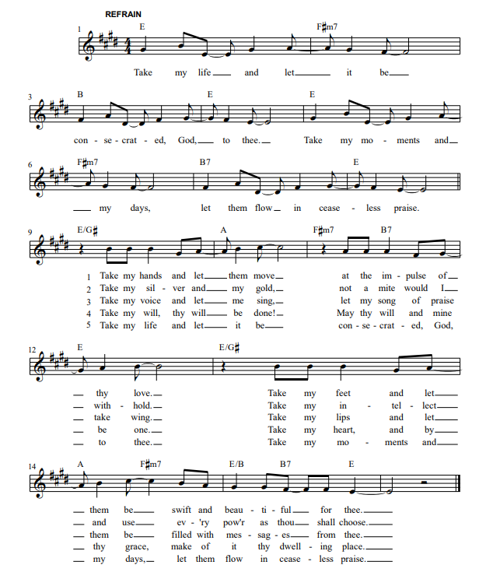

**Announcements:**

* After Worship: Our Whole Lives (OWL), for adults 35+ begin to meet weekly at noon. Contact Pastor Nora to get enrolled.
* We have lots of open slots for Meals on Wheels Delivery in October. Please sign up by visiting our Flocknote or contact Pastor Nora.
* Oct 5 is World Communion Sunday, join to share bread from around the globe!
* Open Doors for Youth is taking a monumental step forward in their mission to combat youth homelessness with the launch of our new Transitional Housing Program! The official opening of the program is scheduled for July 2026 and will be housed in the former Parsonage of Union Congregational Church, UCC, in Elk River, providing a safe and stable home for vulnerable young people and giving them the foundation they need to build a brighter future.
* **Safe, Sacred, and Strong: A Capital Campaign**

*Restoring our sacred space for justice, welcome, and care.*

We’ve already surpassed our first milestone of raising $17,000

by October 1 for essential bat mitigation! Work has begun to

get the bats out of our belfry, and for phase 2, which seeks to

make our chancel area more accessible.

**Benediction:**

**Postlude:**

**Elk River Union UCC Worship Staff**

**Next Council Meeting is October 9th**

**Upcoming Hospitality:**  Oct. 5th | Congregational Life, Inner Church Oct. 12th | Centennial

**General Questions?**

Email April at church[office@](mailto:office@)elkriverucc.org

**Mailing Address**

1118 4th St. NW

Elk River, MN 55330

**Web Address**

[www.elkriverucc.org](http://www.elkriverucc.org)

**Office Hours:**

Mon-Thurs 9:30 AM-3:30 PM

Sun9:30 AM -11:30 AM

Pastor: Rev. Nora P. Elliott

*763-267-7845; revnora@elkriverucc.org*

Office Administrator: April Sundstrom

*763-441-1203; churchoffice@elkriverucc.org*

Director of Music: Carson Schneider

[*music-director@elkriverucc.org*](mailto:music-director@elkriverucc.org)

Deacon: Lisa Cawthra

Hospitality: Choir

Accompanist: Carson Schneider

Song Leader:

Audio/Video: Marce Ediger & Keith Stevens

Usher/Greeter(s): Ruth Johnson & Bev Putnam

Sunday School: Laura Elliott & Amanda Hooper