


September 13th, 2026 Rally Sunday
Union Congregational Church seeks to create a celebrating, covenanting, affirming, and justice seeking faith community, inspiring people to unite & create a peaceful, loving world.

- We welcome LGBTQ+ people into the full life of the church, as an Open & Affirming Congregation, of the United Church of Christ.

- Listening devices are available at the rear of the Sanctuary, for enhanced audio accessibility during the service. Ushers can assist.

- For kids: The Pray-ground is in the Vestry (by the chancel ramp). You’ll find a welcoming space for all ages and space for littles with wiggles. All ages are welcome in Sunday School, but we ask a parent/guardian to accompany children under 6.

- Stay connected: Revisit our sermons with our Podcast, CommUnion, available on our website, www.ElkRiverUCC.org/watch, and on most major podcast apps.

- In scripture, you may see the letters YHWH - the sacred, unpronounced name of God. To honor the mystery of the Divine and as witness to our expansive faith, we invite our liturgists to substitute the title or aspect of God they find most meaningful, such as Holy One, Mother, Lord, Creator, or Spirit. We invite you to listen for these diverse expressions of the Divine as we worship together.

* Indicates to rise Bold text indicates to speak
Order of Worship

Prelude: Come Christians Join to Sing by Mark Hayes

Welcome: The Rev Nora Elliott

May peace be with you
And also, with you.

Centering Breath

Gathering Prayer:
Come from the east and west, the north and south, and worship the God of our ancestors, the God of Jesus Christ. The grace of Jesus Christ and the love of God and the communion of the Holy Spirit by with us all. Amen

Offering Peace
Please greet each other with "May peace be with you."

*Opening Hymn: They're Know We are Christians by Our Love #300 GtG

Call to Worship:
One: Almighty and merciful God, you created and are creating still.
Many: In your presence our limits lie stark before us. We confess our cynical hearts, our turning away from neighbors, and our broken promises.
One: We confess having squandered the gifts given to us, neglected our lands, and cared for technology more than humanity.
Many: Forgive us for loving power more than people. Soften our hearts and rebuild us a new, again.
One: God hears the confessions of our hearts and by grace we are forgiven.
Many: The past is finished and gone, everything has become fresh and new. Thanks be to God and the promises of the Gospel. Amen

Scripture: Matthew 15:21-28

Time with Children: Can you tie a knot?

Sermon: Community is Artwork

*Responsive Hymn: My Life Flows on in Endless Song #476 NCH

Offertory: Give electronically by scanning the QR code

Doxology: God of Grace and God of Glory NCH #436 v1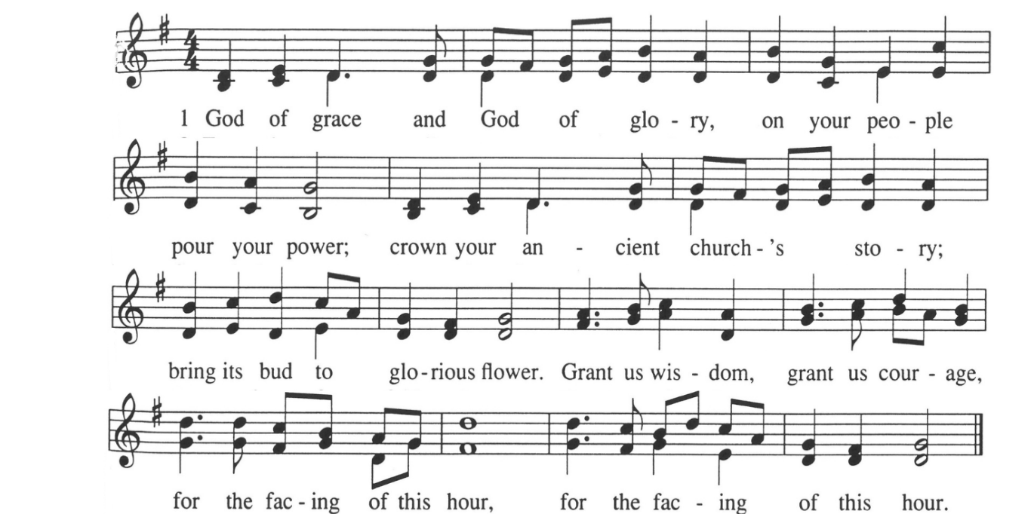

Special Music: They'll Know We Are Christians By Our Love arr. Mark Hayes

Offering Prayer:
Fount of Grace, may these gifts serve to inspire the world anew. Let them build up a church where the outsider is prioritized, and self-interest released. Amen

Communion: Our Communion table is open to everyone of every age and spirituality
Invitation

Consecrating of the Elements

Pastoral Prayer
Submit prayer requests electronically by scanning the QR code:

Prayer of Jesus: Traditional Expansive
Our Loving God, who art in heaven,
hallowed be thy name.
Thy kin-dom come, thy will be done
on earth as it is in heaven.
Give us this day our daily bread,
and forgive us our debts as we forgive our debtors.
Save us from temptation, and deliver us from evil.
For thine is the kin-dom, and the power, and the glory forever. Amen.

*Closing Hymn: The Church of Christ in Every Age #306 NCH

Announcements:
- New Adult Education Forum Sep 20 – Oct 18 in the Community Room. Planning for our return to God: Being intentional about our end-of-life concerns
- Have an announcement for the bulletin or newsletter? Email ChurchOffice@ElkRiverUCC.org by 10 a.m. on Wednesday, for publication in the Thursday email and next Sunday bulletin.

Benediction

Postlude: Joyful, Joyful, We Adore You arr. Mark Hayes

Our church calendar is available online at ElkRiverUCC.org, at the bottom of the home page

Worship Staff & Volunteers
Next Council Meeting: October 1st
Upcoming Hospitality: Sep. 13th | Liturgical Art Sep. 20th | OPEN
General Questions?
Email the Office at ChurchOffice@ElkRiverUCC.org

Mailing Address
1118 4th St. NW
Elk River, MN 55330

Web Address
www.ElkRiverUCC.org

Office Hours:
Tues. - Thurs. 9:30 AM - 3:30 PM

Pastor: Rev. Nora P. Elliott
763-276-7204; RevNora@ElkRiverUCC.org

Music Director: Carson Schneider
Music-Director@ElkRiverUCC.org

Office Manager: Rachel Cangello
763-441-1203; ChurchOffice@ElkRiverUCC.org

Accompanist: Deb Kopperud
Audio/Video: Joan Stevens
Deacon:
Hospitality: Diaconate
Sunday School: Amanda Hooper
Ushers and Greeters: Frater Family
