


August 23th, 2026 13th Sunday After Pentecost
Union Congregational Church seeks to create a celebrating, covenanting, affirming, and justice seeking faith community, inspiring people to unite & create a peaceful, loving world.

- We welcome LGBTQ+ people into the full life of the church, as an Open & Affirming Congregation, of the United Church of Christ.

- Listening devices are available at the rear of the Sanctuary, for enhanced audio accessibility during the service. Ushers can assist.

- For kids: The Pray-ground is in the Vestry (by the chancel ramp). You’ll find a welcoming space for all ages and space for littles with wiggles. All ages are welcome in Sunday School, but we ask a parent/guardian to accompany children under 6.

- Stay connected: Revisit our sermons with our Podcast, CommUnion, available on our website, www.ElkRiverUCC.org/watch, and on most major podcast apps.

- In scripture, you may see the letters YHWH - the sacred, unpronounced name of God. To honor the mystery of the Divine and as witness to our expansive faith, we invite our liturgists to substitute the title or aspect of God they find most meaningful, such as Holy One, Mother, Lord, Creator, or Spirit. We invite you to listen for these diverse expressions of the Divine as we worship together.

* Indicates to rise Bold text indicates to speak
Order of Worship

Prelude: Amazing Grace by Larry Shackley

Welcome: The Rev. Nora P. Elliott

May peace be with you
And also, with you.

Centering Breath

Gathering Prayer:

God of all nations and neighborhoods, shatter the walls we have built in our hearts and minds, and give us the courage to let your Spirit disrupt our comfortable assumptions. Teach us, like your Son, to listen to the voices from the margins, for it is there that faith grows and the boundaries of your kindom expanded. Amen

Offering Peace
Please greet each other with "May peace be with you."

*Opening Hymn: Amazing Grace, How Sweet the Sound #547 NCH

Call to Worship:

One: How many of us have built fences around our faith?
Many: We confess we have conformed to the patterns of this world, excluding and denying the breadth of our God’s love.
One: When voices from the outside challenge our status quo, we often harden our hearts and prefer the comfort of the familiar over the risk of the new.
Many: Forgive our narrow imaginations; and teach us to welcome the stranger who brings us closer to you.
One: In Christ, the wall of hostility has been broken down.
Many: Thanks be to God, who makes all things new and invites us into a kindom with no borders or outsiders.

Scripture: Romans 12: 2 & Matthew 15:21-28

Time with Children: Who's a rule follower?

Sermon: The Education of Jesus

*Responsive Hymn: O for a World #575 NCH

Special Music: I Need Thee Every Hour by Joel Raney

Offertory

Give electronically by scanning the QR code with a smart phone camera:
Doxology: God of Grace and God of Glory NCH #436 v1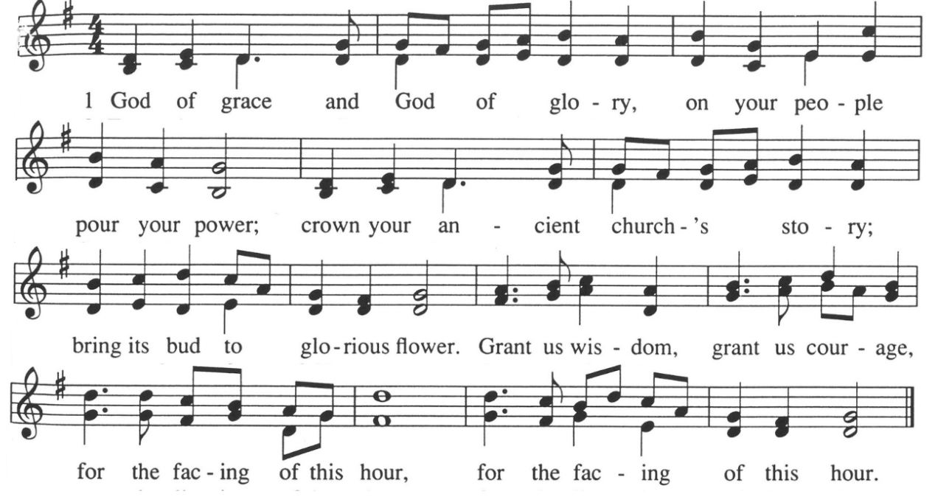

Offering Prayer:
Boundless God, we bring these gifts from our varied lives and backgrounds. Bless it to be a bridge across cultures and a testament that your table is wide enough for everyone, especially those the world tries to leave out. Amen.


Community Prayers
…O God, hear our prayers
Submit prayer requests electronically by scanning the QR code:

Prayer of Jesus: Casa del Sol, by John Philip Newell

Ground of all being, Mother of life, Father of the universe, Your name is sacred, beyond speaking. May we know your presence, may your longings be our longings in heart and in action. Today, may there be food for the human family and for the whole earth community. Forgive us the falseness of what we have done as we forgive those who are untrue to us. Do not forsake us in our time of conflict, but lead us into new beginnings. For the light of life, the vitality of life, and the glory of life are yours now and forever. Amen.

*Closing Hymn: The Church of Christ in Every Age #306 NCH

Announcements:
- Parents and caregivers, please join us at 11:30am TODAY downstairs, in the Youth Room, for our parent and family orientation of fall children and youth opportunities. Childcare will be provided!
- Rally Sunday, September 13, featuring a block party in the new parking lot. Coffee and treats outside, seating, games, and of course, a bounce house for the kids, with a second one just for the littles to have their own! Invite a friend!
- Do you enjoy cookies and food after worship? Sign up to volunteer for hospitality by emailing ChurchOffice@ElkRiverUCC.org to get on the list.
- Have an announcement for the bulletin or newsletter? Email ChurchOffice@ElkRiverUCC.org by 10 a.m. on Wednesday, for publication in the Thursday email and next Sunday bulletin.

Benediction

Postlude: Blest be the Tie by Mark Hayes

Our church calendar is available online at ElkRiverUCC.org, at the bottom of the home page

Union Congregational UCC Worship Staff & Volunteers
Upcoming Hospitality: August 30th | Faith Formation September 6th | Diaconate
General Questions?
Email the Office at ChurchOffice@ElkRiverUCC.org

Mailing Address
1118 4th St. NW
Elk River, MN 55330

Web Address
www.ElkRiverUCC.org

Office Hours:
Tues. - Thurs. 9:30 AM - 3:30 PM

Pastor: Rev. Nora P. Elliott
763-276-7204; RevNora@ElkRiverUCC.org

Director of Music: Carson Schneider
Music-Director@ElkRiverUCC.org

Church Office: Rachel Cangello
763-441-1203; ChurchOffice@ElkRiverUCC.org

Accompanist: Carson Schneider
Audio/Video: Joan Stevens
Deacon: Marietta Saxon
Hospitality: Trustees
Sunday School: Amanda Hooper
Ushers and Greeters: Su Arnold and Janine
