


August 2nd, 2026 10th Sunday After Pentecost
Union Congregational Church seeks to create a celebrating, covenanting, affirming, and justice seeking faith community, inspiring people to unite & create a peaceful, loving world.

- We welcome LGBTQ+ people into the full life of the church, as an Open & Affirming Congregation, of the United Church of Christ.

- Listening devices are available at the rear of the Sanctuary, for enhanced audio accessibility during the service. Ushers can assist.

- For kids: The Pray-ground is in the Vestry (by the chancel ramp). You’ll find a welcoming space for all ages and space for littles with wiggles. All ages are welcome in Sunday School, but we ask a parent/guardian to accompany children under 6.

- Stay connected: Revisit our sermons with our Podcast, CommUnion, available on our website, www.ElkRiverUCC.org/watch, and on most major podcast apps.

- In scripture, you may see the letters YHWH - the sacred, unpronounced name of God. To honor the mystery of the Divine and as witness to our expansive faith, we invite our liturgists to substitute the title or aspect of God they find most meaningful, such as Holy One, Mother, Lord, Creator, or Spirit. We invite you to listen for these diverse expressions of the Divine as we worship together.

* Indicates to rise Bold text indicates to speak
Order of Worship

Prelude: How Firm a Foundation by Mark Hayes

Welcome: The Rev. Nora P. Elliott

May peace be with you
And also, with you.

Centering Breath

Gathering Prayer:

Eternal Maker of heaven and earth, in a world where foundations shake and shadows lengthen, we lift our focus from collapsing structures of fear, to the stability of your presence. Be our rock and our refuge today, with your help that never slumbers nor sleeps. Amen

Offering Peace
Please greet each other with "May peace be with you."

*Opening Hymn: For the Beauty of the Earth #28 NCH

Call to Worship:

One: O God, when the ground beneath us trembles, we often seek the sand, trying to build our security on things that shift and fade.
Many: We have trusted in walls that crack, economies that fail, and forget that our help comes from the Creator of all.
One: Help us from staying awake with anxiety, instead of resting in the One who watches over our coming and going.
Many: Forgive our misplaced trust and turn our focus toward you.
One: Our God is our shade at our right hands, to protect us from the fires of our days.
Many: Thanks be to God, who preserves us from all evil and establishes our house firmly on the Rock that cannot be moved. Amen

Scripture: Psalm 121 & Matthew 7:24-27

Time with Children: How can we find help?

Sermon: Source of our Help

*Responsive Hymn: We Are Your People #309 NCH

Special Music: Joy In My Soul by Mark Hayes


Offertory
Give electronically by scanning the QR code with a smart phone camera:
Doxology: God of Grace and God of Glory NCH #436 v1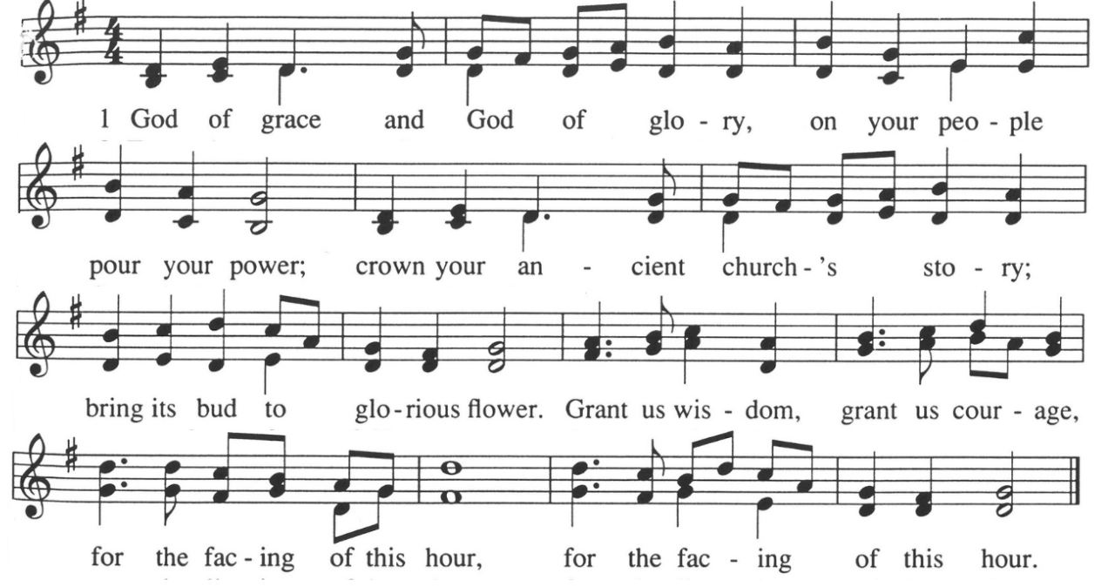
Offering Prayer:
Gracious Architect of our souls, we bring these gifts as stones for your foundation, trusting that you will bind them together with love to build a shelter that no storm can shake; bless this offering to be the mortar of mercy and the beam of hope for a world searching for solid ground. Amen.


Community Prayers
…O God, hear our prayers
Submit prayer requests electronically by scanning the QR code:

Prayer of Jesus: Translated from the Aramaic by Mark Hathaway
O cosmic Birther of all radiance and vibration, soften the ground of our being,
and carve out a space within us where your Presence can abide. Fill us with your creativity, so that we may be empowered to bear the fruit of your mission. Let each of our actions bear fruit in accordance with our desire. Endow us with the wisdom to produce and share what each being needs to grow and flourish. Untie the tangled threads of destiny that bind us, as we release others from the entanglement of past mistakes. Do not let us be seduced by that which would divert us from our true purpose, but illuminate the opportunities of the present moment.For you are the ground and the fruitful vision, the birth power, and fulfillment, as all is gathered and made whole once again. And So It Is!

*Closing Hymn: What a Fellowship, What a Joy Divine #837 GtG

Announcements:
- Congregational Life's meetings have moved to the last Sunday of the Month at 12pm
- Do you enjoy cookies and food after worship? Sign up to volunteer for hospitality by emailing ChurchOffice@ElkRiverUCC.org to get on the list.
- Have an announcement for the bulletin? Email ChurchOffice@ElkRiverUCC.org no later than 10 a.m. on Wednesday, for publication in the Thursday email and next Sunday bulletin. Please limit announcements to 100 words. Thank you!

Benediction

Postlude: Sweet Sweet Spirit by Mark Hayes

Our church calendar is available online at ElkRiverUCC.org, at the bottom of the home page

Union Congregational UCC Worship Staff & Volunteers
Next Church Council Meeting: August 6th
Upcoming Hospitality: August 9th | OPEN August 16th | Centennial
General Questions?
Email the Office at ChurchOffice@ElkRiverUCC.org

Mailing Address
1118 4th St. NW
Elk River, MN 55330

Web Address
www.ElkRiverUCC.org

Office Hours:
Tues. - Thurs. 9:30 AM - 3:30 PM

Pastor: Rev. Nora P. Elliott
763-276-7204; RevNora@ElkRiverUCC.org

Director of Music: Carson Schneider
Music-Director@ElkRiverUCC.org

Church Office: Rachel Cangello
763-441-1203; ChurchOffice@ElkRiverUCC.org

Accompanist: Carson Schneider
Audio/Video: Mike Richmond
Deacon:
Hospitality: Congregational Life
Sunday School: Amanda Hooper
Ushers and Greeters: Bex Hibbert and Laura Elliott
