


June 7th, 2026 Honoring Transitions
Union Congregational Church seeks to create a celebrating, covenanting, affirming, and justice seeking faith community, inspiring people to unite & create a peaceful, loving world.

- We welcome LGBTQ+ people into the full life of the church, as an Open & Affirming Congregation, of the United Church of Christ.

- Listening devices are available at the rear of the Sanctuary, for enhanced audio accessibility during the service. Ushers are able to assist.

- For kids: The Pray-ground is in the Vestry (by the chancel ramp). You’ll find a welcoming space for all ages and space for littles with wiggles. All ages are welcome in Sunday School, but we ask a parent/guardian to accompany children under 6.

- Stay connected: Revisit our sermons with our Podcast, CommUnion, available on our website, www.ElkRiverUCC.org/watch, and on most major podcast apps.

- In scripture, you may see the letters YHWH - the sacred, unpronounced name of God. To honor the mystery of the Divine and as witness to our expansive faith, we invite our liturgists to substitute the title or aspect of God they find most meaningful, such as Holy One, Mother, Lord, Creator, or Spirit. We invite you to listen for these diverse expressions of the Divine as we worship together.

* Indicates to rise Bold text indicates to speak

Prelude:
Order of Worship

Welcome: The Rev. Nora P. Elliott

May peace be with you
And also with you.

Centering Breath

Gathering Prayer
Wonderful God, we delight in your presence. We find shelter in your abiding and enduring love. You humble us, Holy Love, by gathering us as a people. Thank you for being our Companion and Guide on this journey. Amen

Offering Peace
Please greet each other with "May peace be with you."

*Opening Hymn: Blessed Be the Tie That Binds, #393 NCH v 1,2,4

Call to Worship:
One: Rejoice in the Holy One! God loves righteousness and justice; the earth is full of God’s steadfast love.
Many: Your Word created the heavens & earth. Praise God with loud shouts!
One: Rejoice in the Holy One! God loves righteousness and justice; the earth is full of God’s steadfast love.
Many: Let our voices ring & sing a new song. Let us turn to our Creator in awe.
One: Rejoice in the Holy One! God loves righteousness and justice; the earth is full of God’s steadfast love.
Many: Happy are the people who seek God’s counsel, who seek God’s heart, and who seek God’s kindom. Rejoice in the Holy One!

Scripture: Gen 12:1-3 & Romans 4:13-16a New Revised Standard Version

Time with Children: Do we have to go alone?

Sermon: Honoring our Transitions

Responsive Hymn: I Was There to Hear Your Borning Cry #351 NCH


Offertory
Give electronically by scanning the QR code with a smart phone camera:

Special Music: Pomp & Circumstance, by Sir Edward Elgar

*Doxology: God of Grace and God of Glory, NCH #436 v1
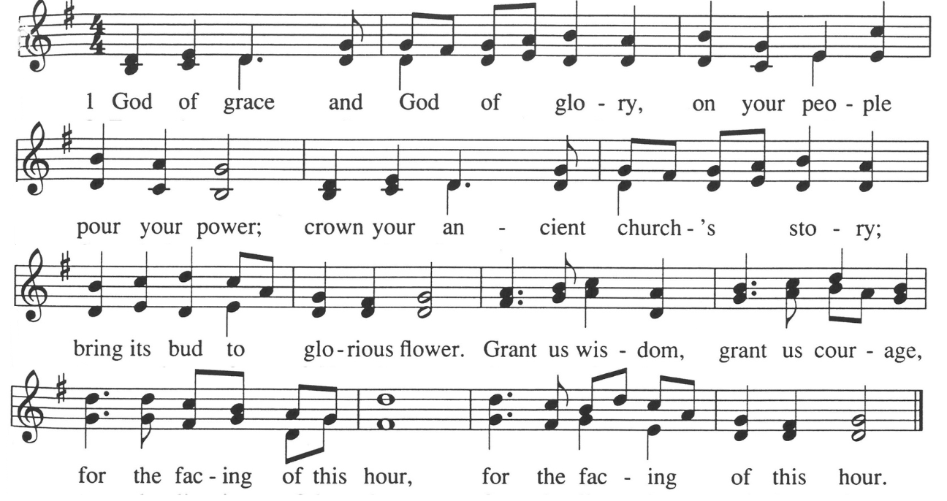

*Prayer of Dedication
Let us share the gifts of life and love given to sustain us on the journey. Our generosity strengthens communities and witnesses to the love of God in the world. May our time, talent, and treasure testify to the goodness and abundance of God’s creation. Amen

Communion: Our Communion table is open to everyone of every age and spirituality
Invitation

Consecrating of the Elements

Pastoral Prayer
Submit prayer requests electronically by scanning the QR code:

Prayer of Jesus – Youth Prayer 2023
Our loving God, who surrounds us always and inspires authentic care, bring us together in holy community through the way of love from pain to peace. Provide nourishment for the hungry. Help us find strength when we fail, as we uplift others in need of support. Refocus us when we go astray and fill our world with justice, because we all need your hope and joy and continued love. Amen.

*Closing Hymn: Won't You Let Me Be Your Servant, NCH #539

Announcements:
- The Annual Congregational Meeting is TODAY immediately following worship in the fellowship hall, for the business of receiving the annual ministry report and voting in new ministry team members and leads. All ministry team members are strongly encouraged to stay afterward for All Boards meeting.
- Do you enjoy cookies and food after worship? Sign up to help provide it or we’ll just have coffee! Email ChurchOffice@ElkRiverUCC.org to get on the list.
- Summer Sermon Series: Scriptures Worth Writing Home About. Pastor Nora is inviting everyone to submit a scripture that has been impactful in their lives with a little bit about why it’s impactful. She plans to uplift as many of these as she can throughout the summer.
- Have an announcement for the bulletin? Email ChurchOffice@ElkRiverUCC.org no later than 10 a.m. on Wednesday, for publication in the Thursday email and next Sunday bulletin. Please limit announcements to 100 words. Thank you!

Benediction

Postlude:

Our church calendar is available online at ElkRiverUCC.org, at the bottom of the home page

Union Congregational UCC Worship Staff & Volunteers
Next Church Council Meeting: June 11th
Upcoming Hospitality: June 14th | Open & June 21st | OPEN
General Questions?
Email the Office at ChurchOffice@ElkRiverUCC.org

Mailing Address
1118 4th St. NW
Elk River, MN 55330

Web Address
www.ElkRiverUCC.org

Office Hours:
Tues. & Thurs. 9:30 AM - 3:30 PM
Wed 9:30 AM - 12:30 PM

Pastor: Rev. Nora P. Elliott
763-276-7204; RevNora@ElkRiverUCC.org

Director of Music: Carson Schneider
Music-Director@ElkRiverUCC.org

Church Office
763-441-1203; ChurchOffice@ElkRiverUCC.org

Accompanist: Carson Schneider
Audio/Video: Marce Ediger
Deacon: Val Hanson
Hospitality: Congregational Life
Sunday School: Amanda Hooper
Ushers and Greeters: Bex Hibbert & Laura Elliott
