


June 21th, 2026 Father’s Day
Union Congregational Church seeks to create a celebrating, covenanting, affirming, and justice seeking faith community, inspiring people to unite & create a peaceful, loving world.

- We welcome LGBTQ+ people into the full life of the church, as an Open & Affirming Congregation, of the United Church of Christ.

- Listening devices are available at the rear of the Sanctuary, for enhanced audio accessibility during the service. Ushers are able to assist.

- For kids: The Pray-ground is in the Vestry (by the chancel ramp). You’ll find a welcoming space for all ages and space for littles with wiggles. All ages are welcome in Sunday School, but we ask a parent/guardian to accompany children under 6.

- Stay connected: Revisit our sermons with our Podcast, CommUnion, available on our website, www.ElkRiverUCC.org/watch, and on most major podcast apps.

- In scripture, you may see the letters YHWH - the sacred, unpronounced name of God. To honor the mystery of the Divine and as witness to our expansive faith, we invite our liturgists to substitute the title or aspect of God they find most meaningful, such as Holy One, Mother, Lord, Creator, or Spirit. We invite you to listen for these diverse expressions of the Divine as we worship together.

* Indicates to rise Bold text indicates to speak

Prelude: Be Thou My Vision, by Larry Shackley
Order of Worship

Welcome: The Rev. Nora P. Elliott

May peace be with you
And also with you.

Centering Breath

Gathering Prayer
Abba God, we come with grateful hearts for the protection your grace has washed over our lives. Open our hearts to connect with you anew. May we be restored and inspired by your guiding hand. Amen

Offering Peace
Please greet each other with "May peace be with you."

*Opening Hymn: Come, God, Creator, Be Our Shield #69 NCH

Call to Worship: inspired by Psalm 86
One: The Holy One is great and does marvelous things. Delight in God!
Many: The Holy One gladdens the soul. We lift them up!
One: In a day of trouble, we call on Comforter and Protector, Counselor and Provider, Companion and Peace.
Many: The Holy One soothes the soul. We call upon their name!
One: Our Gracious and Eternal God knows our prayers and cares for our cries.
Many: The Holy One hold our soul. We turn to our God in hope and faith!

Scripture: Gen. 21:8-13 & Matt 13:31-32 New Revised Standard Version

Time with Children: What’s a father?

Sermon: Abba God

Responsive Hymn: We Plant a Grain of Mustard Seed #540 NCH


Offertory
Give electronically by scanning the QR code with a smart phone camera:

Special Music: A Poem, by Florence Price (for Juneteenth!)

*Doxology: God of Grace and God of Glory, NCH #436 v1
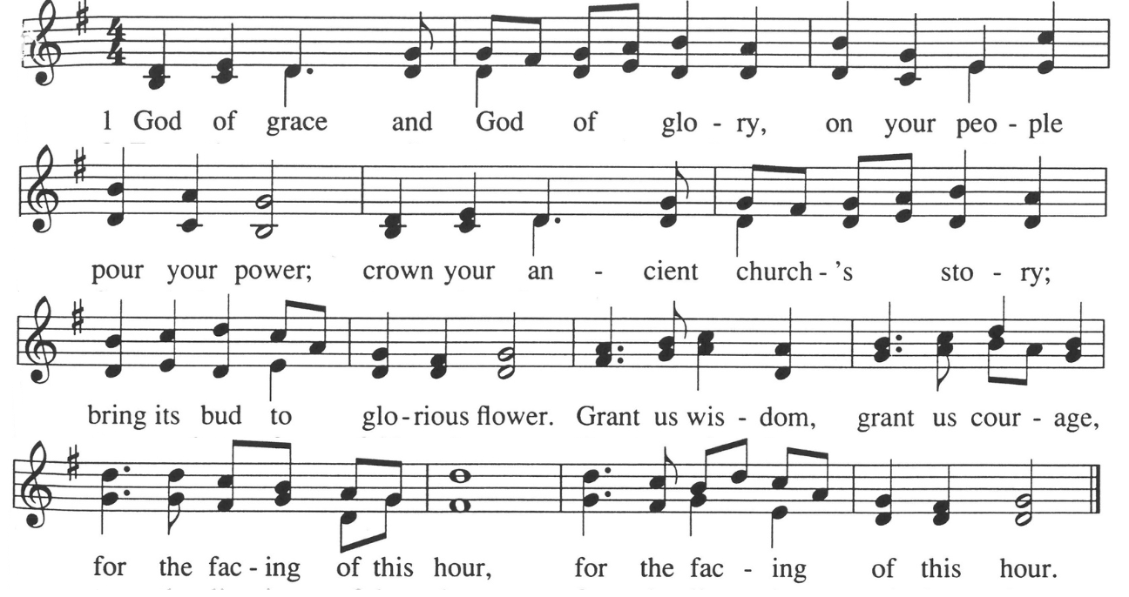

*Prayer of Dedication
Holy One, thank you for the privilege of giving. Bless these gifts and those who give. Enable us to trust and participate in your abundance. Extend wisdom and discernment as we allocate these offerings. Expand our reach and impact for your kindom and glory. Amen.


Community Prayers
…O God, hear our prayers
Submit prayer requests electronically by scanning the QR code:

Prayer of Jesus – Traditional
Our Father who art in heaven, hallowed be thy name. Thy kingdom come.
Thy will be done, on earth as it is in heaven. Give us this day our daily bread, and forgive us our trespasses, as we forgive those who trespass against us, and lead us not into temptation,but deliver us from evil.
For thine is the kingdom and the power, and the glory, forever and ever.
Amen.

*Closing Hymn: Lift Every Voice & Sing, NCH #593

Announcements:
- Do you enjoy cookies and food after worship? Sign up to help provide it or we’ll just have coffee! Email ChurchOffice@ElkRiverUCC.org to get on the list.
- Summer Sermon Series: Scriptures Worth Writing Home About. Pastor Nora is inviting everyone to submit a scripture that has been impactful in their lives with a little bit about why it’s impactful. She plans to uplift as many of these as she can throughout the summer.
- Have an announcement for the bulletin? Email ChurchOffice@ElkRiverUCC.org no later than 10 a.m. on Wednesday, for publication in the Thursday email and next Sunday bulletin. Please limit announcements to 100 words. Thank you!

Benediction

Postlude: How Can I Keep From Singing, by Mark Hayes

Our church calendar is available online at ElkRiverUCC.org, at the bottom of the home page

Union Congregational UCC Worship Staff & Volunteers
Next Church Council Meeting: July 9th
Upcoming Hospitality: June 28th | Open & July 5th | The Diaconate
General Questions?
Email the Office at ChurchOffice@ElkRiverUCC.org

Mailing Address
1118 4th St. NW
Elk River, MN 55330

Web Address
www.ElkRiverUCC.org

Office Hours:
Tues. & Thurs. 9:30 AM - 3:30 PM
Wed 9:30 AM - 3:30 PM

Pastor: Rev. Nora P. Elliott
763-276-7204; RevNora@ElkRiverUCC.org

Director of Music: Carson Schneider
Music-Director@ElkRiverUCC.org

Church Office:
763-441-1203; ChurchOffice@ElkRiverUCC.org

Accompanist: Carson Schneider
Audio/Video: Mike Richmond
Deacon: Lisa Cawthra
Hospitality: Christina Schmitt
Sunday School: Amanda Hooper
Ushers and Greeters: Dave and Judy Halgren
