


May 17th, 2026 Seventh Sunday of Easter | Youth Sunday
Union Congregational Church seeks to create a celebrating covenanting, affirming, and justice seeking faith community that inspires people to unite and create a peaceful, loving world.

- We welcome LGBTQ+ people into the full life of the church, as an Open & Affirming Congregation, of the United Church of Christ.

- Listening devices are available at the rear of the Sanctuary, for enhanced audio accessibility during the service. Ushers are able to assist.

- For kids: The Pray-ground is in the Vestry (by the chancel ramp). You’ll find a table with activity bags for children to use during the service. Kids are welcome at the table or with their parents in worship. All ages are welcome in Sunday School, but we ask a parent/guardian to accompany children under 6.

- Stay connected: Missed a sermon or want to share it digitally? Listen to our Sunday sermons on our Podcast, CommUnion, at www.ElkRiverUCC.org/watch. You’ll also find our live stream and an online bulletin if you are unable to attend in person.

- In scripture, you may see the letters YHWH - the sacred, unpronounced name of God. To honor the mystery of the Divine and as witness to our expansive faith, we invite our liturgists to substitute the title or aspect of God they find most meaningful, such as Holy One, Mother, Lord, Creator, or Spirit. We invite you to listen for these diverse expressions of the Divine as we worship together.

* Indicates to rise Bold text indicates to speak
Order of Worship
Prelude:

Welcome: Ingrid Ludquist

May peace be with you
And also with you.

Gathering Prayer
God of all ages, your children have come together to celebrate and honor the movement of your spirit in the lives of young people. Open our hearts to receive their wisdom, knowing that the Kin-dom of Heaven is such as these. Amen.

Offering Peace
Please greet each other with "May peace be with you."

*Opening Hymn: Abide with Me, NCH #63
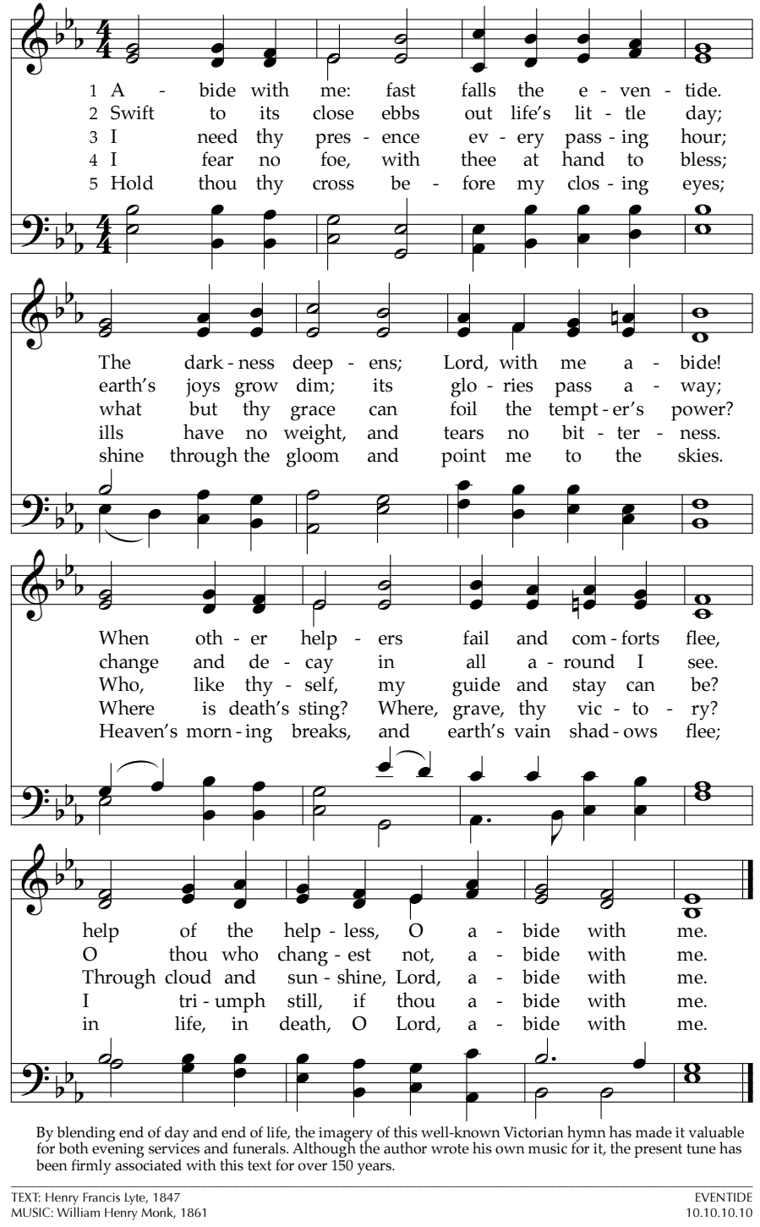

Call to Worship: Ava Slupe
One: We are surrounded by wickedness and temptation
Many: Yet, many of us remember when life was simpler, can’t we go back?
One: There is no going back, only continuing on into the unknown.
Many: How are we to know what to do? Aren’t we supposed to have it all together and be in control?
One: Hear this good news: only God knows where we are going and we will not be going there alone.
Many: Help us to find rest and comfort when we do not know what’s going to happen next.
One: May the spirit of God move through us and guide us to green pastures.
Many: Thanks be to God. Amen.

Scripture: Finley Hooper; First Egalitarian Translation
Psalm 23
YHWH, you are my shepherd – I want nothing more. You let me lie down in green meadows; you lead me beside restful waters: you refresh my soul. You guide me to lush pastures for the sake of your Name. Even if I’m surrounded by shadows of Death, I fear no danger, for you are with me. Your rod and your staff – they give me courage. You spread a table for me in the presence of my enemies, and you anoint my head with oil – my cup overflows! Only goodness and love will follow me all the days of my life, and I will dwell in your house, YHWH, for days without end.

John 14:27
And Jesus said, “Peace I leave with you; my peace I give you. I do not give to you as the world gives. Do not let your hearts be troubled and do not be afraid.”

Time with Grownups: What do you think it’s like?

Sermon: Walking the Dark Valley, by Sophia Adams

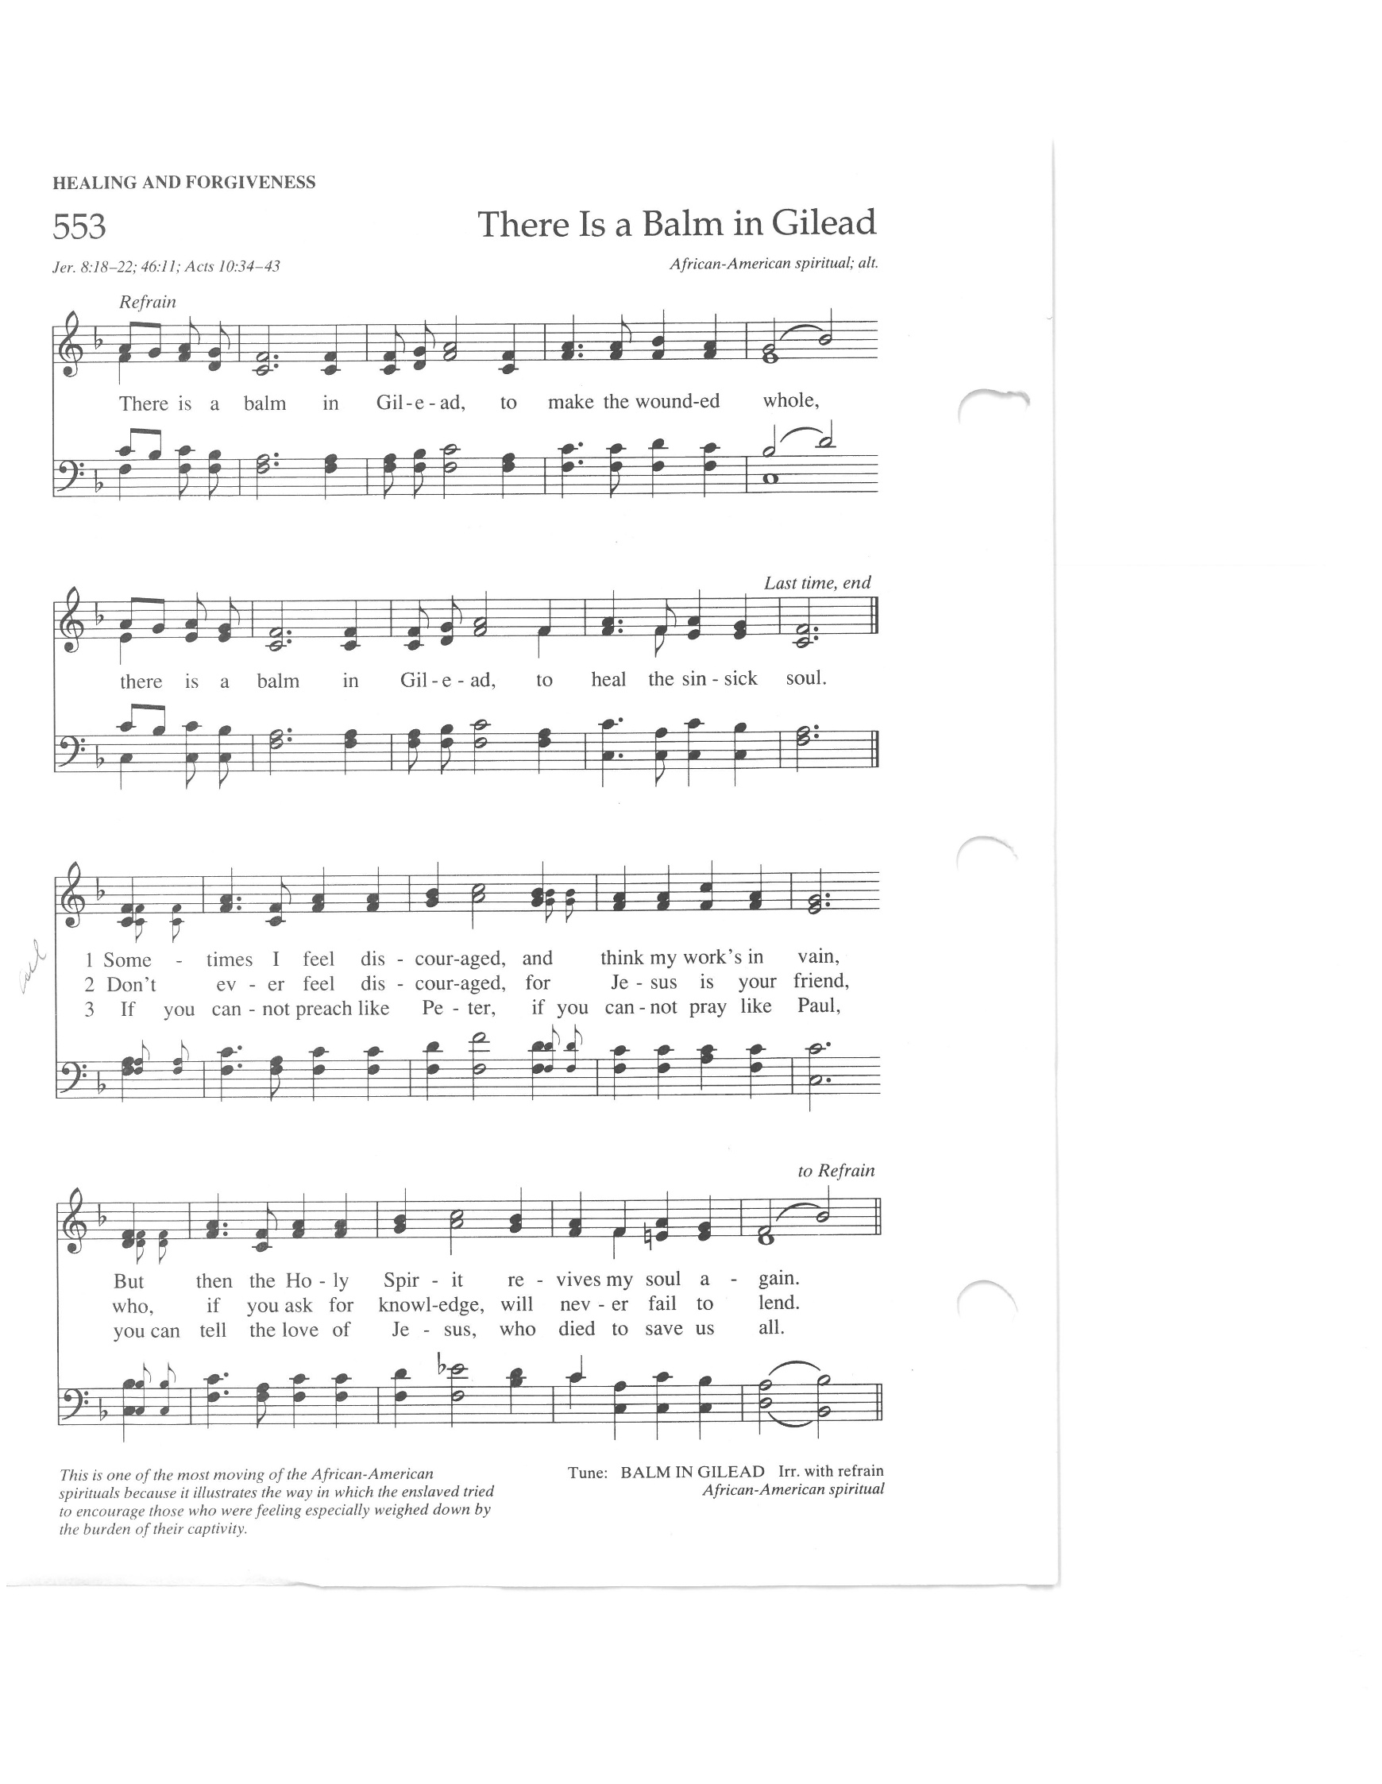
Responsive Hymn: There is a Balm in Gilead, NCH #553


Offertory
Scan QR code with smart phone camera to give electronically.

Special Music:

*Doxology: NCH #780
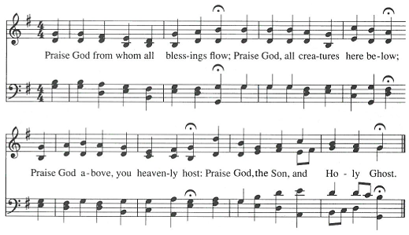
AMEN

AMEN

*Prayer of Dedication
Companion God, bless these gifts of treasure and intention shared today. May it strengthen your church and provide comfort to all people hungry for compassionate community in this new technologically dominant era. Amen.

Prayers of the Community
…O God, hear our prayer

Prayer of Jesus – Youth Prayer, 2023
Our loving God, who surrounds us always and inspires authentic care, bring us together in holy community through the way of love from pain to peace. Provide nourishment for the hungry. Help us find strength when we fail, as we uplift others in need of support. Refocus us when we go astray and fill our world with justice, because we all need your hope and joy and continued love. Amen.

*Closing Hymn: Come, O Fount of Every Blessing NCH #459
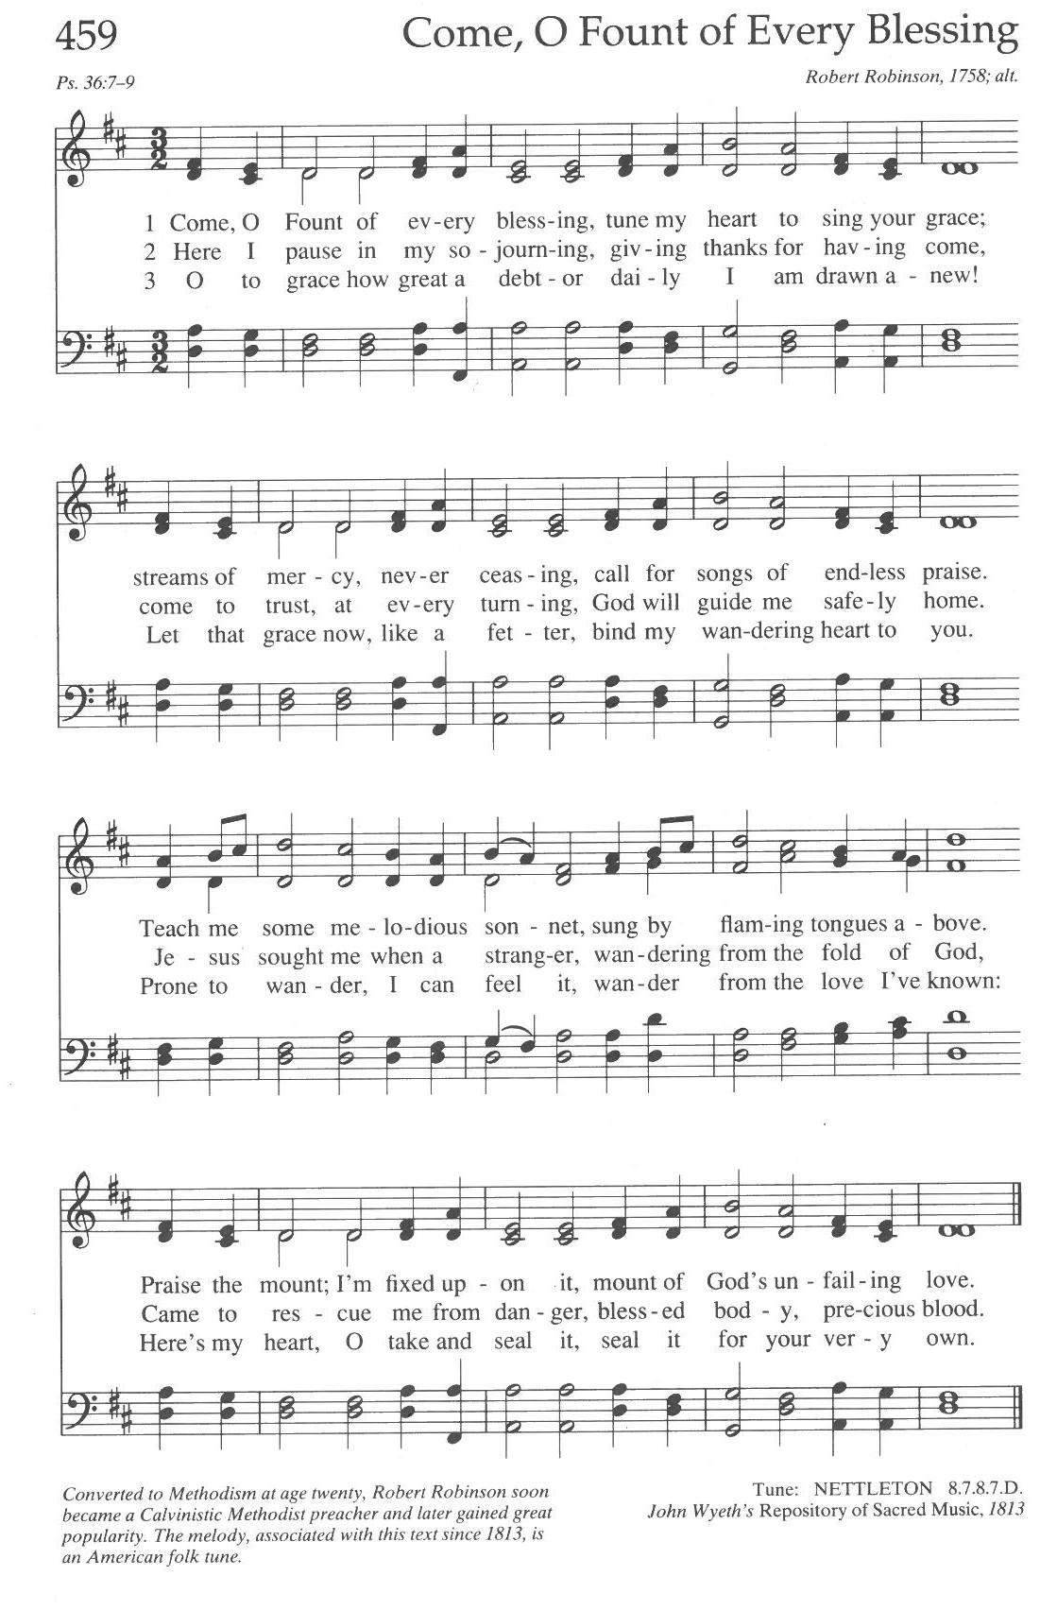

Announcements:
- Church Grounds Clean-up has been rescheduled to May 31st, due to weather
- In August, Paula Benfer will be teaching two summer camps for ISD728 at the Handke Community Ed. Center. She is teaching paper mache sculpture and is requesting old newspapers. Please place any old newspapers or magazines in the box provided in the front entry (near the plastic bag recycling boxes). She thanks everyone for your help and will pick them up regularly to keep the area tidy.
- Please let the office know if you would like to keep your historic name tag, all other name tags will be updated to the new design this summer.
- Pentecost is NEXT SUNDAY, May 24, and everyone is invited to wear RED
- Have an announcement for the bulletin? Email ChurchOffice@ElkRiverUCC.org no later than 10 a.m. on Wednesday, for publication in the Thursday email and next Sunday bulletin. Please limit announcements to 100 words. Thank you!

Benediction

Postlude:

Mark Your Calendars: Please contact Pastor Nora for more information

- May 24 – Pentecost Sunday All are invited to wear RED as we remember and celebrate the Holy Spirit of God descending onto the apostles and into our world

- June 7 — Honoring Our Graduates We celebrate graduates of all ages in worship. We will present Bibles to all 5th graders, as well as to any older youth who never received one. Please let Pastor Nora know if you have a K, 5th, 8th, or 12th grad.

- June 7 — Annual Congregational Meeting Following worship, we hold our annual congregational meeting for the commissioning of new volunteer ministry terms. If you would like to nominate someone (or yourself) please email the office. Ministry team openings and descriptions are posted on the bulletin board just outside the Fellowship Hall.

- June 7 — All Boards Meeting Following the Congregational Meeting, those who are serving a new or continuing term on a ministry team are strongly encouraged to stick around to connect with their ministry team, the Council, and Pastor.

- Summer Sermon Series: Scriptures Worth Writing Home About. Pastor Nora is inviting everyone to submit a scripture that has been impactful in their lives with a little bit about why it’s impactful. She plans to uplift as many of these as she can throughout the summer.

Our church calendar is always available online at ElkRiverUCC.org
at the bottom of the home page.

Other Opportunities for Service to the Church
- Faith Formation: Looking for another member to help plan programs and activities that support the development of our youngest and their families.
- Financial Secretary: Ensures offerings are deposited in our bank account and works with the Pastor and Trustees during stewardship time.
- Trustees: Looking for one more at-large member to steward our physical resources
- Historian: Preserve and celebrate the historical archives of the church
Union Congregational UCC Worship Staff
Next Church Council Meeting: May 14th
Upcoming Hospitality: May 24th | The Centennial Society & May 24th | Trustees
General Questions?
Email the Office at ChurchOffice@ElkRiverUCC.org

Mailing Address
1118 4th St. NW
Elk River, MN 55330

Web Address
www.ElkRiverUCC.org

Office Hours:
Tues. & Thurs. 9:30 AM - 3:30 PM
Wed 9:30 AM - 12:30 PM

Pastor: Rev. Nora P. Elliott
763-276-7204; RevNora@ElkRiverUCC.org

Director of Music: Carson Schneider
Music-Director@ElkRiverUCC.org

Church Office
763-441-1203; ChurchOffice@ElkRiverUCC.org

Accompanist: Carson Schneider
Audio/Video: Hunter Hooper
Deacon: Joyce Hodge
Hospitality: Laurie Lang
Sunday School: Laura Elliott
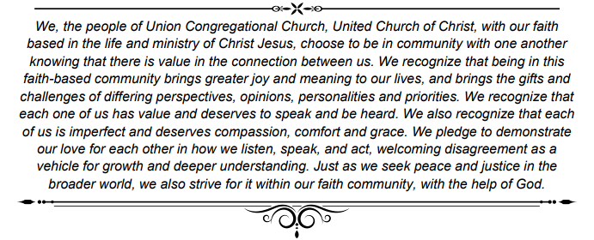
Ushers and Greeters: Frater Family

