


April 5th, 2026 Easter
Union Congregational Church seeks to create a celebrating covenanting, affirming, and justice seeking faith community that inspires people to unite and create a peaceful, loving world.

- We welcome LGBTQ+ people into the full life of the church, as an Open & Affirming Congregation, of the United Church of Christ.

- Listening devices are available at the rear of the Sanctuary, for enhanced audio accessibility during the service. Ushers are able to assist.

- For kids: The Pray-ground is in the Vestry (off the sanctuary). You’ll find a table with activity bags for children to use during the service. Kids are welcome at the table or with their parents in worship. All ages are welcome in Sunday School, but we ask a parent/guardian to accompany any children under 6.

- Stay connected: Missed a sermon or want to share it digitally? Listen to our Sunday sermons on our Podcast, CommUnion, at www.ElkRiverUCC.org/watch. You’ll also find our live stream and an online bulletin if you are unable to attend in person.

- In scripture, you may see the letters YHWH - the sacred, unpronounced name of God. To honor the mystery of the Divine and as witness to our expansive faith, we invite our liturgists to substitute the title or aspect of God they find most meaningful, such as Holy One, Mother, Lord, Creator, or Spirit. We invite you to listen for these diverse expressions of the Divine as we worship together.

* Indicates to rise Bold text indicates to speak
Order of Worship
Prelude: Christ Is Risen, Shout Hosanna by Mark Hayes

Welcome: Rev. Nora P. Elliott

May peace be with you
And also with you.

Gathering Prayer
God of life and resurrection, help us have faith in you and the eternal blessings of your grace. Amen

Offering Peace
Please greet each other with "May peace be with you."

*Opening Hymn: Christ the Lord is Risen Today NCH #233, v1,3,1
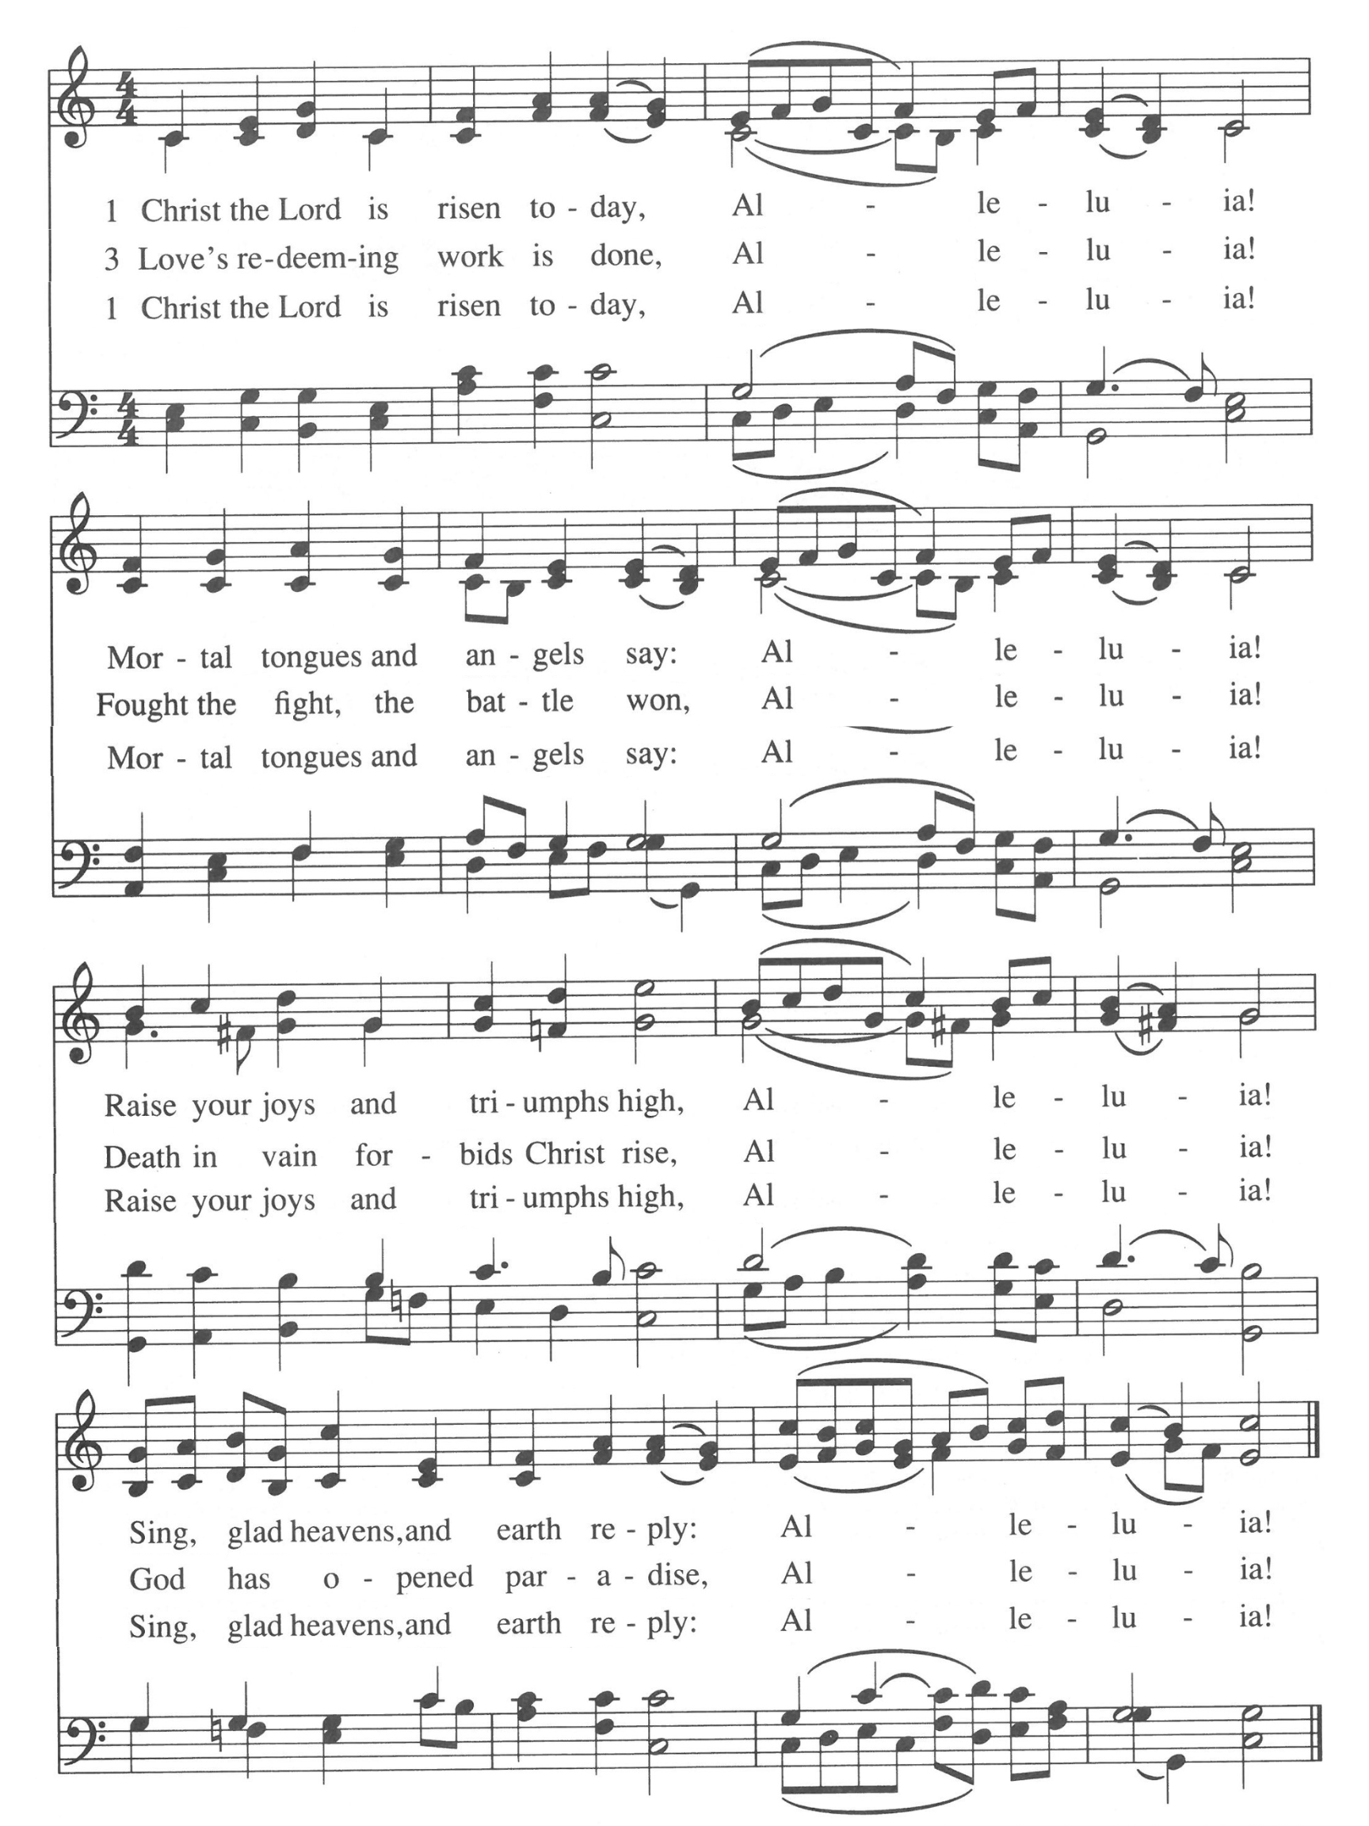

Call to Worship -
One: Christ is risen!
Many: He is risen indeed!
One: The worst the empire could throw at him was not enough.
Many: Yet we confess sometimes it is hard to have faith in resurrection.
One: Even the women at the tomb and the apostles on the road doubted. Hear these words and know, even if we doubt we are still beloved and worthy of the blessings of God.
Many: Thanks be to God.
One: Christ is risen!
Many: He is risen indeed! Alleluia!

Scripture
Joel 2:28-29
After that, I will pour out my Spirit on all humankind. Your daughters and sons will prophesy, your elders will have prophetic dreams, and your young people will see visions. In those days, I will pour out my Spirit even on those in servitude, women and men alike.

Mark 16: 9-16
Jesus rose from the dead early on the first day of the week, appearing first to Mary of Magdala, out of whom the savior had cast seven devils. She went and reported it to Jesus’ companions, who were grieving and weeping. But when they heard that Jesus was alive and had been seen by her, they refused to believe it. Later on, as two of them were walking along on their way to the country, Jesus appeared to them in a different form. These two went back and told the others, who did not believe them either. Finally, the risen Christ appeared to the Eleven themselves while they were eating at the table, and scolded them for their disbelief and their stubbornness, since they had put no faith in those who had seen Jesus after the resurrection. Then Jesus told them “Go into the whole world and proclaim the Good News to all creation. The one who believes it and is baptized will be saved; the one who refuses to believe it will be condemned.”

Time with Children: Is resurrection real?

Sermon: Kingdom Come; We Are the Evidence

Choir Anthem: Jesus Is Risen by Joseph Martin

Offertory:

Scan QR code with smart phone camera to give electronically.

Special Music: Praise! By Mark Hayes

*Doxology: Praise God from Whom All Blessings Flow
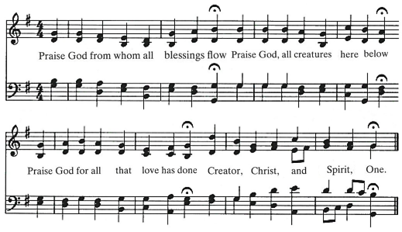
AMEN

*Prayer of Dedication
God of resurrection, may these gives of time and talent offered here today raise up your spirit in this place. Gratefully given, inspired by the way of Christ. Amen.

Communion
(Our Communion table is open to everyone of every age and spirituality)

Invitation


Consecrating of the Elements

Pastoral Prayers – Scan QR code to send your prayers to the office.

Prayer of Jesus – Revised Lord’s Prayer
Our Loving God, who art in heaven, hallowed be thy name. Thy kin-dom come, thy will be done on earth as it is in heaven. Give us this day our daily bread, and forgive us our debts as we forgive our debtors. Save us from temptation, and deliver us from evil. For thine is the kin-dom, and the power, and the glory forever. Amen.

*Closing Hymn: Come, O Fount of Every Blessing NCH #459
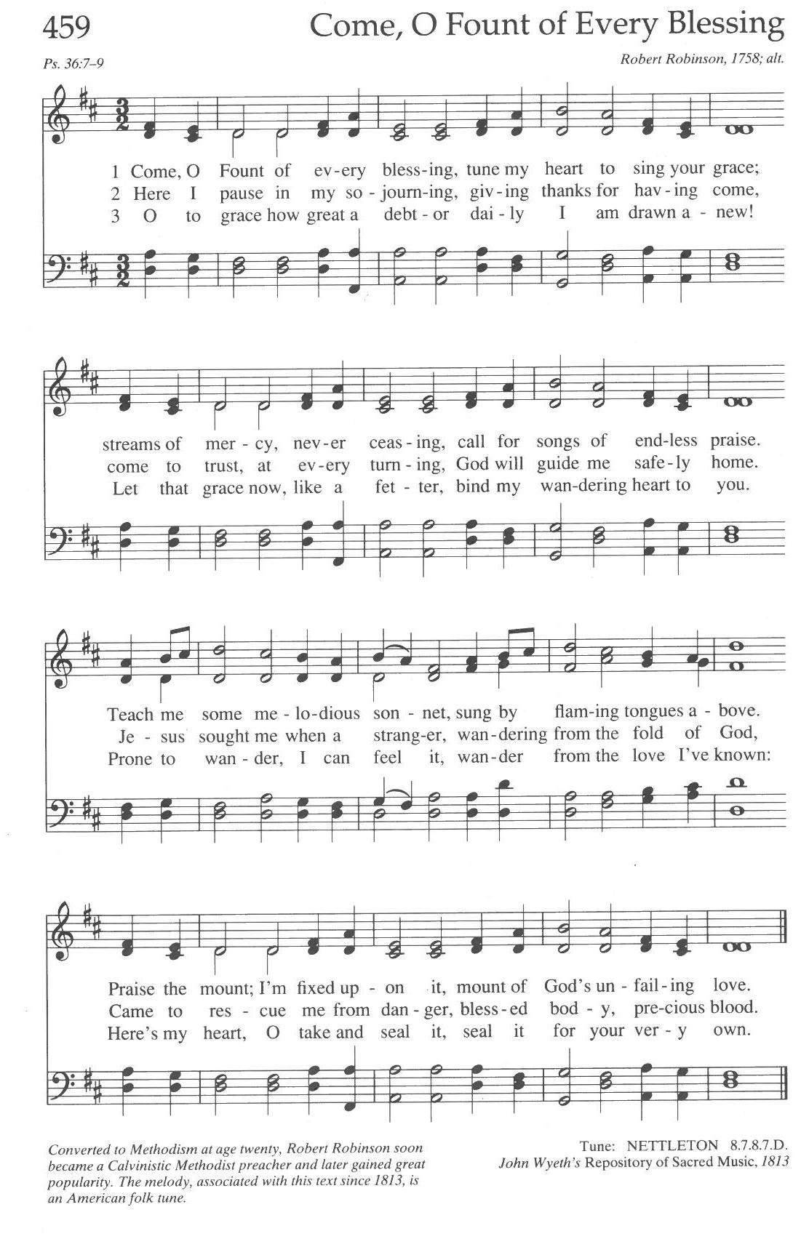

Announcements:
- Wed, April 8, Union UCC is signed up to support the CAER Food Shelf. For more information on how to support this ministry, please contact Rylie Priolo or Pastor Nora.

- In celebration of 150 years, The Centennial Society cordially invites all to their annual Spring Potluck Luncheon on Wednesday, April 8 at 11:30 A.M. And be sure to mark your calendars for the SESQUICENTENNIAL CELEBRATION on May 3, 2026!

- Next week, April 12, New Members Class after worship, no obligation, all welcome to learn about UCC history and local governance.

- Next week, April 12, join the Pastoral Relations Committee for a Listening Circle to discern a communal vision for the future of Union UCC. All are welcome.

- Chancel Access Ramp Update: After public forums and Council discernment, construction process will begin after worship April 12, concluding Sat. April 18. All able to help Faith Formation move furniture out of the Pray-ground after worship, are welcome. Find Ruth Johnson or Laura Elliott for more info.

Benediction:

Postlude: Halleluiah Chorus by Handel

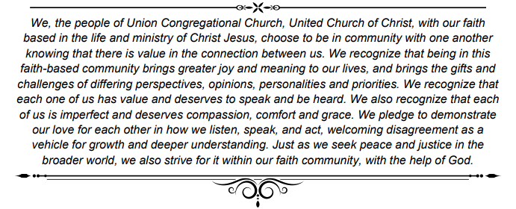



Mark Your Calendars: Please contact Pastor Nora for more information

- April 19 — Dedication of Chancel Ramp Disability justice minister, Rev. Laura Cannata will be preaching at this special service where we will dedicate our new access ramp to the chancel

- April 26 — Orono Park Cleanup Gathering at a nearby park after worship to keep our local community clean and enjoy some spring fellowship outdoors; all ages welcome!

- May 3 — The Centennial Society's 150th Anniversary A service dedicated to the impact of women and their historical service to the church, even through times when they were not allowed formal inclusion.

- May 17 — Youth Sunday All youth and children are warmly welcomed and encouraged to be part of the planning and leadership of this special service. Following worship, we will host our annual Spring Cleanup of our grounds.

- June 7 — Honoring Our Graduates We celebrate graduates of all ages in worship. We will present Bibles to all 5th graders, as well as to any older youth who never received one.

- June 7 — Annual Congregational Meeting Following worship, we hold our annual congregational meeting for the commissioning of new volunteer ministry terms. If you would like to nominate someone (or yourself) please reach out or note it on the survey. Ministry team openings and descriptions are posted on the bulletin board just outside the Fellowship Hall.

- June 7 — All Boards Meeting Following the Congregational Meeting, those who are serving a new or continuing term on a ministry team are strongly encouraged to stick around to connect with their ministry team, the Council, and Pastor.

Our church calendar is always available online at ElkRiverUCC.org
at the bottom of the home page.

Union Congregational UCC Worship Staff
Next Council Meeting is April 9th
Upcoming Hospitality: Apr. 12th | OPEN Apr. 19th | OPEN
General Questions?
Email April at churchoffice@elkriverucc.org

Mailing Address
1118 4th St. NW
Elk River, MN 55330

Web Address
www.ElkRiverUCC.org

Office Hours:
Mon. & Thurs. 9:30 AM-3:30 PM

Pastor: Rev. Nora P. Elliott
763-276-7204; revnora@elkriverucc.org
Office Administrator: April Sundstrom
763-441-1203; churchoffice@elkriverucc.org
Director of Music: Carson Schneider
music-director@elkriverucc.org

Hospitality: Congregational Life
Deacon: Lisa Cawthra
Accompanist: Carson Schneider
Audio/Video: Marce Ediger & Keith Stevens
Usher/Greeter(s): Su Arnold and Janine
Sunday School: Ruth Johnson

