


April 26th, 2026 Fourth Sunday of Easter
Union Congregational Church seeks to create a celebrating covenanting, affirming, and justice seeking faith community that inspires people to unite and create a peaceful, loving world.

- We welcome LGBTQ+ people into the full life of the church, as an Open & Affirming Congregation, of the United Church of Christ.

- Listening devices are available at the rear of the Sanctuary, for enhanced audio accessibility during the service. Ushers are able to assist.

- For kids: The Pray-ground is in the Vestry (off the sanctuary). You’ll find a table with activity bags for children to use during the service. Kids are welcome at the table or with their parents in worship. All ages are welcome in Sunday School, but we ask a parent/guardian to accompany any children under 6.

- Stay connected: Missed a sermon or want to share it digitally? Listen to our Sunday sermons on our Podcast, CommUnion, at www.ElkRiverUCC.org/watch. You’ll also find our live stream and an online bulletin if you are unable to attend in person.

- In scripture, you may see the letters YHWH - the sacred, unpronounced name of God. To honor the mystery of the Divine and as witness to our expansive faith, we invite our liturgists to substitute the title or aspect of God they find most meaningful, such as Holy One, Mother, Lord, Creator, or Spirit. We invite you to listen for these diverse expressions of the Divine as we worship together.

* Indicates to rise Bold text indicates to speak
Order of Worship
Prelude:

Welcome: Rev. Nora P. Elliott

May peace be with you
And also with you.

Gathering Prayer
Creator God, remind us of Octavia Butler’s words, “The world is full of painful stories. Sometimes it seems as though there aren’t any other kind, and yet I found myself thinking how beautiful that glint of water was through the trees.” Amen.

Offering Peace
Please greet each other with "May peace be with you."

*Opening Hymn: All Things Bright and Beautiful NCH #31
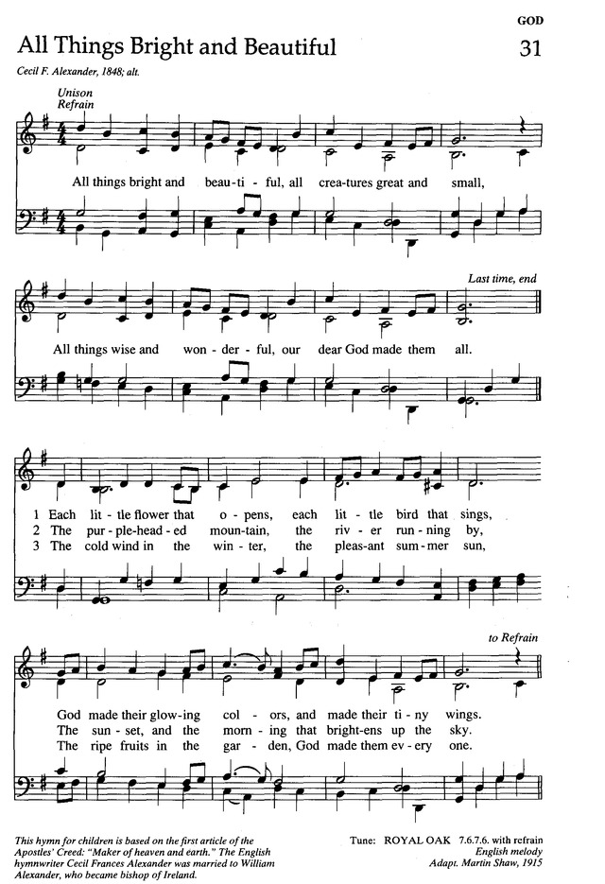

Call to Worship
One: | God is raising up people, even today, to bring us through this dark time.
Many: | Life-giving God, we offer ourselves in service to you, supported by a great cloud of witnesses who urge us on.
One: | We are connected to other people of faith and conscience around the world who are working for a peaceful, just, and sustainable world.
Many: | This global community supports us, as we support each other.
One: | We are related to the earth and all its creatures in a web that cannot be broken without injury to all.
Many: | The earth and our fellow creatures support us, as we are their advocates.
One: | We are connected to Jesus Christ, who reveals God to us, sends us the Spirit, and sends us out in his name.
Many: | Though the path is long, we continue in his stead, as we are his disciples. Amen

Scripture
Psalm 23
YHWH, you are my shepherd, I want nothing more. You let me lie down in green meadows; you lead me beside restful waters: you refresh my soul. You guide me to lush pastures for the sake of your Name. Even if I’m surrounded by shadows of Death, I fear no danger, for you are with me. Your rod and your staff they comfort me. You spread a table for me in the presence of my enemies, and you anoint my head with oil; my cup overflows! Only goodness and love will follow me all the days of my life, and I will dwell in your house, YHWH, for days without end.

Acts 2:42-47
They devoted themselves to the apostles’ teaching and to fellowship, to the breaking of bread and to prayer. Everyone was filled with awe at the many wonders and signs performed by the apostles. All the believers were together and had everything in common. They sold property and possessions to give to anyone who had need. Every day they continued to meet together in the temple courts. They broke bread in their homes and ate together with glad and sincere hearts, praising God and enjoying the favor of all the people. And the Lord added to their number daily those who were being saved.

Time with Children: Where’s your favorite place outside?

Sermon: Is Salvation Complicated?

Responsive Hymn: God of the Sparrow God of the Whale NCH #32
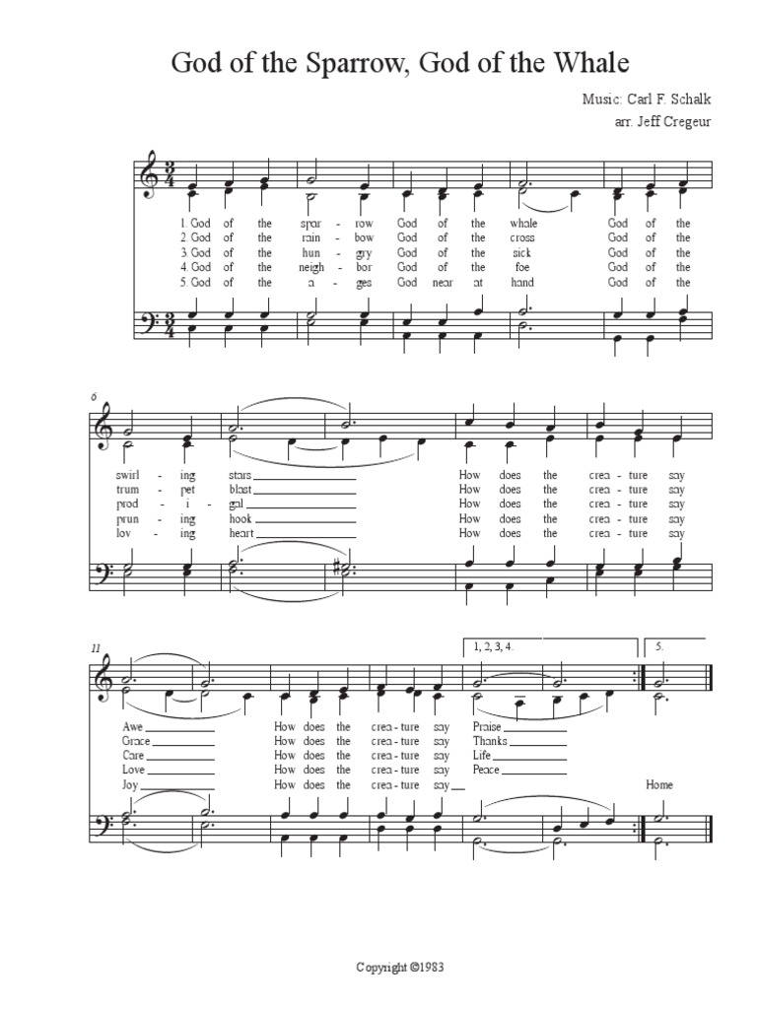

Moment for Mission: Neighbors in Need


Offertory
Scan QR code with smart phone camera to give electronically.

Special Music:

*Doxology: NCH #780
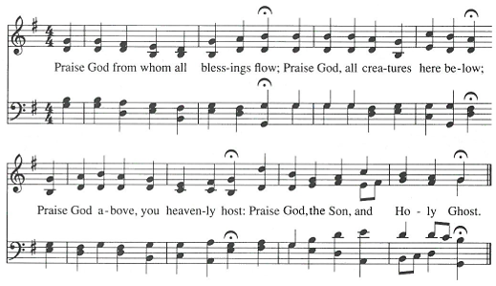
AMEN
*Prayer of Dedication
Generous God, you have blessed us with the resources to share the good news of your love for all creation. We dedicate these gifts and pray that they may bring healing, wholeness, and hope to the world, that future generations may also know your graciousness and love. Amen.

Community Prayers
Pastor Nora will offer a blessing for each prayer raised and then invite the congregation to pray together, "Oh God, hear our prayer.

Prayer of Jesus: Casa del Sol, by John Philip Newell
Ground of all being, Mother of life, Father of the universe, Your name is sacred, beyond speaking. May we know your presence, may your longings be our longings in heart and in action. Today, may there be food for the human family and for the whole earth community. Forgive us the falseness of what we have done as we forgive those who are untrue to us. Do not forsake us in our time of conflict, but lead us into new beginnings. For the light of life, the vitality of life, and the glory of life are yours now and forever. Amen.

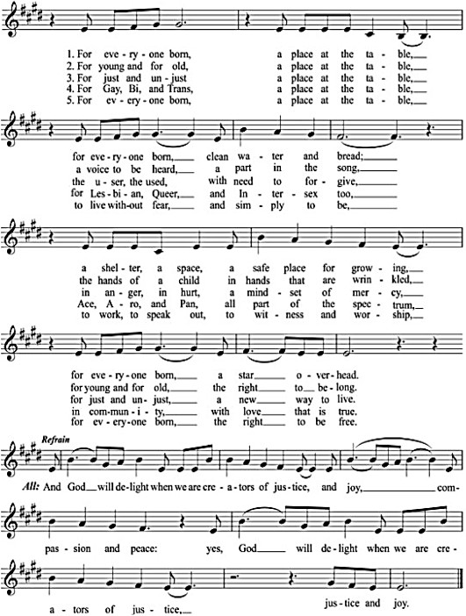
*Closing Hymn: For Everyone Born GtG #769

Announcements
- Join us at Orono Park after worship to help keep our local community clean and enjoy some spring fellowship outdoors; all ages welcome!

Benediction

Postlude:

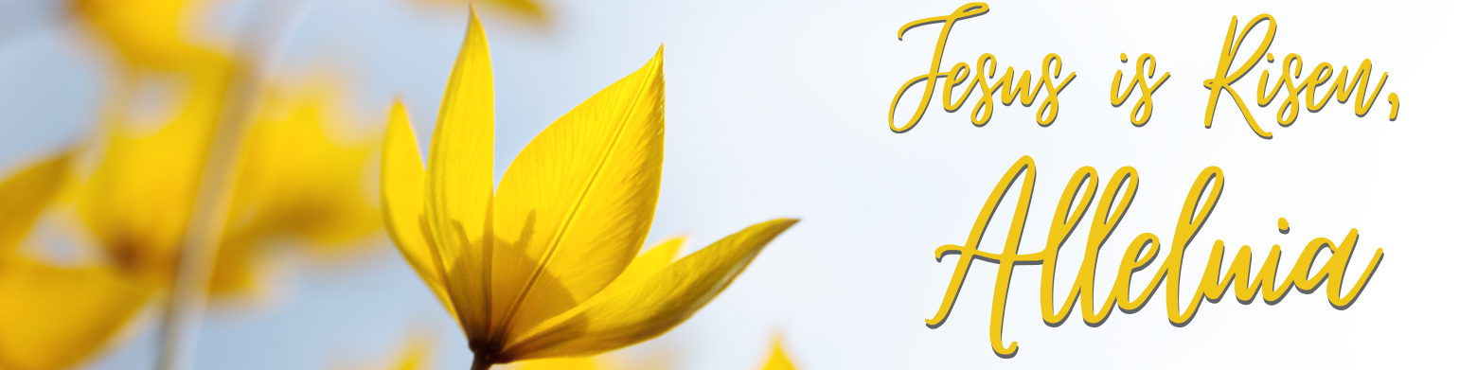

Mark Your Calendars: Please contact Pastor Nora for more information

- May 3 — The Centennial Society's 150th Anniversary A service dedicated to the impact of women and their historical service to the church, even through times when they were not allowed formal inclusion.

- May 17 — Youth Sunday All youth and children are warmly welcomed and encouraged to be part of the planning and leadership of this special service. Following worship, we will host our annual Spring Cleanup of our grounds.
- June 7 — Honoring Our Graduates We celebrate graduates of all ages in worship. We will present Bibles to all 5th graders, as well as to any older youth who never received one.
- June 7 — Annual Congregational Meeting Following worship, we hold our annual congregational meeting for the commissioning of new volunteer ministry terms. If you would like to nominate someone (or yourself) please reach out or note it on the survey. Ministry team openings and descriptions are posted on the bulletin board just outside the Fellowship Hall.
- June 7 — All Boards Meeting Following the Congregational Meeting, those who are serving a new or continuing term on a ministry team are strongly encouraged to stick around to connect with their ministry team, the Council, and Pastor.

Our church calendar is always available online at ElkRiverUCC.org
at the bottom of the home page.

Union Congregational UCC Worship Staff
Next Council Meeting is May 11th
Upcoming Hospitality: May 3rd | Cong Life May 10th | Diaconate
General Questions?
Email the Office at ChurchOffice@ElkRiverUCC.org

Mailing Address
1118 4th St. NW
Elk River, MN 55330

Web Address
www.ElkRiverUCC.org

Office Hours:
Tues. - Thurs. 9:30 AM-3:30 PM

Pastor: The Rev. Nora P. Elliott
763-276-7204; RevNora@ElkRiverUCC.org

Director of Music: Carson Schneider
Music-Director@ElkRiverUCC.org

Church Office
763-441-1203; ChurchOffice@ElkRiverUCC.org

Accompanist: Carson Schneider
Audio/Video:
Deacon: Kelly Lundquist
Hospitality: Congregational Life
Sunday School: Ruth Johnson
Usher/Greeter(s): Dave & Judy Halgren

