
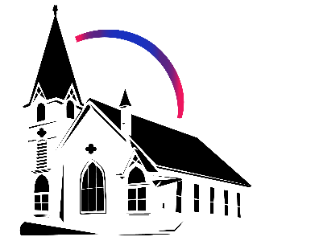

March 15th, 2026 Lent IV
Union Congregational Church seeks to create a celebrating covenanting, affirming, and justice seeking faith community that inspires people to unite and create a peaceful, loving world.

- We welcome LGBTQ+ people into the full life of the church, as an Open & Affirming Congregation, of the United Church of Christ.

- Listening devices are available at the rear of the Sanctuary, for enhanced audio accessibility during the service. Ushers can assist.

- For kids: The Pray-ground is in the Vestry (off the sanctuary). You’ll find a table with activity bags for children to use during the service. Kids are welcome at the table or with their parents in worship. All ages are welcome in Sunday School, but we ask a parent/guardian to accompany any children under 6.

- Stay connected: Missed a sermon or want to share it digitally? Listen to our Sunday sermons on our Podcast, CommUnion, at www.ElkRiverUCC.org/watch. You’ll also find our live stream if you can’t attend in person and an online bulletin to follow along. Hard copies of the sermon are available by the front door.

- In scripture, you may see the letters YHWH - the sacred, unpronounced name of God. To honor the mystery of the Divine and as witness to our expansive faith, we invite our liturgists to substitute the title or aspect of God they find most meaningful, such as Holy One, Mother, Lord, Creator, or Spirit. We invite you to listen for these diverse expressions of the Divine as we worship together.

* Indicates to rise Bold text indicates to speak
Order of Worship
Prelude: Here I Am, Lord by Mark Hayes

Welcome: Rev. Nora P. Elliott
May peace be with you
And also with you.

Gathering Prayer
God of the Broken, thank you for meeting us in our "thorns." Remind us that when we stop pretending to be perfect, your power finally has room to dwell in us. Amen

Offering Peace
Please greet each other with "May peace be with you."

*Choir Anthem: It Is Well by John Ness Beck

Call to Worship -
One: We spend so much energy hiding our mistakes and pretending we don't need anyone else.
Many: We confess that we are afraid to be known for who we really are.
One: We forget that your grace is enough, and that it is made perfect in our limitations.
Many: Forgive us for our pride; help us to be honest about our need for one another.
One: We are forgiven, not for our performance, but for our humanity.
Many: Thanks be to God. Amen

Scripture
Exodus 3:10-14
“Now, Go! I will send you to Pharah, to bring my people, the children of Israel, out of Egypt.” But Moses said to God, “Who am I, that I should go to Pharaoh and lead the children of Israel out of Egypt?” God answered, “I will be with you, and this is the sign by which you will know that it is I who have sent you: after you bring my people out of Egypt, you will all worship at this very mountain.” “But,” Moses said, “when I go to the children of Israel and say to them, ‘The God of your ancestors has sent me to you,’ if they ask me, ‘What is this god’s name?’ what am I to tell them?” God replied, “I AM AS I AM. This is what you will tell the Israelites: ‘I AM has sent me to you.’”

2 Corinthians 12:7a–10
Because of the surpassing greatness of the revelations, in order to keep me from becoming conceited, I was given a thorn in my flesh… Three times I begged God that it might leave me. And God said to me, “My grace is sufficient for you, for power it perfected in weakness.” Most gladly, therefore, I would rather boast about my weaknesses, that the power of Christ may dwell in me. So I am content with weakness, with mistreatment, with distress, with persecutions and difficulties for the sake of Christ; when I am powerless, it is then that I am strong.

Time with Children: How do we learn?

Sermon: The Grace of Imperfection

Responsive Hymn: Come, O Fount of Every Blessing NCH #459
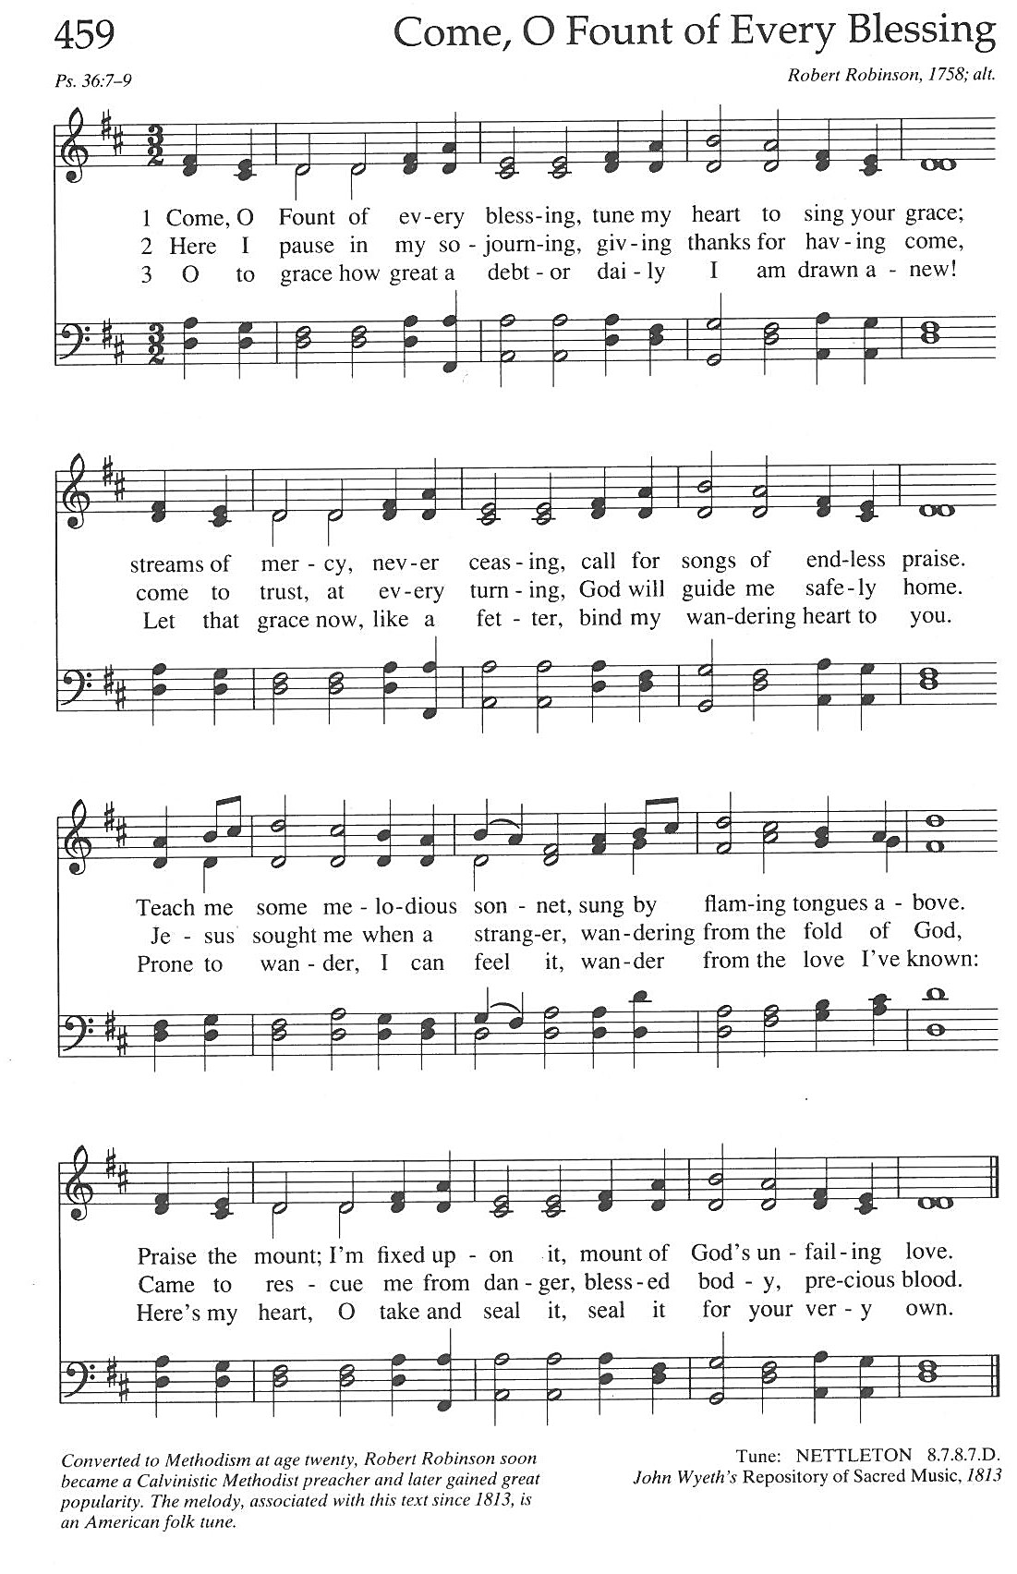

Offertory:

Scan QR code with smart phone camera to give electronically.

Special Music: Reflection by Mark Hayes

*Doxology: Praise God from Whom All Blessings Flow
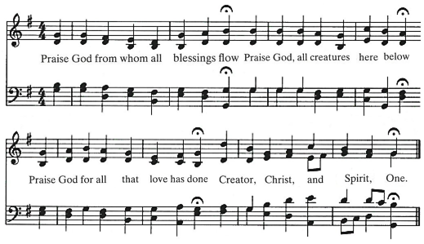
AMEN

*Prayer of Dedication
Gracious God, we offer what we have; not because we are perfect, but because we are yours. May these gifts support a community that values authenticity over performance, and may our collective strength be found in our willingness to support one another in every season. Amen.

Community Prayers:
Pastor Nora will offer a blessing for each prayer raised and then invite the congregation to pray together, "Oh God, hear our prayer.”

Prayer of Jesus – Traditional Inclusive
Our Loving God, who art in heaven, hallowed be thy name. Thy kin-dom come, thy will be done on earth as it is in heaven. Give us this day our daily bread, and forgive us our debts as we forgive our debtors. Save us from temptation, and deliver us from evil. For thine is the kin-dom, and the power, and the glory forever. Amen.

*Closing Hymn: Draw the Circle Wide
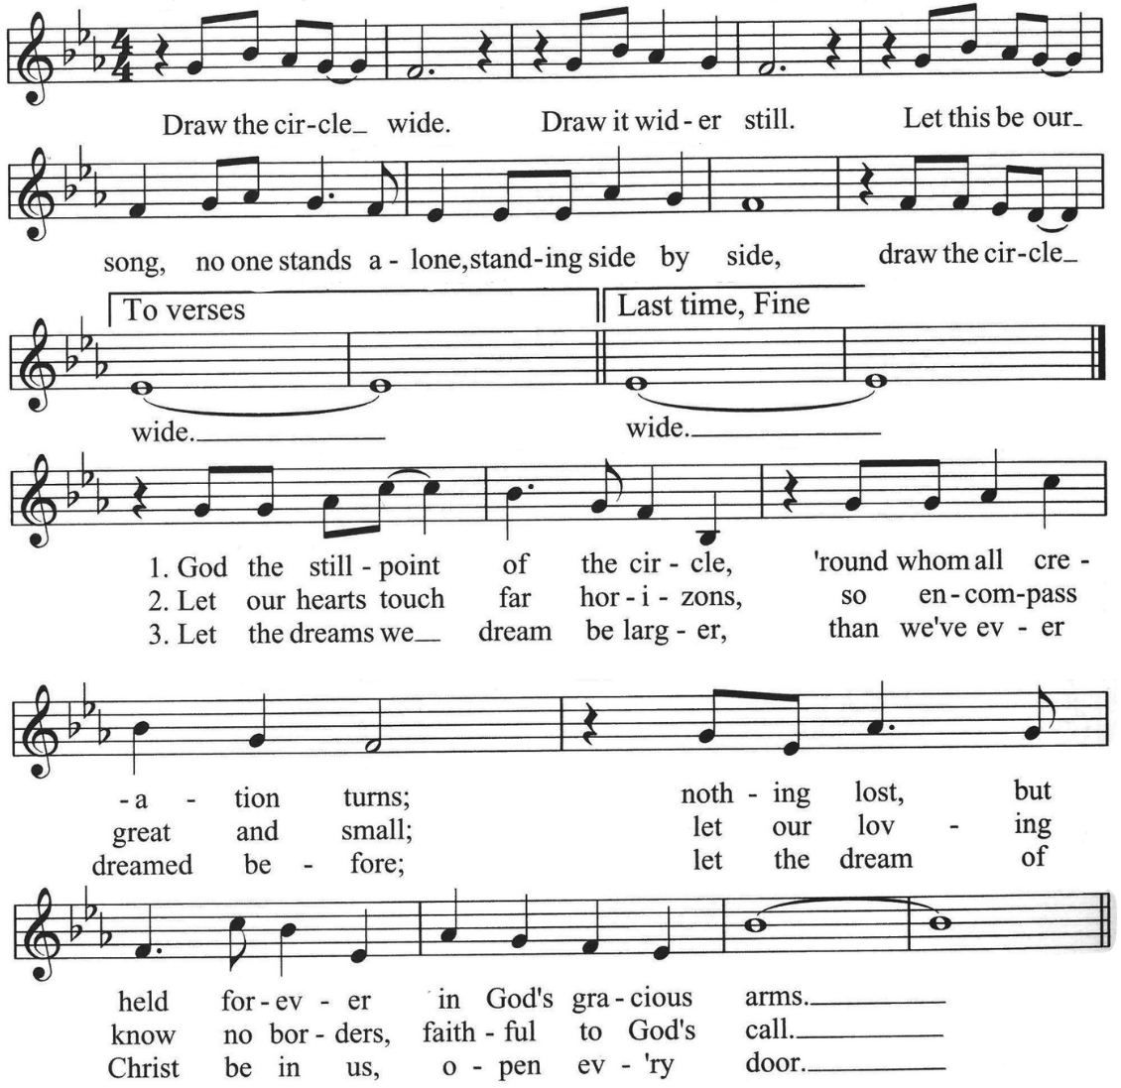

Announcements

- Today is the last day for Easter flower orders. To order flowers to decorate our chancel on Easter, look for order forms in the Narthex.
- Union UCC is rolling out new nametags! You can register for your new one via the ENews on Flocknote, or by filling out a signup sheet in the Narthex.
- If you would like to support out Hospitality Ministry and create a warm welcoming gathering space, you can sign up near the front door, or send your information to April in the office at Churchoffice@elkriverucc.org to get signed up for the Hospitality Volunteer Team. If you have any questions, feel free to contact the office. Thank you!
- More donations came in after our special congregational meeting, bringing our capital campaign total to 65,000 received and more than 75,000 pledged. Putting us 3/4 of the way to our goal! You can see the architect’s rendering in the narthex.

Benediction:

Postlude:

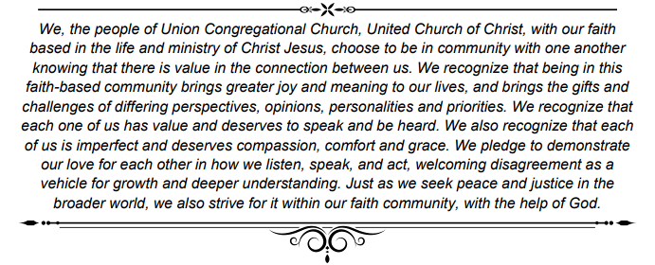

Spring Equinox Meditation Retreat

Awakening the Wild Holy Within Us
March 20-22, 2026, at Camp Onamia

This weekend, during the Spring Equinox, we are balancing the energies of the Divine and the Earth. Spring represents the element of air, which is essential to life. We emerge from the winter cave, breathing in the Divine spirit and releasing the intentions we've nurtured over the winter into the universe. We send these intentions across the land like dandelion seeds carried on a spring breeze.
This weekend is filled with the balanced breath of the Divine and meditation. Through group meditation, Shamanic Breathwork, and drum meditation, each breath nurtures harmony within and without, welcoming us into the season of emergence.
Register Here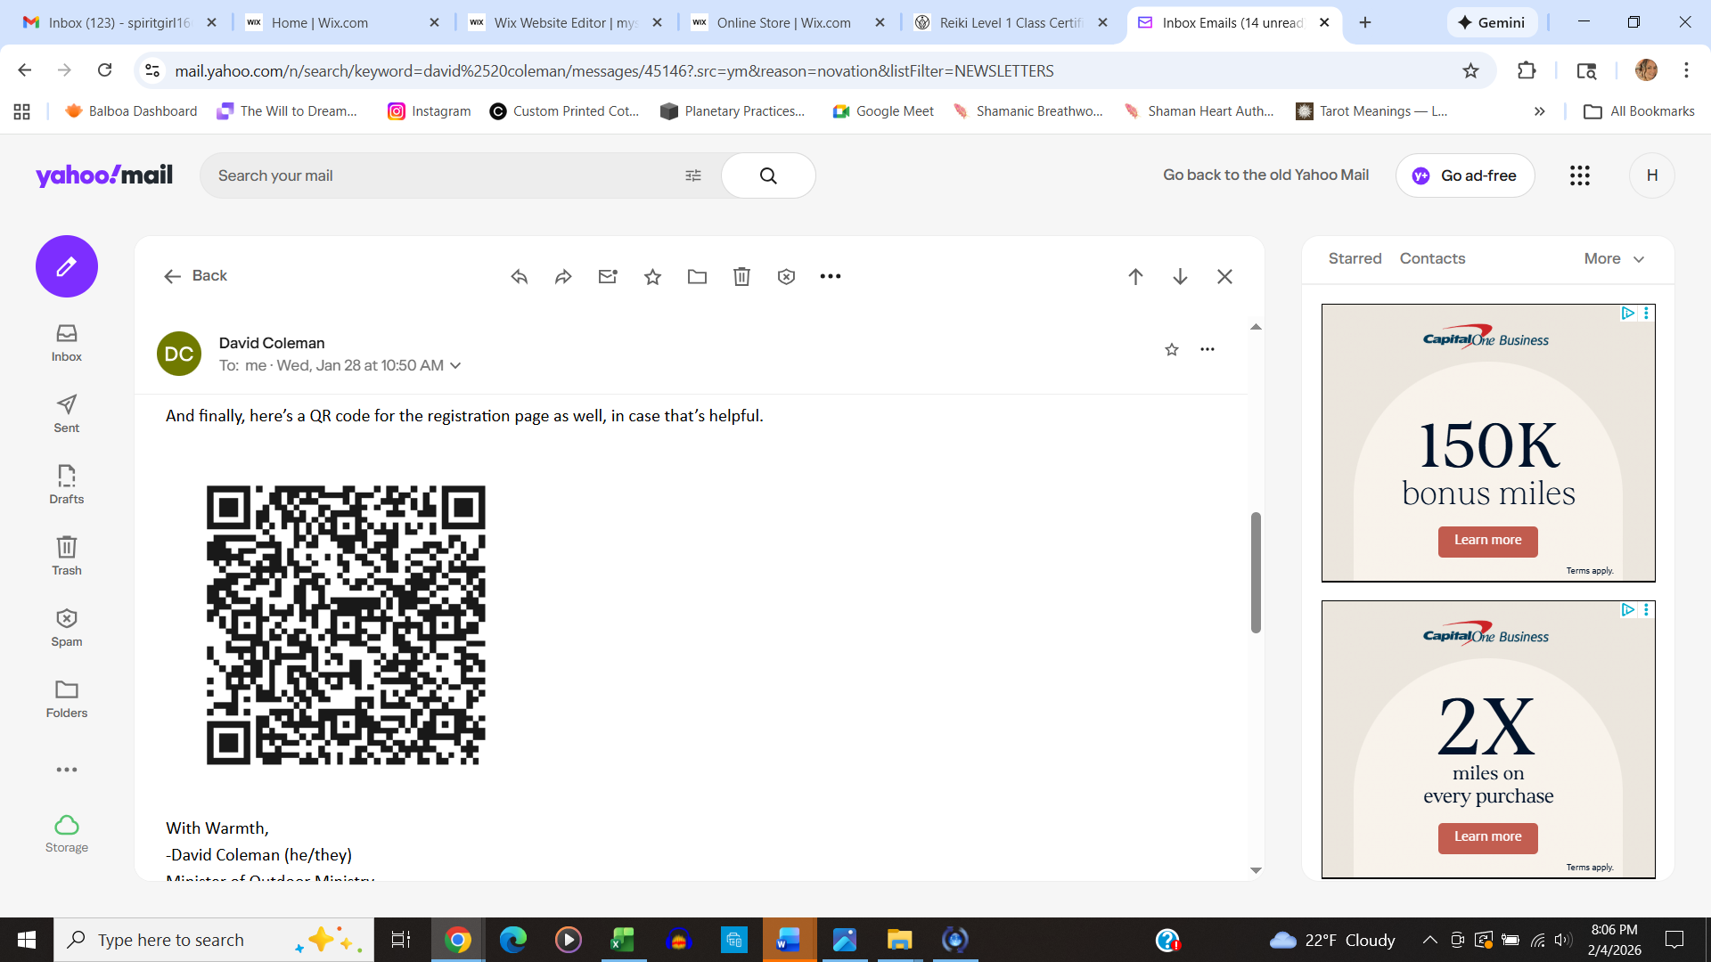
Cost $250 Includes food and lodging.

Weekend Facilitator: Heidi Steffens is the owner of My Spirit Experience, a spiritual center in Minneapolis, MN. She is a Master Reiki Instructor, Author, Ordained Shamanic Minister, and a Shamanic Breathwork Facilitator. She has been the organizer of MPRS – Minnesota Paranormal Research Society since 2008, co-hosts The Gathering Paracast, which is a weekly paranormal show, and also has a YouTube channel called My Spirit Experience.

She holds a Bachelor of Elemental Studies and a Master of Shamanic Intuitional Practices through Venus Rising University. She focuses on helping people navigate their spiritual, healing, and soul-purpose paths in this world, and on working with lost or unwelcome spirits as the lines between planes and dimensions become increasingly intertwined.

Union Congregational UCC Worship Staff
Next Council Meeting is April 9th
Upcoming Hospitality: Mar. 22nd | OPEN Mar. 29th | Paula & Ron Benfer
General Questions?
Email April at churchoffice@elkriverucc.org

Mailing Address
1118 4th St. NW
Elk River, MN 55330

Web Address
www.ElkRiverUCC.org

Office Hours:
By Appointment Only
Sun9:30 AM -11:30 AM

Pastor: Rev. Nora P. Elliott
763-276-7204; revnora@elkriverucc.org
Office Administrator: April Sundstrom
763-441-1203; churchoffice@elkriverucc.org
Director of Music: Carson Schneider
music-director@elkriverucc.org

Hospitality: Choir
Deacon:

Song Leader:
Accompanist: Carson Schneider
Audio/Video: Marce Ediger & Keith Stevens
Usher/Greeter(s): Francis Family
Sunday School: Laura Elliott and Tony Cangello

