
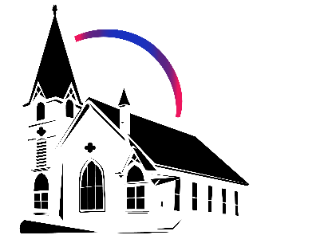

February 22nd, 2026 Lent I
Union Congregational Church seeks to create a celebrating covenanting, affirming, and justice seeking faith community that inspires people to unite and create a peaceful, loving world.

- We welcome LGBTQ+ people into the full life of the church, as an Open & Affirming Congregation, of the United Church of Christ.

- Listening devices are available at the rear of the Sanctuary, for enhanced audio accessibility during the service. Ushers can assist.

- For kids: The Pray-ground is in the Vestry (off the sanctuary). You’ll find a table with activity bags for children to use during the service. Kids are welcome at the table or with their parents in worship. All ages are welcome in Sunday School, but we ask a parent/guardian to accompany any children under 6.

- Stay connected: Missed a sermon or want to share it digitally? Listen to our Sunday sermons on our Podcast, CommUnion, at www.ElkRiverUCC.org/watch. You’ll also find our live stream if you can’t attend in person and an online bulletin to follow along. Hard copies of the sermon are available by the front door.

- In scripture, you may see the letters YHWH - the sacred, unpronounced name of God. To honor the mystery of the Divine and as witness to our expansive faith, we invite our liturgists to substitute the title or aspect of God they find most meaningful, such as Holy One, Mother, Lord, Creator, or Spirit. We invite you to listen for these diverse expressions of the Divine as we worship together.

* Indicates to rise Bold text indicates to speak
Order of Worship
Prelude: Spirit of God Descend Upon My Heart by Heather Sorenson

Welcome: Rev. Nora P. Elliott
May peace be with you
And also with you.

Gathering Prayer
God of the Call, you who do not leave us to wander in our own wisdom. Speak through ancient texts and modern seekers, as we explore the gifts you have woven into this Body. Grant us the humility to learn and the courage to serve. Amen.

Handbell Anthem: Holy, Holy, Holy by John Bacchus Dykes

Offering Peace
Please greet each other with "May peace be with you."

*Opening Hymn: Called at Partners in Christ's Service NCH #495
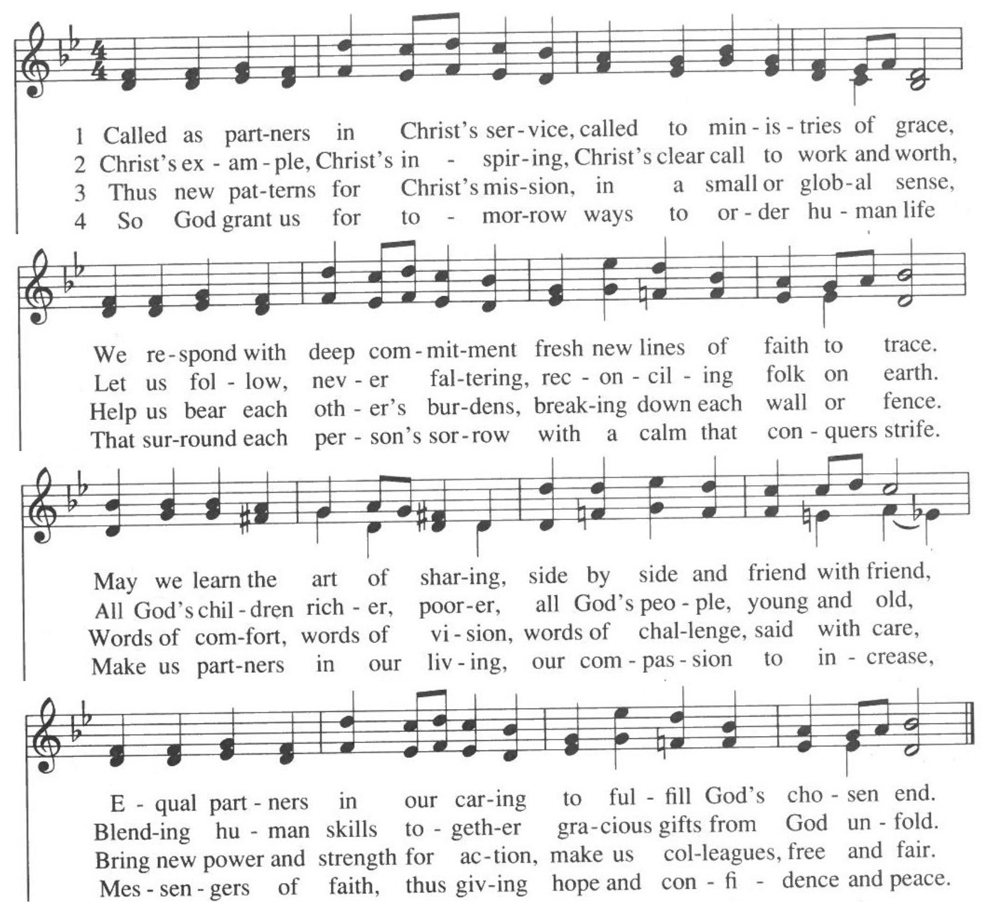

Call to Worship -
One: We come together, many parts of one Body.
Many: We come to recognize the Spirit moving among us.
One: Some are called to preach, some to heal, and some to listen.
Many: All are called to build up the kindom of God.
One: Let us celebrate the diversity of our journeys.
Many: Let us worship the God who calls us into "Us." Amen

Scripture
Numbers 11:16–17, 24–29
YHWH said to Moses, “Gather together seventy of your elders, those you know to be leaders and officials among the people. Have them come to the Tent of Meeting and take their place there with you. I will come down and speak to you there. I will take some of the Spirit that lives in you and give it to them. They will share the burden of your people, so that you do not carry all of it by yourself…
So Moses went and told the people what God had said. He gathered seventy elders and had them surround the Tent. YHWH came down in a cloud and spoke to Moses, God bestowed it on the seventy elders whom Moses had gathered there; and as the Spirit came to rest on them, they were seized with prophesying, and did not stop. Now two other elders, one named Eldad and the other Medad, were not in the gathering but had stayed behind in the camp. They had not been summoned to the tent, but had not gone; yet the Spirit came to rest on them also, and they prophesied in the camp. When a youth came running to tell Moses, “Eldad and Medad are prophesying in the camp,” Joshua, ben-Nun, who from youth had been Moses’ aide, cried, “Moses, stop them!” But Moses answered, “Are you jealous for my sake? If only all of God’s people were prophets! If only YHWH would bestow the Spirit on them all!”

Ephesians 4:11–16
And to some, the gift they were given is that they should be apostles; to some, prophets; to some, evangelists; to some, pastors and teachers. These gifts were given to equip fully the holy ones for the work of service, and to build up the body of Christ—until we all attain unity in our faith and in our knowledge of the Only Begotten of God, until we become mature, attaining to the whole measure of the fullness of Christ. Let us then be children no longer, tossed here and there, carried about by every wind of doctrine, or by human trickery or crafty, deceitful schemes. Rather, let us speak the truth in love, and grow to the full maturity of Christ, the head.

Time with Children: What can we build?

Sermon: Dialogue with a Seminarian, Birdie Cunningham

Handbell Anthem: Let Us Talents and Tongues Employ by Michael Helman


Offertory: Moment for Mission: United Theological Seminary of the Twin Cities

Scan QR code with smart phone camera to give electronically.

Special Music: Sweet Hour of Prayer

*Doxology: Praise God from Whom All Blessings Flow
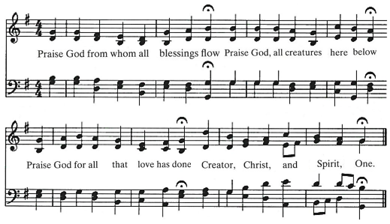
AMEN

*Prayer of Dedication
God of Wisdom, we offer these gifts to support the development of leaders in our own midst. May these resources help us continue the work of "repairing the breach," ensuring new leaders are equipped with compassion and skill to lead us deeper into your Covenant. Amen.

Community Prayers:
Pastor Nora will offer a blessing for each prayer raised and then invite the congregation to pray together, "Oh God, hear our prayer.

Prayer of Jesus – Youth Prayer
Our loving God, who surrounds us always and inspires authentic care, bring us together in holy community through the way of love from pain to peace. Provide nourishment for the hungry. Help us find strength when we fail, as we uplift others in need of support. Refocus us when we go astray and fill our world with justice, because we all need your hope and joy and continued love. Amen.



*Closing Hymn: In the Midst of New Dimensions NCH #391

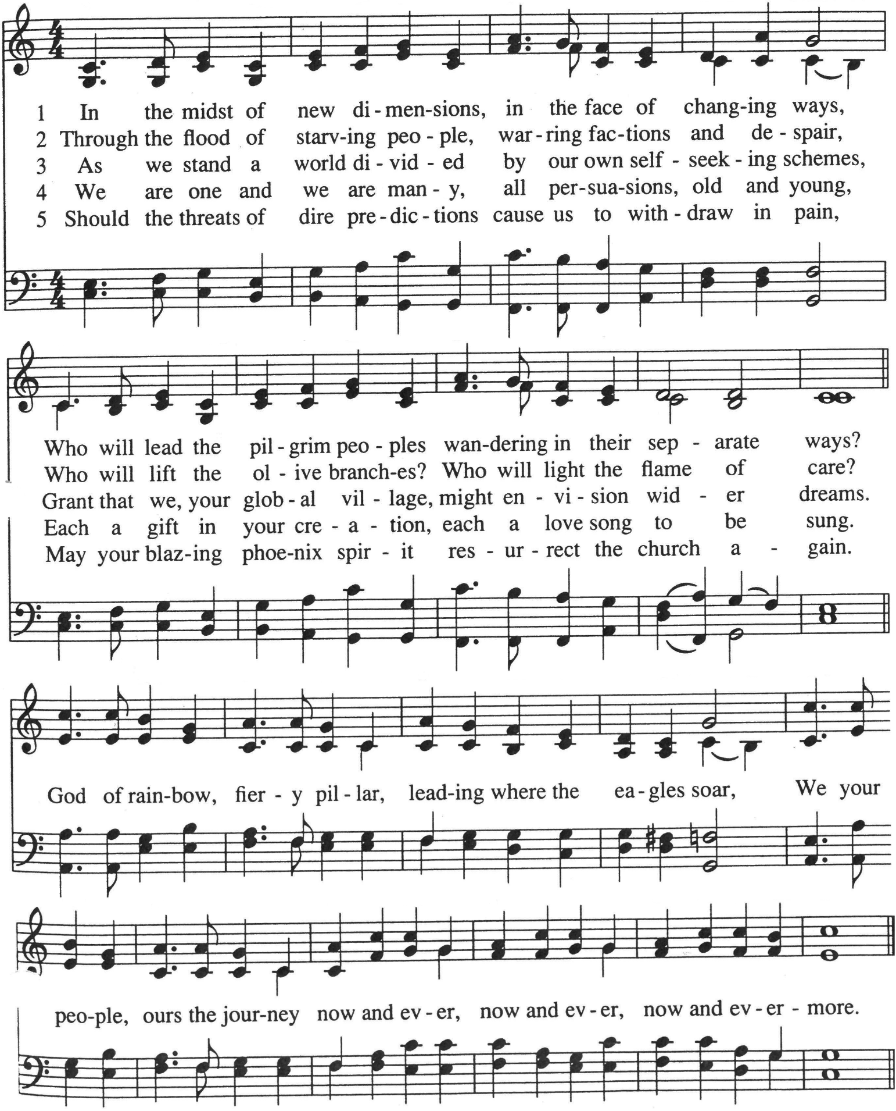

Announcements

- Do you have an old tablet, smart TV, or Roku/Chromecast you no longer need? Please talk to Pastor Nora, as we are working to develop our online and hybrid ministries and our technology team would welcome donations.

- Union UCC is rolling out new nametags! You can register for your new one via the ENews on Flocknote, or by filling out a signup sheet in the Narthex.

- If you would like to support out Hospitality Ministry and create a warm welcoming gathering space, you can sign up near the front door, or send your information to April in the office at Churchoffice@elkriverucc.org to get signed up for the Hospitality Volunteer Team. If you have any questions, feel free to contact the office. Thank you!

Benediction:

Postlude: He Leadeth Me by Joel Raney

Union Congregational UCC Worship Staff
Next Council Meeting is March 12th
Upcoming Hospitality: Mar. 1st | Diaconate Mar. 8th | OPEN
General Questions?
Email April at churchoffice@elkriverucc.org

Mailing Address
1118 4th St. NW
Elk River, MN 55330

Web Address
www.ElkRiverUCC.org

Office Hours:
By Appointment Only
Sun9:30 AM -11:30 AM

Pastor: Rev. Nora P. Elliott
763-276-7204; revnora@elkriverucc.org
Office Administrator: April Sundstrom
763-441-1203; churchoffice@elkriverucc.org
Director of Music: Carson Schneider
music-director@elkriverucc.org

Hospitality:
Deacon: Dave and Judy Halgren

Song Leader: Hesther Bowman
Accompanist: Carson Schneider
Audio/Video: Marce Ediger & Keith Stevens
Usher/Greeter(s):
Sunday School: Ruth Johnson

