
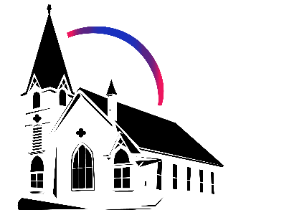

February 2nd, 2026 Fourth Sunday after Epiphany
Union Congregational Church seeks to create a celebrating covenanting, affirming, and justice seeking faith community that inspires people to unite and create a peaceful, loving world.

- We welcome LGBTQ+ people into the full life of the church, as an Open & Affirming Congregation, of the United Church of Christ.

- Listening devices are available at the rear of the Sanctuary, for enhanced audio accessibility during the service. Ushers can assist.

- For kids: The Pray-ground is in the Vestry (off the sanctuary). You’ll find a table with activity bags for children to use during the service. Kids are welcome at the table or with their parents in worship. All ages are welcome in Sunday School, but we ask a parent/guardian to accompany any children under 6.

- Stay connected: Missed a sermon or want to share it digitally? Listen to our Sunday sermons on our Podcast, CommUnion, at www.ElkRiverUCC.org/watch. You’ll also find our live stream if you can’t attend in person and an online bulletin to follow along. Hard copies of the sermon are available by the front door.

- In scripture, you may see the letters YHWH - the sacred, unpronounced name of God. To honor the mystery of the Divine and as witness to our expansive faith, we invite our liturgists to substitute the title or aspect of God they find most meaningful, such as Holy One, Mother, Lord, Creator, or Spirit. We invite you to listen for these diverse expressions of the Divine as we worship together.

* Indicates to rise Bold text indicates to speak
Order of Worship
Prelude: Holy Holy Holy by Joel Raney

Welcome: Rev. Nora P. Elliott
May peace be with you
And also with you.

Gathering Prayer
God of the Quiet and the Quake, we arrive carrying the weight of our own names. Our reputations, opinions, knowledge, and world on our shoulders. Give us the courage to be small, even for an hour. Silence the "I" that clamors for attention, so that we might hear the "We" you are breathing into existence. Amen.

Offering Peace
Please greet each other with "May peace be with you."

*Opening Hymn: Arise, Your Light is Come! NCH 744
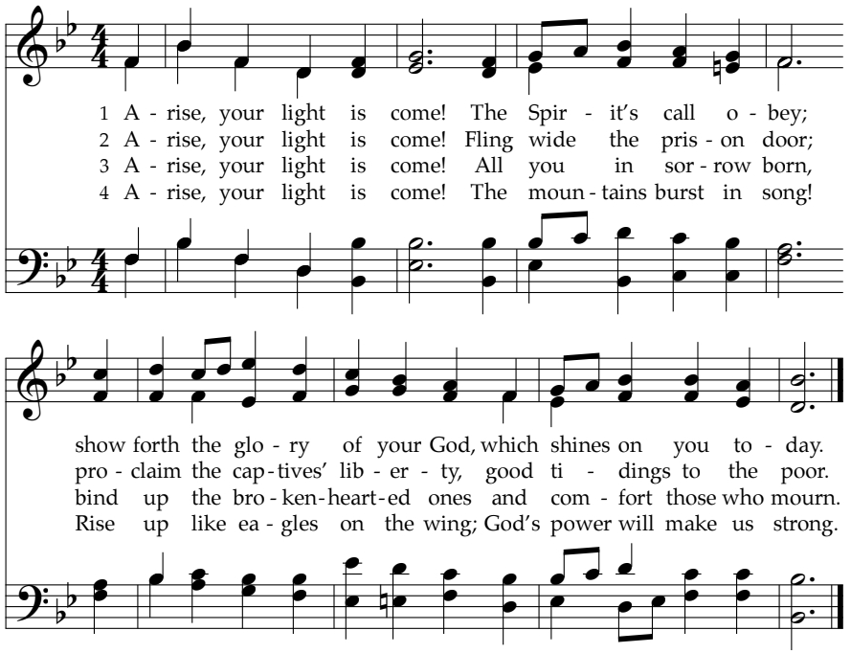

Call to Worship -
One: With what shall we come before the Holy One?
Many: Shall we come with grand gestures or the weight of our achievements? One: Our God has told us what is good.
Many: To do justice, and to love kindness. But, Holy God, we confess that we have made ourselves the center of our own universes.
One: By the grace of God, hear that we are forgiven for walking alone when we are called us to walk together.
Many: By the grace of God, go we. Amen

Scripture
Micah 6:1-8
Hear now what YHWH says: “Come, plead your case before the mountains, and let the hills hear your voice! Listen to YHWH’s indictment, you mountains and you enduring foundations of the earth; for YHWH has a dispute with the people, and is putting Israel on trial. O my people, what have I done to you? How have I wearied you? Give me an answer! For I brought you up from the land of Egypt, and redeemed you from the house of slavery; and I sent Moses to lead you, and Aaron, and Miriam! My people, call to mind the plans devised by the ruler Balak of Moab, and how Balaam ben-Beor answered him! Remember the journey from Shittim to Gilgal, and recall how YHWH brought you justice!” “What shall I bring when I come before YHWH, and bow down before God on high?” you ask. “Am I to come before God with burnt offerings? With year-old calves? Will YHWH be placated by thousands of rams or ten thousand rivers of oil? Should I offer my firstborn for my wrongdoings—the fruit of my body for the sin of my soul?” Listen here, mortal: God has already made abundantly clear what “good” is, and what YHWH needs from you: simply do justice, love kindness, and humbly walk with your God.

1 Corinthians 1:26-29
Consider your calling, sisters and brothers. Not many of you were wise by human standards, not many were influential, and surely not many were well-born. God chose those whom the world considers foolish to shame the wise, and singled out the weak of this world to shame the strong. The world’s lowborn and despised those who count for nothing, were chosen by God to reduce to nothing those who were something. In this way no one should boast before God.

Time with Children: Why are you here?

Sermon: The Weight of the 'I'

Responsive Hymn: What Does the Lord Require of You" NCH 491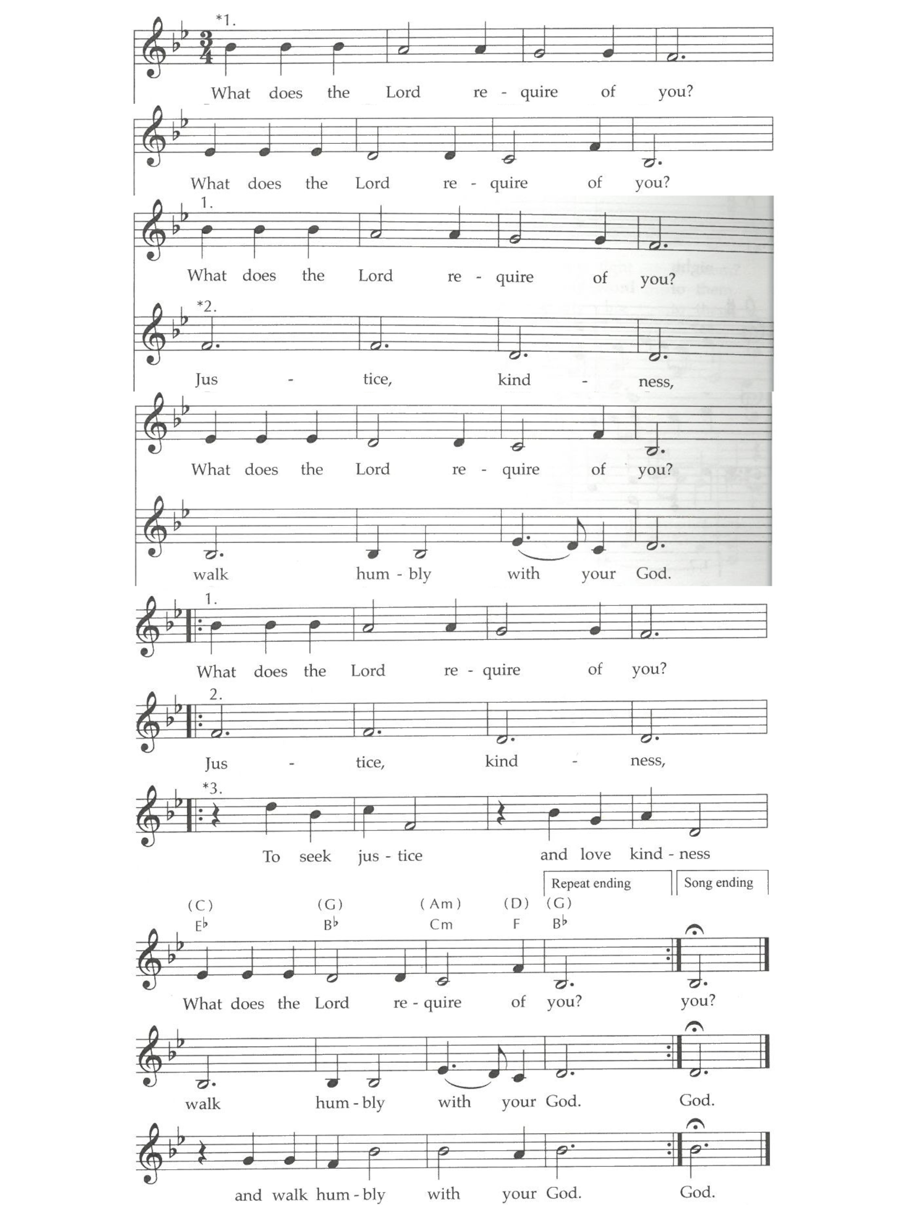


Offertory
Scan QR code with smart phone camera to give electronically.

Special Music: We Are Travelers on a Journey by Mark Hayes

*Doxology: Praise God from Whom All Blessings Flow
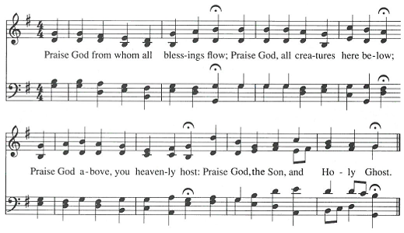
AMEN
*Prayer of Dedication
Holy God, we release these gifts as an act of trust, letting go of the need to be our own sole providers. Take these offerings and use them to fuel the justice and kindness that only a community can sustain. May what we give today strengthen the "Us" and lighten the "I." Amen.

Communion
(Our Communion table is open to everyone of every age and spirituality)

Invitation

Consecrating of the Elements

Pastoral Prayers

Prayer of Jesus – Traditional Inclusive
Our Loving God, who art in heaven, hallowed be thy name. Thy kin-dom come, thy will be done on earth as it is in heaven. Give us this day our daily bread, and forgive us our debts as we forgive our debtors. Save us from temptation, and deliver us from evil. For thine is the kin-dom, and the power, and the glory forever. Amen.

*Closing Hymn: Lead On, O Cloud of Presence" NCH 18
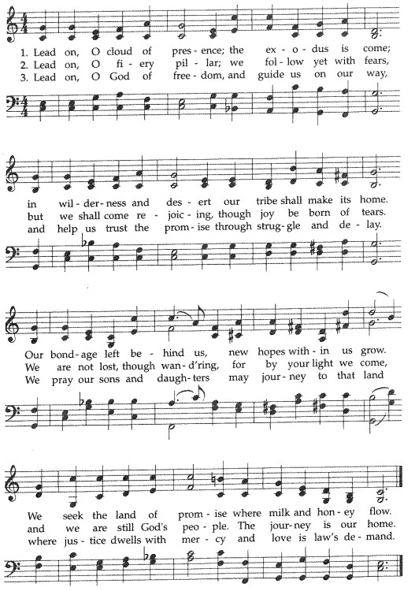

Announcements
- Do you have an old tablet, smart TV, or Roku/Chromecast you no longer need? Please talk to Pastor Nora, as we are working to develop our online and hybrid ministries and our technology team would welcome donations.

- A special Congregational Meeting is planned for February 15th, after worship for the business of receiving capital campaign updates and considering a plan to reprioritize the projects of our building’s accessibility needs. All members are encouraged to attend in person.

- "Happy 151st Birthday to The Union Church on February 1!"

- Congregational Life Meeting on February 4th.

Benediction:

Postlude: Come Thou Fount by Joel Raney


Union Congregational UCC Worship Staff
Next Council Meeting is Feb 12th
Upcoming Hospitality: Feb. 8th | OPEN Feb. 15th | Trustees
General Questions?
Email April at churchoffice@elkriverucc.org

Mailing Address
1118 4th St. NW
Elk River, MN 55330

Web Address
www.ElkRiverUCC.org

Office Hours:
By Appointment Only
Sun9:30 AM -11:30 AM

Pastor: Rev. Nora P. Elliott
763-276-7204; revnora@elkriverucc.org
Office Administrator: April Sundstrom
763-441-1203; churchoffice@elkriverucc.org
Director of Music: Carson Schneider
music-director@elkriverucc.org

Hospitality: Congregational Life
Deacon: Lisa Cawthra

Song Leader: Hesther Bowman
Accompanist: Carson Schneider
Audio/Video: Marce Ediger & Keith Stevens
Usher/Greeter(s):
Sunday School: Amanda Hooper & Ruth Johnson

