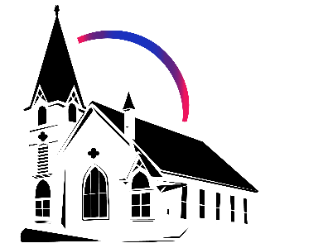

December 14th, 2025 Advent 1II: Joy

Union Congregational Church seeks to create a celebrating covenanting, affirming and justice seeking faith community that inspires people to unite and create a peaceful, loving world.

- We welcome LGBTQ+ people into the full life of the church, as an Open & Affirming Congregation, of the United Church of Christ.

- Listening devices are available at the rear of the Sanctuary, for enhanced audio accessibility during the service. Ushers can assist.

- For kids: The Pray-ground is in the Vestry (off the sanctuary). You’ll find a table with activity bags for children to use during the service. Kids are welcome at the table or with their parents in worship. All ages are welcome in Sunday School, but we ask a parent/guardian to accompany any children under 6.

- Stay connected: Missed a sermon or want to share it digitally? Listen to our Sunday sermons on our Podcast, CommUnion, at www.ElkRiverUCC.org/watch. You’ll also find our live stream if you can’t attend in person and an online bulletin to follow along. Hard copies of the sermon are available by the front door.

* Indicates to rise Bold text indicates to speak
Order of Worship
Prelude: O Come O Come Emanuel by Mark Hayes

Welcome: Rev. Nora P. Elliott

May peace be with you
And also with you.

Gathering Prayer
God of surprises, you interrupt our world with joy and hope beyond our wildest dreams. When we feel forgotten or despair, bless us with your holy joy. When our world feels barren, bless us with the gift of possibility. We pray as people of deep faith, entrusting ourselves and our world to the holy unknown, brought to birth in Jesus, our light and life. Amen.

Offering Peace
Please greet each other with "May peace be with you."

Handbell Call to Worship: Twas in the Moon of Wintertime by Cathy Moklebust

Advent Candle Lighting - Joy
One: The birth of Jesus has been told and retold a thousand times and in a thousand ways.
All: Its impact cannot be contained in any one perspective. But who is telling the story changes how we hear it, how we imagine it, how we experience it. We light the candle of hope because hope creates a path for a new, unknown story to unfold.
Light the first candle.
All: We light the candle of peace because peace requires us to pay attention to the needs of those around us.
Advent Family Liturgy - Beckwith Family
All: Today, we also light the candle of joy because joy sustains us in the midst of uncertainty.

*Opening Hymn: Mary, Woman of the Promise #123 NCH
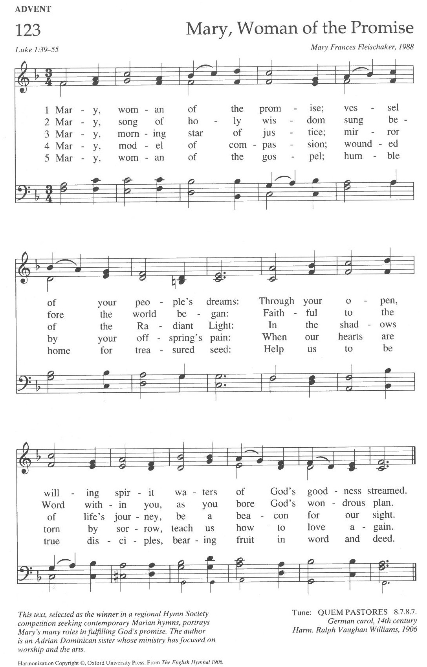

Call to Worship
One: We gather together in this place:
All: prophets and dreamers, singers and poets,
One: we who dare to imagine a world renewed;
All: we who dare to dream God’s dream.
One: We sing with Elizabeth and Mary.
All: Our spirits rejoice in God, our savior!
One: We bless the God of justice and joy,
All: who lifts up the lowly and vulnerable.
One: God’s mercy is upon us all,
All: from generation to generation.
One: Come and worship, all you who dream and wait.
All: We have come to wonder and praise.

Scripture
Isaiah 61:1–3A
“The Spirit of Exalted YHWH is upon me, for YHWH has anointed me: God has sent me to bring good news to those who are poor; to heal broken hearts; to proclaim release to those held captive and liberation to those in prison; to announce a year of favor from YHWH, and the day of God’s vindication; to comfort all who mourn, to provide for those who grieve in Zion—to give them a wreath of flowers instead of ashes, the oil of gladness instead of tears, a cloak of praise instead of despair.”

Luke 1:39–55
Within a few days Mary set out and hurried to the hill country to a town of Judah, where she entered Zechariah’s house and greeted Elizabeth. As soon as Elizabeth heard Mary’s greeting, the child leaped in her womb and Elizabeth was filled with the Holy Spirit. In a loud voice she exclaimed, “Blessed are you among women, and blessed is the fruit of your womb! But why am I so favored, that the mother of the Messiah should come to me? The moment your greeting reached my ears, the child in my womb leaped for joy. Blessed is she who believed that what our God said to her would be accomplished!” Mary said: “My soul proclaims your greatness, O God, and my spirit rejoices in you, my Savior. For you have looked with favor upon your lowly servant, and from this day forward all generations will call me blessed. For you, the Almighty, have done great things for me, and holy is your Name. Your mercy reaches from age to age for those who fear you. You have shown strength with your arm; you have scattered the proud in their conceit; you have deposed the mighty from their thrones and raised the lowly to high places. You have filled the hungry with good things, while you have sent the rich away empty. You have come to the aid of Israel your servant, mindful of your mercy—the promise you made to our ancestors—to Sarah and Abraham and their descendants forever.”

Time with Children: What's in the box?

Sermon: “Joy that Trembles with Us”

Responsive Choir Anthem: God Has Work For Us To Do by Mark Miller


Offertory
Scan QR code with smart phone camera to give electronically.

Special Music: Come Emanuel by Emily Lund with
Senior Choir and Madelynn Rohs, flute

*Doxology: God of Grace and God of Glory NCH #436 v1
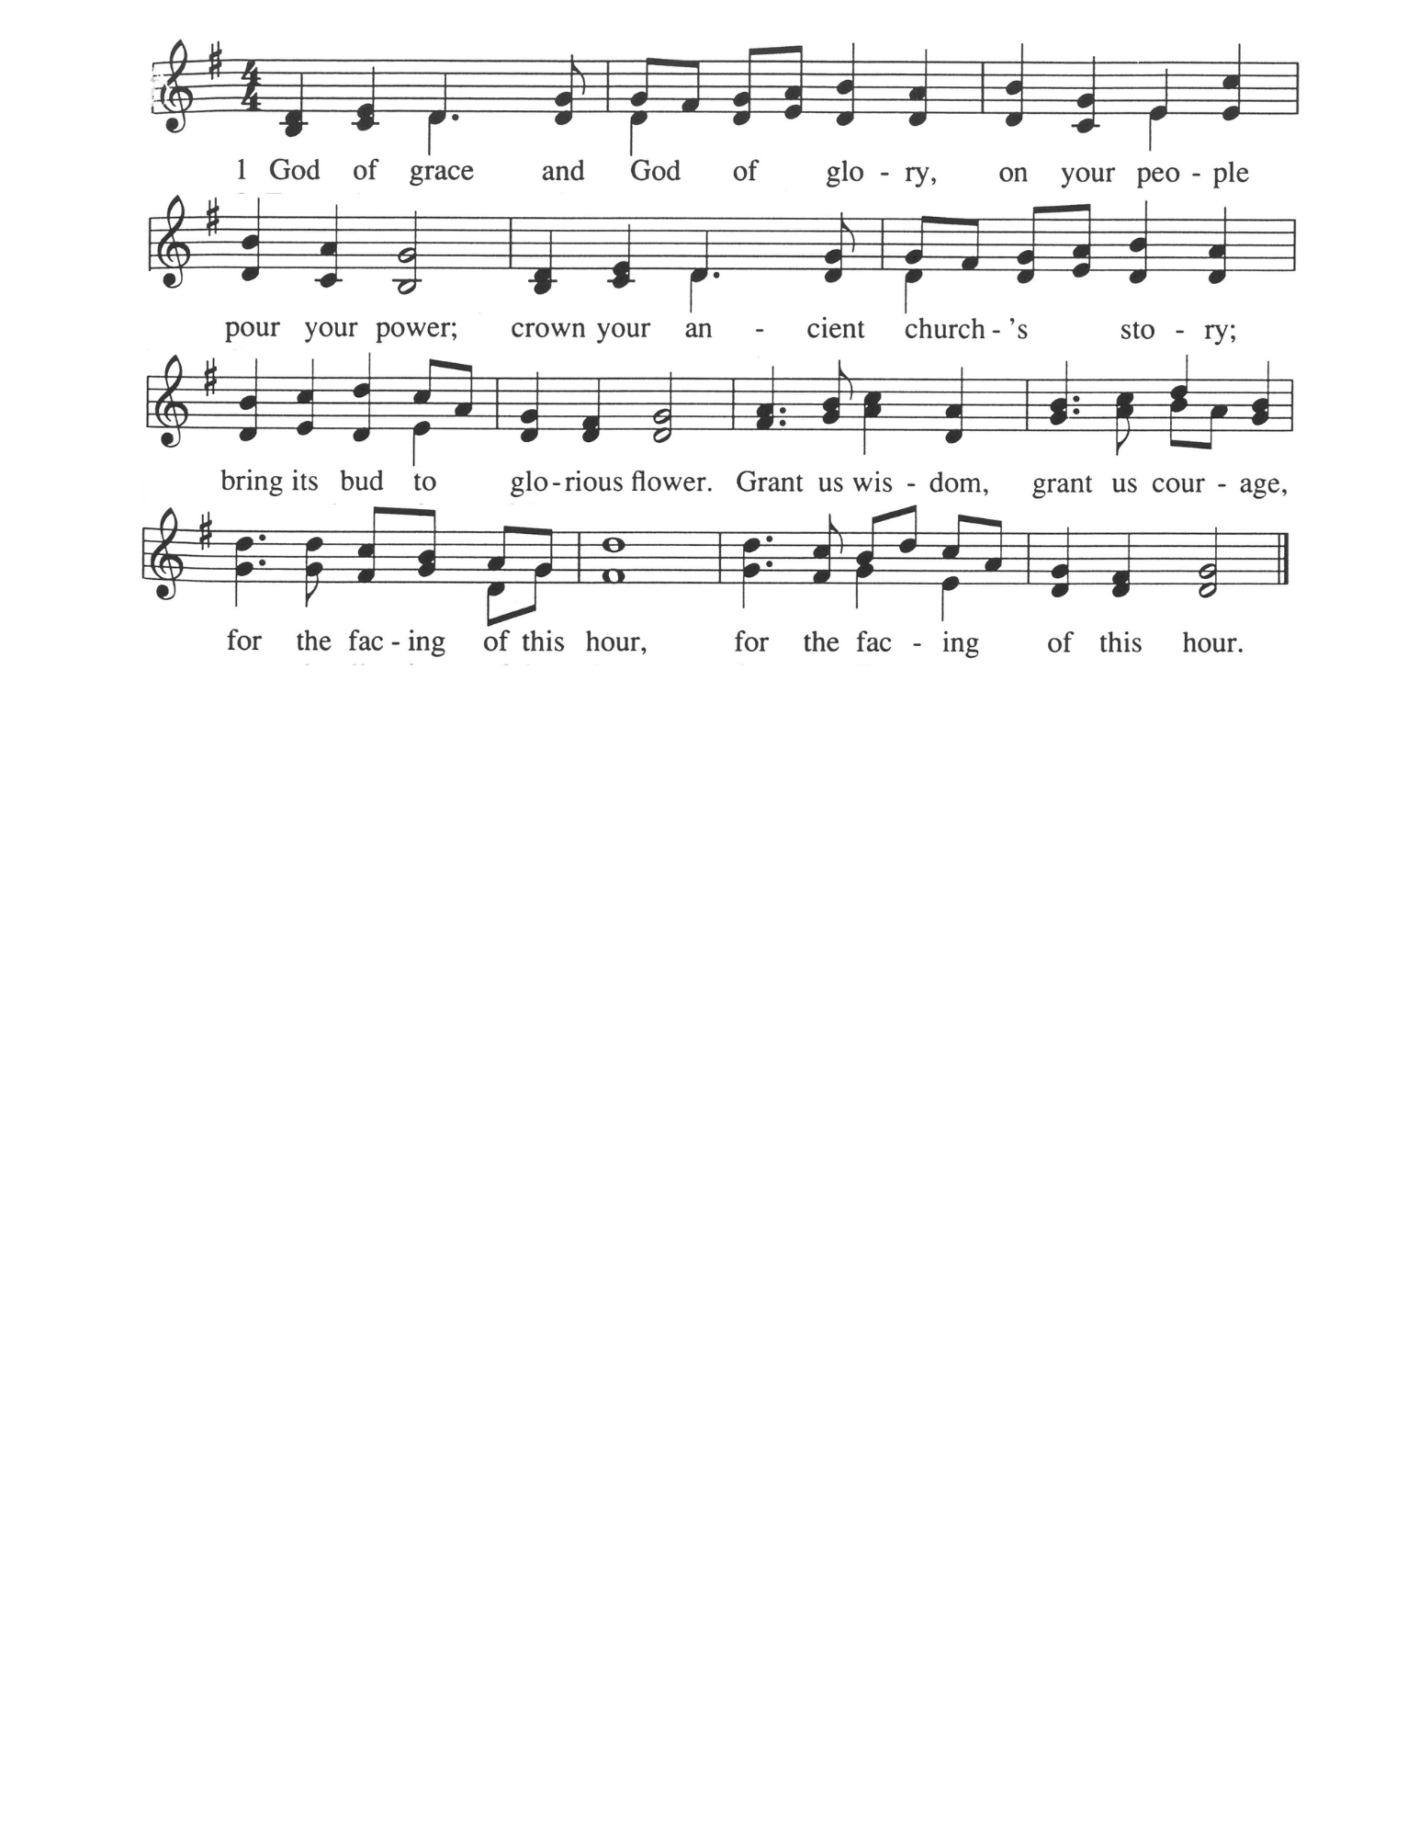

*Prayer of Dedication
Holy God, we bring our gifts and offerings to you because the voices of the prophets remind us of something bigger, something greater than any system this world offers us. We believe when we trust you with our resources, the
kindom of God comes much closer to reality on earth. Help us steward these gifts to create abundant life and love. Amen

Community Prayers
Pastor Nora will offer a blessing for each prayer raised and then invite the congregation to pray together, "Oh God, hear our prayer."

Prayer of Jesus – Casa del Sol, by John Philip Newell
Ground of all being, Mother of life, Father of the universe, Your name is sacred, beyond speaking. May we know your presence, may your longings be our longings in heart and in action. Today may there be food for the human family today and for the whole earth community. Forgive us the falseness of what we have done as we forgive those who are untrue to us. Do not forsake us in our time of conflict but lead us into new beginnings. For the light of life, the vitality of life, and the glory of life are yours now and forever. Amen.

*Closing Hymn: Light Dawns on a Weary World #79 GtG
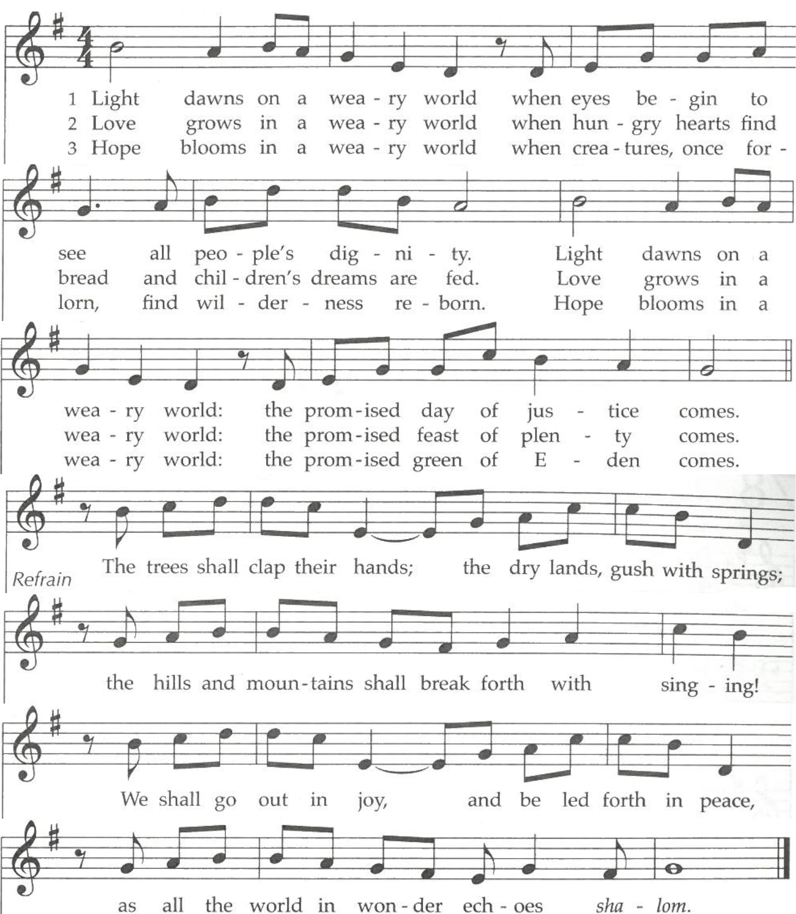

Announcements
- Advent IS HERE!
Dec 14, 11:00am – Jingle Bingo is after worship in the Fellowship Hall. Join us for holiday fun, festive goodies and drinks provided by Congregational Life.
Dec 21, 7:00pm – Blue Christmas, at Elk River Lutheran, a time for lament.
Dec 24, 4:00pm – Lessons and Carols (Family Friendly) Christmas eve service
Dec 24, 7:00pm – Contemplative Christmas eve service, with special music

Benediction:

Handbell Postlude: Come Thou Long Expected Jesus by Lee J Afdhal

Advent Scripture & Themes

Week Four, Dec 21: Merciful Love
Luke 1:57–80 (Zechariah's Story) & Psalm 89:1–4, 19–26

Christmas, Dec 24: Embodied Promise
Luke 2:1–20 (Mary's Story) & Isaiah 9:2–7

Union Congregational UCC Worship Staff
Next Council Meeting is January 8th
Upcoming Hospitality: Dec. 21st | Hooper Family Dec. 28th | Congregational Life
General Questions?
Email April at churchoffice@elkriverucc.org

Mailing Address
1118 4th St. NW
Elk River, MN 55330

Web Address
www.ElkRiverUCC.org

Office Hours:
Mon-Friday: By Appointment Only
Sun9:30 AM -11:30 AM

Pastor: Rev. Nora P. Elliott
763-276-7204; revnora@elkriverucc.org
Office Administrator: April Sundstrom
763-441-1203; churchoffice@elkriverucc.org
Director of Music: Carson Schneider
music-director@elkriverucc.org


Hospitality: Congregational Life, Inner Church
Deacon: Joyce Hodge
Song Leader: Patti Kubicka
Accompanist: Carson Schneider
Audio/Video: Marce Ediger & Keith Stevens
Usher/Greeter(s): Marlene & Joel Stottrup
Sunday School: Amanda Hooper & Ruth Johnson

