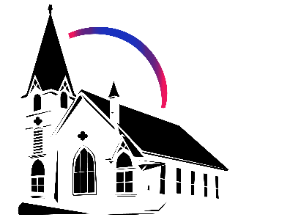

November 30th, 2025 Advent 1: Hope

Union Congregational Church seeks to create a celebrating covenanting, affirming and justice seeking faith community that inspires people to unite and create a peaceful, loving world.

- We welcome LGBTQ+ people into the full life of the church, as an Open & Affirming Congregation, of the United Church of Christ.

- Listening devices are available at the rear of the Sanctuary, for enhanced audio accessibility during the service. Ushers can assist.

- For kids: The Pray-ground is in the Vestry (off the sanctuary). You’ll find a table with activity bags for children to use during the service. Kids are welcome at the table or with their parents in worship. All ages are welcome in Sunday School, but we ask a parent/guardian to accompany any children under 6.

- Stay connected: Missed a sermon or want to share it digitally? Listen to our Sunday sermons on our Podcast, CommUnion, at www.ElkRiverUCC.org/watch. You’ll also find our live stream if you can’t attend in person and an online bulletin to follow along. Hard copies of the sermon are available by the front door.

* Indicates to rise Bold text indicates to speak
Order of Worship
Prelude:

Welcome: Rev. Nora P. Elliott

May peace be with you
And also with you.

Gathering Prayer
God who is, was, and is to come, we enter this season of Advent keenly aware of the brokenness in and around us. Comfort our longing spirits, and teach us again how to be people of profound hope, seeking again the assurance of your salvation, brought to birth in Jesus Christ, our hope and Savior. Amen
Offering Peace
Please greet each other with "May peace be with you."

Choir Anthem: Blow Bethlehem Wind, by Joseph Martin, with Madelynn Rohs, flute

Advent Candle Lighting - Hope: The Hooper Family
One: The birth of Jesus has been told and retold a thousand times and in a thousand ways.
All: Its impact cannot be contained in any one perspective. The element of the story we focus on changes how we hear it, how we imagine it, and how we experience it.
Advent Family Liturgy
All: We light the candle of hope because hope creates a path for a new, unknown story to unfold.

*Opening Hymn: People Look East #105 GtG
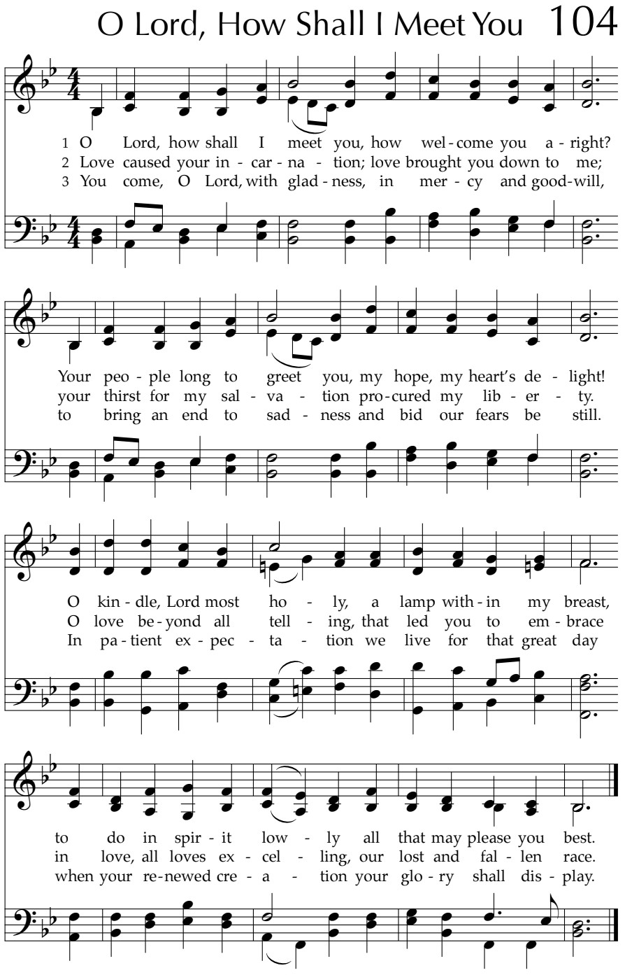

Call to Worship
One: We gather together in this place:
Many: prophets and dreamers, singers and poets,
One: who dare to imagine a world renewed;
Many: we who dare to dream God's dream.
One: We proclaim expectation with Isaiah!
Many: God's redemption is near!
One: Through tears and through trials,
Many: we hold fast to our hope.
One: Do not fear, for God is faithful
Many: Our redemption rises with the dawn.
One: Come and worship, all you who dream and wait.
Many: We have come to wonder and praise.

Scripture

Isaiah 2:1-5
This is what Isaiah ben-Amoz saw concerning Judah and Jerusalem: In the last days, the mountain of YHWH’s Temple will be established as the most important mountain and raised above all other hills—all nations will stream toward it. Many people will come and say: “Come, let us climb YHWH’s mountain to the Temple of the God of Jacob, that we may be instructed in God’s ways and walk in God’s paths.” Instruction will be given from Zion and the word of YHWH from Jerusalem. God will judge between the nations and render decisions for many countries. They will beat their swords into plowshares, and their spears into pruning hooks; one nation will not raise the sword against another, and never again will they train for war. O House of Leah and Rachel and Jacob, come, let us walk in the light of YHWH!

Mark 13:24 - 36
Jesus said, “In those days, after such trouble, the sun will be darkened and the moon will not give its light. The stars will fall from the sky, and the powers of the heavens will be shaken. Then people will see the Promised One coming in the clouds with great power and glory. And the angels will be sent out to gather the chosen ones from the four winds, from the ends of the earth to the ends of the heavens.
“Learn this lesson from the fig tree: when its branch becomes tender and puts out leaves, you know summer is near. In the same way, when you see these things taking place, know that the time is close—right at the door. Truly I tell you, this generation will not pass away until all this has happened. Heaven and earth will pass away, but my words will not pass away.
“But about that day or hour, no one knows—neither the angels in heaven, nor the Only Begotten—only God. So stay awake! Be alert!

Time with Children: Where does the path go?

Sermon: “Dreaming God's Path of Hope”

Responsive Choir Anthem: Come Emmanuel, by Don Besig


Offertory
Scan QR code with smart phone camera to give electronically.

Special Music:

*Doxology: God of Grace and God of Glory NCH #436 v1
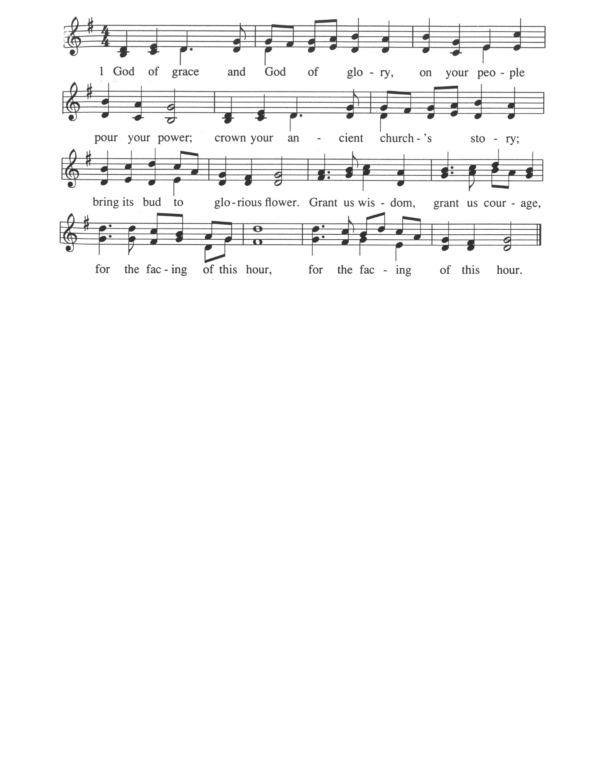

*Prayer of Dedication
Holy God, we bring our gifts and offerings to you because the voices of the prophets remind us of something bigger, something greater than any system this world offers us. we believe when we trust you with our resources, the kindom of God comes much closer to reality on earth. Help us steward these gifts to create abundant life and love. Amen

Community Prayers
Pastor Nora will offer a blessing for each prayer raised and then invite the congregation to pray together, "Oh God, hear our prayer."

Prayer of Jesus – Traditional Inclusive
Our Loving God, who art in heaven, hallowed be thy name. Thy kin-dom come, thy will be done on earth as it is in heaven. Give us this day our daily bread, and forgive us our debts as we forgive our debtors. Save us from temptation, and deliver us from evil. For thine is the kin-dom, and the power, and the glory forever. Amen.

*Closing Hymn: Oh How Shall I Receive You #102 NCH
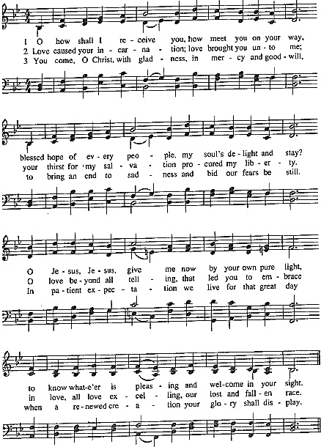

Announcements
      - If you'd like to light an advent candle this year, please let Pastor Nora know ASAP.

- Advent IS HERE!
Dec 14, 11:00am – Jingle Bingo, bring a white elephant style unwrapped gift to share and wear your favorite holiday sweater (who’s to say it’s ugly?!). Festive goodies and drinks provided by Congregational Life.
Dec 21, 7:00pm – Blue Christmas, at Elk River Lutheran, a time for lament.
---There are several opportunities in the service for volunteer readers, please contact Pastor Nora before Dec 12, if you'd like to volunteer to take part in the service.
Dec 24, 4:00pm – Lessons and Carols (Family Friendly) Christmas eve service
Dec 24, 7:00pm – Contemplative Christmas eve service, with special music

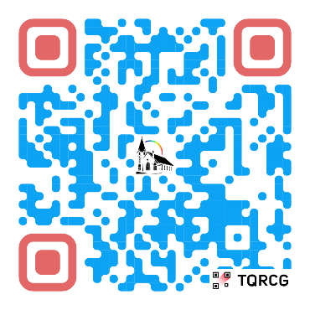
- Enrich your spirit and bless our community
Our sacred community is growing, and your gifts are needed! Scan the QR code to volunteer and find your place in the life of our church, or reach out to Pastor Nora and learn about opportunities available.

Benediction:

Postlude:

Advent Scripture & Themes

Week Two, Dec 7: Prophetic Peace, with Communion
Matthew 3:1–12 (John the Baptist's Story) & Malachi 3:1–6

Week Three, Dec 14: Unexpected Joy, with choir and handbells
Luke 1:39–55 (Elizabeth's Story) & Isaiah 61:1–4,8–11

Week Four, Dec 21: Merciful Love
Luke 1:57–80 (Zechariah's Story) & Psalm 89:1–4, 19–26

Christmas, Dec 24: Embodied Promise
Luke 2:1–20 (Mary's Story) & Isaiah 9:2–7

Union Congregational UCC Worship Staff
Next Council Meeting is December 11th
Upcoming Hospitality: Dec. 7th | Centennial Dec. 14th | CL Wider Church
General Questions?
Email April at churchoffice@elkriverucc.org

Mailing Address
1118 4th St. NW
Elk River, MN 55330

Web Address
www.ElkRiverUCC.org

Office Hours:
Mon-Friday: By Appointment Only
Sun9:30 AM -11:30 AM

Pastor: Rev. Nora P. Elliott
763-276-7204; revnora@elkriverucc.org
Office Administrator: April Sundstrom
763-441-1203; churchoffice@elkriverucc.org
Director of Music: Carson Schneider
music-director@elkriverucc.org


Hospitality: Dar Enfield & Sherry Theuninck
Deacon: Dave Foley
Song Leader: Patti Kubicka
Accompanist: Carson Schneider
Audio/Video: Marce Ediger & Keith Stevens
Usher/Greeter(s): Frater Family
Sunday School: Amanda Hooper & Ruth Johnson

