
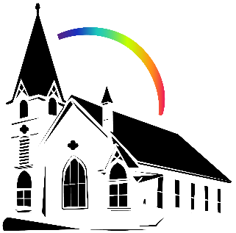
October 26th, 2024
Union Congregational Church seeks to create a celebrating covenanting, affirming and justice seeking faith community that inspires people to unite and create a peaceful, loving world.

- We welcome LGBTQ+ people into the full life of the church, as an Open & Affirming Congregation.

- Listening devices are available at the rear of the Sanctuary, for enhanced audio accessibility during the service. Ushers can assist.

- For kids: The Pray-ground is in the Vestry (off the sanctuary). You’ll find a table with activity bags for children to use during the service. Kids are welcome at the table or with their parents in worship. All ages are welcome in Sunday School, but we ask a parent/guardian to accompany any children under 6.

- Stay connected: Missed a sermon or want to share it digitally? Listen to our Sunday sermons on our Podcast, CommUnion, at www.ElkRiverUCC.org/watch. You’ll also find our live stream if you can’t attend in person and an online bulletin to follow along. Hard copies of the sermon are available by the front door.

* Indicates to rise Bold text indicates to speak
Order of Worship
Prelude: The Church’s One Foundation, by Mark Hayes

Welcome: Rev. Nora P. Elliott

May Peace be with you
And also with you.

Gathering Prayer
Spirit of the Living God, you write your promise not on tablets of stone but on the soft places of our hearts. As we gather in your presence, trace again your love upon our lives, that we might be your letter to the world: faithful, merciful, and true. Amen.

Offering Peace
Please greet each other with "May peace be with you."

*Opening Hymn: Spirit of the Living God #283 NCH (x3), v3 replace ‘me’ with ‘us’
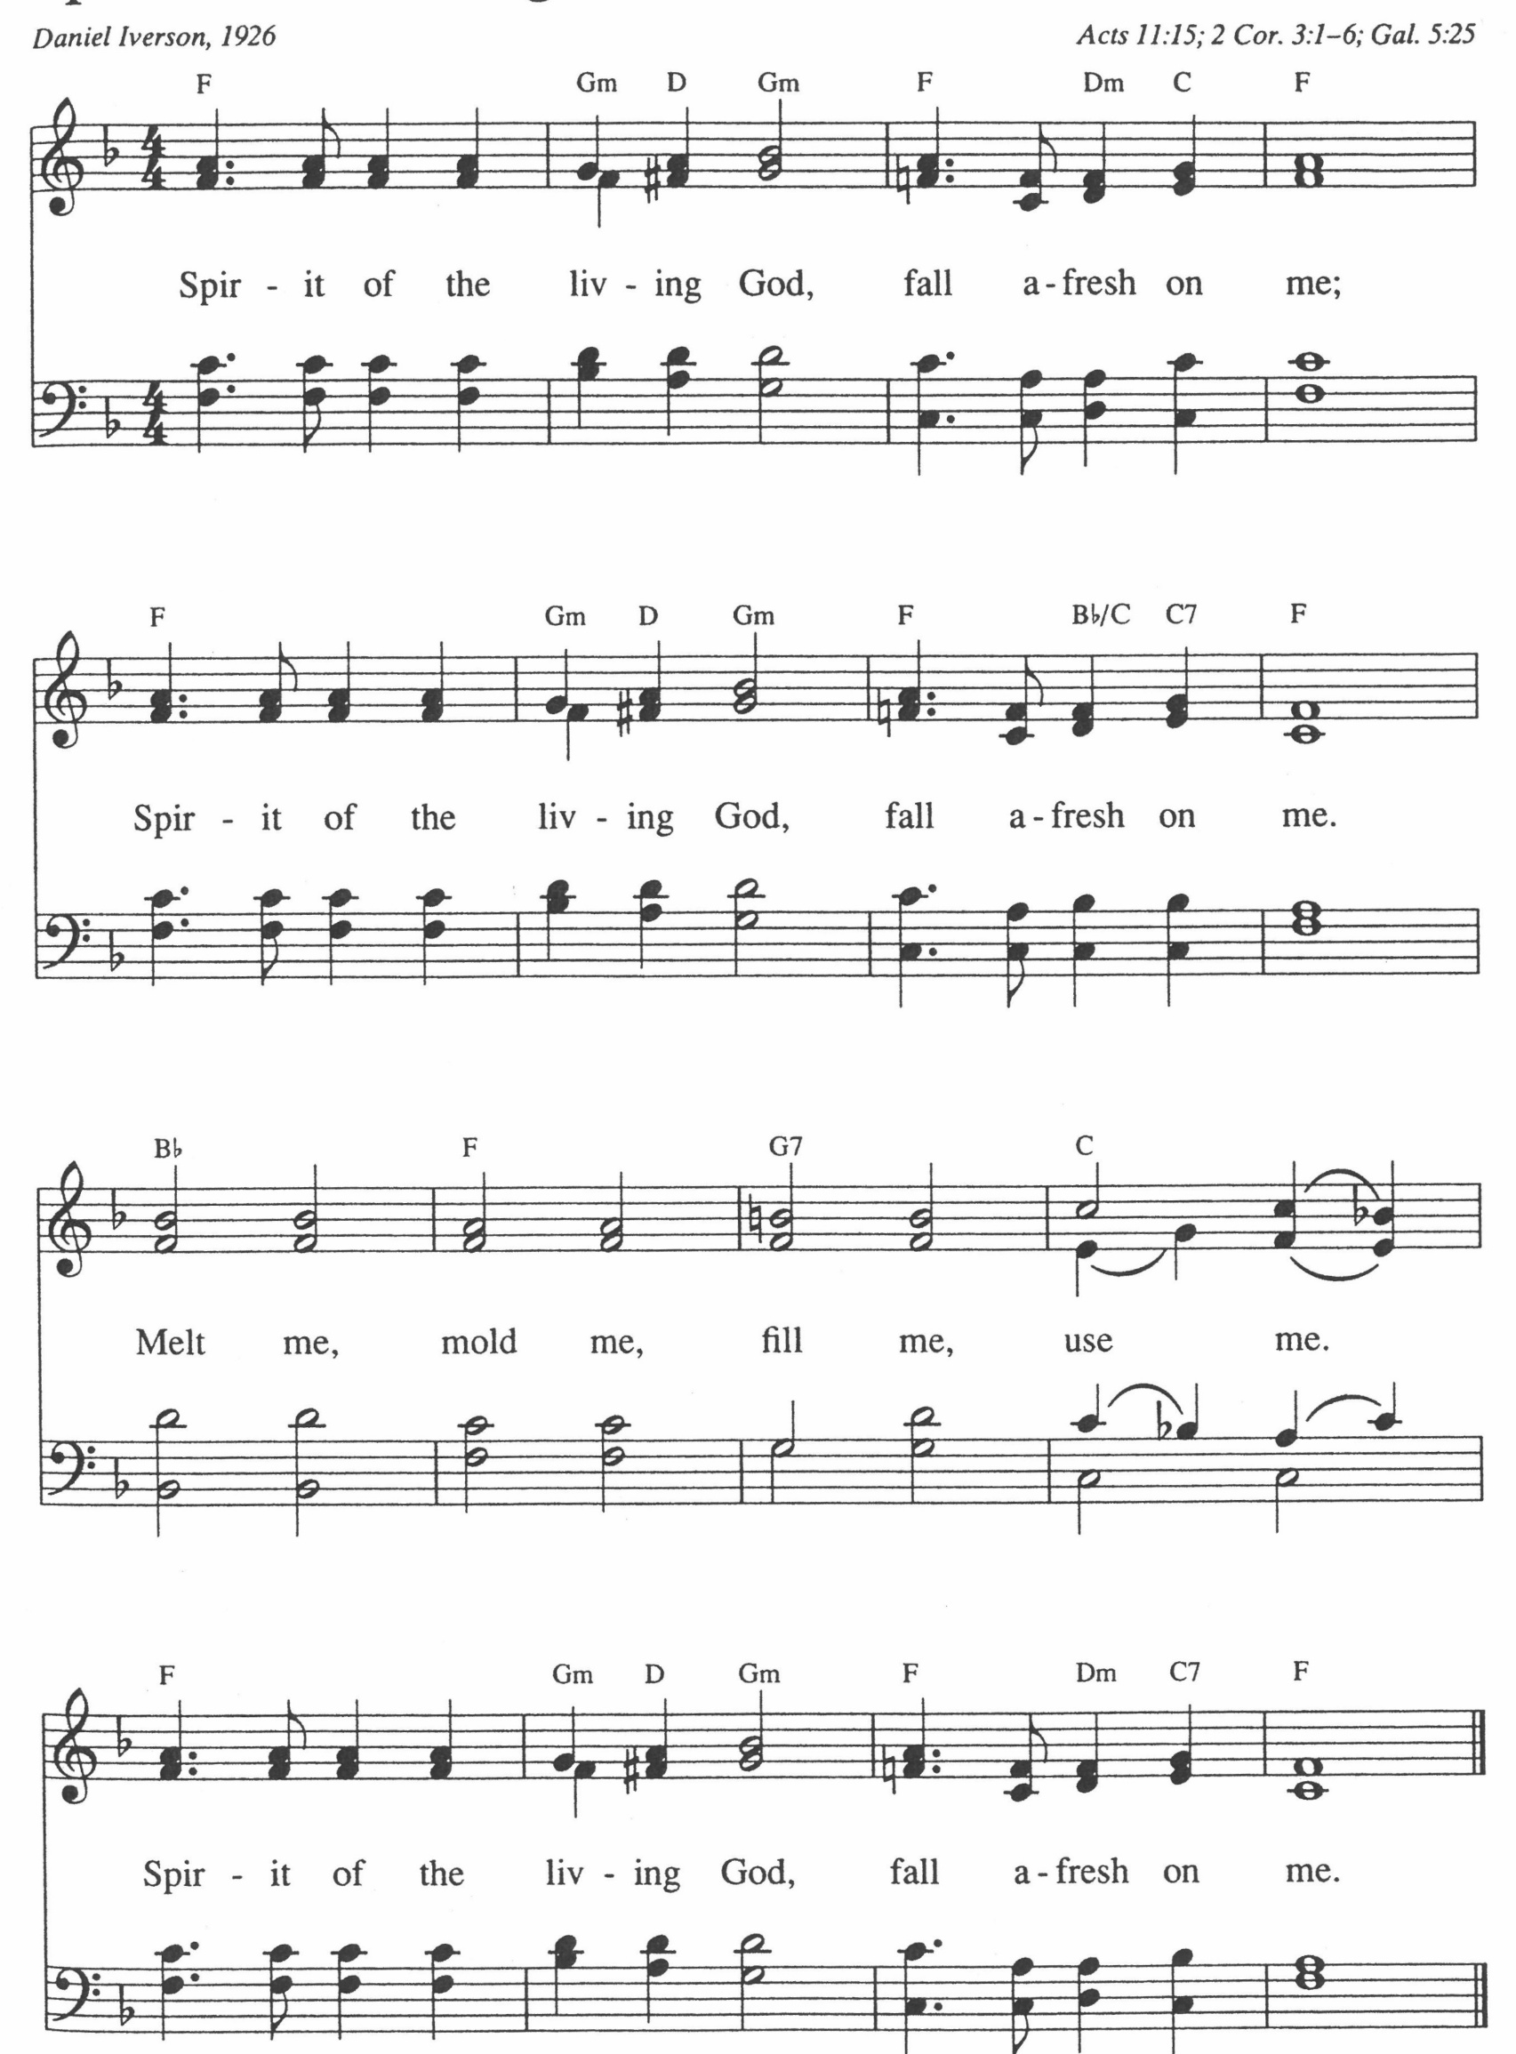
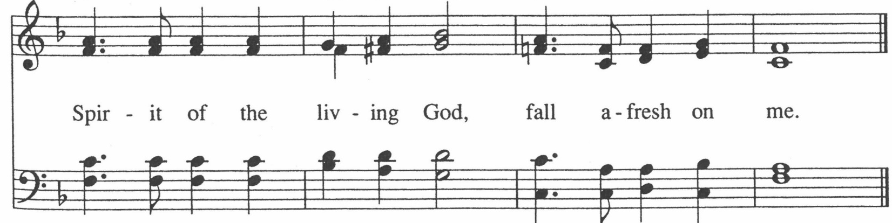

Call to Worship
One: The days are surely coming, says our God, when love will be written on
every heart.

Many: We are God’s living covenant, known and read by all people.
One: Not ink, not stone, not law alone...
Many: But Spirit, alive within us, calling us to compassion.
One: Come, let us worship the One who writes new life into being.
Many: We open our hearts to God’s living Word.

Scripture
Jeremiah 31: 31 – 34
The days are coming, says the Eternal One, when I will make a new covenant with all people. It will not be like the covenant made long ago, when I led my people out of bondage—a covenant they broke, though I was their faithful companion, says the Eternal One. But this is the new covenant I will make: I will place my teaching deep within them, and I will write it upon their hearts. I will be their God, and they will be my people. No one will need to teach another or say, “Know the Eternal,” for all will know me, from the least to the greatest, says the Eternal One; for I will forgive their wrongdoing and remember their failures no more.

2 Corinthians 3:2–6
You yourselves are our letter, written on our hearts, known and read by everyone. You show that you are a letter from the Anointed One, prepared through our service—not written with ink, but with the Spirit of the living God; not on tablets of stone, but on the tablets of human hearts. Such is the confidence we have through the Anointed One toward God. It is not that we are capable in ourselves to claim anything as coming from us; rather, our ability comes from God, who has made us capable of serving a new covenant—one not of written law but of Spirit. For the written code brings death, but the Spirit brings life.

Time with Children: How does God write?

Sermon: “The Living Letter”

This space left blank intentionally for notes or doodles.

Handbell Choir: Meditation on Beautiful Savior, by Cathy Mocklebust

Blessing our Budget


Offertory
Scan QR code with smart phone camera to give electronically.

Special Music: Blest Be the Tie, by Heather Sorenson

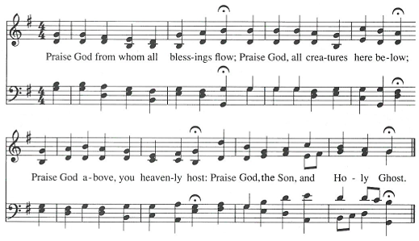
*Doxology: NCH #780 Praise God from Whom All Blessings Flow

Amen

*Prayer of Dedication
Living God, you have written love upon our hearts; may these gifts become the ink of your covenant: signs of hope, mercy, and justice for this generation. Amen.

Community Prayers
Pastor Nora will offer a blessing for each prayer raised and then invite the congregation to pray together, "Oh God, hear our prayer."

Prayer of Jesus: Translated from the Aramaic, by Neil Douglas-Klotz
O Birther! Father-Mother of the Cosmos, You create all that moves in light.
Carve a space for your Name to live. Create your reign of unity now through our fiery hearts and willing hands. Let all wills move together in your vortex, as stars and planets swirl through the sky. Grant what we need each day in bread and insight. Let each heartbeat release the weight of our mistakes and others’ guilt. Let us not be deceived by false illusions, but free us from what holds us back. For from You comes the strength to act and the creative force in the Universe that renews itself endlessly. Amen.

*Closing Hymn: God, When I Came into This Life #691 GtG
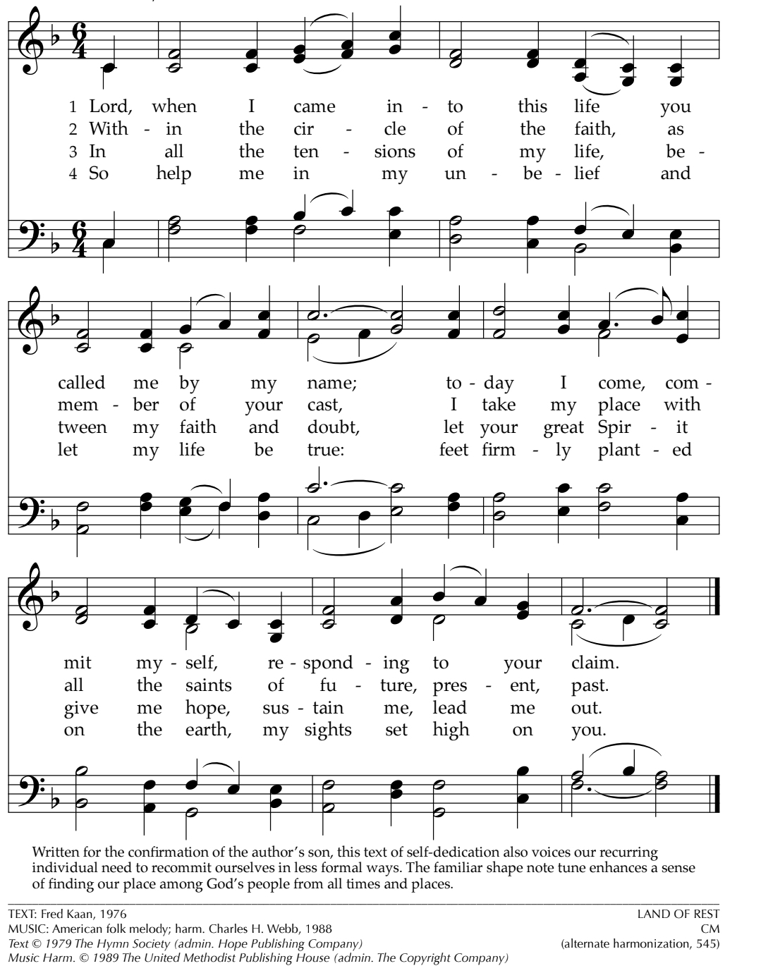

Announcements
- Our Whole Lives cohorts continue today, and FINAL session of Fall Term is next week, Nov 2. We look forward to picking back up in the new year with a new 35+ cohort, but need a couple volunteer facilitators. If you’re interested in being trained, please talk to Pastor Nora.

- Next week, Nov 2, is All Saints Sunday. We will remember those who have returned to God this past year. If you have a loved one you would like remembered, please send their name to Pastor Nora ASAP.

- Congregational Life is partnering with Paula Benfer to help collect school supplies for ISD 728. Paula has specifically been in direct communication with multi-language teachers within ISD 728 and they could use the community’s help in getting some additional supplies. A box will be set up in the Narthex. Look for the requested supply list on the Volunteer Table.

- This week is the final Sunday of Stewardship, but if you forgot your pledge card you can use your phone’s camera to share your commitments of time, talent, and treasure pledges, but using these QR codes.

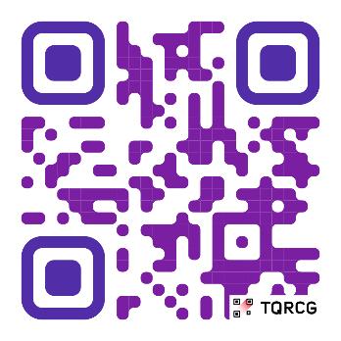
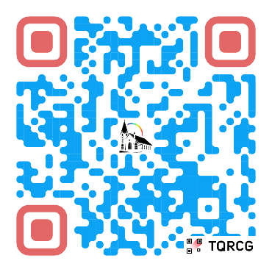
Scan here for Scan here for
2026 Pledge Time & Talent

Benediction

Postlude: The Solid Rock, by Mark Hayes

Union Congregational UCC Worship Staff
Next Council Meeting is November 13th
Upcoming Hospitality: Nov. 2nd | Diaconate Nov. 9th | Trustees
General Questions?
Email April at churchoffice@elkriverucc.org

Mailing Address
1118 4th St. NW
Elk River, MN 55330

Web Address
www.ElkRiverUCC.org

Office Hours:
Mon-Friday: By Appointment Only
Sun9:30 AM -11:30 AM

Pastor: Rev. Nora P. Elliott
763-276-7204; revnora@elkriverucc.org
Office Administrator: April Sundstrom
763-441-1203; churchoffice@elkriverucc.org
Director of Music: Carson Schneider
music-director@elkriverucc.org

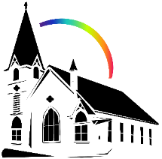
Deacon: Keith Stevens
Hospitality: Congregational Life Wider Church
Accompanist: Carson Schneider
Audio/Video: Marce Ediger & Keith Stevens
Usher/Greeter(s): Paula & Ron Benfer
Sunday School: Christina Schmitt & Ruth Johnson

