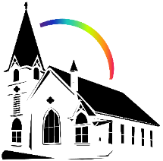


October 25th, 2026 22nd Sunday After Pentecost
Union Congregational Church seeks to create a celebrating, covenanting, affirming, and justice seeking faith community, inspiring people to unite & create a peaceful, loving world.

- We welcome LGBTQ+ people into the full life of the church, as an Open & Affirming Congregation, of the United Church of Christ.

- Listening devices are available at the rear of the Sanctuary, for enhanced audio accessibility during the service. Ushers can assist.

- For kids: The Pray-ground is in the Vestry (by the chancel ramp). You’ll find a welcoming space for all ages and space for littles with wiggles. All ages are welcome in Sunday School, but we ask a parent/guardian to accompany children under 6.

- Stay connected: Revisit our sermons with our Podcast, CommUnion, available on our website, www.ElkRiverUCC.org/watch, and on most major podcast apps.

- In scripture, you may see the letters YHWH - the sacred, unpronounced name of God. To honor the mystery of the Divine and as witness to our expansive faith, we invite our liturgists to substitute the title or aspect of God they find most meaningful, such as Holy One, Mother, Lord, Creator, or Spirit. We invite you to listen for these diverse expressions of the Divine as we worship together.

* Indicates to rise Bold text indicates to speak

Order of Worship

Prelude:

Welcome: Rev. Nora Elliott

May peace be with you
And also, with you.

Centering Breath

Gathering Prayer:
God of all, settle our restless hearts as we gather in faith. We come not with empty hands, but with the gifts You have entrusted to us. Quiet the noise of our worry, that we may hear Your call to courage. Amen.

Offering Peace
Please greet each other with "May peace be with you."

*Opening Hymn: The Church's One Foundation #386 NCH

Call to Worship:
One: The One who builds this church on rock of faith calls us into the building.
Many: We confess, at times, we have hidden our gifts in the ground; afraid of failure, risk, and being seen.
One: We have called ourselves "safe" when we have only been still; compared our portion to our neighbor's, and called our own too small
Many: Forgive us, God of abundance. Forgive our timid hearts that let fear of the dark keep us from carrying Your light.
One: Hear the good news: Our Sovereign God does not count our coins but instead counts our courage.
Many: Thanks be to God. We rise in faith. We build with joy. Amen.

Scripture: Matthew 25: 14-29

Time with Children: What’s in the bag?

Sermon: Build With It

Responsive: Won't You Let Me Be Your Servant #539 NCH

Offertory: Give electronically by scanning the QR code

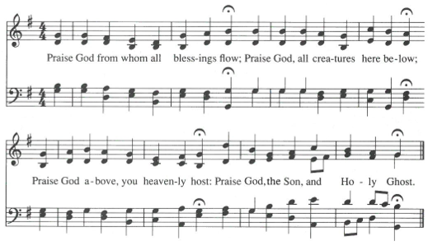
Doxology: Praise God for Whom All Blessings Flow NCH #780 v1

Special Music:

Offering Prayer:

Generous God, you do not give us a little and ask for a little. You entrust us with everything and ask only that we be faithful. Receive these gifts as partnership. Take what we offer, multiply it by Your grace, and let it become abundance for the world You love. In the name of the One who risked everything for us, Jesus Christ. Amen.

Community Prayers
…O God, hear our prayers
Submit prayer requests electronically by scanning the QR code:

Prayer of Jesus:
Traditional Expansive
Our Loving God, who art in heaven, hallowed be thy name.
Thy kin-dom come, thy will be done on earth as it is in heaven.
Give us this day our daily bread,
and forgive us our debts as we forgive our debtors.
Save us from temptation, and deliver us from evil.
For thine is the kin-dom, and the power, and the glory forever. Amen.

*Closing Hymn: Take My Life, That I May Be #583 ELW

Announcements:
- All Saints' Day is Nov. 1st; please submit names to be read to the church office by October 27th. We also welcome photos for display in the Northex from October 18th to November 8th
- Union UCC Guitar Groups Fall Concert will be today during Fellowship! A special guest artist is scheduled to appear!
- Hospitality is open November 8th. If you are willing and able to volunteer, please email churchoffice@elkriverucc.org

Benediction

Postlude:

Our church calendar is available online at ElkRiverUCC.org, at the bottom of the home page

Worship Staff & Volunteers
Next Council Meeting: November 5th
Upcoming Hospitality: Nov. 1st | Diaconate Nov. 8th | Open
General Questions?
Email the Office at ChurchOffice@ElkRiverUCC.org

Mailing Address
1118 4th St. NW
Elk River, MN 55330

Web Address
www.ElkRiverUCC.org

Office Hours:
Tues. - Thurs. 9:30 AM - 3:30 PM

Pastor: Rev. Nora P. Elliott
763-276-7204; RevNora@ElkRiverUCC.org

Music Director: Carson Schneider
Music-Director@ElkRiverUCC.org

Office Manager: Rachel Cangello
763-441-1203; ChurchOffice@ElkRiverUCC.org

Accompanist: Carson Schneider
Audio/Video:
Deacon: Kelly Lundquist
Hospitality: Trustees
Sunday School: Amanda Hooper
Ushers and Greeters: Francis Family
