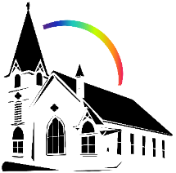


October 4th, 2026 World Communion Day
Union Congregational Church seeks to create a celebrating, covenanting, affirming, and justice seeking faith community, inspiring people to unite & create a peaceful, loving world.

- We welcome LGBTQ+ people into the full life of the church, as an Open & Affirming Congregation, of the United Church of Christ.

- Listening devices are available at the rear of the Sanctuary, for enhanced audio accessibility during the service. Ushers can assist.

- For kids: The Pray-ground is in the Vestry (by the chancel ramp). You’ll find a welcoming space for all ages and space for littles with wiggles. All ages are welcome in Sunday School, but we ask a parent/guardian to accompany children under 6.

- Stay connected: Revisit our sermons with our Podcast, CommUnion, available on our website, www.ElkRiverUCC.org/watch, and on most major podcast apps.

- In scripture, you may see the letters YHWH - the sacred, unpronounced name of God. To honor the mystery of the Divine and as witness to our expansive faith, we invite our liturgists to substitute the title or aspect of God they find most meaningful, such as Holy One, Mother, Lord, Creator, or Spirit. We invite you to listen for these diverse expressions of the Divine as we worship together.

* Indicates to rise Bold text indicates to speak
Order of Worship

Prelude: Gather Us In by Mark Hayes

Welcome: The Rev Nora Elliott

May peace be with you
And also, with you.

Centering Breath

Gathering Prayer:
God of all nations and all sorrows, we gather not to hide the world’s brokenness, but to bring it boldly to your table. Hold us together in this moment, where the joy of our diversity meets the grief of our missing siblings, and remind us that your love is wide enough to contain it all. Amen

Offering Peace
Please greet each other with "May peace be with you."

*Opening Hymn: Si Fui Motivo de Dolor, Oh Dios #544 NCH v1 - 3, v1 (Spanish)

Call to Worship:

One: For the children of this land who are missing, and the families whose voices are unheard.
Many: We promise to remember, and we refuse to be silent.
One: For the cultures we often taste as tourists but ignore as neighbors. Many: We seek to build relationships that last through time.
One: For the bread we break in safety, while others hunger in war and displacement.
Many: We promise to share, and we commit to justice.
One: God of every border and boundary.
Many: Break our hearts for what breaks yours, and make us truly One Body. Amen.

Scripture: Lamentations 3:19-24 & 1 Corinthians 10:17

Time with Children: What’s missing?

Sermon: The Crumb and the Chasm

Choir Responsive: The Prayer by Tom Fettke

Offertory: One Bread, One Body by Joel Raney

You can give electronically by scanning the QR code with a smart phone camera

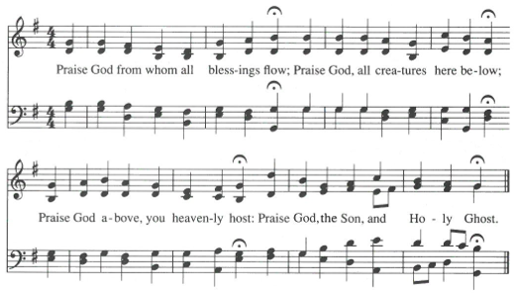
Doxology: Praise God for Whom All Blessings Flow NCH #780 v1

Offering Prayer:
God of the Missing and the Found, we bring these gifts not as a payment, but as a promise. Use this money to fund the search for the lost, to feed the hungry who have no bread, and to repair the broken connections between us. Make our generosity as real as our grief, and our action as loud as our songs. Amen.

Communion Our Communion table is open to everyone of every age and spirituality
Invitation

Consecrating of the Elements

Submit prayer requests electronically by scanning the QR code:

Prayer of Jesus: Traditional Expansive

Our Loving God, who art in heaven,
hallowed be thy name.
Thy kin-dom come, thy will be done
on earth as it is in heaven.
Give us this day our daily bread,
and forgive us our debts as we forgive our debtors.
Save us from temptation, and deliver us from evil.
For thine is the kin-dom, and the power, and the glory forever. Amen.

*Closing Hymn: Wakantanka Take Nitawa NCH 3

Announcements:
- Calling all Volunteers for Meals on Wheels for October! We still have the following slots available (10/14, 10/15, 10/20, 10/21, 10/27, 10/28, 10/29) please email the office if you can volunteer any of those days! ChurchOffice@ElkRiverUCC.org
- Next Sunday Oct 11th, Congregational Life is hosting fellowship after worship at Orono Park! Come help clean up the park and share some grilled hotdogs and chips!

Benediction

Postlude: Now Thank We All Our God by Victor Labenske

Our church calendar is available online at ElkRiverUCC.org, at the bottom of the home page

Worship Staff & Volunteers
Next Council Meeting: November 5th
Upcoming Hospitality: Oct. 11th | Congregational Life Oct. 18th | OPEN
General Questions?
Email the Office at ChurchOffice@ElkRiverUCC.org

Mailing Address
1118 4th St. NW
Elk River, MN 55330

Web Address
www.ElkRiverUCC.org

Office Hours:
Tues. - Thurs. 9:30 AM - 3:30 PM

Pastor: Rev. Nora P. Elliott (She/They)
763-276-7204; RevNora@ElkRiverUCC.org

Music Director: Carson Schneider
Music-Director@ElkRiverUCC.org

Office Manager: Rachel Cangello (She/Her)
763-441-1203; ChurchOffice@ElkRiverUCC.org

Accompanist: Carson Schneider
Guest Musician: Carl Olsen
Audio/Video:
Deacon: Lisa Cawthra
Hospitality: Congregational Life
Sunday School:
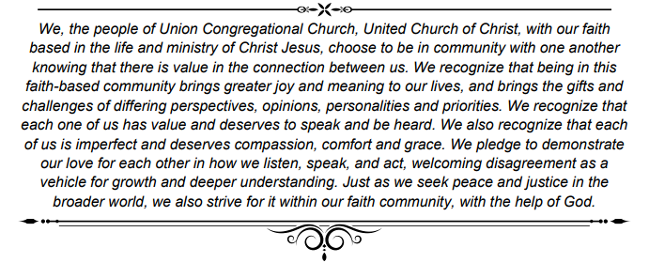
Ushers and Greeters: Su Arnold and Janine

