
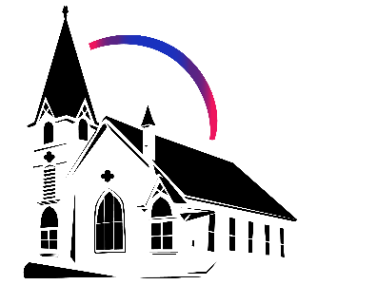

January 11th, 2026 Baptism of Christ
Union Congregational Church seeks to create a celebrating covenanting, affirming, and justice seeking faith community that inspires people to unite and create a peaceful, loving world.

- We welcome LGBTQ+ people into the full life of the church, as an Open & Affirming Congregation, of the United Church of Christ.

- Listening devices are available at the rear of the Sanctuary, for enhanced audio accessibility during the service. Ushers can assist.

- For kids: The Pray-ground is in the Vestry (off the sanctuary). You’ll find a table with activity bags for children to use during the service. Kids are welcome at the table or with their parents in worship. All ages are welcome in Sunday School, but we ask a parent/guardian to accompany any children under 6.

- Stay connected: Missed a sermon or want to share it digitally? Listen to our Sunday sermons on our Podcast, CommUnion, at www.ElkRiverUCC.org/watch. You’ll also find our live stream if you can’t attend in person and an online bulletin to follow along. Hard copies of the sermon are available by the front door.

- In scripture, you may see the letters YHWH - the sacred, unpronounced name of God. To honor the mystery of the Divine and as witness to our expansive faith, we invite our liturgists to substitute the title or aspect of God they find most meaningful, such as Holy One, Mother, Lord, Creator, or Spirit. We invite you to listen for these diverse expressions of the Divine as we worship together.

* Indicates to rise Bold text indicates to speak
Order of Worship
Prelude: Amazing Grace by Mark Hayes

Welcome: Rev. Nora P. Elliott
May peace be with you
And also with you.

Gathering Prayer
Immanuel, God with us. Your people gather in the middle of the mess. So much has been undone, and so much is left to do before your Kindom comes. Help us to breathe before it is finished. Be with us while we forge ahead and are only certain of where we need to go, not how to get there.

Offering Peace
Please greet each other with "May peace be with you."

*Opening Hymn: What Ruler Wades through Murky Streams #169 NCH
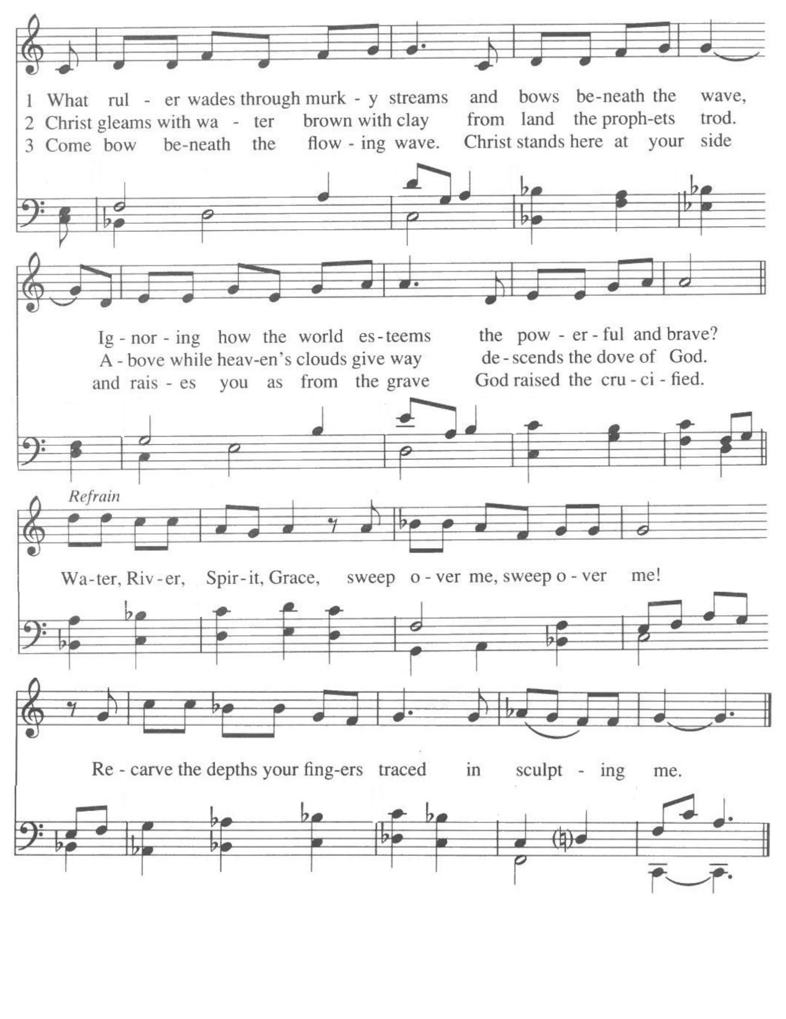

Call to Worship - From “Black Liturgies,” by Cole Arthur Riley
One: God of Change,
Many: We are not who we once were. We are tired of being known only in memory.
One: Protect us from being dragged into a selfhood that no longer feels true for us.
Many: Help us [move] in our present selves without forgetting or dismissing who we’ve been - the pain we may have caused, the stories we carry.
One: Remind us that our journey to selfhood is not escapism but listening, attunement. And as we look toward deeper change still, help us to remember that we can honor our future selves without degrading who we have been.
Many: There is beauty here too, on the edge of our becoming. Amen

Scripture
Isaiah 42:1-8
“Here is my Servant, whom I uphold my chosen one, in whom I delight! I have endowed you with my Spirit that you may bring true justice to the nations. You do not cry out or raise your voice, or make yourself heard in the street. So gentle that you do not break a bruised reed, or quench a wavering flame, faithfully you will bring forth true justice. You will neither waver nor be crushed until justice is established on earth, for the islands await your teaching! Thus says YHWH, who created the heavens and spread them out, who gave shape to the earth and what it produces, who gave life to its peoples and spirit to its inhabitants: I, YHWH, have called you to serve the cause of right; I have taken you by the hand, and I watch over you. I have appointed you to be a covenant people, a light to the nations: to open the eyes of the blind, to free captives from prison, and those who sit in darkness from the dungeon. I am YHWH! This is my Name! I will not yield my glory to another god or my praise to idols.”

Acts 10:34-43
So Peter said to them, “I begin to see how true it is that God shows no partiality—rather, that any person of any nationality who fears God and does what is right is acceptable to God. This is the message God has sent to the people of Israel, the Good News of peace proclaimed through Jesus Christ, who is Savior of all. “You yourselves know what took place throughout Judea, beginning in Galilee with the baptism of John proclaimed. You know how God anointed Jesus of Nazareth with the Holy Spirit and with power, and how Jesus went about doing good works and healing all who were in the grip of the Devil, because God was with him. We are eyewitnesses to all that Jesus did in the countryside and in Jerusalem. Finally, Jesus was killed and hung on a tree, only to be raised by God on the third day. God allowed him to be seen, not by everyone, but only by the witnesses who had been chosen beforehand by God—that is, by us, who ate and drank with Christ after resurrection from the dead. And Christ commissioned us to preach to the people and to bear witness that this is the one set apart by God as judge of the living and the dead. To Christ Jesus all the prophets testify, that everyone who believes has forgiveness of sins through this Name.”

Time with Children: What matters?

Sermon: The Piddly Brook of the Soul
*space left blank for notes or doodles*

Responsive Hymn: God Weeps, text by Shirley Erena Murry & Music by Mark Miller
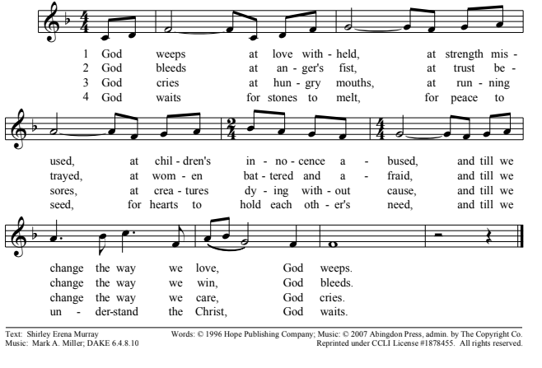


Offertory
Scan QR code with smart phone camera to give electronically.

Special Music: There is a Balm in Gilead by Mark Hayes

*Doxology: Praise God from Whom All Blessings Flow

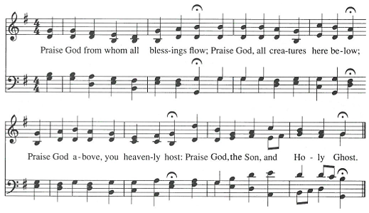
AMEN

*Prayer of Dedication
Generous spirit, bless these offerings of intention and treasure to serve your sacred ministry of care in the mess of our world. May it be a sign that even now, your promises will still rise again like a dove.

Community Prayers:
Pastor Nora will offer a blessing for each prayer raised and then invite the congregation to pray together, "Oh God, hear our prayer.

Prayer of Jesus – Translated from the Aramaic by Mark Hathaway
O cosmic Birther of all radiance and vibration, soften the ground of our being, and carve out a space within us where your Presence can abide. Fill us with your creativity, so that we may be empowered to bear the fruit of your mission. Let each of our actions bear fruit in accordance with our desire. Endow us with the wisdom to produce and share what each being needs to grow and flourish. Untie the tangled threads of destiny that bind us, as we release others from the entanglement of past mistakes. Do not let us be seduced by that which would divert us from our true purpose, but illuminate the opportunities of the present moment. For you are the ground and the fruitful vision, the birth, power, and fulfillment, as all is gathered and made whole once again. And So It Is!

*Closing Hymn: O for a World #575 NCH
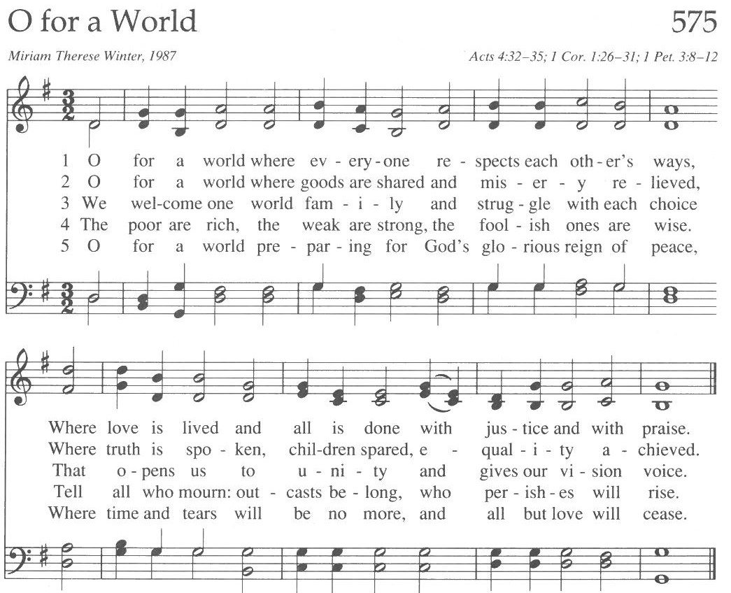

Announcements
- If you’re able, please stick around after worship today to help put away all of our Advent/Christmas decorations.

- Do you have an old tablet, smart TV, or Roku/Chromecast you no longer need? Please talk to Pastor Nora, as we are working to develop our online and hybrid ministries and our technology team would welcome donations.

- Support for Renee Good’s wife and son can be given:
  - https://www.gofundme.com/f/support-for-renee-goods-wife-and-son

- Council has voted to forego their Jan meeting and meet again in February

- Thank you to everyone who came to our Annual Meeting last week and heard reports on our 2026 budget, capital campaign, and a vision of our future together.

- Plans for a special Congregational Meeting to review and potentially reprioritize our building’s accessibility needs is in the works and will be announced when set.

Benediction:

Postlude: Carson Schneider

Union Congregational UCC Worship Staff
Next Council Meeting is Feb 12th
Upcoming Hospitality: Jan. 18th | AVAILABLE Jan. 25th | Trustees
General Questions?
Email April at churchoffice@elkriverucc.org

Mailing Address
1118 4th St. NW
Elk River, MN 55330

Web Address
www.ElkRiverUCC.org

Office Hours:
Tues & Thurs: 10:00 AM-2:00 PM
Sun9:30 AM -11:30 AM

Pastor: Rev. Nora P. Elliott
763-276-7204; revnora@elkriverucc.org
Office Administrator: April Sundstrom
763-441-1203; churchoffice@elkriverucc.org
Director of Music: Carson Schneider
music-director@elkriverucc.org

Hospitality: Centennial Society
Deacon: Lisa Cawthra

Song Leader: Patti Kubicka
Accompanist: Carson Schneider
Audio/Video: Marce Ediger & Keith Stevens
Usher/Greeter(s):
Sunday School: Amanda Hooper & Ruth Johnson

