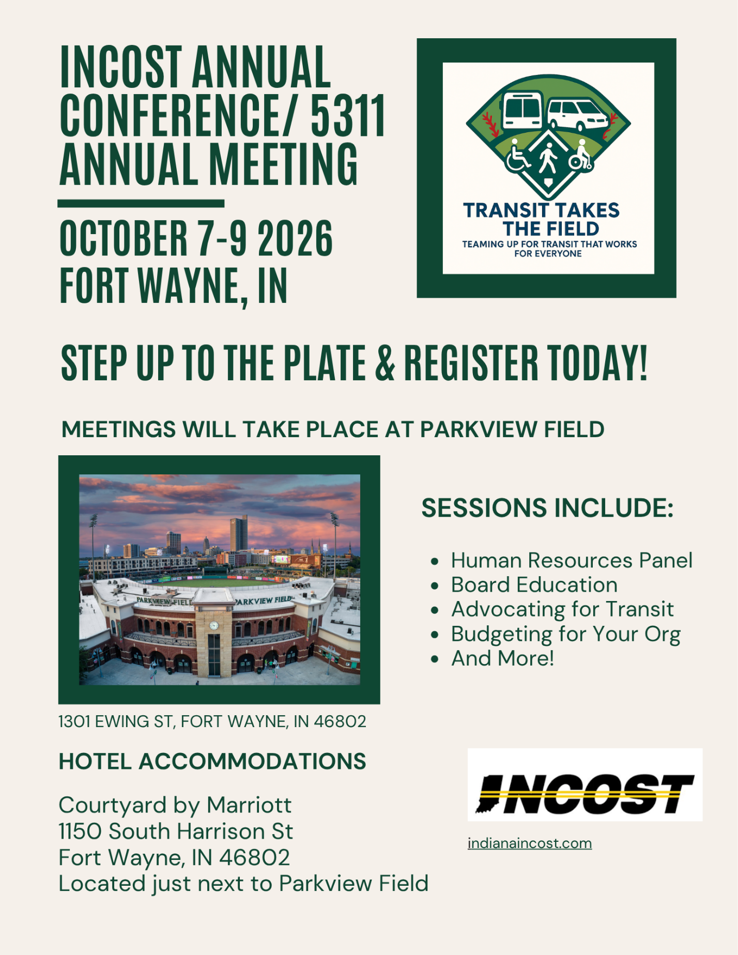

REGISTRATION FORM
Registrant Name: _______________________________________________________________
Agency Name: _________________________________________________________________
Address: ______________________________________________________________________
City/State/Zip: _________________________________________________________________
Agency Phone: ________________________________Cell Phone:______________________
E-Mail Address: _________________________________________________________________
Registration Fee is $175.00 for members and $225.00 for Non-members. More than one coming from your agency? Additional registrant is $165.00. Registration includes conference, meals, take home resources, vendor access, transportation to evening event, and attendance at the annual meeting/dinner. Please be sure to mark if you are attending the 5311 meeting!
___I will only be attending the 5311 meeting. ONE agency representative is Free. Each additional agency personnel: $25.00) ________ Number x $ 25.00 = ________________
Names of additional person(s) for 5311 only: __________________________________________________________________________________
________________ INCOST member $175.00 _____________ Additional $165.00 (Please complete separate registration form for each additional attendee)
___________________ Non –Member $225.00
______________________________$75.00 Annual INCOST 2025 Membership
(pay to receive discounted conference rate if not a current member)
I will be attending the dinner and awards ceremony on Thursday evening:
Yes:______________ No:_____________ Name:______________________________________
Additional guest cost to attend dinner (and dancing) is $45.00:
Guest name:___________________________Guest name:____________________________
Guest name:___________________________
_____________________________ Total number of guests x $45.00
___I will be attending the evening at The Fairfield Number of guest X $20__________

ANNUAL AUCTION
My agency or I would like to donate an item for the annual meeting auction:
Yes_______ Item to be donated:__________________________________________ No________
BAG GIVEAWAYS
My agency would like to donate money so the committee can buy goodie bag items and assemble bags in advance of the conference:
Yes_____ Amount to be donated: ________________________________________No_________

We are stepping up to the plate and are ready to knock the INCOST 2026 Annual Conference out of the park!
The Fairfield
Wednesday evening we will head to The Fairfield for an evening of fun, food, and games! There will be duck pin bowling lanes reserved as well as Urban Golf sims that include 30+ games to choose from, along with corn hole boards, darts, and more. This event costs $20 per attendee. Please mark if you (and your guests) are attending in the space provided on page two! https://www.thefairfieldfw.com/
Let’s Play Ball!
Thursday evening we will be celebrating with the INCOST awards ceremony and dinner followed by some baseball fun! Parkfield staff will be giving a behind the scenes tour of the ball park and will open up the batting cages and the spectator section of the ball park for us to use. Please make sure you indicate that you (and your guests) are attending in the space provided on page two!

Registrations forms must be received by September 1st to avoid a $25 late fee.
Please mail completed forms along with your check made out to INCOST to:
BethAnn Knotts
4806 State Road 45
Nashville, IN 47448
(812) 350-0909
bknotts@columbus.in.gov
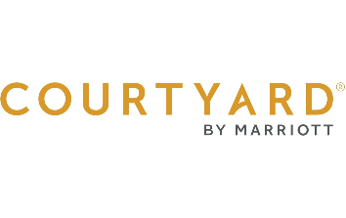
The Courtyard by Marriott, 1150 S Harrison St. Fort Wayne, IN 46802
The Courtyard is located in the heart of downtown Fort Wayne and walking distance to tons of restaurants and shop.
Reservations must be made by September 18, 2026, using the link below to receive the group rate.
Book your group rate for Indiana Council on Specialized Transportation (INCOST)
Room rates are $150.00 +tax per night for either 2 queens or a king room.
Note: Because this is the rate associated with the “hosting hotel” on an INDOT sponsored conference, the hotel can be fully reimbursed, even being able the State allocation, for those eligible.
Parking is discounted to $8 daily.
Connor’s Kitchen + Bar is located inside The Courtyard and open from 6 am-10pm
All reservations must be guaranteed with a major credit card. Hotel(s) will not hold any reservation unless secured by a major credit card. Individual reservations canceled less than 48 hours prior to scheduled arrival are subject to a cancellation fee equal to one night’s room and tax.
For those getting into town on Tuesday evening, here is a list of restaurants within walking distance of the hotel. https://downtownfortwayne.com/downtown-dining/
If you are looking to explore Fort Wayne, walking the Public Art Trail is a great way to see downtown. https://assets.simpleviewinc.com/simpleview/image/upload/v1/clients/fortwayne/Public_Art_Flyer_Map_2024_c7f676f7-a57e-4cf6-a155-c00021cc2e05.pdf
Full reservation link if you are having issues: https://www.marriott.com/event-reservations/reservation-link.mi?id=1774035478580&key=GRP&app=resvlink&_branch_match_id=1501967778583415173&_branch_referrer=H4sIAAAAAAAAA8soKSkottLXTywo0MtNLCrKzC8p0UvOz9UvSi3OyczLtgdK2ALZZSCOWmaKraG5uYmBsamJuYWphYFadmqlrXtQgFpdUWpaKlB3Xnp8UlF%2BeXFqka1zRlF%2BbioA%2Fyy%2FJGAAAAA%3D
Schedule of Events
More details to follow and subject to change

October 7th, 5311 Annual Meeting, Parkview Field Suite Level Lounge
8:00-4:00 5311 Annual Meeting
4:00-5:00 Vendors and INCOST registration opens
6:00-9:00 The Fairfield for dinner and fun

October 8th, INCOST Annual Conference, Parkview Field Suite Level Lounge
7:30-8:00 Registration
8:00-12:00 Educational Sessions
12:00-1:45 Lunch and vendors
1:45-4:00 Educational Sessions
4:00-4:45 INCOST Annual Meeting
4:45-6:00 Vendors, silent auction, and drinks
6:00-9:00 Awards Dinner, Batting Cages, Ball Park Behind the Scenes Tour

October 9th, INCOST Annual Conference, Parkview Field Lincoln Financial Event Center
9:00-12:00 Educational Sessions
12:00- Final remarks and raffle

