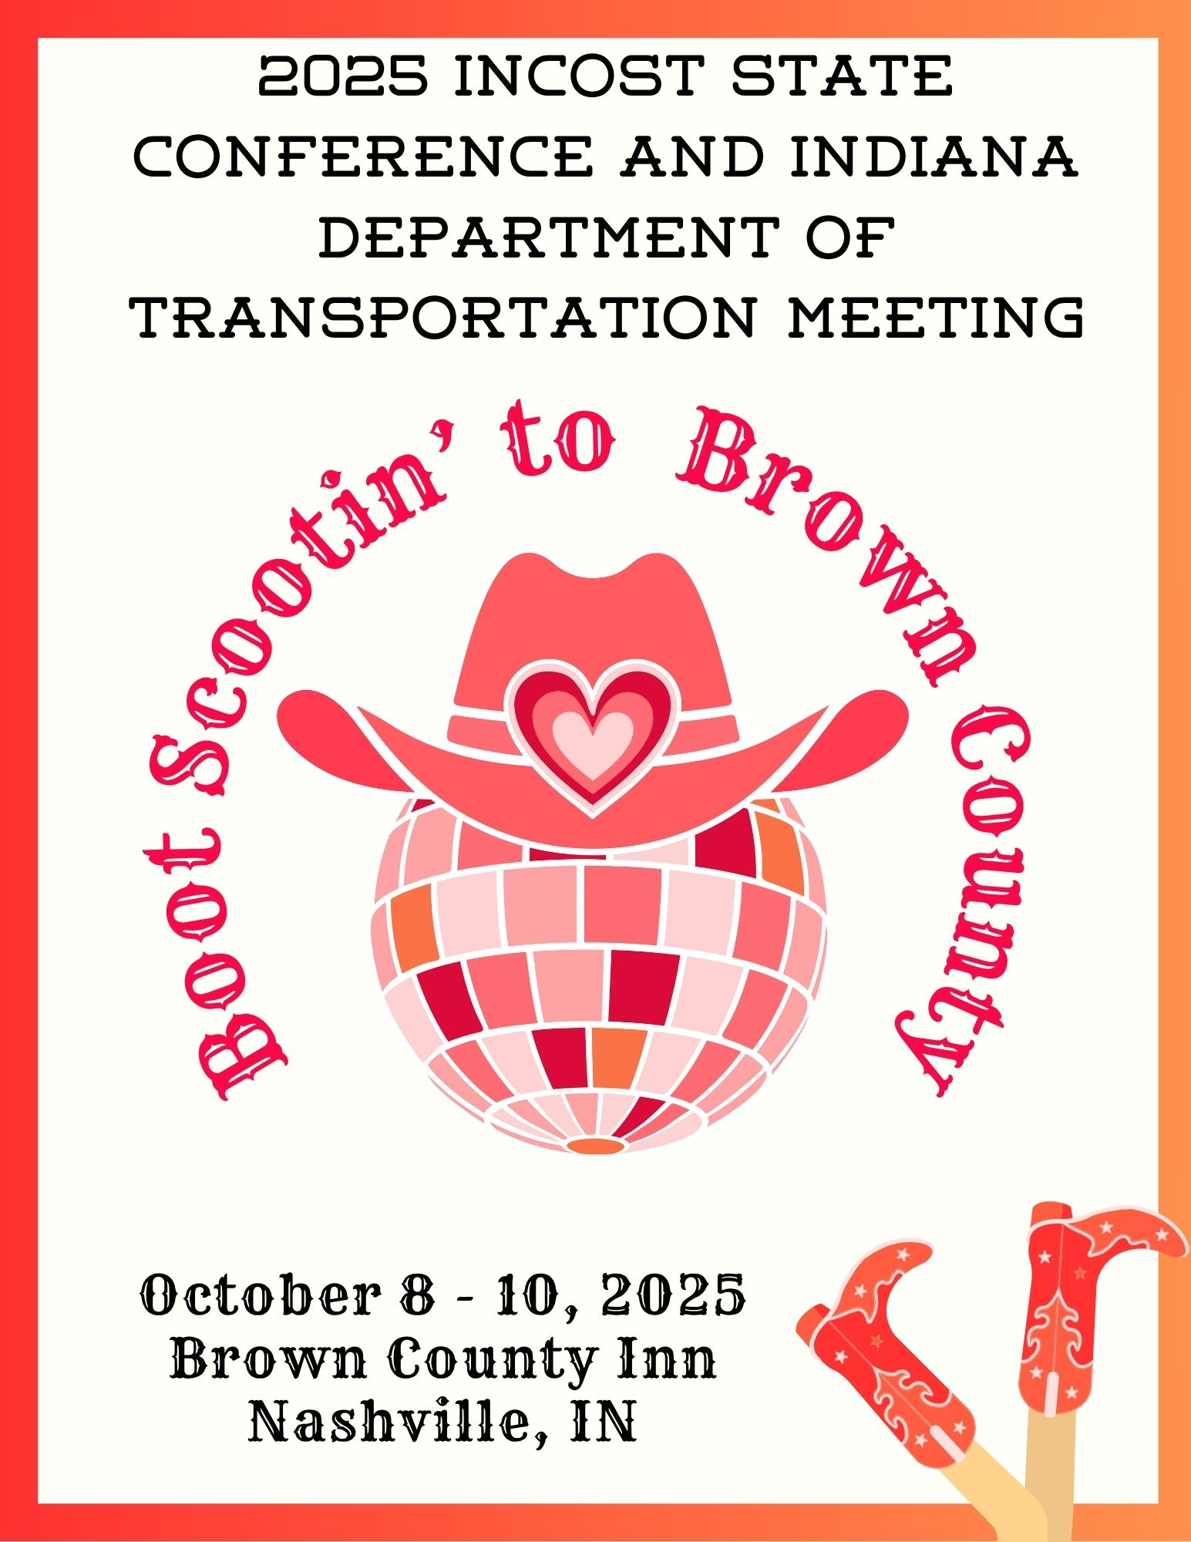

REGISTRATION FORM

Registrant Name: _______________________________________________________________

Agency Name: _________________________________________________________________

Address: ______________________________________________________________________

City/State/Zip: _________________________________________________________________

Agency Phone: _________________________________________________________________

Cell Phone: ____________________________________________________________________

E-Mail Address: _______________________________________________________________

Registration Fee is $175.00 for members and $225.00 for Non-members. More than one coming from your agency? Additional registrant is $165.00. Registration includes conference, meals, take home resources, vendor access, transportation to evening event, and attendance at the annual meeting/dinner.

___I will only be attending the 5311 meeting. ONE agency representative is Free. Each additional agency personnel: $25.00) ________ Number x $ 25.00 = ________________

Names of additional persons for 5311 only: _________________________________________________________________________

________________ INCOST member $175.00 _____________ Additional $165.00 (Please complete separate registration form for each additional attendee)
___________________ Non –Member $225.00

______________________________$75.00 Annual INCOST 2025 Membership
(pay to receive discounted conference rate if not a current member)

I will be attending the dinner and awards ceremony on Thursday evening:
Yes:______________ No:_____________ Name:____________________________________

Additional guest cost to attend dinner (and dancing) is $45.00: Guest name:______________

Guest name:____________________________ Guest name:_________________________
______________________Total number of guests x $45.00
ANNUAL AUCTION
My agency or I would like to donate an item for the annual meeting auction: Yes_______ Item to be donated:_____________________________ No________
BAG GIVEAWAYS
My agency would like to donate money so the committee can buy goodie bag items and assemble bags in advance of the conference: Yes_____ Amount to be donated: _______________ No_____

We have several boot scootin’ fun events planned during the
2025 INCOST conference. Please let us know if you, or members of your party, can join in the fun!

Dinner and Dancin’!**
Thursday evening festivities includes dinner and the INCOST awards ceremony followed by an evening of boot scootin’ fun on the dance floor with world renown line dancing instructors Billy and Carla of Dancin’ with Billy! **Please make sure you’ve indicated that you (and guests) are attending in the space provided on page two!

Golf!

While members and registered participants attend classes on Wednesday and Thursday, guests not attending meetings are welcome to enjoy a round of golf at Salt Creek Golf Course.

I, or a member(s) of my party would like to golf on: Wednesday:__________ Thursday:__________ ($43 per 18 holes with cart. Please indicate total number of golfers playing each day so reservations can be secured).

Distillery tasting and dinner!
We will be visiting Hard Truth Distillery Wednesday evening. Distillery tours, spirit tasting, and dinner will be available for purchase for anyone who wishes to participate in any or all events. Transportation will be provided (but please let us know you plan to attend so we can save you a seat on the shuttle)!
I (we) would like to visit Hard Truth (number attending):_____________

Registration forms must be received by September 1st to avoid a $25 late fee.
Please mail completed forms along with your check made out to INCOST to:

BethAnn Knotts 4806 State Road 45 Nashville, IN 47448
(812) 350-0909 bknotts@columbus.in.gov

Hotel Reservation Information


Brown County Inn
51 E. State Road 46
Nashville, IN 47448
(800) 772-5249

Reservations must be made by September 1st, 2025
Group promo code: INCOST
Reservations can be made by calling the Inn at 1-800-772-5249 or online at www.browncountyinn.com. When making reservations, guests should use the group promo code INCOST in order to receive the group rate.

Room rate is $109.00 +tax per night (2 queen beds) or
$119.00 +tax per night (king)

Breakfast is served daily from 8am to 11am and features selections from continental fare to biscuits and gravy priced from $4-$15 +beverage. Lunch and dinner are available onsite daily.

Inn amenities include complimentary Wi-Fi, a miniature golf course onsite, horse shoes, shuffleboard, live music in the Corn Crib Lounge (evenings), a children’s play area, and a covered and enclosed pool. The Inn is just a three block walk to scenic downtown Nashville and is bordered by the paved Salt Creek walking trail.

HOTEL TERMS AND CONDITIONS: Reservations are secured at time of booking by major credit card. The credit card account will be debited for the amount of first night's stay per room reserved as a deposit to secure it at the time reservation is ordered. Hotel check in time is 4:00pm. Check out is Noon. In the event that guests cancel and give 48 hours notice prior to their scheduled arrival date, they will be given a full refund for the amount of their deposit.
SCHEDULE OF EVENTS
WEDNESDAY, OCTOBER 8th, 9:00 – 3:30pm

INDIANA DEPARTMENT OF TRANSPORTATION
5311 Rural Public Transit Program
Agenda
8:00-9:00 Registration

9:00 – 10:45 Welcome and Introductions
Todd Jennings, 5311 Program Manager
Roll Call – Introductions of Systems

10:45-11:00 Break

11:00-12:00 (Program content will be decided upon in September)

12:00-1:00 Lunch

1:00-2:00 (Program content will be decided upon in September)

2:00-2:15 Break

2:15-2:30 (Program content will be decided upon in September)

2:30-3:30 5311 Program Issues – Todd Jennings

3:30 Adjourn

WEDNESDAY, OCTOBER 8th
Evening Events

4:30 – 5:30 -- Vendor Room open

4:30-5:00 pm -- INCOST Registration Begins

5:30-6:00 pm -- Shuttle to Hard Truth

6:00 p – 9:00 -- Hard Truth visit (transportation provided!)

9:00 – 9:30pm – Shuttle back to Brown County Inn

THURSDAY, OCTOBER 10th

7:30 – 8:30 am -- Registration/Breakfast

8:30 – 10:00 am – Crisis Management (Kelly Shawn of RLS and Associates)

10:00 – 10:15 am -- Break

10:15 – 12:00 pm -- Adversity Intelligence (Rick Weinheimer)

12:00 – 1:45 -- Lunch and Vendor Room open

1:45 – 2:45 pm -- All about HIPPA (Kelly Shawn)

2:45 – 3:00 pm - Break

3:00 – 4:00 pm -- Roundtable breakout--Medicaid

4:00-04:30 pm -- Annual INCOST Meeting

4:30-5:30 pm -- Vendor Room Open (Please stop by and see all of the vendors)

5:30-6:00 pm –- Drinks and Networking

6:00-7:00 pm -- Dinner, Roadeo and Master Driver Recognition, Sponsor Recognition

7:00 -9:00 pm -- Dancin’ with Billy

FRIDAY, OCTOBER 11th

9:00 – 10:30 am -- Employee Retention (Kelly Shawn)

10:30 – 11:15 am -- Department of Homeland Security

11:15 – 11:30am – Break

11:30 – 12:15 – Roundtable Breakout--funding

12:15 -- Door Prizes/Adjournment

