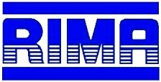

Environmental Policy

RIMA is committed to conducting our business in an environmentally responsible manner. Management of manufacturing operations in an environmentally friendly manner is an integral part of our business plan and is the responsibility of all associates in our facility.

We are committed to complying with all relevant environmental legislation and regulations and other requirements to which our organization subscribes.

We are committed to continual improvement to enhance environmental performance.

Management is committed to setting and achieving environmental objectives and targets, which reflects the company’s commitment to the protection of the environment, including prevention of pollution.

