**Paint the City Purple Campaign (PTCP) Annual Sponsorship, Partnership & Membership Form**

Thank you for your interest in supporting the Paint the City Purple Campaign (PTCP). Your sponsorship, partnership, or membership helps us continue to provide resources, workshops, and support to victims of domestic violence and gender-based violence (GBV) on both local and global scales. Each package comes with an **Annual PTCP Pledge Form**, designed to be proudly displayed on your wall as a commitment to eradicating GBV and empowering survivors.

Please select the option that best fits your commitment:

**1. Annual PTCP Sponsorship - $1,000**

As an **Annual PTCP Sponsor**, you will receive:

* **Recognition as a Sponsor** on our website and in all PTCP events and materials
* **Company logo** displayed on all event banners, flyers, and promotional materials
* **Two free entries** to our annual events and workshops
* **PTCP T-Shirt (1 included)** with free shipping
* **Exclusive sponsor benefits**, including a personal feature on our website
* **Priority access** to global resources and events
* **Annual PTCP Pledge Form** for display
* **Social media shout-outs** thanking you for your support

**2. Annual PTCP Partnership - $100**

Join us as a partner and become a vital part of our community.  
As an **Annual PTCP Partner**, you will receive:

* **Recognition as a Partner** on our website and event materials
* **One free entry** to our annual events and workshops
* **Access to PTCP resources** and partner-only updates
* **Annual PTCP Pledge Form** for display
* **Priority listing** in our partnership network
* **Discounted tickets** to events and workshops

**3. Annual PTCP Membership - $10**

By becoming an **Annual PTCP Member**, you will receive:

* **Exclusive member newsletters** with updates on PTCP initiatives and progress
* **Member-only discounts** on event tickets, merchandise, and workshops
* **PTCP Membership Card** to showcase your support
* **Annual PTCP Pledge Form** for display
* **Invitation to virtual events and webinars** related to GBV awareness and prevention

**4. PTCP T-Shirts**

Show your support with our **PTCP T-Shirt**, featuring the official **Paint the City Purple Campaign logo**.

* **T-Shirt Price (without shipping): $33**
* **T-Shirt Price (with shipping): $55**

Each T-shirt purchase includes:

* **Official PTCP T-shirt** in your preferred size
* **Annual PTCP Pledge Form** for display

**Payment and Shipping Information**

1. **Name:** ____________________________________________
2. **Company/Organization (if applicable):** ____________________________________________
3. **Address:** ____________________________________________ (City, State, Zip Code)
4. **Phone Number:** ____________________________________________
5. **Email Address:** ____________________________________________

**T-Shirt Size (if applicable):**  
o Small  
o Medium  
o Large  
o Extra Large  
o 2XL (add $3)

**Preferred Package (Check One):**  
o Annual PTCP Sponsorship - $1,000  
o Annual PTCP Partnership - $100  
o Annual PTCP Membership - $10  
o PTCP T-Shirt (without shipping) - $33  
o PTCP T-Shirt (with shipping) - $55

**Payment Method**

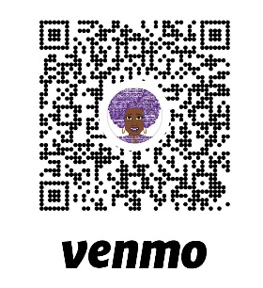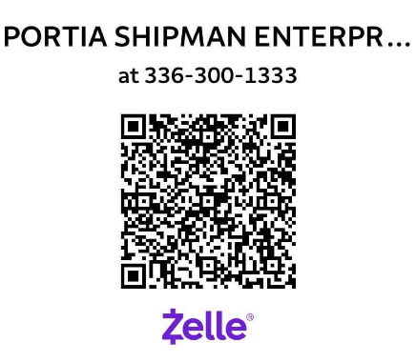o Credit/Debit Card  
o Check  
o PayPal  
o Other (please specify): _______________________

**Additional Information**

If you have any specific questions or need assistance, please contact us at Portia Shipman Enterprises LLC (336) 300-1333 or visit our website at [www.paintthecitypurplecampaign.com](http://www.paintthecitypurplecampaign.com) .

**Thank you for your commitment to supporting the Paint the City Purple Campaign. Together, we can make a difference in the fight against domestic violence and gender-based violence!**